1. Given the provided data, what are three conclusions we can draw about Kickstarter campaigns?

-The successful campaigns have the most variances in backers count, all successful campaigns have been spotlighted. Most of the supported campaigns are related with arts such as documentaries, shorts, music, photograph books. To success you must have a big number of backers or supporters.

- The Failed Campaigns have less variances in backers count, the 95% of percentage found is between -105.14 and 140.56 indicating that there is not a normal distribution.

- There is a 53.76 Percent of probability to success in founding campaigns, this probability increases as they are film and video and music. Photography books and Theater plays may increase their probability of success but not at the same rate.

1. What are some limitations of this dataset?

It does not show us, in detail, other preferences in order to understand why backers support some campaigns, for instance, Why backer support nonfiction or radio & podcast instead of children’s and fiction books. Why they choose to support film & Video instead of technology.

1. What are some other possible tables and/or graphs that we could create?

* Per percentage by Category, It indicates us that the artistic categories are more likely to success than the other categories such as food or journalism.

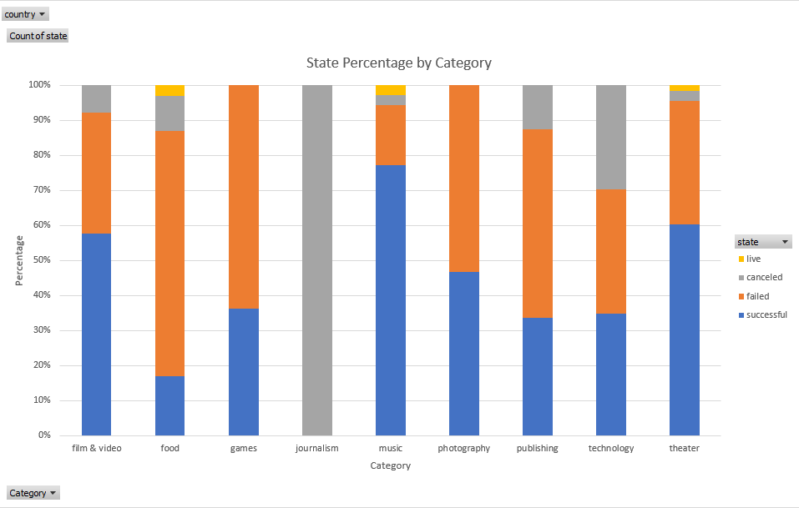

* Per State by Category – Subcategory

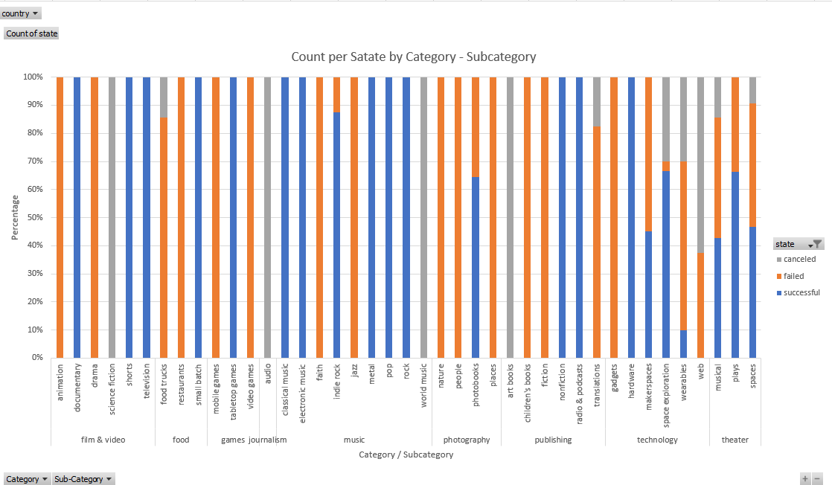

* Each category has at least one subcategory that have better chances to reach the goal, for instance in technology, hardware has reach 100% of success in each campaign.

