Oblig3 – IN3160 – jorundht

a)
When rst_n =’1’ and mclk is on the rising edge signals are allowed to change from 0 to something else. a gets the value of inndata on the rising edge of mclk, but this value is not set until the end of the process, so all other signals are still 0 on the clock cycle where a is set to ‘1’. On the next rising edge of the clock, the variable v1 is assigned ‘1’ and b is assigned the value of v1, all the other variables retain their value because b is not set before the end of the process. On the rising edge after b is updated to ‘1’, v2 variable is assigned ‘1’ and thus c-signal is updated to ‘1’. Because outdata is updated outside the process, this is updated on the same clock cycle as the c-signal.
The reason for the delay, is that the signals (a, b, c) have to propagate the signal before it reaches outdata. It is not possible to update a signal several times per clock cycle, that is why it takes two clock cycles for outdata to update.
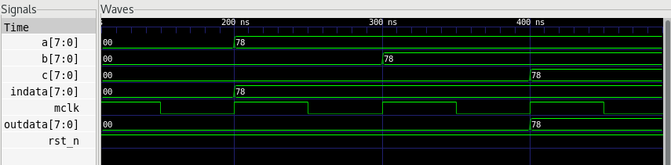
b)

- Now the outdata signal change four clock cycles after the inndata is updated as opposed to two clock cycles when v1 and v2 were variables.
- When v1 and v2 were variables they could send the byte to b and c on the same clock cycle as they “received” it. But when they were changed to signals, b and c had to wait one clock cycle to be updated.
- That is because it gets its value from the other signals, and they do not get initialized until later.
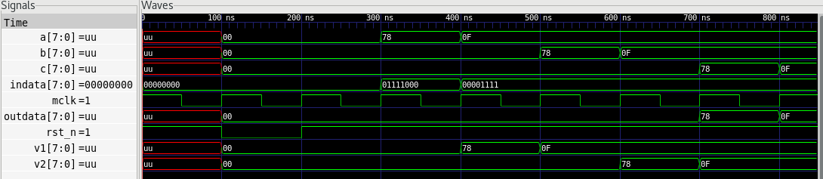

c)
- sig1 and sig2 are signals, therefore the assignment of new values to these signals does not come into effect until after the process is done. output(7 downto 6) and output(3 downto 2) both get their values from sig1 and sig2 that is why they are always the same.
- var1 and var2 are variables. output(1 downto 0) gets values from these two variables, after that the variables are given new values before output(5 downto 4) gets values from these variables. Since var1 and var2 get updated before output(5 downto 4) is set, it is different from output(1 downto 0).
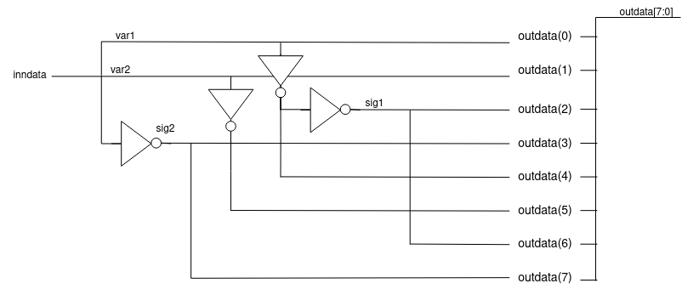

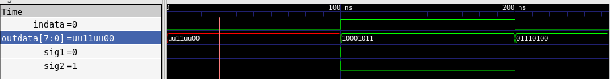

d) This is because sig1 and sig2 cannot propagate a signal until they are set. And that can only be done the next time the process is triggered by the indata. Because the two signals are no longer in the sensitivity list, there is a delay of updating outdata.

