Stevens Institute of Technology
Department of Electrical and Computer Engineering

Fall Semester 2021

CpE 462 Introduction to Image Processing

Homework 7: Due Dec 2

7.1 Assume that a bi-level input image x[n₁, n₂] of 512×512 as shown below, where the dark region has amplitude of 50 and the white background has amplitude of 200.

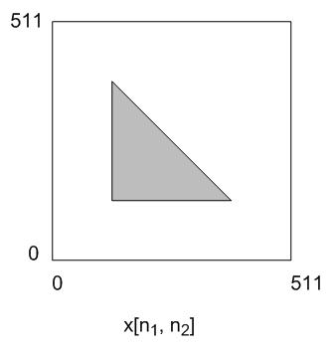

An edge detector (consisting of two filters) is applied to x[n₁, n₂] which will produce two filtered images G₁(x[n₁, n₂]) and G₂(x[n₁, n₂]). These two images will be combined to form one gray level image y[n₁, n₂] using the absolute sum
y[n₁, n₂]=|G₁(x[n₁, n₂])| + |G₂(x[n₁, n₂])|
A segmentation will then be performed on this image to produce a binary edge image. Assume that segmentation is based on the operator
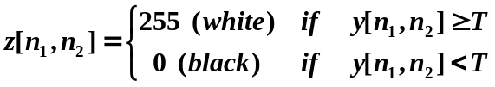

7.1.1. Use Roberts edge detector on this image. Select an appropriate threshold values T such that z[n1, n2] will only show all the edges. Specify your threshold T and sketch your output image.

7.1.2. Repeat 7.1.1. using Prewitt edge detector.

(Note: each actual edge may result in single, double, triple or more lines depending on different edge detector, please specify the lines you get.)

7.2 Based on the imageprocessing.c structure, write a small routine which can automatically calculate the global threshold value according to the iterative global threshold estimation algorithm we discussed in class.

Hint: you have to initialize a T; then read through the image several times to update the T; your iteration will stop when your newly updated T_{i} is not much different from the previous T_{i-1}, i.e. ⏐T_{i} – T_{i-1}⏐< a. You can let a = 5 for example. You should try to let the program display the updated T_{i} at each iteration so you’ll have an idea of whether it is running properly. Finally you should apply your final T to the image and obtained a binary output image and print out the result.

