Jennifer Rushing-Crocker

11/14/2020

IT FND 110A

Assignment 05

**Using Lists and Dictionaries**

**Introduction**

In this assignment the goal, was to take existing code provided by instructor and write additional code to complete the program. Also, the use of lists and dictionaries is used.

**Completing Code**

First the provided code, Assignment05_starter.py, was downloaded from class website into PyCharm.

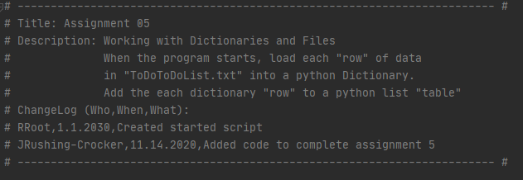

Figure 1 Change Log

I added my name, date to the Change Log at top of program to document my work on program.

In the processing area of the program (Figure 2), I had the “ToDoList.txt” open() and read any existing data in the file then close the file. I didn’t need to make any changes to the menu. So I moved on.

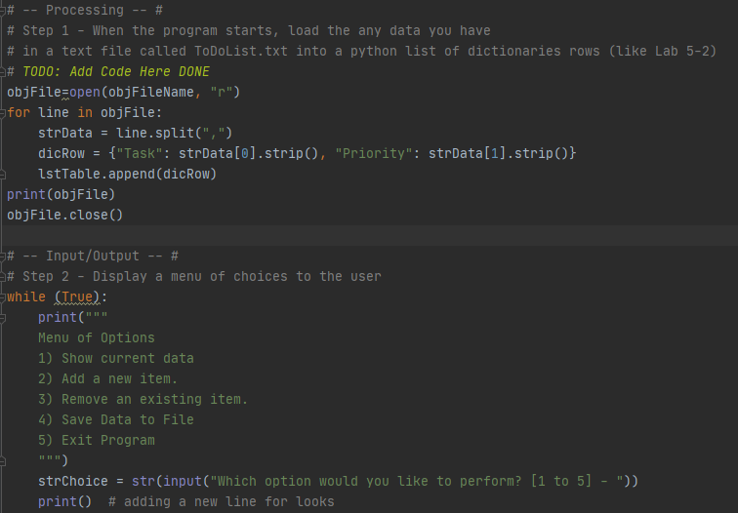

Figure 2 Program Start and Display Menu

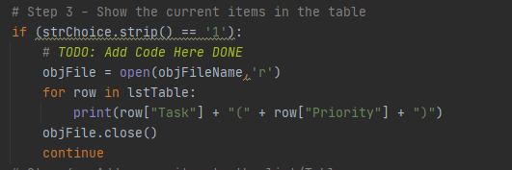

Figure 3 Display Current Contents of Table

In this step, “ToDoLixt.txt” was opened, lstRow (List Row) was read and printed then closed. Figure 3

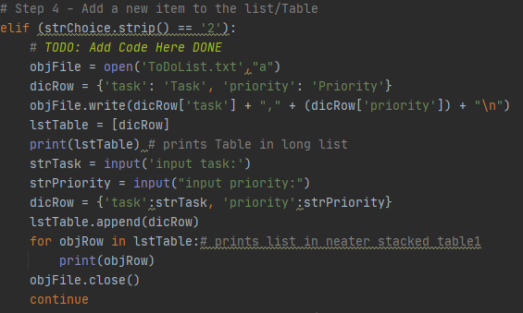

Figure 4 Add New Items To List/Table

Once again “ToDoList.txt” was opened. I added a dictionary for Title row with the dicRow() and wrote it to the .txt file with objFile.write() then placed it in the lstTable() and printed it. Then I asked for user input for task and priority with strTask and strPriority. Then placed strTask and strPriority into a dictionary row( dicRow). the user input was written to .txt file and appending the file instead of writing it as it the data would get replaced instead of adding to it. Fig 4

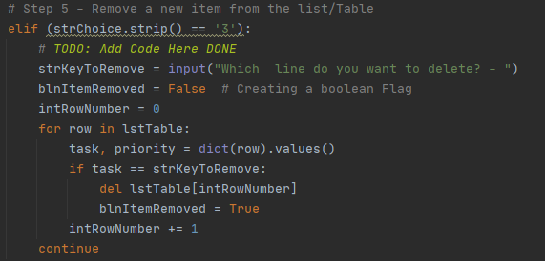

Figure 5 Remove new item from list Table

This is the one area where I experienced trouble. While I understand that I am being asked to remove a row from the was table of user entered data, I could not figure out how to do the last line. It was explained again and changed the code.

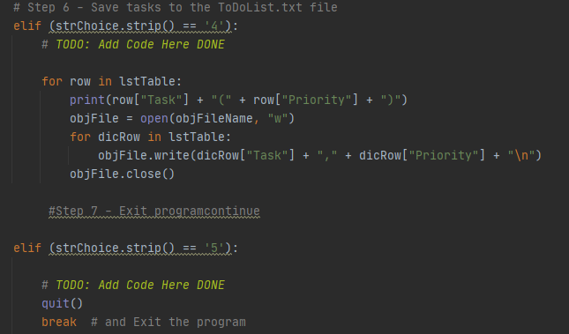

Figure 6 Save Tasks to File and then close the program

The last things to do in the program is save user enter data or deleted rows to .txt file then close the file and print “Data Saved”, confirming to the user the data was saved. After that the user has the option to exit the program which was a simple quit() function.

Lastly is the code working in the command prompt Fig 7.

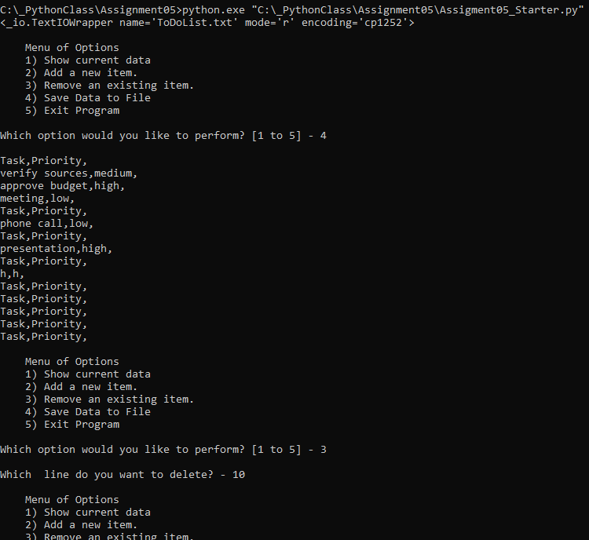

Figure 7 code in Command Prompt

**Conclusion**

Assignment 05 of adding code to preexisting code, through lists and dictionaries, to display, add, delete, and saving tasks and finally closing file and quitting program.