**BCRV TECH - VOC, INC. – SCHOOL EVENT ATTENDANCE MONITORING SYSTEM**

A Java Program Presented to:

**Mr. John Kenneth Reyes**

**Trainer**

**BCRV Tech - Voc, Inc.**

**Elbo St., San Vicente Central, Calapan City,**

**Oriental Mindoro**

In Partial Fulfilment

of the Requirements for the Course

**Programming (JAVA) NCIII**

By:

**JOHN RUSSELL D. DALINA**

**JADE MAVEN C. VEGA**

**MYCA JANE A. RUIZ**

**RONA BETH GRACE**

**VINSEY CONSTANTINO**

May 2024

**TABLE OF CONTENTS**

**TITLE PAGE i**

**TABLE OF CONTENTS ii**

**I. INTRODUCTION 3**

**II. SIGNIFICANCE OF THE STUDY 3-4**

**III. OBJECTIVES 4**

**IV. SCOPE AND LIMITATIONS 5**

**V. PROGRAM OUTPUT 6**

**A. Database Design 6-7**

**B. Output 8-11**

**VI. SUMMARY AND CONCLUSION 11**

**VII. RECOMMENDATION 12**

**REFERENCES 12**

1. **Introduction**

In academic institutions, especially departments that conduct frequent events, tracking student attendance remains a critical task. However, traditional methods such as manual sign-in sheets are prone to errors, time-consuming, and inefficient when handling a large number of students. To address these challenges, this study presents a **School Event Attendance Monitoring System** that leverages QR code technology to streamline attendance processes. According to Bucol and Villanueva (2018), QR code-based attendance systems are significantly more reliable and efficient than manual methods, offering faster processing and reducing the chance of errors. The system features a QR Code Check-In module for students and a secure login portal for administrators and officers, allowing for streamlined management of student information, event creation, and accurate attendance logging.

1. **Significance of the Study**

This study is significant for the following stakeholders:

**For Students:** The system provides a convenient method for checking in to events through QR code scanning, ensuring their attendance is properly recorded without delays or manual processes.

**For Administrators and Officers:** It offers a structured and secure platform to manage student records, create and monitor events, and view attendance logs. As noted by Radhakrishna and Shastri (2019), the automation of attendance systems enhances administrative productivity and reduces paperwork.

**For Academic Institutions:** It supports the digital transformation of administrative tasks, contributing to more organized and data-driven event management practices.

**For Future Researchers:** This system can serve as a basis for further innovations in educational technology, particularly in improving digital attendance tracking and event management.

1. **Objectives**

General Objective:

To develop a **School Event Attendance Monitoring System** that simplifies and automates the management of events and student attendance in schools and academic departments.

Specific Objectives:

* To implement a QR code-based module allowing students to check in by entering their student ID.
* To create a secure login system for officers and administrators.
* To provide features for maintaining an up-to-date student masterlist.
* To allow creation, updating, and management of school or departmental events.
* To enable real-time logging and tracking of student attendance.
* To generate accurate attendance reports for documentation and analysis.

1. **Scope and Limitations**

**Scope:**

* The system enables students to generate QR codes using their student ID.
* Only authorized users (administrators and officers) can access the management dashboard.
* The dashboard includes modules for managing student records, creating events, and viewing attendance logs.
* The system is designed primarily for school departments conducting extracurricular or academic events that require attendance tracking.

**Limitations:**

* The system is not intended for use in daily classroom attendance unless further modified.
* QR code scanning requires a device with a functional camera and compatible scanning software.
* The application is built using Java and currently functions best on desktop systems; mobile compatibility is limited.
* Integration with other institutional systems or external databases is not included in the current version.

1. **Program Output**
   1. Database DesignA screenshot of a computer

      AI-generated content may be incorrect.

*Figure 1*

*Entity Relational Diagram (ERD)*

The *Figure 1* is the Entity Relationship Diagram (ERD) of the School Event Attendance Monitoring System. It consists of four main entities that work together to manage users, students, events, and attendance records. The relationships between these tables ensure that attendance data is properly linked to both students and specific events, while access and control are managed through the user table. This structure supports a reliable and organized attendance monitoring system for schools and departments.

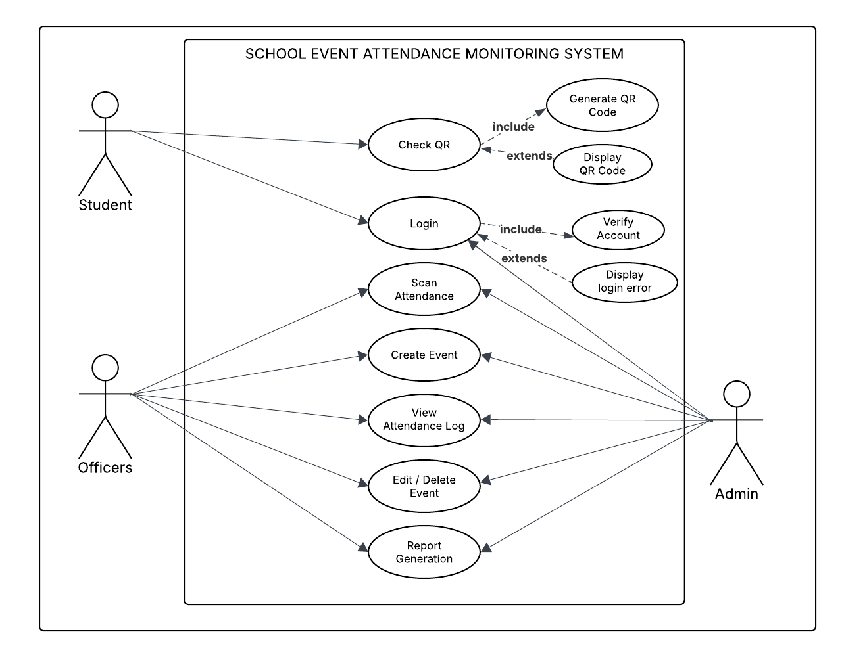**Use Case Diagram**

*Figure 2*

*Use Case Diagram*

This use case diagram illustrates the interaction between users and the School Event Attendance Monitoring System. It identifies three primary actors: Student, Officers, and Admin, each interacting with different system functionalities based on their roles.

* 1. 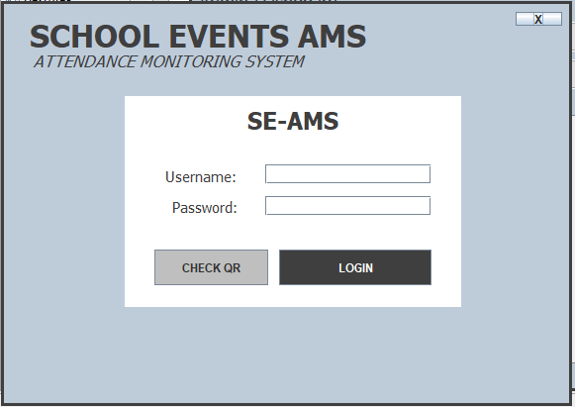Output

This is the login interface for the School Event Attendance Monitoring System (SE-AMS). It features fields for entering a username and password, along with buttons for QR code check-in and secure login. This setup ensures efficient attendance tracking and event management in academic institutions.

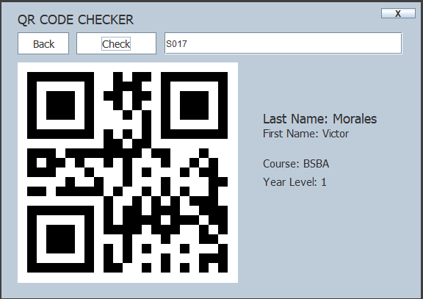This is the QR code check-in interface for the School Event Attendance Monitoring System (SE-AMS). It displays a QR code scanning module, a text box labeled “S017,” and buttons for checking attendance or navigating back. On the right side, student details—including name, course, and year level—are displayed upon successful check-in, ensuring efficient and accurate tracking during school events.

This is the admin dashboard for the School Event Attendance Monitoring System (SE-AMS). It provides easy access to key functions such as user management, event monitoring, and attendance tracking. The dashboard displays statistics on the number of users, students, and events, along with a list of upcoming events and their scheduled dates.

This is the attendance scanner interface of the School Event Attendance Monitoring System (SE-AMS). It features a live webcam feed for QR code scanning and a section labeled "Scanned Information" displaying details such as lastname, firstname, course, and year level upon successful scan. Dropdown menus allow selection of the event category (e.g., "Library Orientation") and time status (e.g., "AM - IN"). 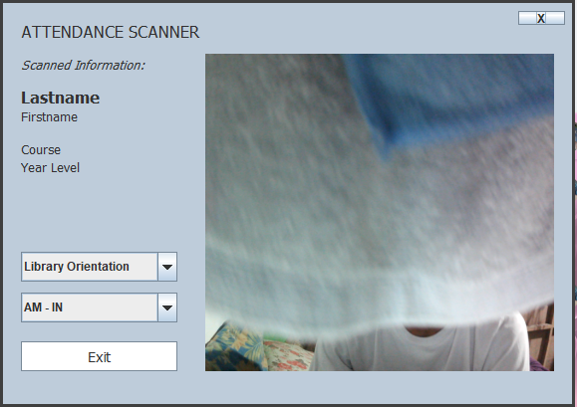

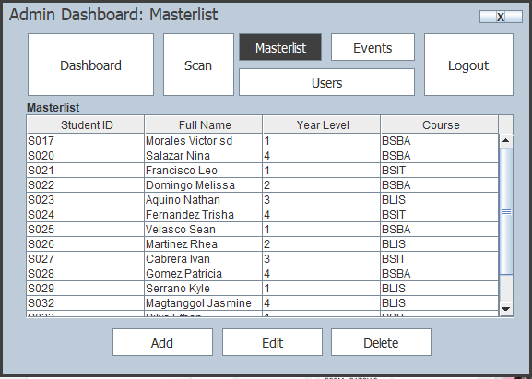

This is the student masterlist interface of the School Event Attendance Monitoring System (SE-AMS). It displays student records with options to add, edit, and delete entries, ensuring efficient management of attendance data.

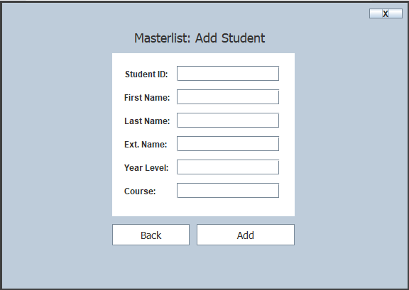

This is the Add Student interface in the School Event Attendance Monitoring System (SE-AMS). It allows administrators to input student details, including ID, name, course, and year level, with options to add or go back, ensuring efficient management of student records.

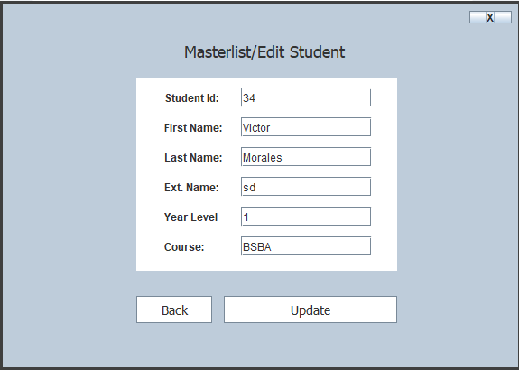

This is the Edit Student interface in the School Event Attendance Monitoring System (SE-AMS). It allows administrators to update student records by modifying details such as ID, name, course, and year level, with options to go back or save changes

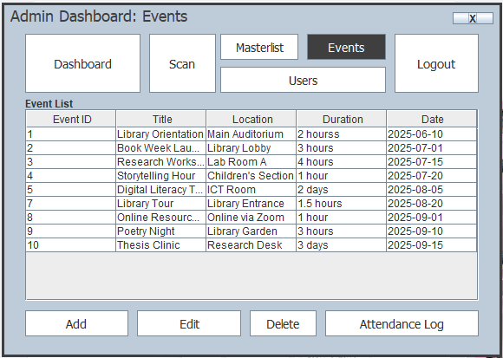

This is the event management interface in the School Event Attendance Monitoring System (SE-AMS). It displays a list of scheduled events with details such as title, location, duration, and date, along with options to add, edit, delete, or view attendance logs, ensuring efficient event coordination.

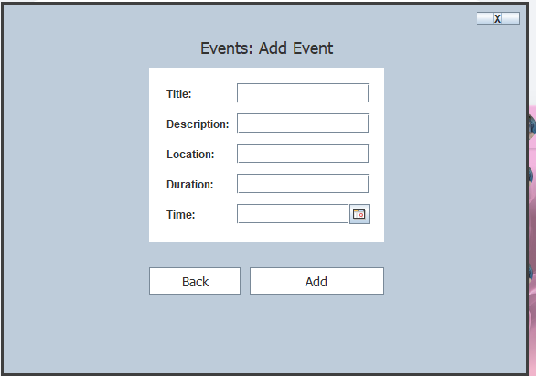

This is the Add Event interface in the School Event Attendance Monitoring System (SE-AMS). It allows administrators to input event details such as title, description, location, duration, and time, with options to go back or add the event, ensuring seamless event management.

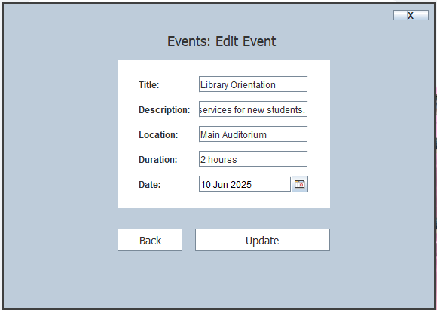

This is the Edit Event interface in the School Event Attendance Monitoring System (SE-AMS). It allows administrators to update event details, including title, description, location, duration, and date, with options to go back or save changes, ensuring efficient event management.

This is the Attendance Log interface for the School Event Attendance Monitoring System (SE-AMS). It displays student attendance records for a specific event, including check-in and check-out times for both morning and afternoon sessions. Options to edit or delete entries ensure accurate attendance tracking and data management.

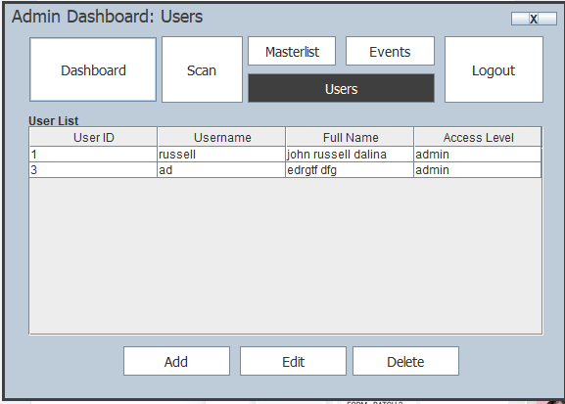

This is the User Management interface of the School Event Attendance Monitoring System (SE-AMS). It displays a list of registered users with details such as User ID, Username, Full Name, and Access Level, along with options to add, edit, or delete users, ensuring secure system administration.

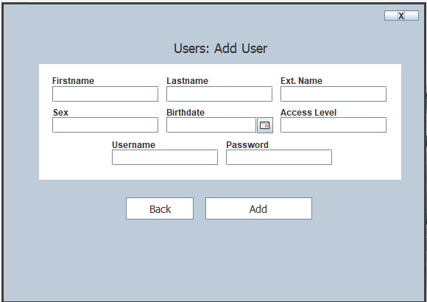This is the Add User interface in the School Event Attendance Monitoring System (SE-AMS). It allows administrators to input user details such as name, sex, birthdate, access level, and login credentials, with options to go back or add, ensuring secure user management.

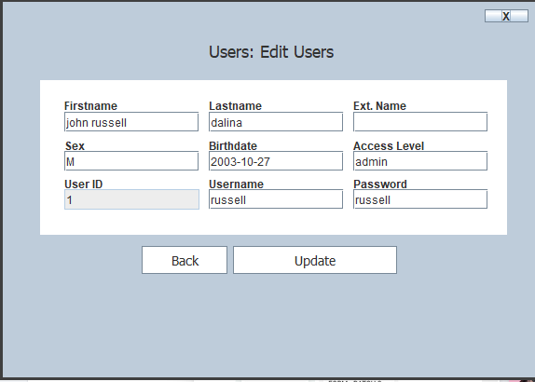

This is the Edit User interface in the School Event Attendance Monitoring System (SE-AMS). It allows administrators to modify user details such as name, sex, birthdate, access level, username, and password, with options to go back or update, ensuring secure user management.

1. **Summary and Conclusion**

The School Event Attendance Monitoring System was developed to address the growing need for efficient and reliable tracking of student attendance during school or departmental events. The system integrates user management, event creation, and QR code-based attendance logging to ensure seamless and accurate data collection.

Through the use of a user-friendly interface, students can easily generate their QR codes, while officers and administrators are granted access to event creation, attendance monitoring, and report generation. The system enhances transparency, minimizes manual errors, and promotes digital record-keeping, making event attendance tracking more convenient and organized.

In conclusion, the system effectively supports the administrative functions of educational institutions by streamlining event management and attendance recording processes.

1. **Recommendation**

* **Biometric or RFID Integration** – Future versions of the system could incorporate biometric or RFID scanners to further automate the attendance process.
* **Mobile App Development** – Developing a companion mobile app would improve accessibility for students and staff.
* **Automated Notifications** – Implementing SMS or email notifications for upcoming events or attendance issues can enhance communication.
* **Cloud-based Backup** – Integrating cloud storage ensures data safety and accessibility even in the event of system failures.
* **Analytics Dashboard** – Including graphical data representations would help admins analyze attendance patterns and trends.

**References**

*Bucol, A. A., & Villanueva, M. (2018). QR Code-Based Attendance Monitoring System. International Journal of Advanced Research in Computer Science and Software Engineering, 8(4), 1–5.*

*Radhakrishna, V., & Shastri, R. K. (2019). Design and Implementation of Smart Attendance System using QR Code and Face Recognition. IJEAT, 8(6S3), 124–128.*

*Kaur, G., & Kaur, J. (2020). Review on Student Attendance System using QR Code. International Journal of Scientific Research in Computer Science, Engineering and Information Technology, 6(2), 144–148.*