Exam1Question4

Justice Ruwona

2023-03-08

## Load PlantGrowth dataset

data(PlantGrowth)  
head(PlantGrowth) #check for data

## weight group  
## 1 4.17 ctrl  
## 2 5.58 ctrl  
## 3 5.18 ctrl  
## 4 6.11 ctrl  
## 5 4.50 ctrl  
## 6 4.61 ctrl

## Layering concept

library(ggplot2)  
  
ggplot(PlantGrowth, aes(x = group, y = weight)) +  
 geom_boxplot() +  
 geom_point() +  
 labs(title="Plant Growth by Treatment Group", x="Treatment Group", y="Weight (gm)")

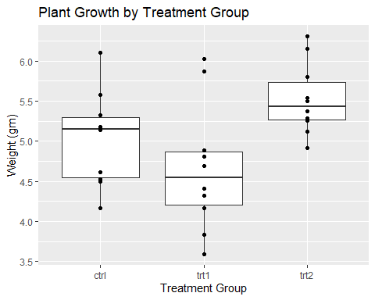

## Scales concept

library(ggplot2)  
  
ggplot(PlantGrowth, aes(x = group, y = weight, color = group)) +  
 geom_boxplot() +  
 geom_point() +  
 scale_color_discrete(name = "Treatment\nGroup", labels = c("Control", "Treatment 1", "Treatment 2"))+  
 labs(title="Plant Growth by Treatment Group", x="Treatment Group", y="Weight (gm)")

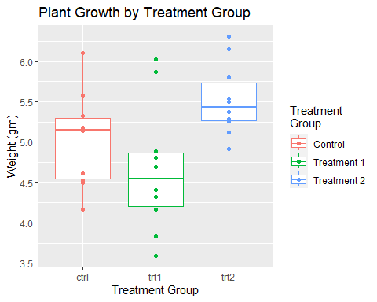

## Themes concept

library(ggplot2)  
  
ggplot(PlantGrowth, aes(x = group, y = weight, color = group)) +  
 geom_boxplot() +  
 geom_point() +  
 scale_color_discrete(name = "Treatment\nGroup", labels = c("Control", "Treatment 1", "Treatment 2")) +  
 labs(title="Plant Growth by Treatment Group", x="Treatment Group", y="Weight (gm)") +  
theme_bw()

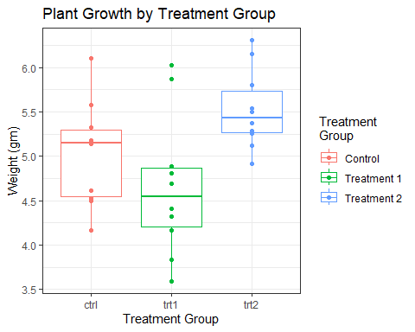

## Facets

ggplot(PlantGrowth, aes(x=weight)) +  
 geom_histogram(binwidth = 1, color = "black", fill = "white") +  
 facet_wrap(~ group, nrow = 1)

