Tools for Jobs Management in LCG
Patricia Mendez Lorenzo, Jakub Moscicki (IT/GD)

1. Introduction

The submission of large bunches of jobs to LCG resources is a common practice of the different VOs during their production phases (i.e, software implementation, data production and analysis, etc).
The monitoring of these bunches of jobs can become a difficult task without adapted tools able to handle the submission and the retrieve of the outputs.
Most of the VOs have developed their own tools to perform such job. In this report we propose as well a framework to submit automatically large bunches of jobs and keep track of their outputs. It is intended to assist and guide the users or VOs which pretend to develop their own tools or those users and VOs which already having developed their own frameworks could seize parts of this framework to implement it in their own applications.

The framework is distributed as a tar file. It can be installed in any user account of any UI independent of the rest of LCG packages.

2. Description of the Elements

The framework consists mainly of 2 tools:
1. submitter_general.pl: It performs the automatic submission of the jobs
2. get_output.pl: It retrieves and handle the corresponding outputs

1. submitter_general.pl

Given a jdl file model containing the user requirements (provided by the user), this tool will work as follows:
- It will list all the sites able to run the jdl file provided by the user
- For each job, it will generate automatically a jdl file based on this provided by the user (certain modification will be eventually needed. For example, the name of the queue where to submit the job).
- It will submit the created jdl file containing the user application.
- Moreover it creates as well a subdirectory (located by the user) containing a list of the sites where the jobs have been submitted, the corresponding jdl files and the jobs Ids (one file per jobID). In this report, we call this subdirectory, the working directory.

USAGE:

submitter_general.pl –vo <vo name> -jobfile <directory name> -CEName <list of queues> -data <required lfns> -jdl <jdl example>

Attributes description:
--vo: Name of the user VO (mandatory)

-jobfile: Working directory defined by the user (mandatory)
-jdl: The jdl example containing the user requirements for his jobs (mandatory)

-CEName: In the case the user prefers to specify the list of queues where to run his jobs, he can declare them with this argument. The script will check these queues to verify whether they match the job requirements given by the jdl file example or not. If these queues match the requirements, the jobs will be submitted only to these sites. Otherwise the script will announce to the user, the submission was not possible because the specified queues do not match his requirements.

-data: In the case the user application needs some data already registered to the Grid, this option allows to introduce the corresponding LFNs. The tool will therefore look for their corresponding TURLs and include them in a file created inside the working directory. If this option was specified by the user, the corresponding file will be included in the InputSandbox attribute of the generated jdl files.

WARNING: The current version of the script assumes the submission of one job per site.
It is intended therefore to submit those bunches of job which pretend for example to check experiment software areas, or software installation tools, or any application that needs to execute one job per site. The next version of the tool is including the possibility to submit bunches of jobs depending on the rank (defined by the user in the jdl or assuming that defined in default in the RB).

Example of use:

Now we consider the case of a user who wants to spread a bunch of jobs to all LCG sites submitting one job per site. He will need as well to copy to the working directory of the WN a certain file stored in the GRID with a lfn: “data_calorimeter.dat”. Finally as requirement he wants to be sure their jobs will run only in those sites which hold SLC3 as operative system.

Script Execution

submitter_general.pl –vo dteam –jobfile /home/pmendez/CAL –data dates_calorimeter.dat –jdl myExample.jdl

The user has to provide an example of jdl file. Otherwise it will not be possible to match his requirements with the available LCG resources. Here you have an example:

myExample.jdl

Executable = ”my_application.pl”;
#Name of the user application
StdOutput = “std.out”;
StdError = “std.out”;
##### The user has decided in the case the StdOutput and StdError share the same file
InputSandbox = {“my_application.pl”};
OutputSandbox = {“std.out”};
Requirements = (other.GlueHostOperationSystemName == “SLC” && other.GlueHostOperationSystemVersion == 3);

The script will now check all queues which can hold the user application following its requirements. In this case and since the user has not specified any queue requirements, among the different queues found in the Information System per each site, only the first queue will be chosen to submit the job.
At this point, under the subdirectory defined by the user in the –jobfile argument (/home/pmendez/CAL, the user does not need to created it previously. It will be generated by the program), a file called CEslist.dat will be created and it will hold the list of queues where the jobs have been submitted.
Once the queues have been found the program will generate a jdl per queue following the example provided by the user. In this case, it will build the following jdl per site:

spread_jdl.template

Executable = “sw_installation.pl”;
StdOutput = “std.out”;
StdError = “std.out”;
InputSandbox = {“sw_installation.pl”,”turl_number_data.txt”};
#### The user needs to copy the file data_calorimeter.dat to the WN. It has therefore specified the option –data. The file turl_number_data.txt will be automatically created including the TURL of this file.
OutputSandbox = {“std.out”};
Requeriments = (other.GlueCEUniqueID==”To be filled by the script with the name of the queue once it has been found”);
## The requirements written by the user were intended to find the possible queues. Once they have been found these requirements are not needed any more. What now it is needed is the name of the queue able to hold the job. Therefore the script will overwrite the requirements written by the user by just the name of the queue holding the job.

Finally these generated jdl files will be submitted to the different sites.

Inside /home/pmendez/CAL these jdl files will be stored together with the jobIDs in files called: test_x_<#job>.jobid

2. get_output.pl

The monitoring of the job status and the retrieve of their outputs will be provided by the tool.

USAGE:

./get_output –jobfile <working directory> -dest <where to retrieve the outputs> -html <files to include in the report.html file>

Description of arguments:

-jobfile: (mandatory) It contains the working directory created during the execution of the submitter_general.pl script.
-dest: (mandatory) it defines the directory where to store the outputs.
-html [1]: In the case the user wants to visualize the output of the job directly on the web, he should specify this option, including the name of the files he wants to retrieve. In the example, the user will include the file std.out. In other cases the user can decided which files to include in the html file among all those files included in the OutputSansbox.

Example of use:

After the jobs submission the user wants to follow the status of his jobs. The corresponding JOBIDs are inside /home/pmendez/CAL.

Script execution

./get_output.pl –jobfile /home/pmendez/CAL –dest /home/pmendez/CAL/outputs –html std.out std.err

First of all the script will check the status of the jobs. It will therefore use the jobIDs included in the test_x_<#job>.jobid files created by submitter_general.pl.
Then it will inform the user of the status of his jobs queue per queue as follows:

The job ran in ramses.dcic.upv.es:2119/jobmanager-torque-dteam is in status: Scheduled
The job ran in grid01.phy.ncu.edu.tw:2119/jobmanager-torque-dteam is in status: running
The job ran in scaic10.scai.fraunhofer.de:2119/jobmanager-torque-dteam is over.
[...]
In those cases where the job is over (status DONE) the script will retrieve its output to the directory specified by the user in the argument –dest.

Each time this script is used, 2 different files per job will be created inside the working subdirectory (in this example: /home/pmendez/CAL): text_x_<#job>.tmp2 and test_x_<#job>.tmp3. test_x_<#job>.tmp2 contains the last status of the job while test_x_<#job>.tmp3 contains the retrieve message of the job. Each time this script is executed, the file test_x_<#job>.tmp2 will be overwritten.

The user has specified the option –html with arguments std.out and std.err. It means a file report.html will be created inside the working directory containing the file std.out and std.err queue per queue. Figure 1 shows an example of this file.

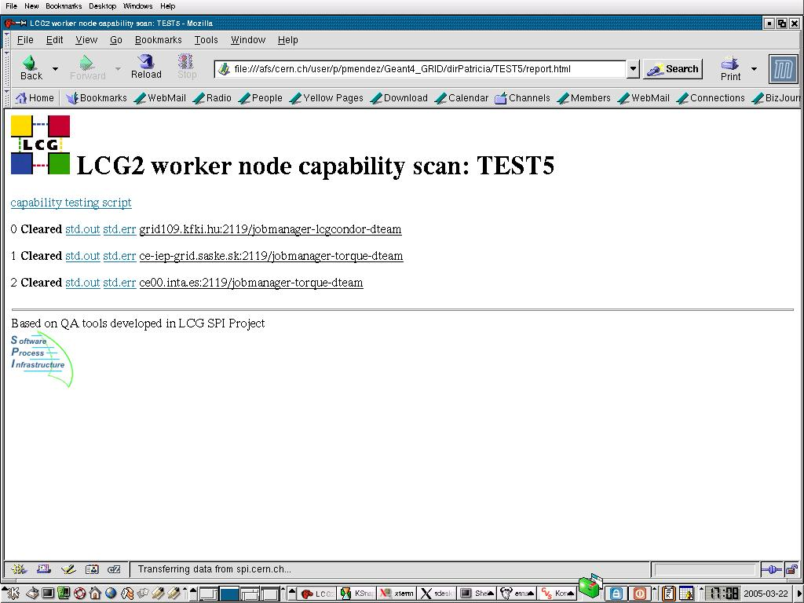

Figure 1. Visualization of the report.html page

In this case the working directory was called TEST4 and it contained only one job. It was executed in the scaic10.scai.fraunhofer.de:2119/jobmanager-torque-dteam queue. Its status is DONE (Success) and the link output contains the file std.out.

[1] This option uses tools developed in the LCG SPI Project and implemented by Jakub Moscicki (CERN IT/GD).

3. Additional Elements

The package includes as well two tools, test_wn_capabilities and test_wn_wrapper. Those scripts (provided by Jakub Moscicki) are intented to provide examples of WN tests. A test.jdl file is included as well to send such tests.

