


EMBnet/CNB
Centro Nacional de Biotecnología, CSIC
C/Darwin, 3.
28049. Madrid, Spain

Quantum Biology

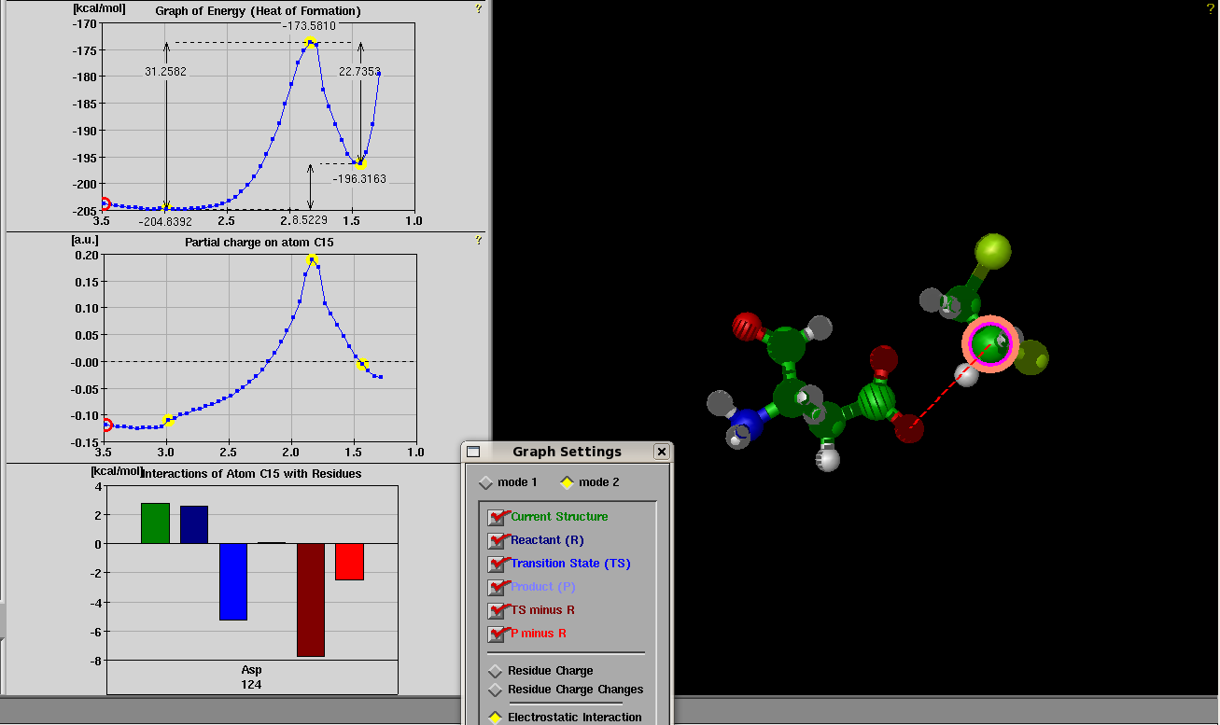

This is to certify that XXX attended and satisfactorily completed the EMBnet (European Molecular Biology Network) course Introduction to Quantum Biology, which took place 12th - 13th, November 2008, 9:30 to 16:30 at the Centro Nacional de Biotecnología, Consejo Superior de Investigaciones Científicas, Madrid, Spain.

This is an introductory course to Quantum Chemistry methods employed in the Life Sciences, oriented to scientists with an interest in molecular modeling, pharma- and cheminformatics, and modeling of chemical reactions in enzymes. The course lasts 16 hours evenly split in theory and practice, and relies on several major packages for practical training, covering
- A general introduction to basic theory and methods in Quantum Chemistry
  - Visualization
  - Molecular Modeling (QM, MM, MD)
  - Pharmainformatics, QSAR and molecular docking
  - Quantum Mechanics
- A practical project on in silico modeling, molecular docking and reaction modeling.

There was considerable emphasis on developing first-hand experience through practical sessions using professional tools like DeepView, Triton, Modeller, MOPAC, NWChem, MPQC, GAMESS-US and WebMO.

José R. Valverde, PhD MD
Head of Scientific Computing Services
EMBnet/CNB, CSIC.
jrvalverde@cnb.csic.es

