**Software Requirements Specifications**

**For FBLAEM Event Registration**

**Version 0.01**

**Prepared by**

**Team Flagellum’s**

**Anthony Guertin**

**Norm Johnson**

**Preston Taylor**

**J. R. Westmoreland**

**December 6th 2013**

Table of Contents

Part 1. Executive Summary 1

Part 2. System Features 2

Part 3. User Interface Screens 3

Part 4. Entity Relationship Diagram 4

Part 5. Sequence Diagrams 5

Part 6. Project Structure 6

Part 7. Proposed Technologies 7

# 

# Part 1) Executive Summary

**Purpose**

The purpose of this document is to represent all of the material that is pertaining to the FBLAEM Event Management System created by The Flagellum’s. All of the information that is going to be covered in this document is relevant to the original project specifications. If there are any questions outside of what this document covers, it will be accommodated appropriately.

**Project Scope**

This project is intended to help with the process of even registration through a website.

**Product Summary**

Create an event registration system that grabs/inserts data into a database. It is a web based application that is created from scratch with no external software influence

**Product Features**

The application will be a web based portal where an instructor can access/update information pertaining to events that their students will be attending.

**2. User System**

**1.** User Login.

**2.** Once the user is logged in, depending on their role, they will be taken to a main page where all of their registration will be handled.

**3.** Depending on whether or not the user is a teacher or an admin, they will be able to make changes/view their registration roster for a particular event.

**4.** There will be an ability to print off list of different views.

**3. User Interface Screens**

**4. Entity Relationship Diagram** 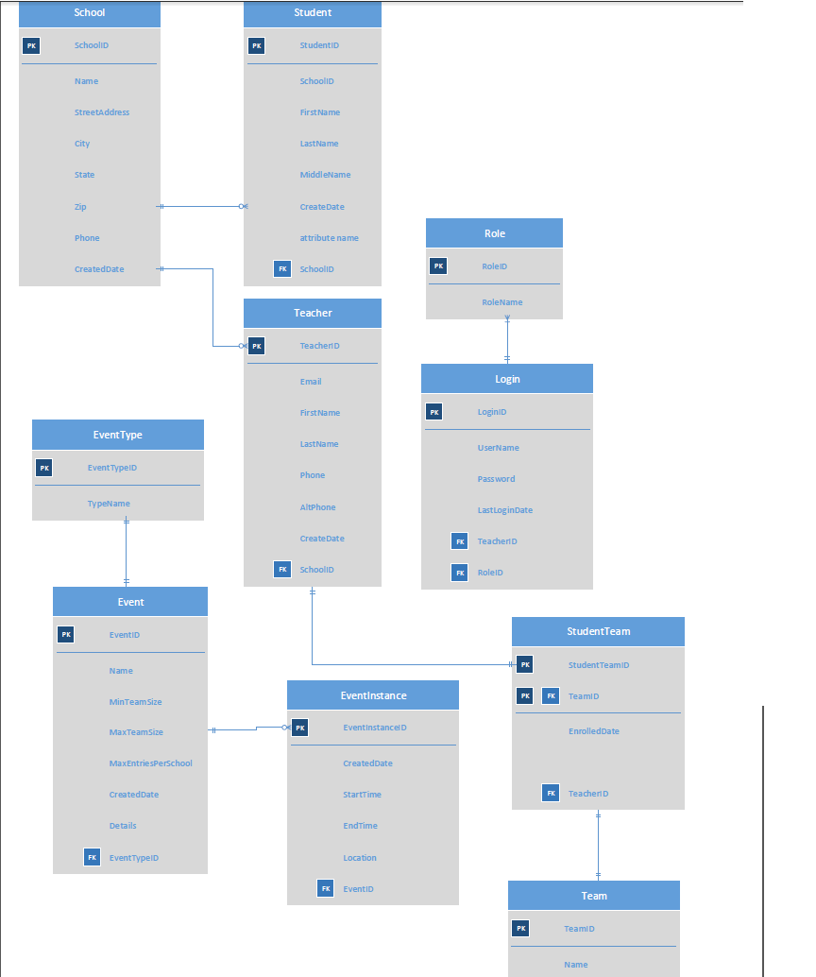

5. Sequence Diagram

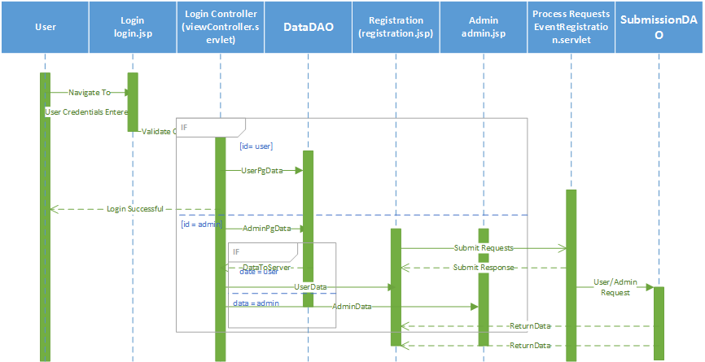

6. Project Structure

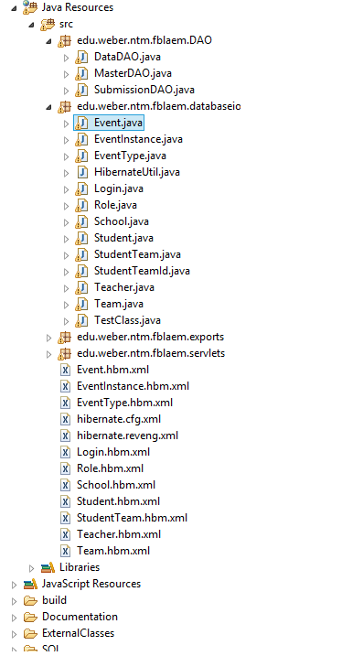

7.Proposed Technologies

We decided on using an MVC structure for our project. It was the most reasonable structure do to the fact that we were handling several requests from jsp’s and handlng the request to the data in the model portion of our code. It was useful because it separated the different layers of logic and allowed each portion of our structure to talk to each other.

We used hibernate technology to separate redundant database calls. Hibernate also allowed us to easily map our Java classes to our database tables.