THIS IS JUST A TEMPLATE, PLEASE IGNORE

John Woodward

2023-02-22

|  |  |  |
| --- | --- | --- |
| test | test | test |
| 11 | 11 | 11 |

## Introduction

Our Data Science department wants to answer the main question: **“Does limiting user posts increase 7-day retention compared to the unlimited posting model?”**

We randomly assigned 90189 new users into two groups: unlimited and limited posting. Moreover, the data collected includes six columns. Each observation details user metrics such as retention (e.g., seven-day, one-day), visits, and the observation day of the week.

The following questions are also of interest, and we will explore them:

1. Does the number of site visits by day 7 differ between the two posting models?
2. Does 1-day retention vary between the two posting models?
3. Do other relationships among the recorded variables warrant further investigation?

## Analysis

The company needs to see evidence of increasing user retention because of the software version before deciding on further action.

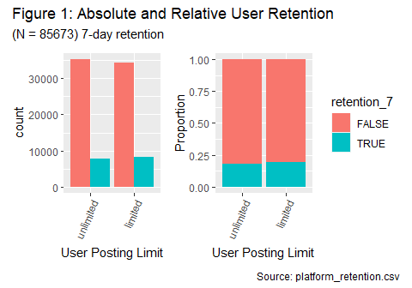

Specifically, the conditional proportion bar chart, Figure 1, shows only a minor improvement of a few percent. Likewise, Figure 1’s absolute bar plot and the table below are challenging to catch any improvements in comparison and show plenty of data. Thus, there is a lack of practically significant improvements.

Below is a summary of the seven-day retention and totals:

| version | retention_true | totals |
| --- | --- | --- |
| unlimited | 7872 | 43168 |
| limited | 8122 | 42505 |

We conducted a difference of two proportions test, with the sample proportions of unlimited and limited version 7-day retention as 0.182, 0.191. We are 99% confident that the actual proportion difference is between -0.016 and -0.002. Although we can statistically conclude a significant difference between seven-day retention proportions because the interval excludes 0, there was no practical difference between them. So let us explore the data further.

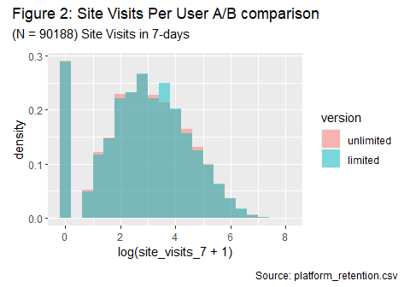

To answer: “*Does the number of site visits by day 7 differ between the two posting models?*” we conducted a means difference test between the different versions and used seven-day site visits, 51.635, 51.605. We are 99% confident that the actual mean difference is between -1.731 and 1.79. We fail to reject the null hypothesis because the confidence interval includes 0, so we cannot conclude a statistical difference.

Below is a table summary for one-day retention and totals:

| version | retention_true | totals |
| --- | --- | --- |
| unlimited | 19117 | 43168 |
| limited | 19063 | 42504 |

To answer: “*Does 1-day retention vary between the two posting models?*” we conducted a two proportions difference test between the different versions and used 1-day retentions, 0.443, 0.448, we are 99% confident that the actual proportion difference is between -0.014 and 0.003. We fail to reject the null hypothesis because the confidence interval includes 0, so we cannot conclude a statistical difference.

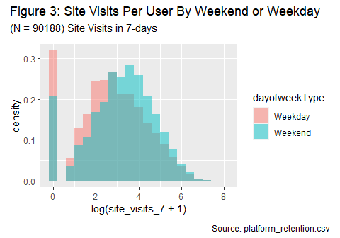

To answer: “*Do other relationships among the recorded variables warrant further investigation?*” we conducted a difference of means test, grouping by weekend or weekday and comparing seven-day site visits, 48.04, 61.567. We are 99% confident that the actual mean difference is between -15.59 and -11.463. We reject the null hypothesis because the confidence interval does not include 0, and we conclude a statistical difference.

## Conclusion

Although the software versions A/B testing had a statistically significant result in 7-day user retention with the limited posts, I recommend “hold the horses.” Because there is a more decisive statistically insignificant result regarding 1-day retention, and the seven-day site visit comparisons between the two versions are comparable. I do not recommend investing any further time in this software patch. Instead, we should consider other more worthwhile ventures.

For example, weekends correlate to higher website visits. Presumably, this is when users have more available time than during typical weekday office hours. Thus, the company could convert idle users’ weekend hours into site visits through ads, social media events, or exclusive games to coincide with these higher user logins.