Azure Governance-Management Groups

Introduction

Azure Governance is a collection of concepts and services that are designed to enable management of your various Azure resources at scale. These services provide the ability to organize and structure your subscriptions in a logical way, create and deploy re-usable and Azure native packages of resources, to define, audit and remediate your resources, and more.

Objectives

* Build a governance strategy from the scratch using Management Groups, Azure Policy, and Blueprints
* Group and organize your subscriptions in a logical hierarchy that support the deployment of other Governance services in a structured way
* Monitor and review all resources deployed through Resource Graph

Create an organization structure with Management Groups

Scenario

The very first step in implementing a governance strategy in Azure is to create a logical hierarchy in Management Groups

1. Sign in to the Azure Portal using your Azure account
2. Launch the **Management Groups** service in Azure portal by clicking **All services**, then searching for and selecting **Management Groups**.
3. Click **Add Management Group** to create the following structure:

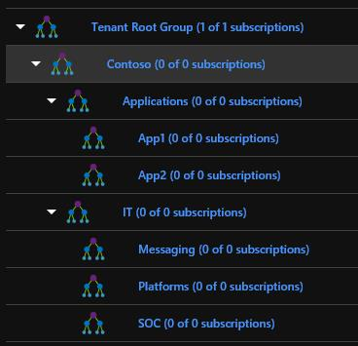

1. After the management groups are created, you need to assign subscription to the management group.

Navigate to the **Tenant Root Group**, click the elipsis next to your subscription, select **Move**

Select **Contoso** and **Save** it.

Each management group can be assigned to a different subscription. However, for this lab we will have only 1 subscription assigned to the root management group.

