 |  | SE Power | Gregory 1
 |  | Onboarding to the home of your dreams!
Onboarding guide  __  What are your duties?  Learn all the nitty gritty of your job, as the manager of this power production facility  __  What do we offer?  Get an introduction to all the amenities in the office, and outside, at the city of XL2127GdRpHM  __  Company directory  Contact information for your three superiors. |  | 

Duties
As the new manager of the SE Aham power production facility, you have 3 main duties. We like to describe these with the three M’s. Management, Manipulation, and Meetings. See more details below!
Management:
As the manager of the power facility, it is your job to manage all employees in the department, you will control hiring, firing, and current objectives of all employees. They will listen to all directions immediately without failure. The objective of this is to upkeep power production above 100%
Manipulation:
You will also be the reporter on all site activities. You will need to compile, manipulate and use data to prove your delivery objectives. This will be important to prove your efforts to your supervisors in the next section, Meetings.
Meetings:
You will need to meet weekly with Eduardo, to review your production metrics, and begin any next steps. Remember, failure isn’t bad! It just means you have room to grow! Do not let our energy run out.

Onboarding
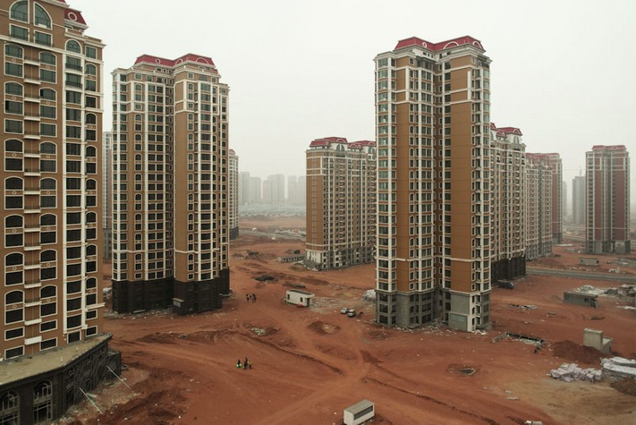  Company directory  If you ever need any advice, questions answered, or even some extra special support from an expert in your field, feel free to connect with one of your supervisors!  - Drectar  Drectar@Drectarsmail.fyi  555-0618  - Uardo  (deactive)  - Mink  Helpdesk@Drectarsmail.fyi  555-1921 |  |  | Amenities  Here at the SE Aham power plant, we have many events. Daily we offer fine company provided lunches including dirt, and meat! We also include 1 mandatory 10 minute break a day! This is on top of our great compensation for a full day of work!  Outside the plant we have the wonderful city of XL2127GdRpHM, short for AAAAAAAAAAAAAAAAAAAAAAAA!  Thet have fantastic local establishments such as a park with tables! A store! And even one dog I think!  You don’t even need official approval to partake in these joys! Feel completely free to go to The store whenever you want! (off work hours)
 | Final message  Thank you so much for accepting this opportunity to work at the Southeast Aham Power facility. We are so excited to see you prosper in this role. The team is always here to support you and only hopes your days are smooth and productive.  Fate is up to you now! Good luck!  - Mink!

