
04/08/26

Joseph Stewart | Market Access, Reimbursement, and Policy Strategy
for Complex Provider-Administered Products
Portfolio brief for manufacturers, client stakeholders, and interview panels
Audience: manufacturer hiring teams, client stakeholders, and interview panels
Prepared April 8, 2026. Facts are generalized and intentionally avoid confidential product-specific details.

This brief is designed to show the breadth of work performed and the utility of that work to manufacturers, not to retell a resume and not to disclose confidential product-specific details. Images carry the story; copy adds detail.

Breadth of capability
This package shows how Joseph works across launch and in-market management: reimbursement mapping, GTN decomposition, lifecycle benchmarking, and field-usable decision tools. It is meant to prove range, not just policy fluency.
- Launch, on-market, and mature asset support.
- Payer, provider, channel, and 340B economics.
- Practical outputs for market access, finance, and field teams.


04/08/26

The reimbursement architecture Joseph maps

Different payment systems create different adoption incentives

The same therapy behaves differently depending on where and how it is used. Joseph’s work separates the major reimbursement systems so launch teams do not blend inpatient, outpatient, office, formulary, and channel economics into one average story.

Lifecycle reimbursement architecture
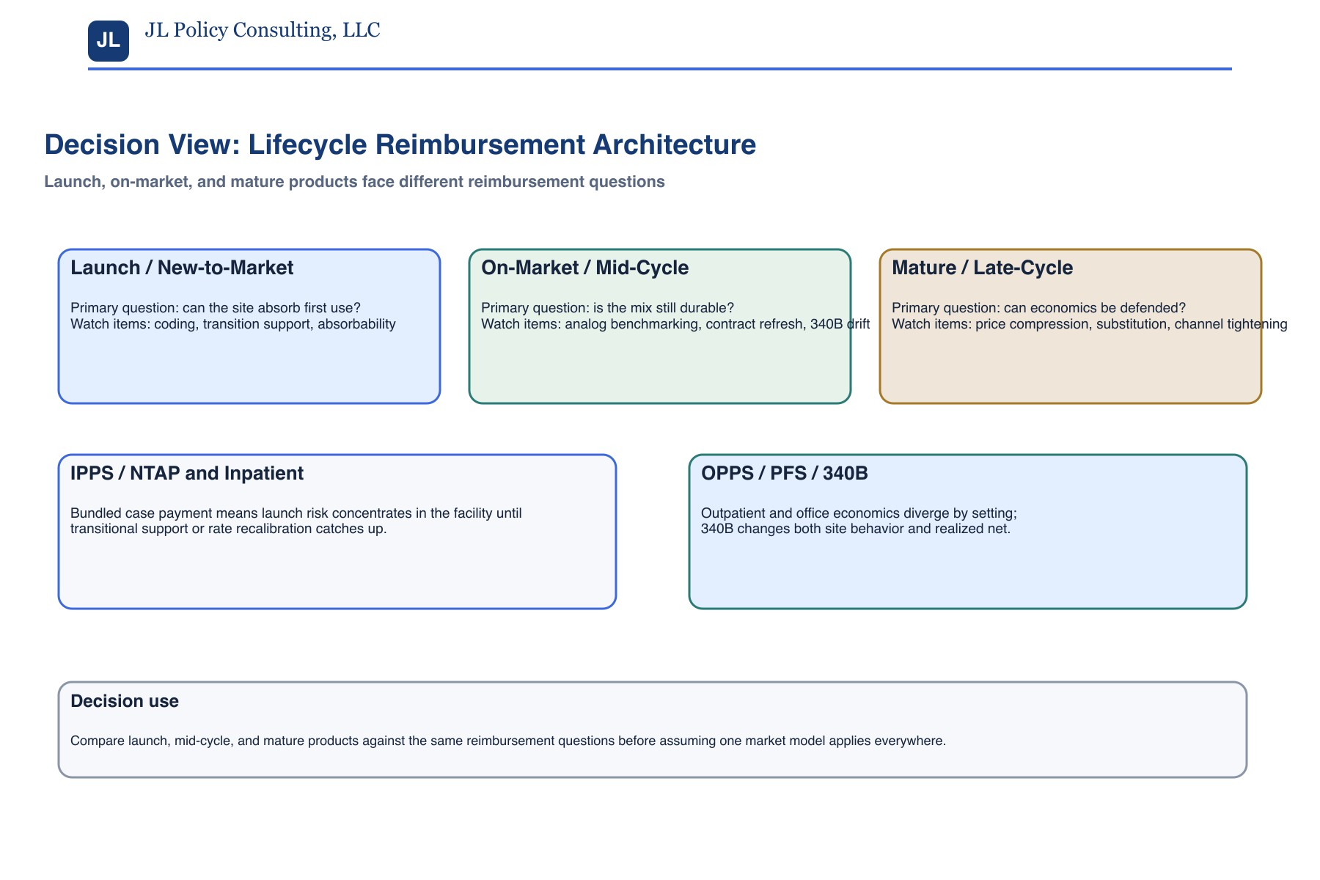

What this means commercially
The same product can look materially different by site of care and benefit structure. Joseph uses the pathway map to force teams to stop averaging inpatient, outpatient, office, Medicaid, MA, commercial, and 340B into one story.
- IPPS and NTAP: bundled inpatient economics, transitional support, and residual hospital risk.
- HOPPS / OPPS / PFS: outpatient and office economics diverge by site, claims visibility, and payment timing.
- MA / MA-PD / Commercial: utilization management, site-of-care rules, and benefit design shape access.
- Part D / formulary / 340B: tiering, prior auth, step therapy, and covered-entity concentration change realized net and launch interpretation.


04/08/26

Launch economics pressure map

Launch volume can rise while realized net falls

Launch economics should be benchmarked against what established analogs and mid-cycle products already absorb. The point is to identify where value leaks and which losses are structural versus recoverable.

Launch economics against on-market analogs and mid-cycle comparators
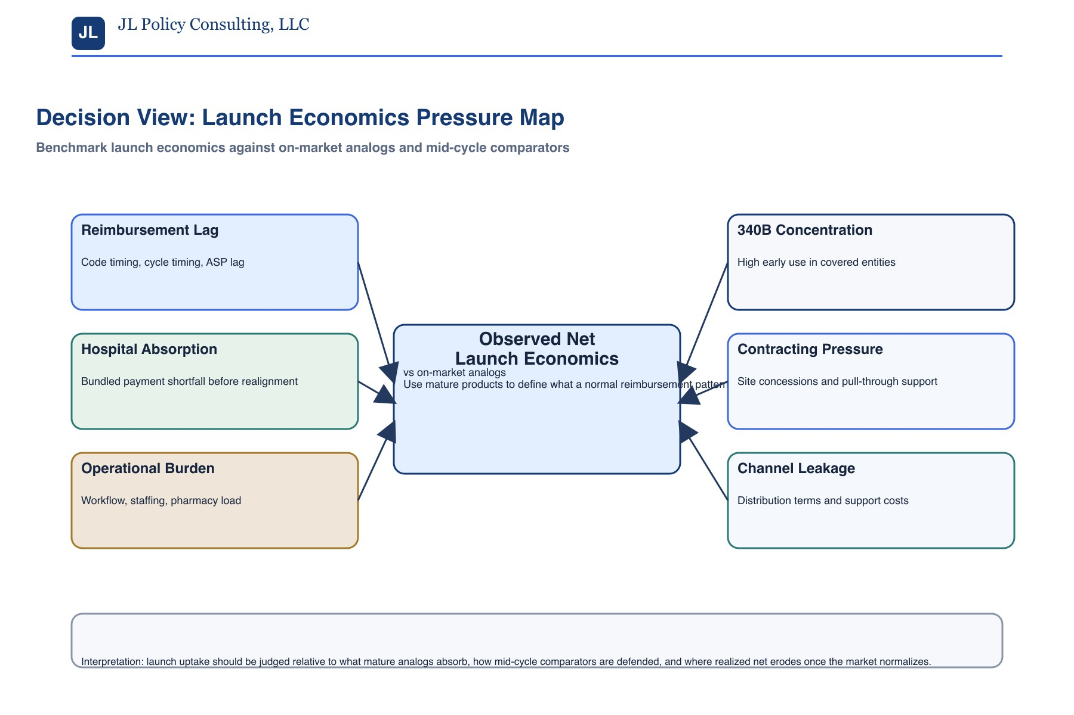

GTN recovery lens
This page tells the manufacturer where value leaks before they try to recover it. The goal is to separate structural loss from recoverable loss and then size the right tools.
- GTN pressure buckets include 340B concentration, contracting concessions, reimbursement support, ASP timing, distribution leakage, and channel-driven discounting.
- Launch signal quality should be judged against on-market analogs, not against a national average that ignores site mix.
- Operational burden, first-use absorbability, and hospital margin sensitivity matter as much as clinical pull-through.
- Early support should be sized to the site and channel economics, not to a single national assumption.


04/08/26

On-market / mid-cycle landscape assessment

Benchmark established products to understand normal market behavior

This view is not a launch view. It is a lifecycle benchmark that shows how mature products behave once reimbursement is established, channel patterns settle, and 340B, formulary, or contract refresh start shaping realized net.

On-market / mid-cycle behavior across medical benefit and Part D
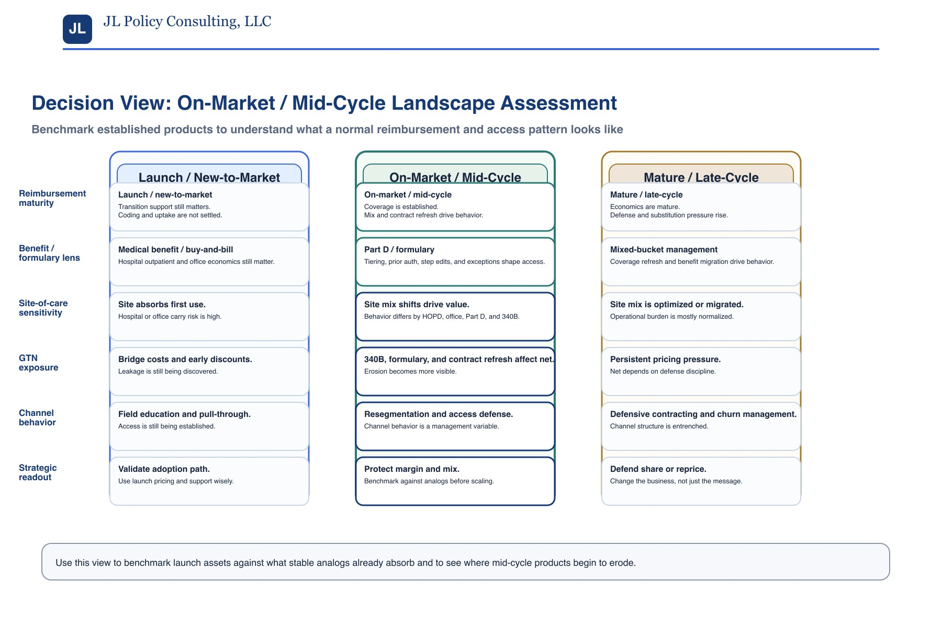

The mid-cycle question
The question changes from “can it launch?” to “is the mix still defensible?” The answer requires both a medical-benefit lens and a Part D / formulary lens where pharmacy benefit is in play.
- Mid-cycle assessment has to include both a medical-benefit lens and a Part D / formulary lens where pharmacy benefit matters.
- Look for benefit migration, tiering, prior authorization, step therapy, 340B mix, and channel drift rather than headline price changes alone.
- Use the benchmark to decide whether a market is normal, deteriorating, or already over-concentrated in advantaged channels.
- The right question is not “can it launch?” but “is the mix still defensible?”


04/08/26

Recoverable versus structural losses

Separate unavoidable economics from controllable leakage

The strategy problem is not just to identify losses. It is to distinguish structural economics from the items Joseph can help recover through better channel design, reimbursement mechanics, or evidence strategy.

Structural versus recoverable economics How Joseph works the problem end to end
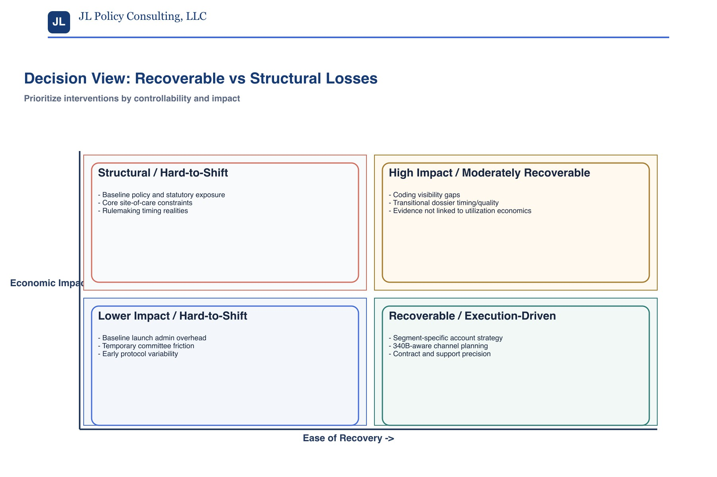
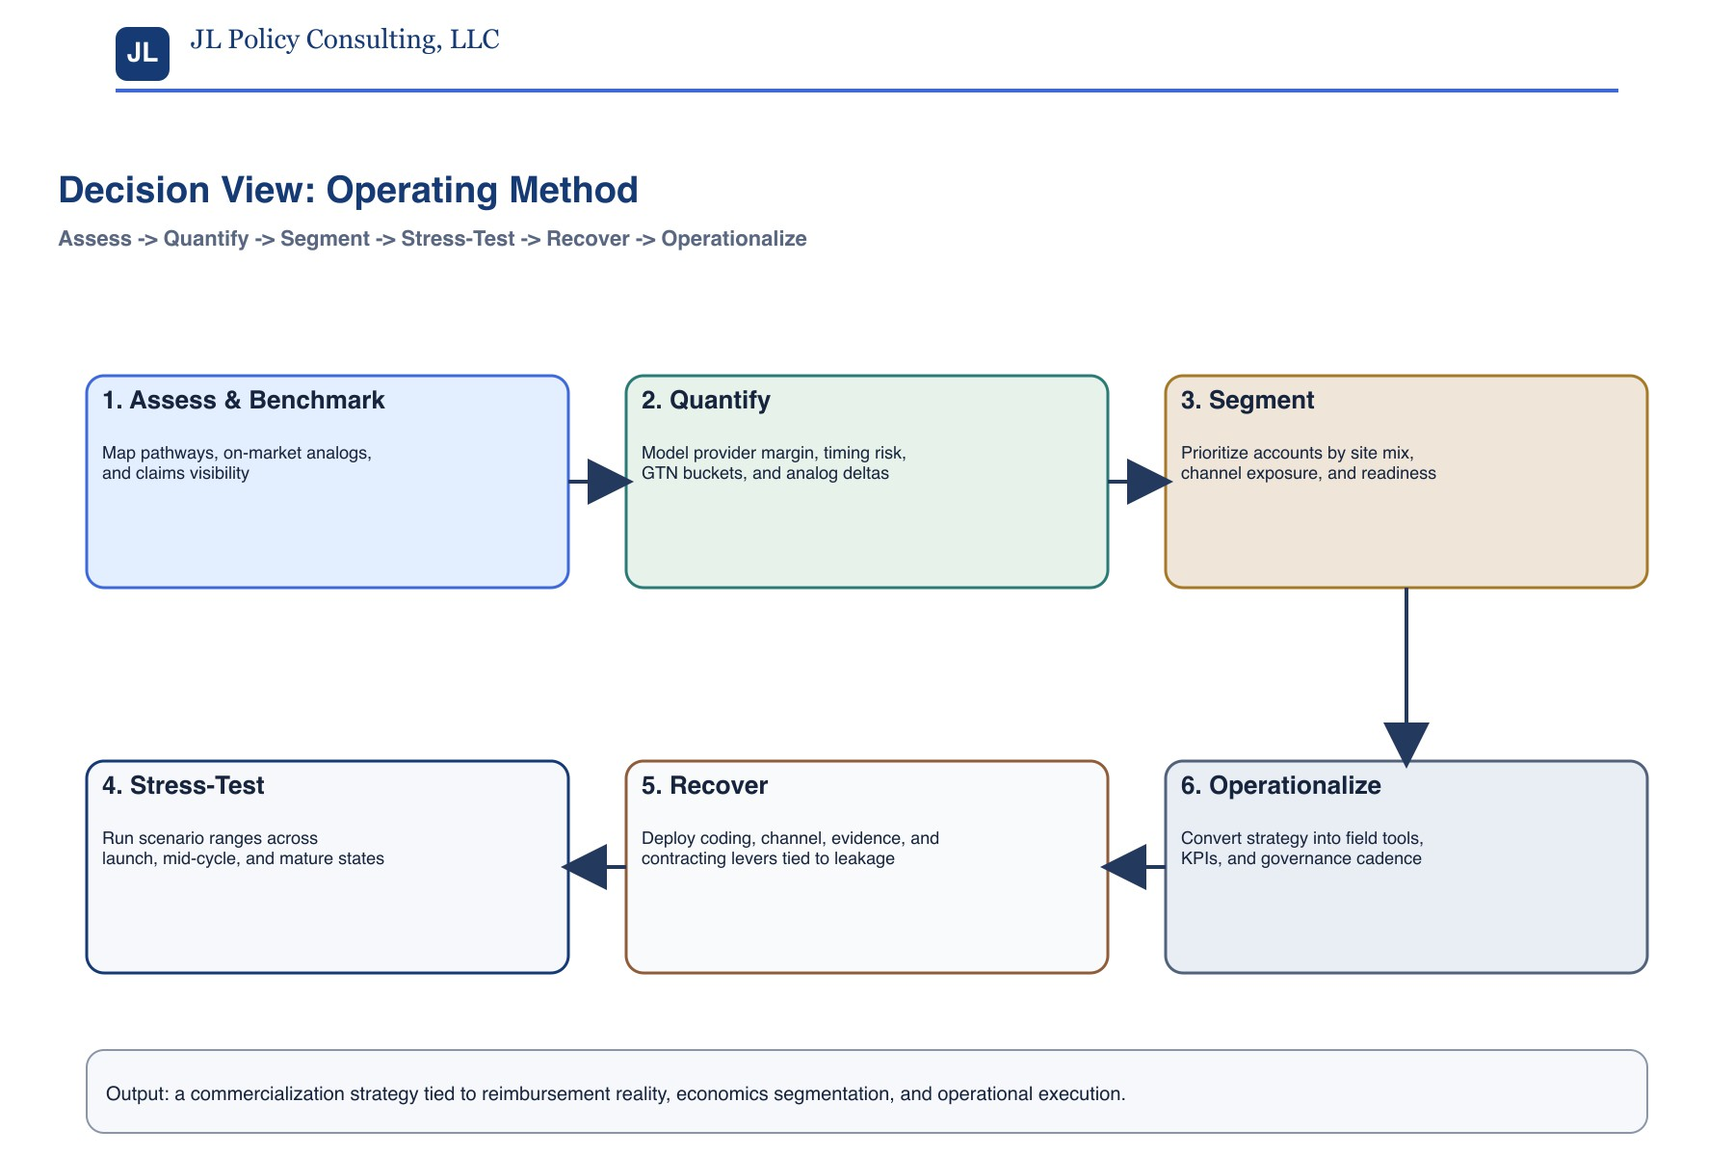

How the work turns into action
The portfolio is not a memo alone. It is meant to show the tools a manufacturer can actually use: recovery roadmaps, account sequencing, benchmark models, and field-ready execution logic.
- Structural versus recoverable losses.
- Assess -> Quantify -> Segment -> Stress-test -> Recover -> Operationalize.
- The output is a decision system, not generic access language.


04/08/26


Why Joseph fits this work

Last page bio

Joseph is credible for this exact type of work because his background combines manufacturer reimbursement, biosimilars commercialization, provider economics, market access analytics, and policy translation across launch and in-market brands. He is not a policy commentator; he translates policy mechanics into commercial action and can operate at the level a head of market accWeshsynJeoesedpsh. fits this work
Joseph is credible for this exact type of work because his background combines manufacturer reimbursement, biosimilars commercialization, provider economics, market access analytics, and policy translation. He is not a policy commentator; he translates policy mechanics into commercial action.
- More than 10 years across reimbursement, pricing, market access, and health policy.
- Supports biosimilars and other complex commercialization questions, including ASP evolution, payer/provider/GPO barriers, and reimbursement-sensitive uptake dynamics.
- Current consulting work spans Medicare, Medicaid, commercial, launch planning, pricing models, provider economics, and reimbursement risk.
- Prior roles across manufacturer, trade association, and advisory settings show the same pattern: identify where value leaks, what is recoverable, and what the company should do next.

Commercial close
The value Joseph brings is the ability to show how the market actually behaves, where economics are breaking, which losses are structural, which are recoverable, and what a manufacturer should do next.
- Commercially usable strategy for complex provider-administered products.
- Useful for launch planning, in-market brand management, and advisory situations.

