ChipDoc AI
Grounded Question Answering over Microcontroller Datasheets using Hybrid Retrieval and a Fine-tuned Small Language Model
Project Report
[Course name and code]
Submitted by
[Team member name] [Register number]
[Team member name] [Register number]
Under the guidance of
[Faculty name]
[School / Department, Institution]
October 2026
Video demonstration: Watch the ChipDoc demo on Google Drive
Source code: github.com/js0nnn/chip-doc

Abstract
Microcontroller datasheets run to hundreds or thousands of pages, and engineers lose time searching them for single values such as a clock limit, a pin function or a register address. General-purpose chat models answer such questions fluently but often from memory, rounding or inventing values. This project builds ChipDoc AI, a terminal tool that takes any datasheet PDF and answers questions only from that document, citing the page of each fact and replying “Not found in the provided datasheet” when the answer is absent.
ChipDoc combines page-bounded chunking, hybrid retrieval (dense bge-small embeddings and BM25, fused with Reciprocal Rank Fusion) and a 0.6-billion-parameter Qwen3 model fine-tuned with LoRA. Training data was generated locally: a 4B teacher model wrote question–answer pairs from 30 vendor datasheets (9,834 pages), automatic evidence and number checks kept 1,990 of 2,293 pairs, and these were turned into retrieval-augmented fine-tuning (RAFT) examples that mix the true passage with retrieved distractors, including 20% with the answer removed.
On five datasheets held out from training, hybrid retrieval places the evidence in the top five passages for 88% of questions (dense-only: 79%). Compared with the untuned base model, the fine-tuned model raised correct page citations from 0.22 to 0.91 and correct refusals on unanswerable inputs from 0.30 to 0.74, with token F1 rising from 0.50 to 0.56; the cost is a rise in false refusals from 5% to 15%. The whole system trains in about an hour and runs offline on a 4 GB laptop GPU.
Keywords: retrieval-augmented generation, technical documents, datasheets, hybrid retrieval, LoRA, small language models, hallucination

Contents
Abstract
Contents
1. Introduction
1.1 Background
1.2 Problem Statement
1.3 Objectives
1.4 Contributions
1.5 Organisation of the Report
2. Literature Review
2.1 Retrieval-Augmented Generation
2.2 Question Answering over Technical Documents
2.3 Retrieval Methods
2.4 Efficient Fine-tuning for Grounded Answering
2.5 Summary and Research Gap
3. Methodology
3.1 System Overview
3.2 Dataset Collection
3.3 PDF Extraction and Chunking
3.4 Hybrid Retrieval
3.5 Synthetic Question–Answer Generation
3.6 RAFT-style Training Examples
3.7 Model and Fine-tuning
3.8 Terminal Application
3.9 Evaluation Protocol
4. Results
4.1 Dataset Statistics
4.2 Training
4.3 Retrieval
4.4 Answer Quality
4.5 Seen versus Unseen Datasheets
4.6 Qualitative Examples
4.7 Error Analysis and Limitations
4.8 Efficiency
5. Conclusion
6. Future Work
References

1. Introduction

1.1 Background
Every embedded-systems project starts with a datasheet. Vendors publish them as PDFs that combine prose, electrical-characteristics tables, pin-out diagrams, register maps and timing figures. In our corpus they range from an 8-page ATtiny85 summary to a 1,459-page SAM3X8E reference. Answering a routine question—“What is the maximum SPI clock?”, “Which pin carries UART0 TX?”—means finding one row in one table among thousands of pages, often across several documents that use different vocabulary for the same concept.
Large language models (LLMs) have made natural-language question answering widely available, but they have two weaknesses that matter here. First, they answer from parametric memory, which for niche parts is incomplete and for specific numbers is unreliable. Second, they rarely signal uncertainty: a model that does not know a value will often produce a plausible one. In hardware design a wrong voltage limit or pin assignment can destroy a board, so an assistant must be grounded—every answer traceable to the source document—and must refuse rather than guess.
Retrieval-Augmented Generation (RAG) addresses both weaknesses by retrieving relevant passages and conditioning the model on them [1]. This project applies RAG to datasheets under a practical constraint: the system must run locally on a student laptop with a 4 GB GPU, so that no proprietary or unreleased documentation leaves the machine.

1.2 Problem Statement
Given a microcontroller datasheet PDF supplied at run time and a natural-language question, return a short answer that (i) is supported by the text of that PDF, (ii) cites the page it came from, and (iii) states explicitly when the PDF does not contain the answer—using only models small enough to train and run on a 4 GB consumer GPU.

1.3 Objectives
- Build a dataset of real manufacturer datasheets covering multiple vendors, architectures and document styles.
- Design an ingestion pipeline that turns any datasheet PDF into page-accurate, retrievable passages.
- Retrieve relevant passages reliably, including for exact identifiers such as register and pin names.
- Fine-tune a small language model to answer only from retrieved passages, cite pages and refuse when appropriate.
- Deliver the system as a terminal application and evaluate it on datasheets never seen during training.

1.4 Contributions
- A 30-datasheet corpus (9,834 pages, 32,399 indexed passages) from eight vendors, with five held out as a test set of unseen documents.
- A fully local synthetic-data pipeline: a 4B teacher model generates QA pairs that pass automatic evidence and number checks (1,990 kept, 87%).
- Hybrid retrieval that lifts Recall@5 on unseen datasheets from 0.79 (dense only) to 0.88.
- A RAFT-style LoRA fine-tune of Qwen3-0.6B that raises page-citation accuracy from 0.22 to 0.91 and correct refusals from 0.30 to 0.74, trained in 63 minutes.
- ChipDoc, an open-source terminal tool (python -m chipdoc datasheet.pdf) with validated input, per-PDF caching and fully offline operation.

1.5 Organisation of the Report
Section 2 reviews related work on technical-document question answering, retrieval and efficient fine-tuning. Section 3 describes the dataset and every stage of the system. Section 4 reports retrieval and answer-quality results with examples and error analysis. Sections 5 and 6 conclude and outline future work.

2. Literature Review

2.1 Retrieval-Augmented Generation
Lewis et al. [1] introduced Retrieval-Augmented Generation, in which a neural retriever selects passages from a large corpus and a sequence-to-sequence generator conditions on them. RAG outperformed purely parametric models on knowledge-intensive tasks and, importantly for this project, makes answers attributable to retrieved evidence. Most later systems keep the same two-stage structure—retrieve, then read—and differ in how documents are segmented, how retrieval is performed and how the reader is trained.

2.2 Question Answering over Technical Documents
DocEDA [2] targets electronic documents directly. It combines computer vision, datasheet layout analysis and LLM-based parameter extraction to pull electrical parameters and circuit topologies from analog-circuit documents, reducing manual effort and transcription errors. Its focus is structured extraction for circuit design rather than open-ended question answering or summarisation.
Sobhan and Haque [3] propose a structured-data-aware RAG pipeline for technical documents containing tables, images and scanned pages. It combines OCR, vector similarity search, re-ranking with Gemma-2-9B-IT and retrieval-augmented fine-tuning (RAFT), and reports 94% RAGAS and 96% DeepEval faithfulness with 87% and 93% answer relevancy. The approach handles visual and tabular content well but is general-purpose and relies on models far larger than a laptop GPU can host.
TechDocRAG [4] argues that flat chunking destroys the relationships between text, tables, figures, captions and procedures that technical documents depend on. It builds a heterogeneous element graph with identifier-aware retrieval, semantic re-ranking and evidence bundling, and improves retrieval and evidence-grounded QA on several technical-document benchmarks—at the cost of a more complex pipeline than vector-based RAG.
LMDX [5] uses LLMs for information extraction and localisation in visually rich, semi-structured documents, grounding each extracted entity to its position in the document. Evaluated with PaLM 2-S and Gemini Pro, it achieved state-of-the-art results on the VRDU and CORD benchmarks. Its grounding idea parallels our page citations, although LMDX targets forms and receipts rather than long datasheets.
DSciSum [6] addresses detailed summarisation of long scientific documents with an extract-then-generate framework that first selects salient information, including table captions, and then generates with an LLM. It outperformed reference summaries and prior models on the arXivCap dataset and aligned better with human judgments, showing the value of extracting the right evidence before generation in long technical documents.

2.3 Retrieval Methods
Classical lexical retrieval scores documents with BM25, a probabilistic term-weighting function that rewards query terms that are frequent in a passage but rare in the collection [7]. BM25 excels at exact matches—valuable for identifiers such as TIM2_CCR1 or PA9—but cannot match paraphrases. Dense retrieval embeds queries and passages into a shared vector space; the BGE family of embedding models [8] provides strong, compact English embedders such as bge-small-en-v1.5, and libraries such as FAISS make nearest-neighbour search fast [9]. Reciprocal Rank Fusion (RRF) combines ranked lists by summing reciprocal ranks and outperformed more elaborate fusion methods while needing no score calibration [10].

2.4 Efficient Fine-tuning for Grounded Answering
LoRA [11] freezes a pre-trained model and learns low-rank update matrices for selected weight matrices, cutting trainable parameters by orders of magnitude while matching full fine-tuning quality in many settings; this makes fine-tuning feasible on consumer GPUs. RAFT [12] adapts a model to domain-specific RAG by training on a question together with a mix of the relevant (“oracle”) document and distractor documents, sometimes omitting the oracle entirely, so that the model learns to extract answers from relevant context and ignore irrelevant context. The Qwen3 family [13] offers open models down to 0.6B parameters with a switchable “thinking” mode, making it a practical base for a small, fast reader.

2.5 Summary and Research Gap
Table 1: Summary of the reviewed technical-document approaches
Work | Approach | Strength | Gap for this project
DocEDA [2] | Vision + LLM parameter extraction | Built for circuit documents | Extraction, not open QA
Sobhan and Haque [3] | OCR, vector search, re-ranking, RAFT | Tables and scans; high faithfulness | General docs; large models
TechDocRAG [4] | Element graph, identifier-aware retrieval | Preserves structure; grounded | Complex pipeline
LMDX [5] | LLM extraction with localisation | Grounds each entity in the page | Forms, not long datasheets
DSciSum [6] | Extract-then-generate summarisation | Keeps fine-grained detail | Scientific papers; summaries

None of these combines datasheet-specific evaluation on unseen documents, explicit refusal when evidence is missing, and a pipeline that trains and runs on a 4 GB GPU. ChipDoc borrows identifier-aware retrieval (via BM25) from TechDocRAG, RAFT-style training from Sobhan and Haque [3] and Zhang et al., and grounding from LMDX.

3. Methodology

3.1 System Overview
ChipDoc has three stages (Figure 1). Ingestion validates the PDF, extracts per-page Markdown and splits it into passages. Indexing and retrieval builds dense and keyword indexes and fuses their rankings to select five passages for a question. Generation formats the passages and question into a fixed prompt and lets the fine-tuned Qwen3-0.6B write the answer. The same build_prompt function is used in training and at inference, so the model always sees the format it was trained on.
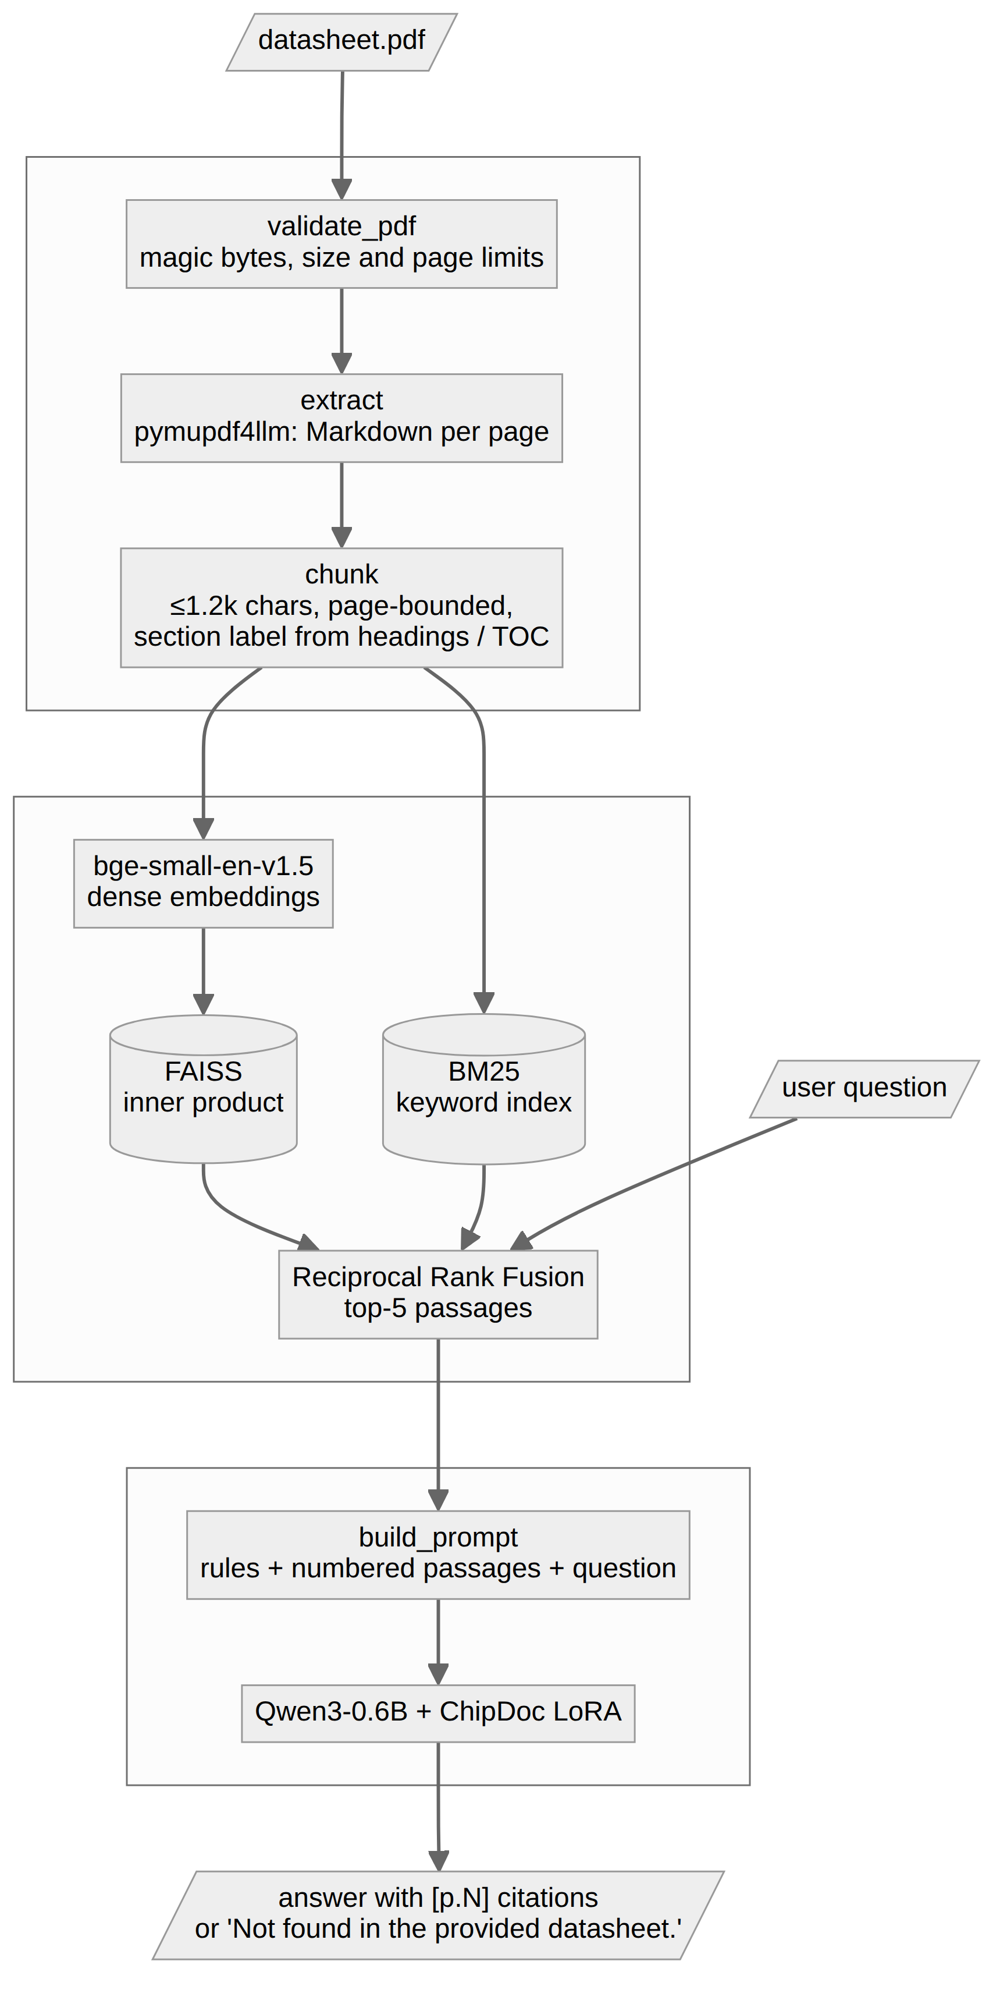
Figure 1: ChipDoc architecture. Top group: ingestion (chipdoc/ingest.py); middle: indexing and retrieval (chipdoc/index.py); bottom: generation (chipdoc/generate.py).

3.2 Dataset Collection
The corpus contains 30 manufacturer datasheets: the 15 collected at the start of the project and 15 added to widen vendor and architecture coverage (Figure 2). They span ST, Espressif, Raspberry Pi, Microchip (AVR, PIC and SAM), Texas Instruments, NXP and Nordic, and the AVR, PIC, ARM Cortex-M0+/M3/M4/M7/M33, Xtensa, RISC-V and MSP430 cores. A download script fetches the added PDFs from vendor sites and verifies each file’s %PDF signature; ST’s site blocks scripted downloads, so those datasheets are listed for manual download.
Five datasheets—one per vendor family—are held out entirely: STM32F103C8, LPC1768, ESP8266EX, ATmega32U4 and MSP430FR2433. No training example comes from them, so the evaluation measures the real use case of a user supplying a datasheet the model has never seen.
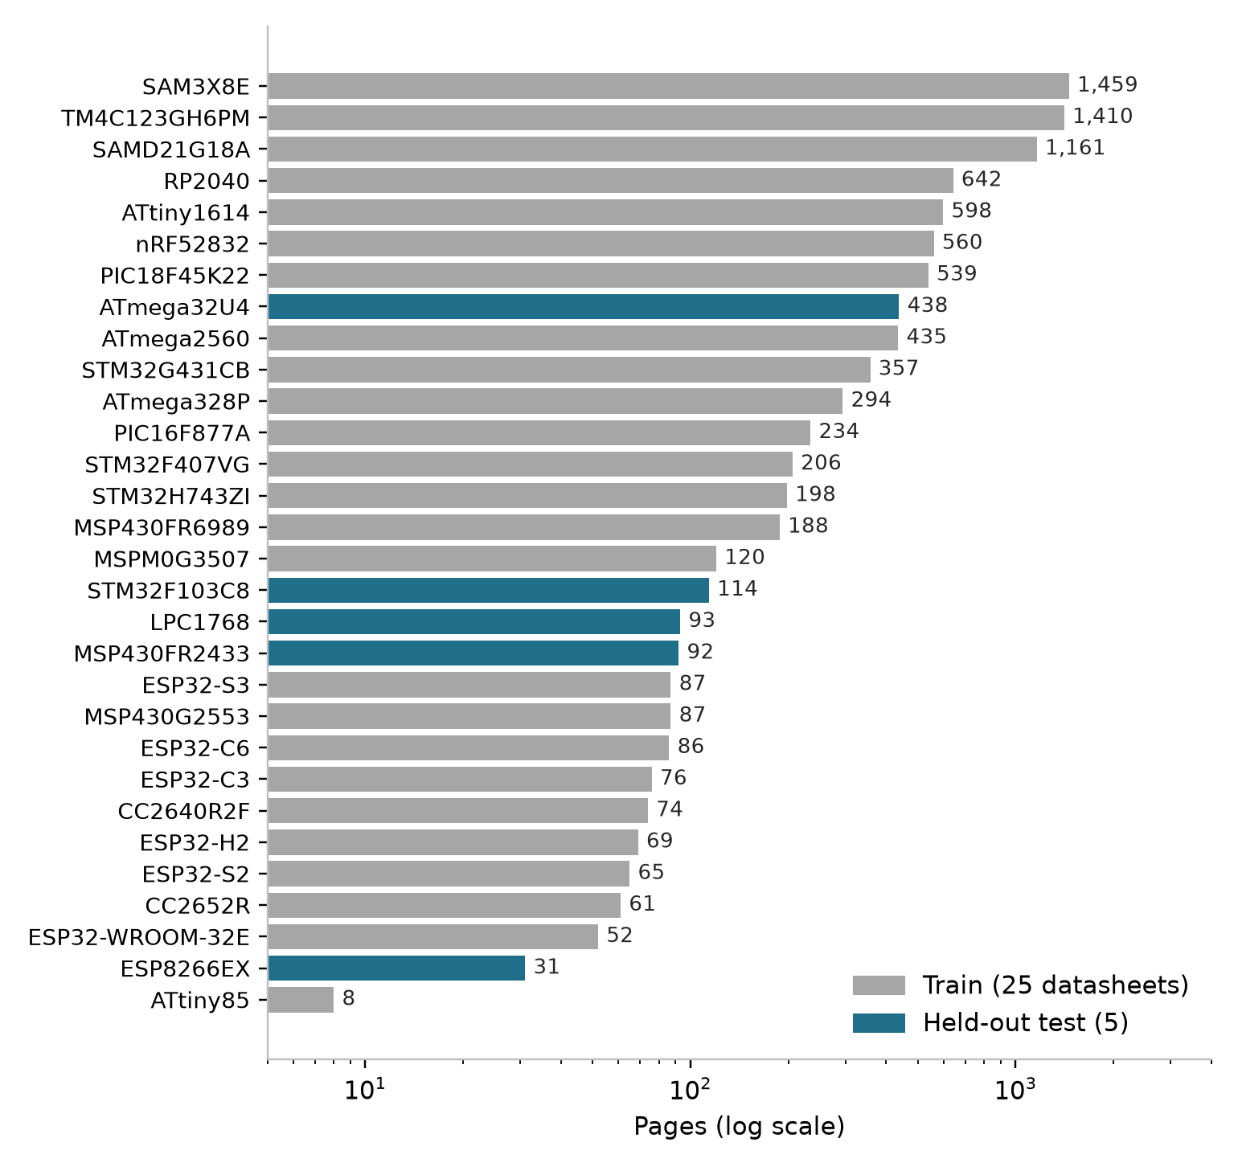
Figure 2: Pages per datasheet (log scale). Blue bars are the five held-out test datasheets.

3.3 PDF Extraction and Chunking
Each PDF is first validated at the trust boundary: it must exist, begin with the %PDF- magic bytes, and be at most 100 MB and 2,000 pages. Text is extracted with pymupdf4llm, which converts every page to Markdown and keeps tables as Markdown tables. Lines shorter than 80 characters that repeat on at least 30% of pages (minimum five) are treated as running headers and footers and removed; table rows are exempt because separator rows repeat legitimately. Invalid Unicode surrogates produced by some PDFs are replaced.
Chunking follows the steps in Figure 3. Each page is split at Markdown headings, and each block is split into passages of at most 1,200 characters, preferring paragraph, then line, then sentence boundaries, with a 150-character overlap. Two design choices matter. First, a passage never crosses a page, so every answer can cite one exact page. Second, the section label is the most recent heading, carried across pages, with the PDF bookmarks as a fallback; PDFs without bookmarks therefore still work. The project’s initial chunker produced passages averaging 3,000 and up to 8,000 characters, far beyond the 512-token window of the embedding model, so most of each passage was never embedded; the 1,200-character limit (about 400–500 tokens of datasheet text) fixes this.
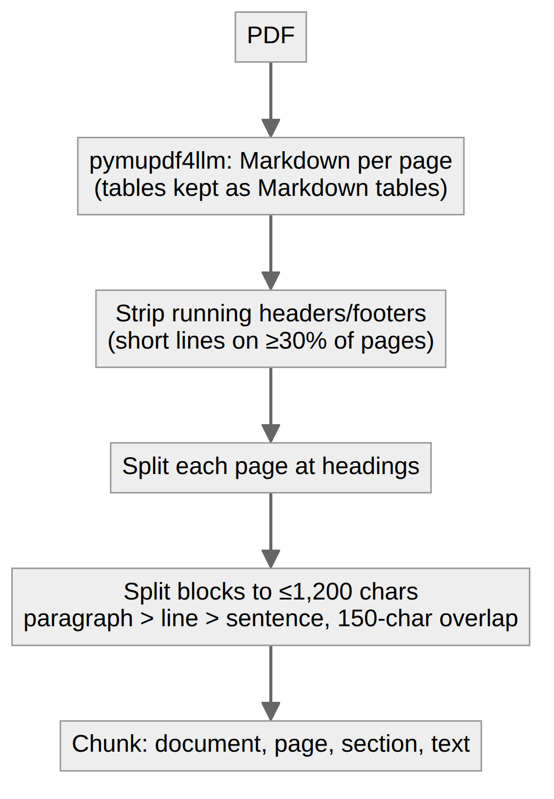
Figure 3: Chunking pipeline: from PDF pages to page-bounded passages with section labels.

3.4 Hybrid Retrieval
Each passage is indexed twice. The dense index embeds “document | section” followed by the passage text with bge-small-en-v1.5 (384 dimensions, normalised) and stores the vectors in a FAISS inner-product index; queries are prefixed with the model’s retrieval instruction. The keyword index is BM25 over a tokenizer that keeps identifiers such as tim2_ccr1 and values such as 3.3 intact. For a question, each retriever returns its top 50 passages, and the two lists are fused with Reciprocal Rank Fusion:
RRF(d) = Σ over rankers r of 1 / (k + rank_r(d)), with k = 60
The five highest-scoring passages are passed to the model. Indexes are stored as JSON plus a FAISS file, deliberately avoiding Python pickle, because loading a pickle can execute code and the cache sits next to user-supplied data. Each PDF’s index is cached under the SHA-256 hash of its contents, so a second session on the same file starts instantly.

3.5 Synthetic Question–Answer Generation
Fine-tuning needs questions with known answers and known evidence. These were generated locally (Figure 4). Up to 40 content-rich passages were sampled per datasheet—skipping passages under 500 characters, without digits, resembling a table of contents, or from revision-history, ordering, legal or package-marking sections—for 1,144 passages in total. A teacher model, qwen3:4b served by Ollama with JSON-schema-constrained output, wrote two questions per passage, each with a short answer and a verbatim evidence span copied from the passage.
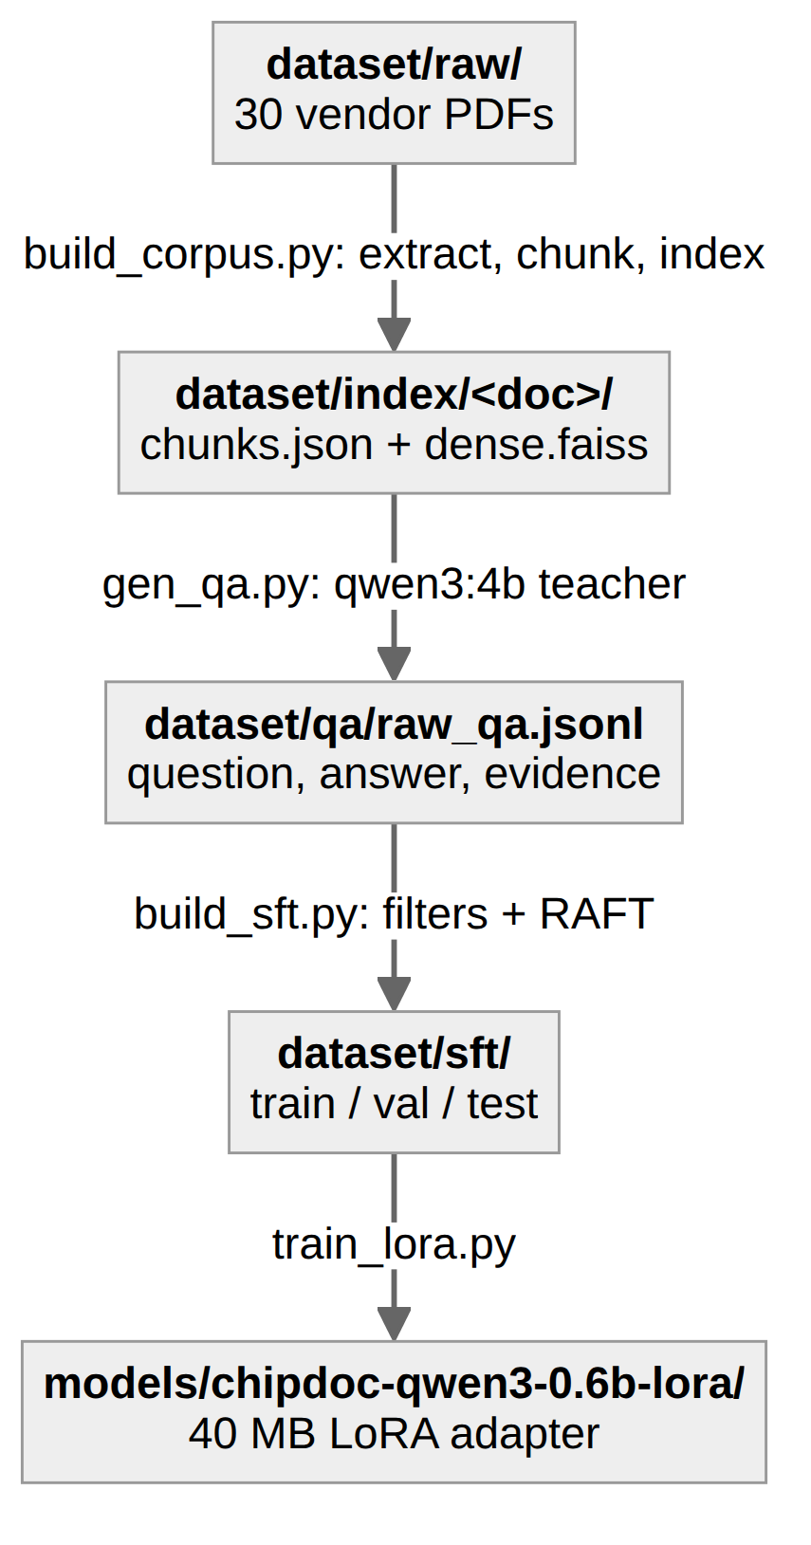
Figure 4: Data pipeline from raw PDFs to the trained adapter, with the script that produces each stage.
A small teacher is error-prone, so every pair passed four automatic filters: (1) the question is 15–300 characters, ends with a question mark and does not refer to “this table”, “the excerpt” or document metadata; (2) the evidence appears in the passage verbatim or with at least 90% of its words; (3) every number in the answer appears in the passage, ignoring digits inside part and register names such as CC2652R; and (4) the question is not a duplicate. Filter (3) is the main guard against invented values.

3.6 RAFT-style Training Examples
Following RAFT [12], each kept pair becomes an example that looks exactly like inference (Figure 5). The question is run through the hybrid retriever on its own datasheet; the top hits other than the source passage become hard distractors—same peripheral, neighbouring pages—so the model must locate the right passage rather than trust the first one. In about 80% of examples the context is the source passage plus four distractors, shuffled, and the target is the answer followed by the source page, e.g. “… up to 100 MHz. [p.1]”. In about 20% the source passage is removed and the target is “Not found in the provided datasheet.”; this happens only if no distractor contains the evidence, so the model is never taught to refuse an answerable question.
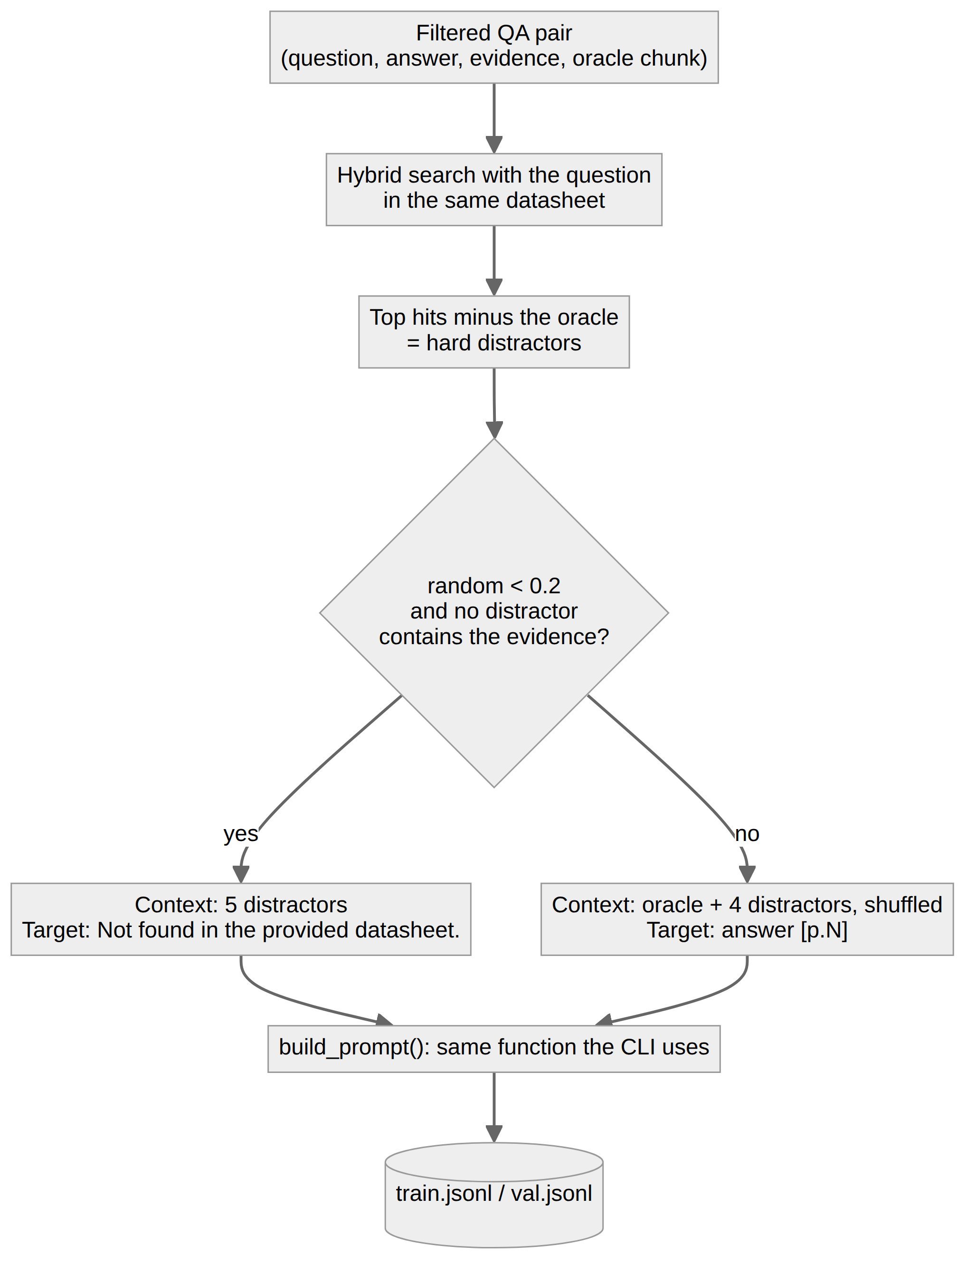
Figure 5: Construction of a RAFT-style training example from a filtered QA pair.

3.7 Model and Fine-tuning
The reader is Qwen3-0.6B with thinking mode disabled. The system prompt instructs it to use only the numbered passages, copy values and units exactly, cite pages as [p.N], and otherwise reply with the fixed refusal sentence. LoRA adapters were trained on all attention and MLP projections with loss computed on answer tokens only (Table 2). Examples longer than 2,560 tokens (3%) were dropped rather than truncated, because truncation would remove the answer, which comes last.
Table 2: Fine-tuning configuration
Setting | Value
Base model | Qwen/Qwen3-0.6B (bf16, thinking off)
Method | LoRA, rank 16, alpha 32, dropout 0.05
Target modules | q, k, v, o, gate, up and down projections
Trainable parameters | 10,092,544 of 606,142,464 (1.67%)
Training data | 1,523 train and 75 validation examples
Batch | 1 per step × 16 gradient accumulation
Optimisation | learning rate 2e-4, cosine schedule, 3% warm-up, 2 epochs
Maximum length | 2,560 tokens; gradient checkpointing
Hardware and time | RTX 3050 Laptop GPU (4 GB), 63 minutes, about 2 GB VRAM

Batch size 1 is forced by Qwen’s 151k-token vocabulary: the output logits for one 2,500-token sequence alone occupy about 1.5 GB in 32-bit precision.

3.8 Terminal Application
The user runs python -m chipdoc datasheet.pdf. On first use the PDF is validated, extracted, chunked and indexed (one to three minutes for a few hundred pages, dominated by layout-aware text extraction); afterwards the cached index loads instantly. Each question triggers hybrid retrieval and a streamed answer (Figure 6). The /sources command shows the passages behind the last answer, -q answers a single question non-interactively, and --base runs the untuned model for comparison. Everything runs locally; no datasheet text or question leaves the machine.
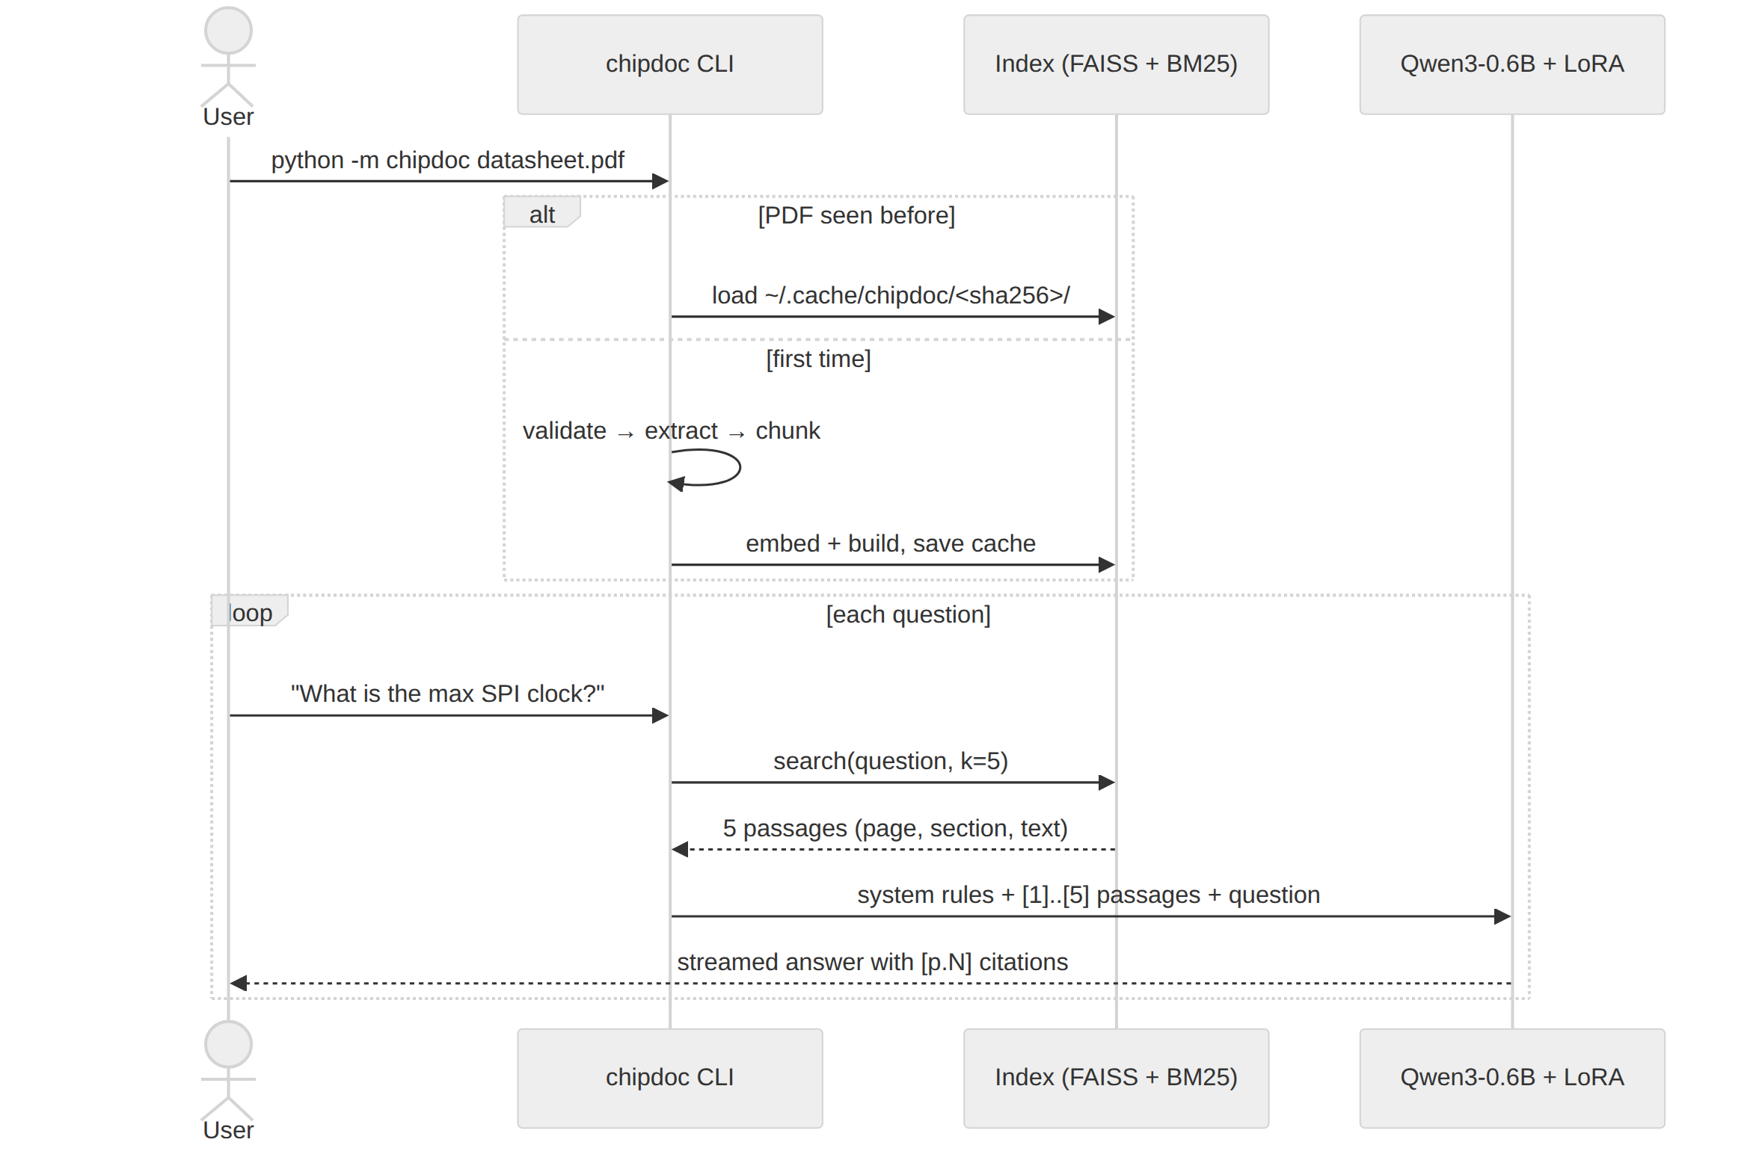
Figure 6: Query flow in the terminal application, including the per-PDF cache.

3.9 Evaluation Protocol
All evaluation uses the five held-out datasheets (341 test QA pairs). Retrieval is measured with Recall@k and MRR@10, where a hit is a retrieved passage that is the source passage or contains the evidence span. Answer quality is measured on a seeded random sample of 100 test questions, each asked twice (Figure 7): once with the real top-five retrieval (answerable), and once with every passage containing the evidence removed (unanswerable), where the only correct output is the refusal sentence.
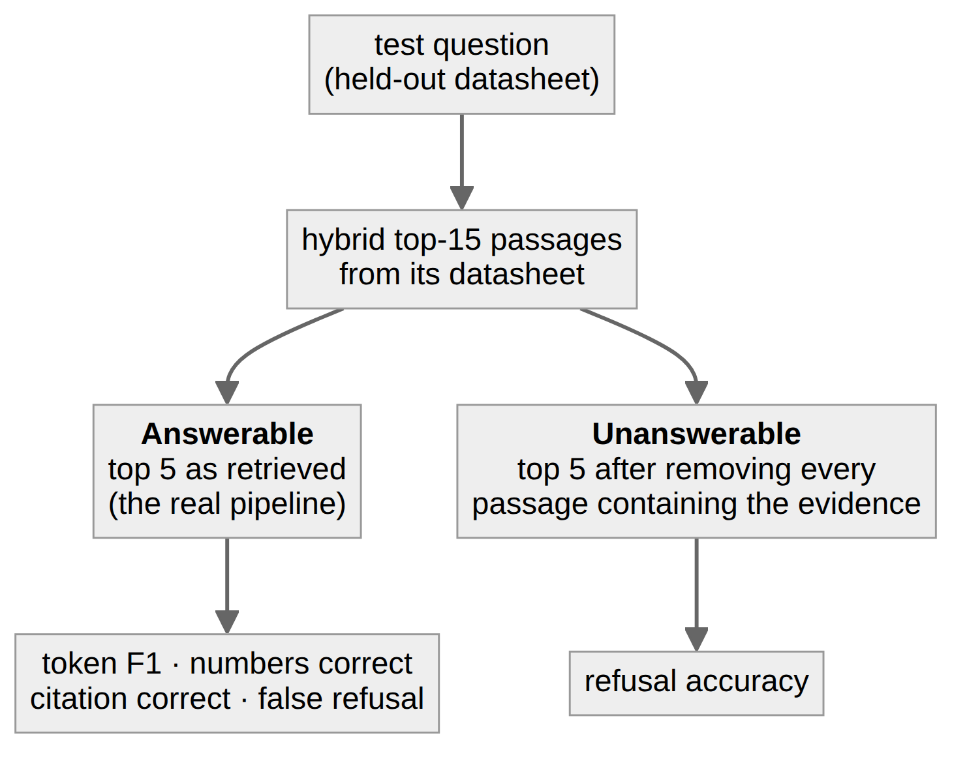
Figure 7: Answerable and unanswerable conditions used to evaluate answer quality.
Metrics on answerable inputs are computed only where retrieval actually found the evidence (92 of 100), so they isolate the generator: token F1 against the reference answer, as in SQuAD [14]; numbers correct, the share of answers reproducing every number in the reference; citation correct, the share of non-refusal answers citing the source page; and false refusal, the share of answerable inputs the model refused. On unanswerable inputs, refusal accuracy is the share correctly refused.

4. Results

4.1 Dataset Statistics
Table 3 summarises the synthetic QA pipeline. Of 2,293 generated pairs, 87% survived the filters; unsupported answers (an evidence span or number not found in the passage) were by far the most common reason for rejection, confirming that the number check is needed with a small teacher.
Table 3: QA generation and filtering
Stage | Count
Passages sent to the teacher | 1,144
QA pairs generated | 2,293
Dropped: format (vague or meta question, length) | 31
Dropped: unsupported (evidence or number not in passage) | 252
Dropped: duplicate question | 20
Kept | 1,990 (87%)
Train / validation examples (25 datasheets) | 1,569 / 80
… of which “Not found” refusal examples | 257
Test QA pairs (5 held-out datasheets) | 341
Training example length in tokens (median / 95th pct. / max) | 1,490 / 2,423 / 4,213

To estimate label quality, 30 random test pairs were checked by hand against their evidence. Twenty-six (87%) were correct and answerable. The four flawed pairs comprised one meaningless question, one answer not supported by its evidence, one that reported a minimum value as if it were the typical value, and one garbled question. Reference answers therefore carry roughly 10–13% noise; this lowers absolute scores for every system equally, so comparisons between systems remain fair.

4.2 Training
Training took 192 optimiser steps over two epochs in 63 minutes (Figure 8). Validation loss fell from 0.333 after the first epoch to 0.314 after the second, so the second epoch still improved generalisation. Training loss dropped sharply at the start of epoch 2, the usual sign that the model has begun to memorise examples it has already seen; the widening gap suggests a third epoch would add little.
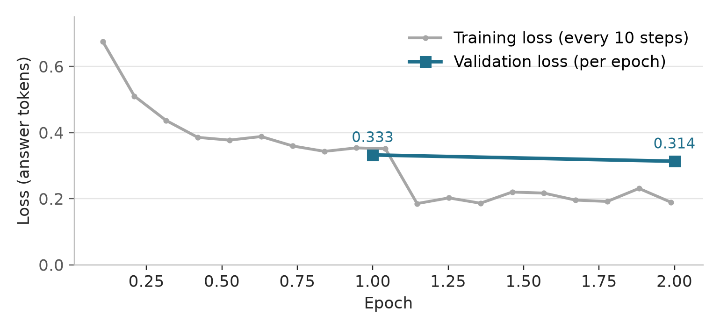
Figure 8: Training loss (every 10 steps) and validation loss (each epoch).

4.3 Retrieval
Hybrid retrieval was best or joint-best on every cut-off except Recall@1, where BM25 alone was marginally higher (Table 4, Figure 9). The cut-off that matters is Recall@5, because the model reads five passages: hybrid fusion raised it from 0.79 (dense only) and 0.84 (BM25 only) to 0.88. Because the questions were written while looking at the passages, they share wording with them, which flatters BM25; with real user phrasing the dense component is likely to matter more than these numbers show.
Table 4: Retrieval on the held-out datasheets (341 questions)
Retriever | R@1 | R@3 | R@5 | R@10 | MRR@10
Dense (bge-small-en-v1.5) | 0.53 | 0.74 | 0.79 | 0.89 | 0.65
BM25 | 0.65 | 0.81 | 0.84 | 0.89 | 0.73
Hybrid (RRF) | 0.63 | 0.84 | 0.88 | 0.92 | 0.74

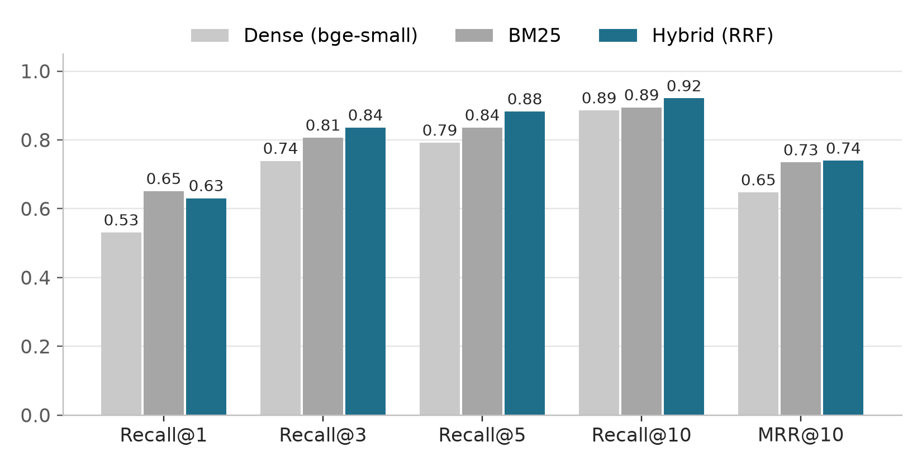
Figure 9: Retrieval quality of dense, BM25 and hybrid search on unseen datasheets.

4.4 Answer Quality
Table 5 and Figure 10 compare the base Qwen3-0.6B with the fine-tuned ChipDoc model on the same 100 questions and the same retrieved passages. The fine-tune changed behaviour most where it was designed to. Page citations went from 0.22 to 0.91 correct; the base model usually cited passage numbers such as [1] or no page at all. On unanswerable inputs, the base model invented an answer 70% of the time; the fine-tuned model did so 26% of the time, converting 47 hallucinations into correct refusals.
Table 5: Answer quality on 100 held-out questions (best value in bold)
Metric | Base Qwen3-0.6B | ChipDoc (fine-tuned)
Token F1 vs. reference | 0.50 | 0.56
Numbers reproduced correctly | 0.72 | 0.75
Correct page citation | 0.22 | 0.91
False refusal (lower is better) | 0.05 | 0.15
Refusal accuracy when evidence is absent | 0.30 | 0.74

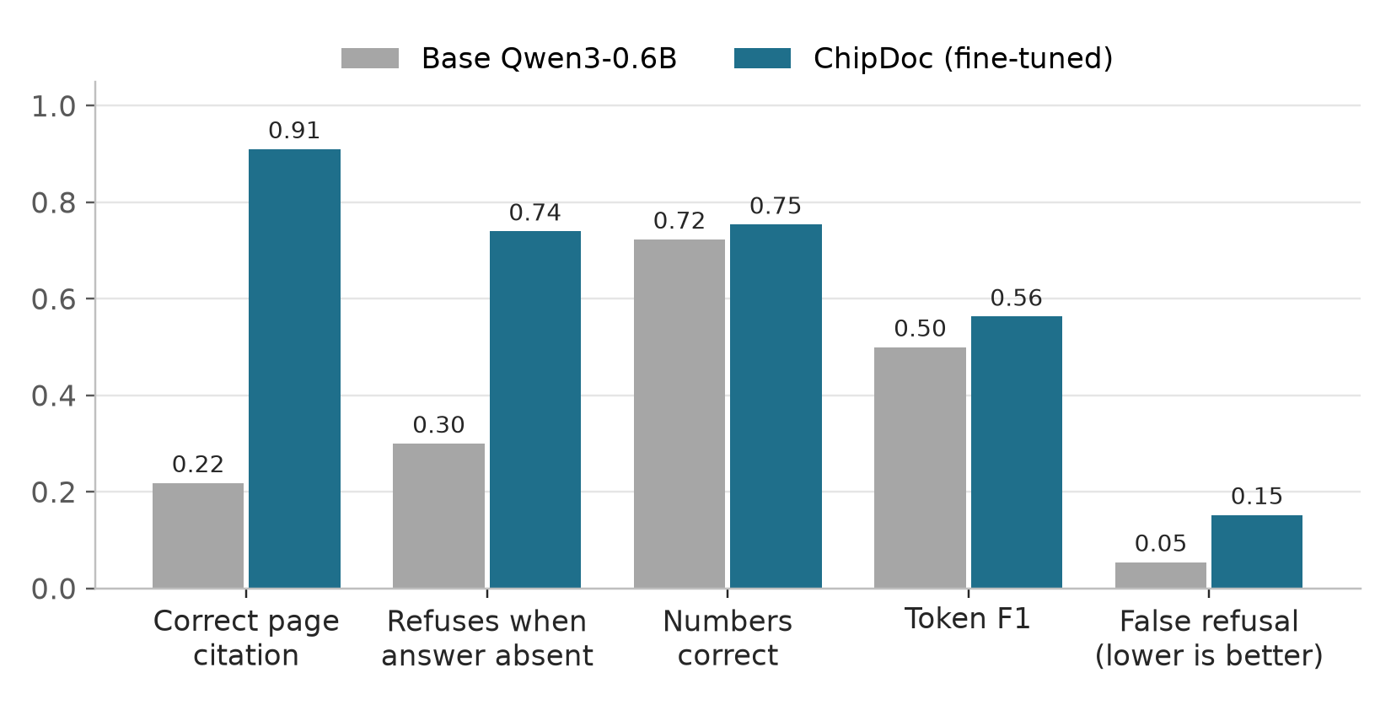
Figure 10: Base versus fine-tuned model on the same retrieved passages.
Answer accuracy itself improved more modestly (F1 +0.06, numbers +0.03). Both models see the same passages, and a 0.6B model’s ability to read dense electrical tables is largely set by pre-training rather than by a short fine-tune. The fine-tune mainly taught format and discipline: short answers, exact copying, citations and refusals.
Figure 11 breaks the same results down by outcome. When the evidence was retrieved, the share of fully correct answers (token F1 of at least 0.5) rose from 48% to 58%, and partly correct or wrong answers fell from 47% to 27%; the price is a larger share of refusals, from 5% to 15%. When the evidence was removed, the share of invented answers fell from 70% to 26%.
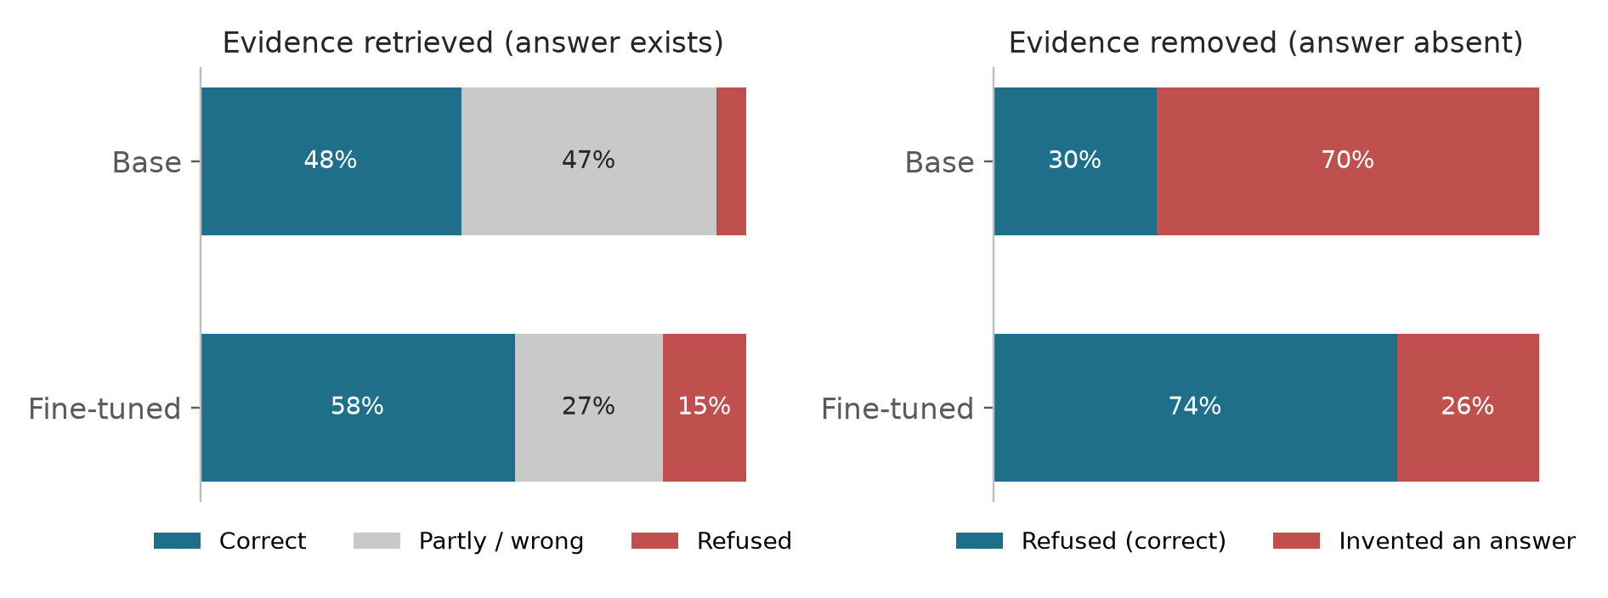
Figure 11: Outcome breakdown on the held-out questions. Left: inputs where retrieval found the evidence. Right: inputs where the evidence was removed, so the only correct output is a refusal.

4.5 Seen versus Unseen Datasheets
To check whether the fine-tune memorised its training datasheets or learned a general reading skill, the fine-tuned model was also run on ten random QA pairs from each of the 25 training datasheets (250 questions), through the same pipeline: the full datasheet index, hybrid top-five retrieval and the same prompt. Table 6 compares these with the held-out results.
Table 6: Fine-tuned model on training (seen) and held-out (unseen) datasheets
Metric | Seen (25 datasheets, 250 Q) | Unseen (5 datasheets, 100 Q)
Evidence in top five passages | 0.85 | 0.92
Token F1 vs. reference | 0.64 | 0.56
Numbers reproduced correctly | 0.70 | 0.75
Correct page citation | 0.82 | 0.91
False refusal (lower is better) | 0.09 | 0.15

The gap is small. F1 is 0.08 higher and false refusals are lower on seen datasheets, as expected, but number accuracy and citation accuracy are actually higher on the unseen ones. The model therefore did not simply memorise its training documents: what it learned, namely to locate the passage, copy the value and cite the page, carries over to datasheets it has never seen. The main lever on accuracy remains retrieval and the model’s ability to read tables, not exposure to a particular document.
Quality also varies by datasheet (Figure 12). Short, well-structured documents with clean electrical-characteristics tables, such as the ATtiny85 summary, the ESP32-H2 and the CC2640R2F, reach 80% fully correct answers with F1 of about 0.8. The weakest are long documents whose answers sit in large register maps or multi-column tables that the text extractor flattens, such as the nRF52832 and PIC18F45K22. With ten questions per datasheet each bar has a margin of roughly ±15 points, so the ranking is indicative rather than exact.
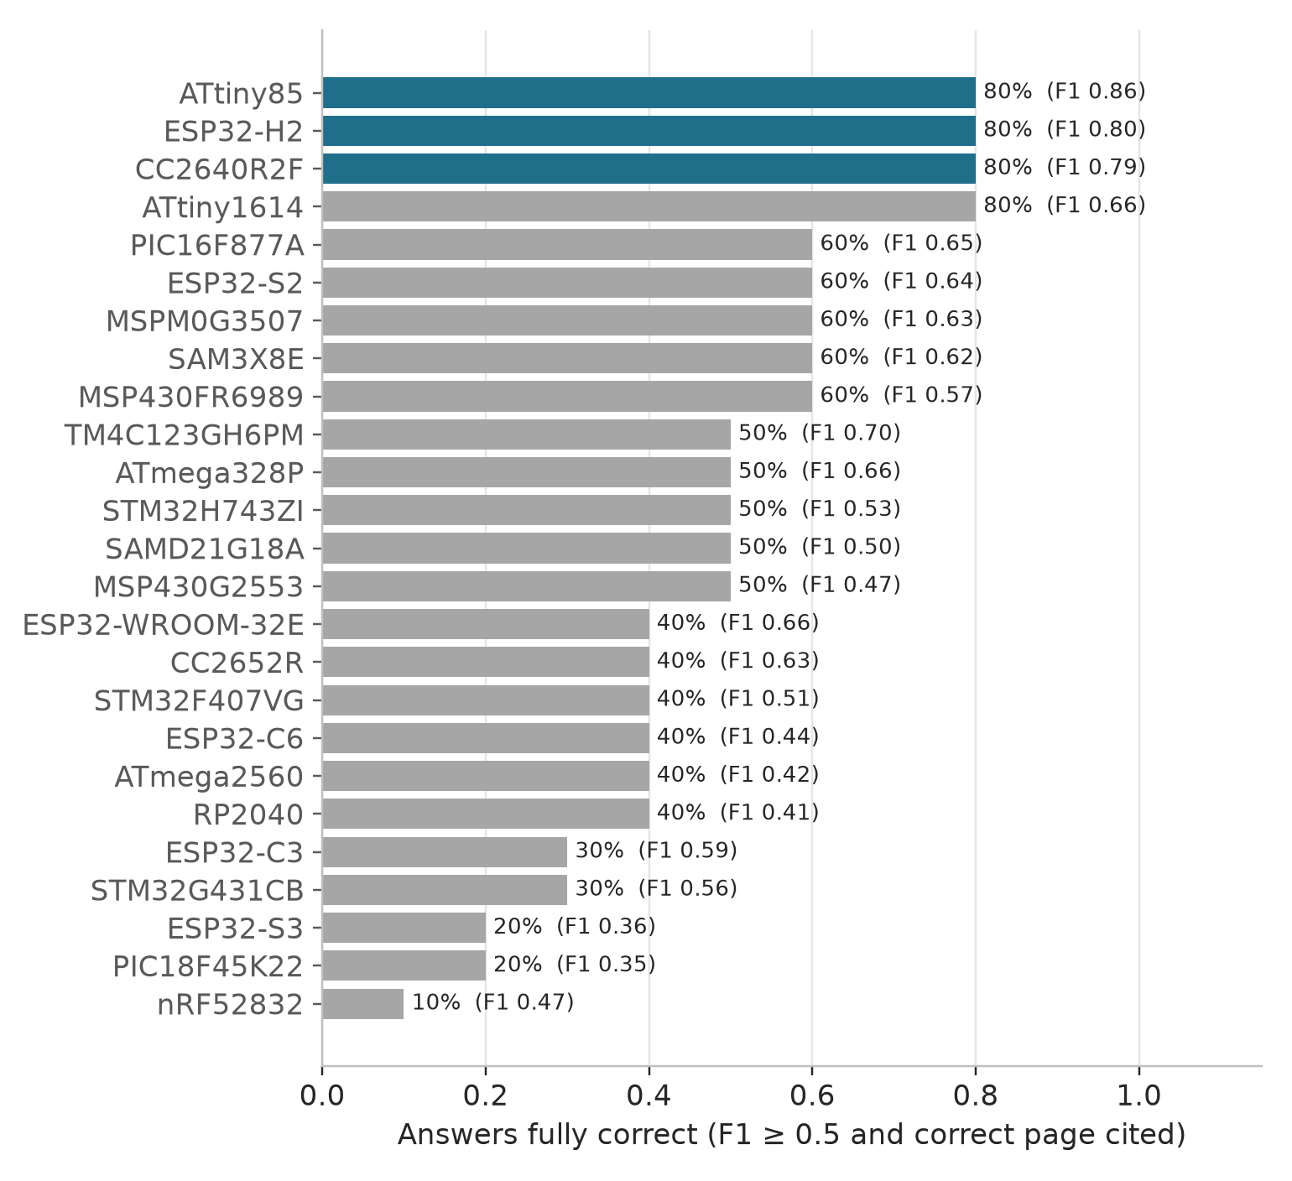
Figure 12: Share of fully correct answers per training datasheet (10 questions each). The three best datasheets, used for the demonstrations in Section 4.6, are highlighted.

4.6 Qualitative Examples
A typical correction on an unanswerable input: asked “What does ULP Advisor check your code against?” with the relevant passage removed, the base model answered that it checks code “against an energy-based code analysis tool to optimize it for ultra-low power consumption [p.92]”—an invented answer with an invented citation. The fine-tuned model replied “Not found in the provided datasheet.” With the passage present, it answered “ULP Advisor checks your code against a thorough ULP checklist…”, matching the reference.
Figures 13 to 15 show complete sessions on the three best-scoring datasheets from Figure 12, captured from a terminal running python -m chipdoc on each PDF. Every factual answer was checked against the datasheet and is correct, and every one cites the page it came from. The Searched line lists the pages of the five retrieved passages, so the user can see which part of the document the model read. Each session ends with a question about a feature the chip does not have, which the model correctly refuses.
The sessions also show the kinds of question the model handles well: one specific fact per question, phrased with the datasheet’s own terms (“differential non-linearity”, “low-level sink current”, “24-MHz oscillator”). Answers range from a single value with its unit (“1.1 µA [p.2]”) to a sentence copied from the datasheet (the stack-pointer monitoring feature in Figure 14). Vague or conversational questions such as “ram?” or “explain the architecture” fall outside this style and are often refused; Section 6 discusses how to close that gap.
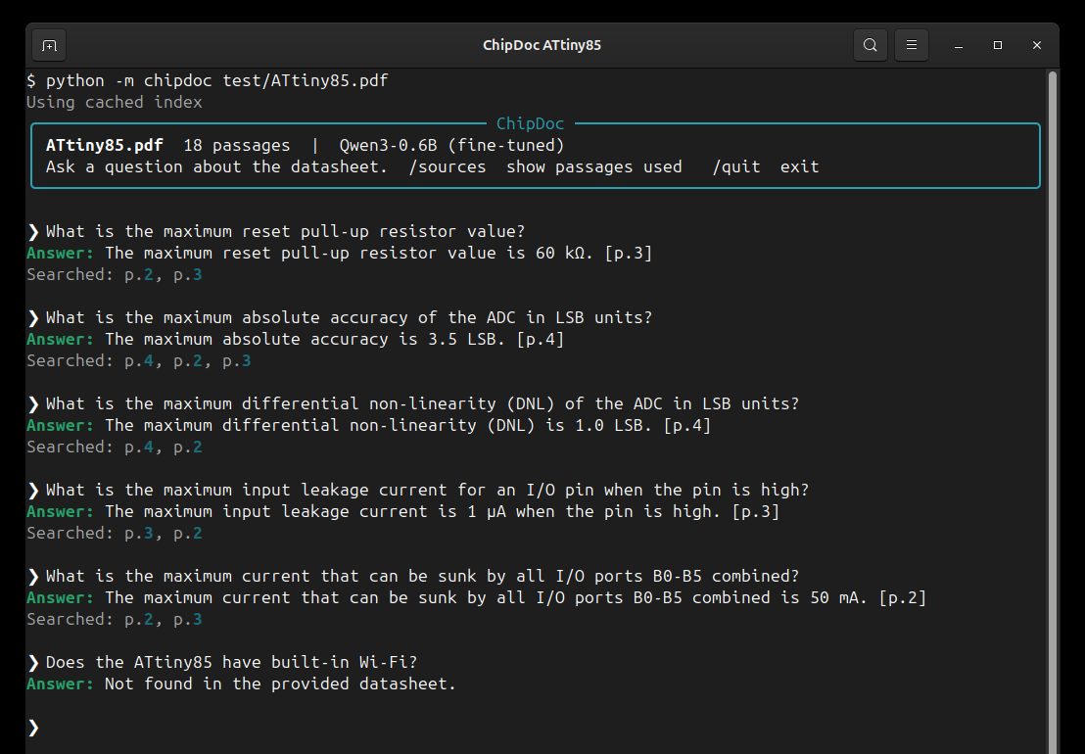
Figure 13: Terminal session on the ATtiny85 datasheet: ADC accuracy, electrical characteristics and a correct refusal.
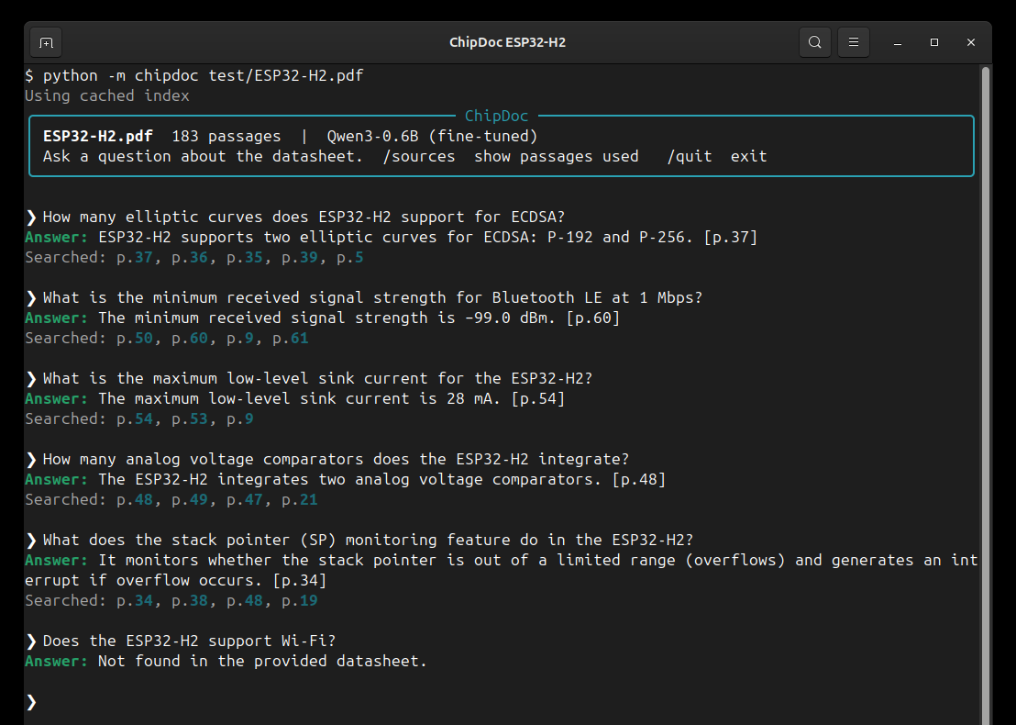
Figure 14: Terminal session on the ESP32-H2 datasheet: security, radio and peripheral questions.
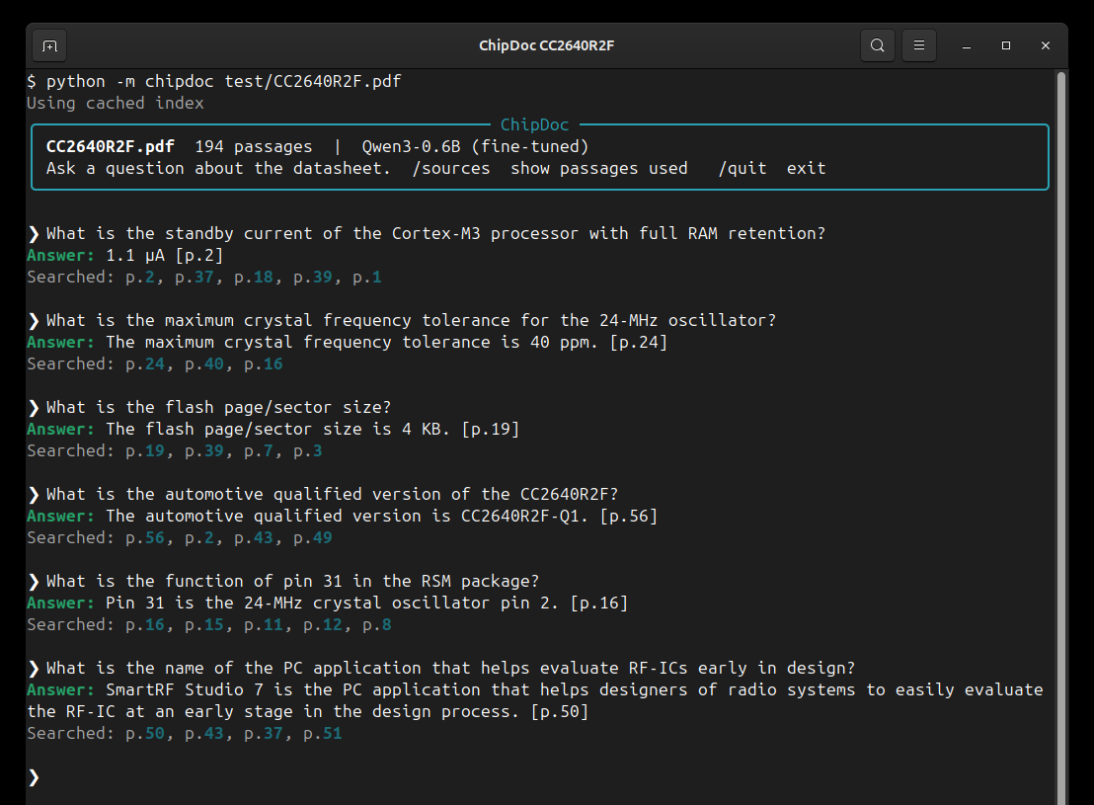
Figure 15: Terminal session on the CC2640R2F datasheet: power, clock, memory, pin-out and tooling questions.
Figure 16 shows how a user can check an answer. After the question about analog comparators, the /sources command prints the five passages the model was given, each labelled with its rank, page number and section. Passage [1], from page 48, contains the sentence the answer was copied from, so the claim and its citation can be verified in seconds without opening the PDF. The other passages are the near-misses that retrieval also returned: the comparator pin assignment, the SAR ADC and the power scheme.
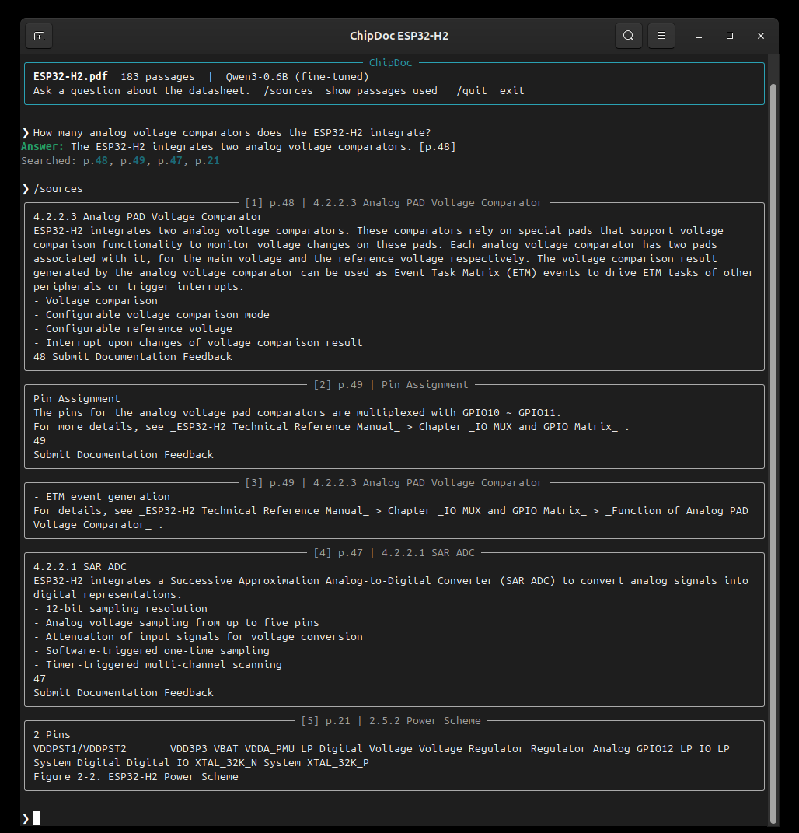
Figure 16: The /sources command after an ESP32-H2 question: the five retrieved passages with their page numbers and sections. Passage [1] holds the evidence for the answer.

4.7 Error Analysis and Limitations
- Casual phrasing. Training questions were precise and formal, so the model tends to refuse short or conversational questions (“ram?”, “how many cores?”) even when the answer is on the page; on a new ESP32-P4 datasheet such questions were all refused, while specific questions using datasheet terms were not.
- Over-caution. False refusals rose from 5% to 15% (14 of 92 answerable inputs), mostly questions whose answer sits inside a dense register or electrical table, such as “What register enables the noise canceler?”. This is the price of the 20% refusal examples; lowering that rate trades refusal accuracy back for coverage.
- Retrieval ceiling. For 8–12% of questions the evidence is not in the top five passages, and no reader can answer those.
- Label noise. About 13% of reference answers are flawed, and the number check cannot catch a wrong unit (one training answer reads mA/MHz where the table says µA/MHz).
- Scanned and figure-only content. Text in images, such as pin-out diagrams and timing figures, is not extracted, so questions answered only by a figure cannot be answered.
- Teacher comparison. The 4B teacher could not be scored as an upper reference because the local build kept emitting its reasoning even with thinking disabled.

4.8 Efficiency
On the RTX 3050 Laptop GPU, evaluation ran at about 1.5 s per question. Hybrid retrieval alone takes 47–83 ms per query on the CPU (93- to 1,459-page datasheets). First-time indexing takes one to three minutes per few hundred pages; the adapter is 40 MB.

5. Conclusion
This project set out to answer questions about a microcontroller datasheet from the datasheet itself, with page citations and honest refusals, on hardware a student owns. ChipDoc meets that goal. A page-bounded chunker and hybrid retrieval find the right passage among the top five for 88% of questions about datasheets never seen in training. A Qwen3-0.6B model fine-tuned with LoRA on 1,523 RAFT-style examples cites the correct page 91% of the time and refuses 74% of unanswerable inputs, against 22% and 30% for the same model without fine-tuning.
The results also show where the remaining difficulty lies. Answer accuracy is bounded by retrieval misses and by how well a very small model reads dense tables, and the refusal training makes the model somewhat over-cautious. Even so, the central finding is encouraging: with careful retrieval and a targeted fine-tune, a model small enough to train in an hour on a laptop can be made substantially more trustworthy for engineering documentation, and the entire pipeline—data generation included—can run without sending a single document to an external service.

6. Future Work
- Re-ranking. A cross-encoder re-ranker over the top 20–50 fused results is the cheapest way to close the retrieval gap that caps answer accuracy.
- Robustness to casual questions. Adding paraphrased and conversational versions of each training question (“ram?”, “how fast is it?”), mapping common words to datasheet terms before retrieval (RAM to SRAM, speed to clock frequency), and always including the overview pages in the context would let the model answer the way people actually ask.
- A human-verified test set. Correcting the roughly 13% of flawed reference answers would make the metrics more precise and enable finer comparisons.
- Calibrated refusal. Tuning the share of refusal examples, or adding a confidence threshold, could reduce false “Not found” answers while keeping hallucinations low.
- Tables and figures. Table-aware chunking that keeps header rows with each row, and OCR or vision models for pin-out and timing diagrams, would answer questions that today fall outside the extracted text.
- A stronger or verified teacher. A larger teacher, or a second model that checks each generated pair, would reduce noise such as wrong units.
- Multi-document questions. Comparing parts (“Which has more ADC channels, the STM32F103 or the ATmega328P?”) requires retrieval across several datasheets and answers that cite more than one document.
- Larger readers where hardware allows. The same pipeline can train Qwen3-1.7B with 4-bit QLoRA when more time or memory is available.

References
[1] Lewis, Patrick, et al. “Retrieval-Augmented Generation for Knowledge-Intensive NLP Tasks.” Advances in Neural Information Processing Systems, vol. 33, 2020, pp. 9459–74.
[2] Chen, Hong Cai, et al. “DocEDA: Automated Extraction and Design of Analog Circuits from Documents with Large Language Model.” arXiv, 2024.
[3] Sobhan, Shadman, and Mohammad Ariful Haque. “LLM-Assisted Question-Answering on Technical Documents Using Structured Data-Aware Retrieval Augmented Generation.” arXiv, 2025.
[4] Lee, Seungjoon, and Myungryul Choi. “TechDocRAG: Relation-Preserving Retrieval-Augmented Generation (RAG) for Technical Documents.” AI, vol. 7, no. 5, 2026, p. 161.
[5] Perot, Vincent, et al. “LMDX: Language Model-based Document Information Extraction and Localization.” Findings of the Association for Computational Linguistics: ACL 2024, 2024, pp. 15140–68.
[6] Liu, Ran, et al. “DSciSum: Detailed Summarization of Long Scientific Documents.” Knowledge-Based Systems, vol. 317, 2025, p. 113409.
[7] Robertson, Stephen, and Hugo Zaragoza. “The Probabilistic Relevance Framework: BM25 and Beyond.” Foundations and Trends in Information Retrieval, vol. 3, no. 4, 2009, pp. 333–89.
[8] Xiao, Shitao, et al. “C-Pack: Packed Resources for General Chinese Embeddings.” arXiv, 2023, arxiv.org/abs/2309.07597.
[9] Johnson, Jeff, et al. “Billion-Scale Similarity Search with GPUs.” IEEE Transactions on Big Data, vol. 7, no. 3, 2021, pp. 535–47.
[10] Cormack, Gordon V., et al. “Reciprocal Rank Fusion Outperforms Condorcet and Individual Rank Learning Methods.” Proceedings of the 32nd International ACM SIGIR Conference on Research and Development in Information Retrieval, 2009, pp. 758–59.
[11] Hu, Edward J., et al. “LoRA: Low-Rank Adaptation of Large Language Models.” International Conference on Learning Representations, 2022.
[12] Zhang, Tianjun, et al. “RAFT: Adapting Language Model to Domain Specific RAG.” arXiv, 2024, arxiv.org/abs/2403.10131.
[13] Yang, An, et al. “Qwen3 Technical Report.” arXiv, 2025, arxiv.org/abs/2505.09388.
[14] Rajpurkar, Pranav, et al. “SQuAD: 100,000+ Questions for Machine Comprehension of Text.” Proceedings of the 2016 Conference on Empirical Methods in Natural Language Processing, 2016, pp. 2383–92.

