1. Training accuracy plot on tensorboard for part 1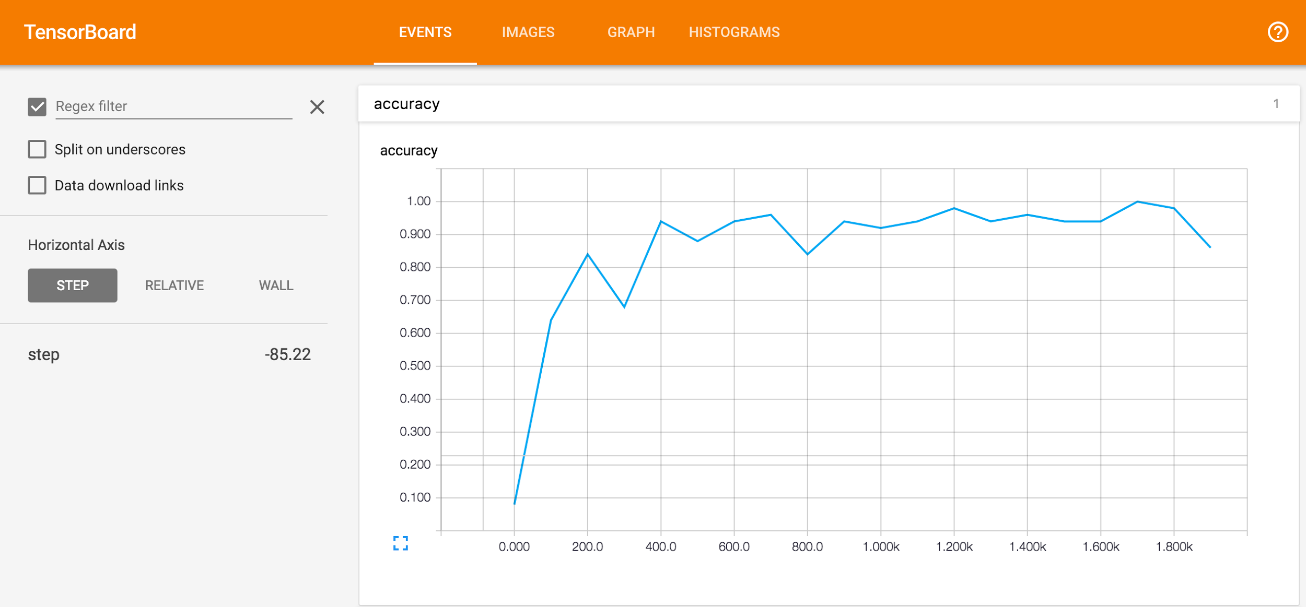
2. For part 2, we modified the structure by adding one more convolutional layer, which has output dimension being 64, after the first 2 layers. We also removed the max pooling so the added layer will be connected to the existing fully connected layers. In the end, we decreased the depth of the first 2 layers which are now 16 and 32 for the first and the second. The final test accuracy is about 99.2% .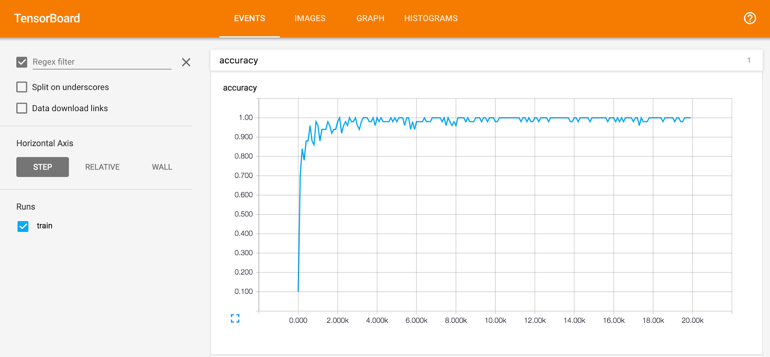
3. Tensorboard accuracy plot for part 3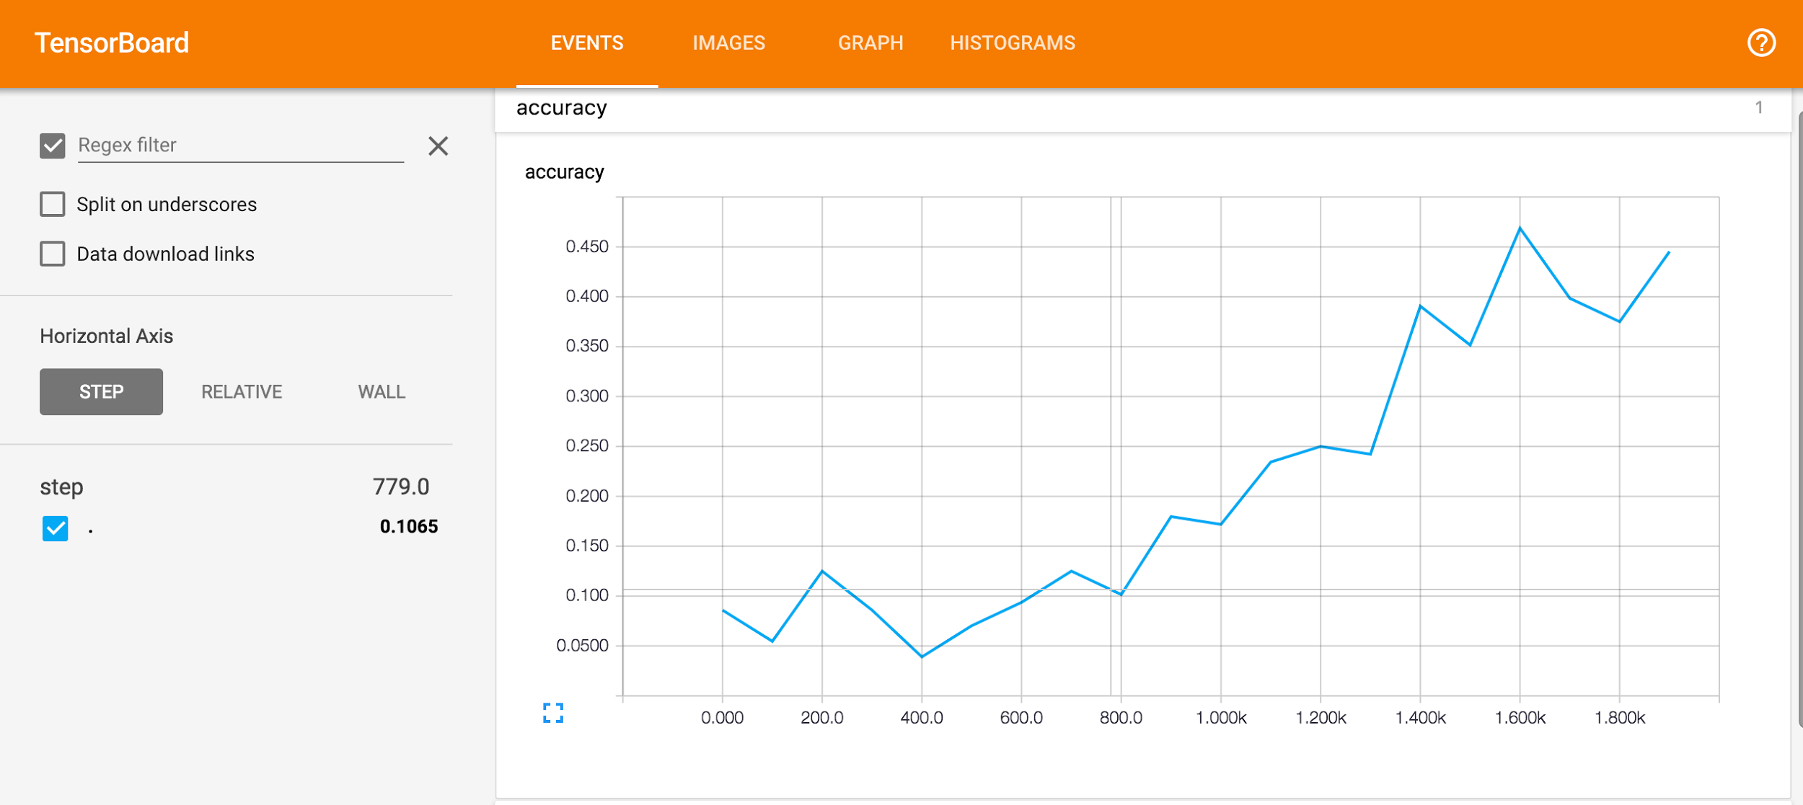
4. For part 4, we added one more convolutional layer after the first 2 convolutional layers with max pooling and local response normalization. Moreover, we added batch normalization for these 3 convolutional layers. After the 2 fully connected layers, we added a dropout layer to avoid overfitting. Then for the output, we normalized the output predictions.