Problem 3.4

1.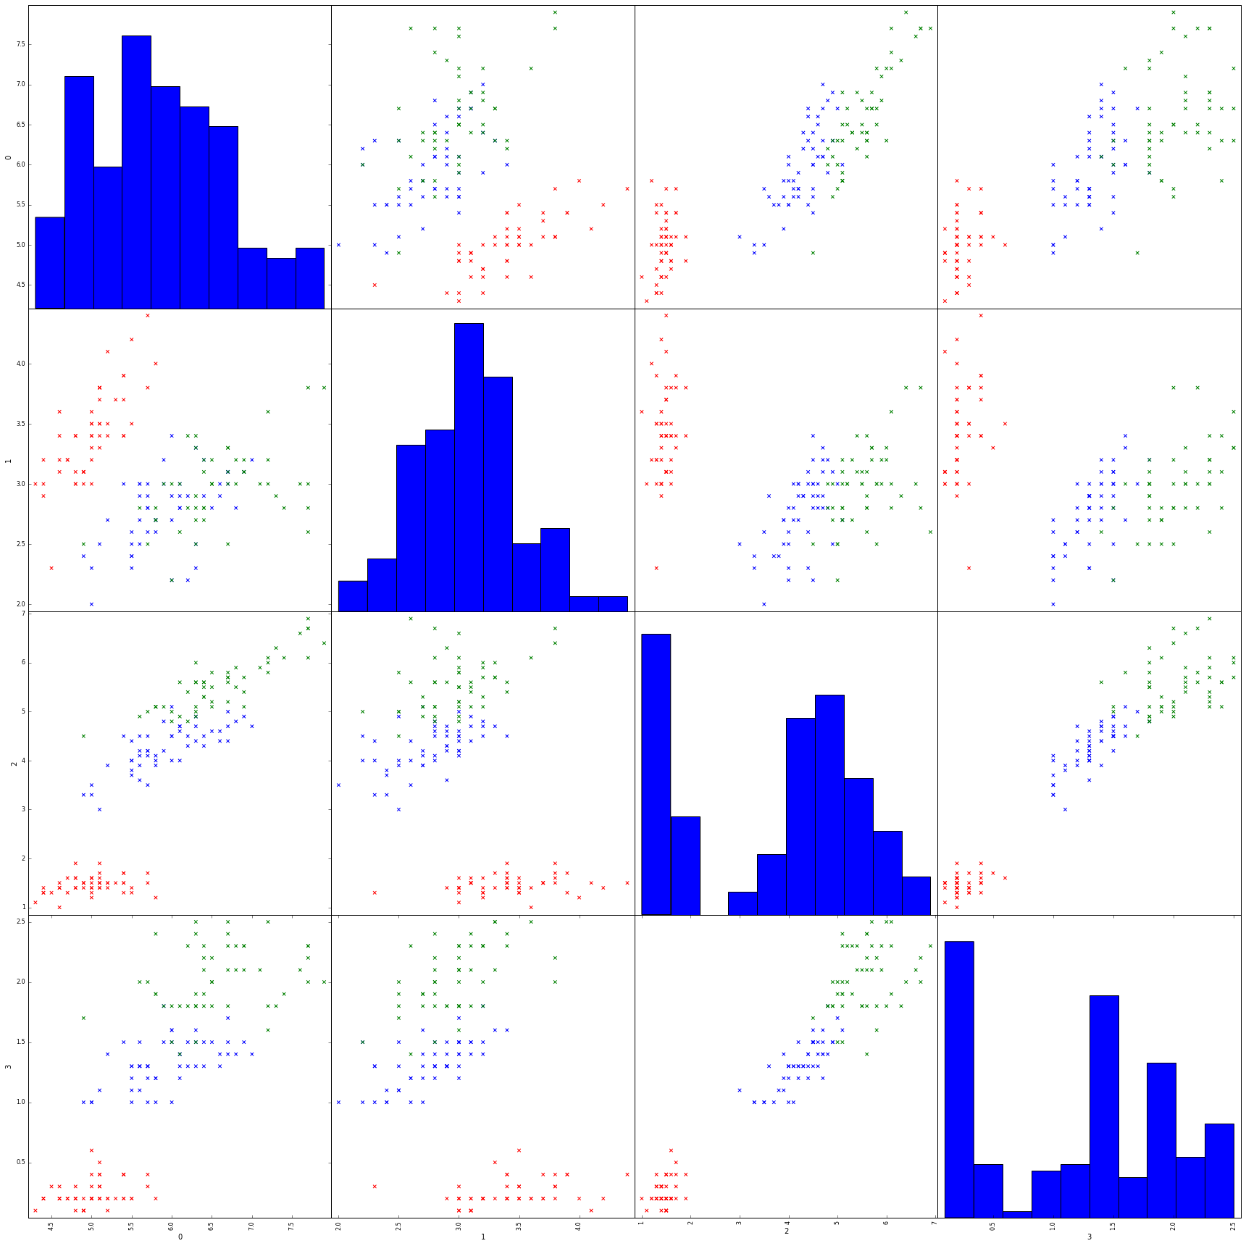

2.

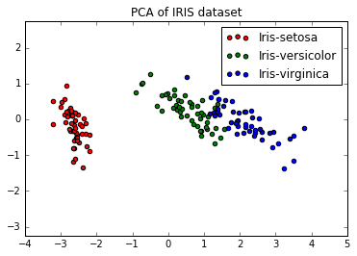

3.

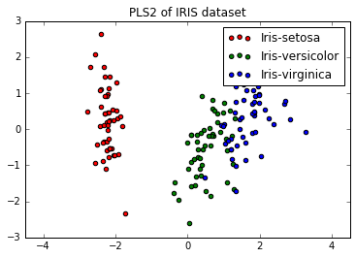

Yes, the pic looks slightly better than in PCA. Because it considers the labels of the data.