Problem 3.5

1.

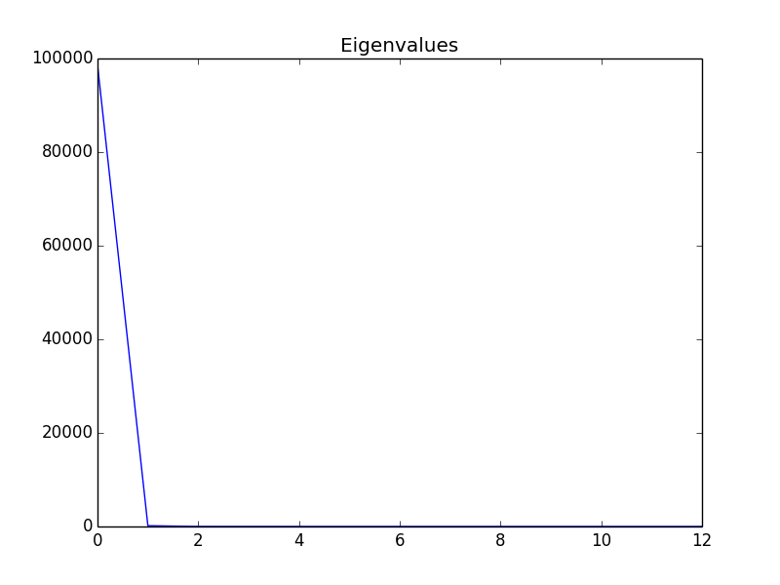

We only need one principal components. Because the first one has a dominantly large value, and other values approach to 0 quickly.

2. First eigenvector

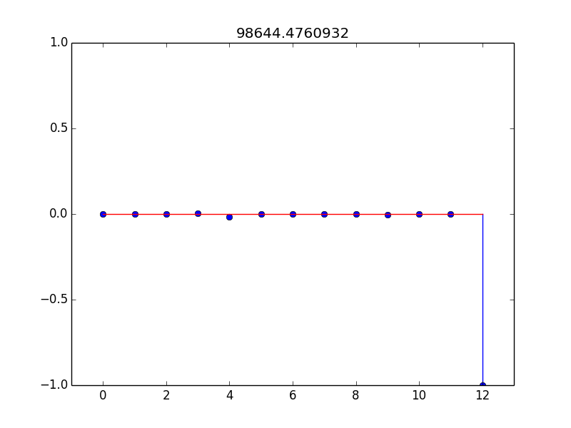

Second eigenvector:

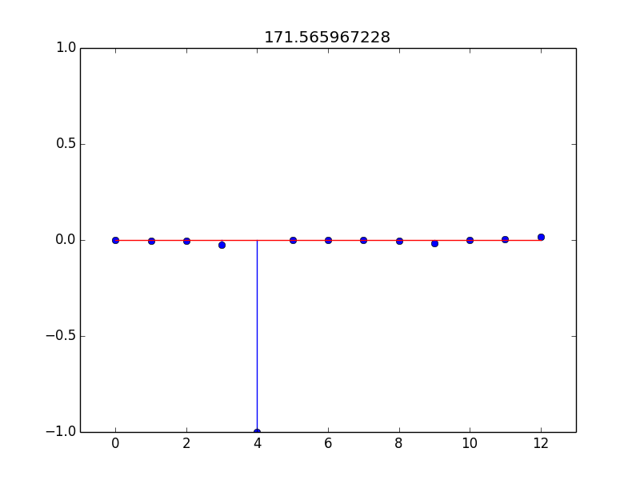

Third eigenvector:

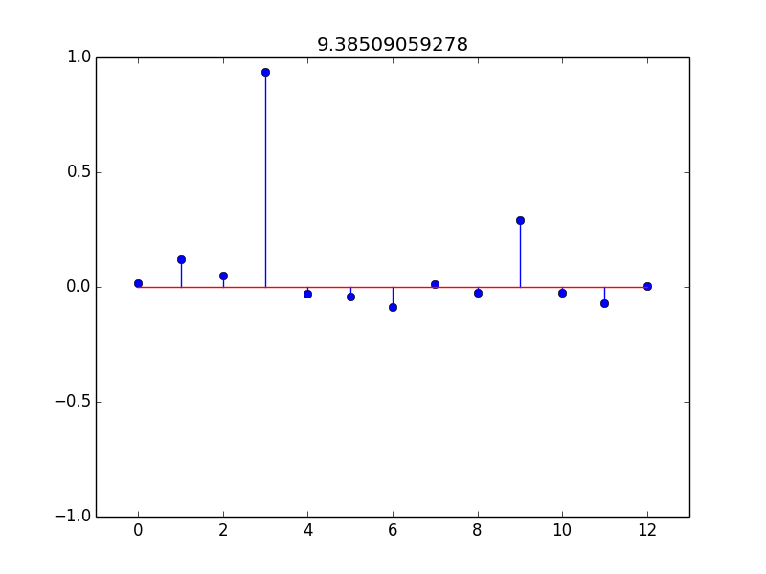

Some of the features contribute greatly to the eigenvectors, some of them don’t.

3.