1. 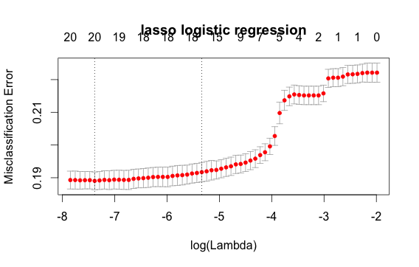

Regularization Lambda: 0.000621080

Accuracy: 0.8076667

1. 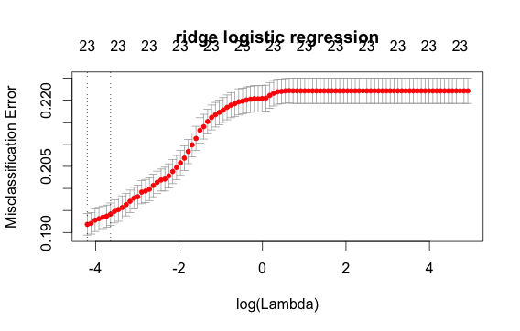

Regularization Lambda: 0.0150309

Accuracy: 0.8048333

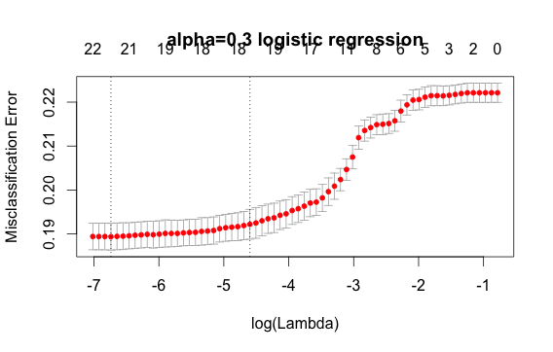

1. Alpha: 0.3

Regularization Lambda: 0.00118468

Accuracy: 0.8075

1. 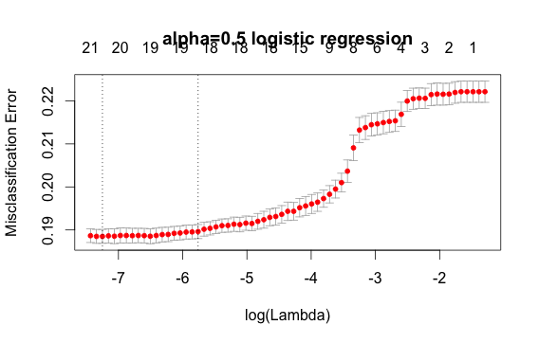

Alpha: 0.5

Regularization Lambda: 0.000710809

Accuracy: 0.8076667

1. 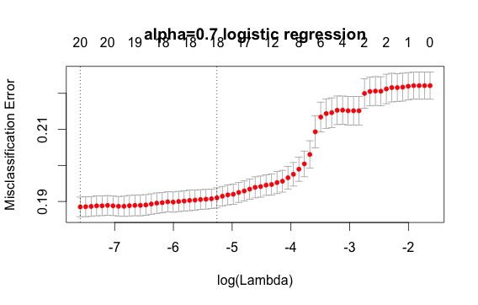

Alpha: 0.7

Regularization Lambda: 0.0005077212

Accuracy: 0.8075