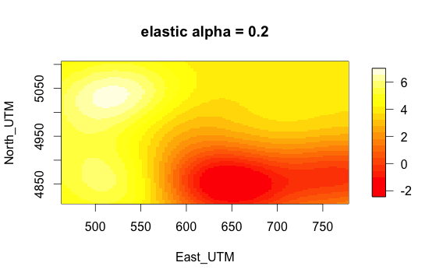

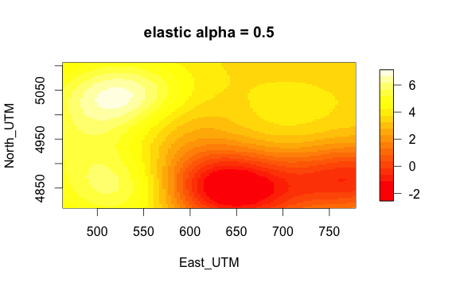

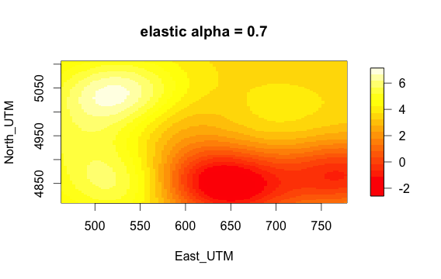

Some not very influential bases with small alpha value would become less obvious on the plot. For e.g. alpha=0.5 and alpha=0.7 have a base point on the right top corner, whereas we cannot see that base point with alpha = 0.2.