### **Data Movement**

Data Lakes allow you to import any amount of data that can come in real-time. Data is collected from multiple sources, and moved into the data lake in its original format. This process allows you to scale to data of any size, while saving time of defining data structures, schema, and transformations.

Read more about data lakes on AWS here: <https://aws.amazon.com/big-data/datalakes-and-analytics/><https://aws.amazon.com/big-data/datalakes-and-analytics/what-is-a-data-lake/>

### **Amazon Kinesis**

Amazon Kinesis makes it easy to collect, process, and analyze real-time, streaming data so you can get timely insights and react quickly to new information. Amazon Kinesis offers key capabilities to cost-effectively process streaming data at any scale, along with the flexibility to choose the tools that best suit the requirements of your application. With Amazon Kinesis, you can ingest real-time data such as video, audio, application logs, website clickstreams, and IoT telemetry data for machine learning, analytics, and other applications. Amazon Kinesis enables you to process and analyze data as it arrives and respond instantly instead of having to wait until all your data is collected before the processing can begin.

There are multiple services in the Amazon Kinesis family. For data ingestion, there is Amazon Kinesis Data Streams, Amazon Kinesis Video Streams, and Amazon Kinesis Data Firehose. Read more about Amazon Kinesis here: <https://aws.amazon.com/kinesis/>

To better understand each service please review the diagrams below.

**Amazon Kinesis Video Streams:**

### **Amazon Kinesis Data Streams:**

**Amazon Kinesis Data Firehose:**

### **Amazon API Gateway**

Amazon API Gateway is a fully managed service that makes it easy to create, publish, and maintain secure APIs at scale. APIs are the front door to backend applications and services. API Gateway handles all the tasks involved in accepting and processing up to hundreds of thousands of concurrent API calls, including traffic management, CORS support, authorization and access control, throttling, monitoring, and API version management.

Read more about API Gateway here: <https://aws.amazon.com/api-gateway/>

[Skip to main content](https://courses.edx.org/xblock/block-v1:AWS+AWS-AWS-OTP-AWSD14+3T2020+type@vertical+block@5f56eae9b7744e4baa5c491913d16f21?show_title=0&show_bookmark_button=0#main)

### **Apache Hadoop on AWS**

Apache Hadoop is an open source framework that is used to efficiently store and process large datasets ranging in size from gigabytes to petabytes of data. Instead of using one large computer to store and process the data, Hadoop allows clustering multiple computers to analyze massive datasets in parallel more quickly.

Read more about Hadoop here: <https://aws.amazon.com/emr/details/hadoop/what-is-hadoop/>

### **Amazon EMR**

Amazon EMR is a managed cluster platform that simplifies running big data frameworks, such as Apache Hadoop and Apache Spark, on AWS to process and analyze vast amounts of data. By using these frameworks and related open-source projects, such as Apache Hive and Apache Pig, you can process data for analytics purposes and business intelligence workloads. Additionally, you can use Amazon EMR to transform and move large amounts of data into and out of other AWS data stores and databases, such as Amazon Simple Storage Service (Amazon S3) and Amazon DynamoDB.

Read more about Amazon EMR here: <https://docs.aws.amazon.com/emr/latest/ManagementGuide/emr-what-is-emr.html>

### **AWS Glue Jobs**

A job is the business logic that performs the extract, transform, and load (ETL) work in AWS Glue. When you start a job, AWS Glue runs a script that extracts data from sources, transforms the data, and loads it into targets. You can create jobs in the ETL section of the AWS Glue console.

Read more about authoring AWS Glue jobs here: <https://docs.aws.amazon.com/glue/latest/dg/author-job.html>

### **AWS Lambda**

AWS Lambda is a compute service that lets you run code without provisioning or managing servers. AWS Lambda runs your code only when needed and scales automatically, from a few requests per day to thousands per second. You pay only for the compute time you consume - there is no charge when your code is not running. With AWS Lambda, you can run code for virtually any type of application or backend service - all with zero administration. AWS Lambda runs your code on a high-availability compute infrastructure and performs all of the administration of the compute resources, including server and operating system maintenance, capacity provisioning and automatic scaling, code monitoring and logging.

When using AWS Lambda, you are responsible only for your code. AWS Lambda manages the compute fleet that offers a balance of memory, CPU, network, and other resources. This can be helpful when processing incoming data for your data lake being hosted on AWS.

Read more about AWS Lambda here: <https://docs.aws.amazon.com/lambda/latest/dg/welcome.html>

### **Amazon Athena**

Amazon Athena is an interactive query service that makes it easy to analyze data directly in Amazon Simple Storage Service (Amazon S3) using standard SQL. With a few actions in the AWS Management Console, you can point Athena at your data stored in Amazon S3 and begin using standard SQL to run ad-hoc queries and get results in seconds.

Read more about Athena here: <https://docs.aws.amazon.com/athena/latest/ug/what-is.html>

### **Amazon RedShift**

Amazon Redshift makes it simple and cost effective to run high performance queries on petabytes of structured data so that you can build powerful reports and dashboards using your existing business intelligence tools.

Read more about Amazon RedShift here: <https://aws.amazon.com/redshift/?whats-new-cards.sort-by=item.additionalFields.postDateTime&whats-new-cards.sort-order=desc>

### **Amazon Kinesis Data Analytics**

With Amazon Kinesis Data Analytics for SQL Applications, you can process and analyze streaming data using standard SQL. The service enables you to quickly author and run powerful SQL code against streaming sources to perform time series analytics, feed real-time dashboards, and create real-time metrics.

To get started with Kinesis Data Analytics, you create a Kinesis data analytics application that continuously reads and processes streaming data. The service supports ingesting data from Amazon Kinesis Data Streams and Amazon Kinesis Data Firehose streaming sources. Then, you author your SQL code using the interactive editor and test it with live streaming data. You can also configure destinations where you want Kinesis Data Analytics to send the results. Kinesis Data Analytics supports Amazon Kinesis Data Firehose (Amazon S3, Amazon Redshift, Amazon Elasticsearch Service, and Splunk), AWS Lambda, and Amazon Kinesis Data Streams as destinations.

Read more about Amazon Kinesis Data Analytics here: <https://docs.aws.amazon.com/kinesisanalytics/latest/dev/what-is.html>

### **Amazon Elasticsearch Service**

Amazon Elasticsearch Service (Amazon ES) is a managed service that makes it easy to deploy, operate, and scale Elasticsearch clusters in the AWS Cloud. Elasticsearch is a popular open-source search and analytics engine for use cases such as log analytics, real-time application monitoring, and clickstream analysis. With Amazon ES, you get direct access to the Elasticsearch APIs; existing code and applications work seamlessly with the service.

Read more about Amazon ES here: <https://docs.aws.amazon.com/elasticsearch-service/latest/developerguide/what-is-amazon-elasticsearch-service.html>

[Skip to main content](https://courses.edx.org/xblock/block-v1:AWS+AWS-AWS-OTP-AWSD14+3T2020+type@vertical+block@e0fe4ca8861948938c079b810dbe6c6a?show_title=0&show_bookmark_button=0#main)

### **AWS Lake Formation**

AWS Lake Formation makes it easier for you to build, secure, and manage data lakes. Lake Formation helps you do the following, either directly or through other AWS services:

* Register the Amazon Simple Storage Service (Amazon S3) buckets and paths where your data lake will reside.
* Orchestrate data flows that ingest, cleanse, transform, and organize the raw data.
* Create and manage a Data Catalog containing metadata about data sources and data in the data lake.
* Define granular data access policies to the metadata and data through a grant/revoke permissions model.

The following diagram illustrates how data is loaded and secured in Lake Formation.

As the diagram shows, Lake Formation manages AWS Glue crawlers, AWS Glue ETL jobs, the Data Catalog, security settings, and access control. After the data is securely stored in the data lake, users can access the data through their choice of analytics services, including Amazon Athena, Amazon Redshift, and Amazon EMR.

Read more about Amazon Lake Formation here: <https://docs.aws.amazon.com/lake-formation/latest/dg/what-is-lake-formation.html>

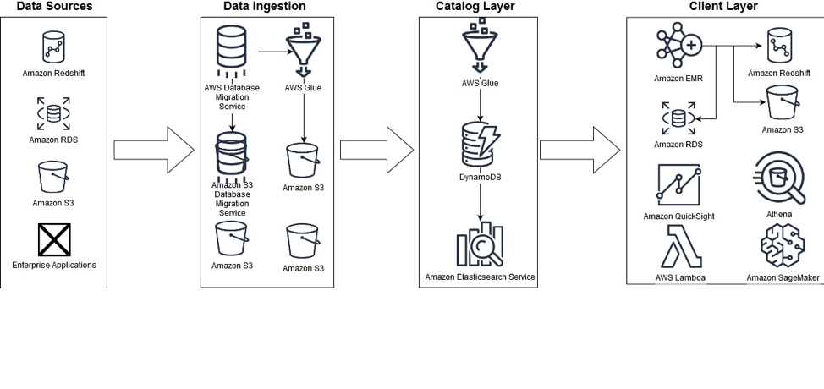

### **Ingestion layer**

The ingestion layer is responsible for bringing data into the data lake. It provides the ability to connect to internal and external data sources over a variety of protocols. It can ingest batch and streaming data into the storage layer. The ingestion layer is also responsible for delivering ingested data to a diverse set of targets in the data storage layer (including the object store, databases, and warehouses).

### **Storage layer**

The storage layer is responsible for providing durable, scalable, secure, and cost-effective components to store vast quantities of data. It supports storing unstructured data and datasets of a variety of structures and formats. It supports storing source data as-is without first needing to structure it to conform to a target schema or format. Components from all other layers provide easy and native integration with the storage layer. To store data based on its consumption readiness for different personas across organization, the storage layer is organized into the following zones:

* **Landing zone** – The storage area where components from the ingestion layer land data. This is a transient area where data is ingested from sources as-is. Typically, data engineering personas interact with the data stored in this zone.
* **Raw zone** – After the preliminary quality checks, the data from the landing zone is moved to the raw zone for permanent storage. Here, data is stored in its original format. Having all data from all sources permanently stored in the raw zone provides the ability to “replay” downstream data processing in case of errors or data loss in downstream storage zones. Typically, data engineering and data science personas interact with the data stored in this zone.
* **Curated zone** – This zone hosts data that is in the most consumption-ready state and conforms to organizational standards and data models. Datasets in the curated zone are typically partitioned, cataloged, and stored in formats that support performant and cost-effective access by the consumption layer. The processing layer creates datasets in the curated zone after cleaning, normalizing, standardizing, and enriching data from the raw zone. All personas across organizations use the data stored in this zone to drive business decisions.

### **Cataloging and search layer**

The cataloging and search layer is responsible for storing business and technical metadata about datasets hosted in the storage layer. It provides the ability to track schema and the granular partitioning of dataset information in the lake. It also supports mechanisms to track versions to keep track of changes to the metadata. As the number of datasets in the data lake grows, this layer makes datasets in the data lake discoverable by providing search capabilities.

### **Processing layer**

The processing layer is responsible for transforming data into a consumable state through data validation, cleanup, normalization, transformation, and enrichment. It’s responsible for advancing the consumption readiness of datasets along the landing, raw, and curated zones and registering metadata for the raw and transformed data into the cataloging layer. The processing layer is composed of purpose-built data-processing components to match the right dataset characteristic and processing task at hand. The processing layer can handle large data volumes and support schema-on-read, partitioned data, and diverse data formats. The processing layer also provides the ability to build and orchestrate multi-step data processing pipelines that use purpose-built components for each step.

### **Consumption layer**

The consumption layer is responsible for providing scalable and performant tools to gain insights from the vast amount of data in the data lake. It democratizes analytics across all personas across the organization through several purpose-built analytics tools that support analysis methods, including SQL, batch analytics, BI dashboards, reporting, and ML. The consumption layer natively integrates with the data lake’s storage, cataloging, and security layers. Components in the consumption layer support schema-on-read, a variety of data structures and formats, and use data partitioning for cost and performance optimization.

### **Security and governance layer**

The security and governance layer is responsible for protecting the data in the storage layer and processing resources in all other layers. It provides mechanisms for access control, encryption, network protection, usage monitoring, and auditing. The security layer also monitors activities of all components in other layers and generates a detailed audit trail. Components of all other layers provide native integration with the security and governance layer.

## **Serverless data lake centric analytics architecture**

To compose the layers described in our logical architecture, we introduce a reference architecture that uses AWS serverless and managed services. In this approach, AWS services take over the heavy lifting of the following:

* Providing and managing scalable, resilient, secure, and cost-effective infrastructural components
* Ensuring infrastructural components natively integrate with each other

This reference architecture allows you to focus more time on rapidly building data and analytics pipelines. It significantly accelerates new data onboarding and driving insights from your data. The AWS serverless and managed components enable self-service across all data consumer roles by providing the following key benefits:

* Easy configuration-driven use
* Freedom from infrastructure management
* Pay-per-use pricing model

The following diagram illustrates this architecture.

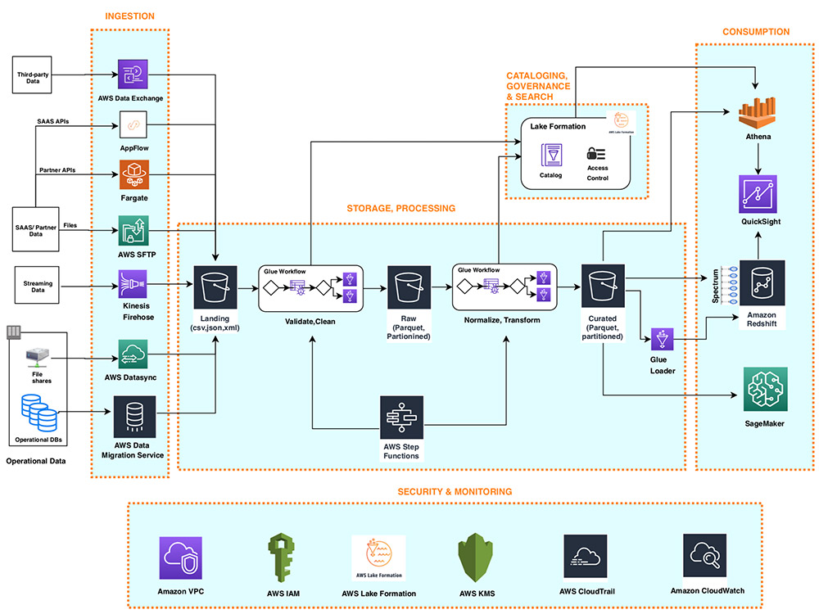

## **Ingestion layer**

The ingestion layer in our serverless architecture is composed of a set of purpose-built AWS services to enable data ingestion from a variety of sources. Each of these services enables simple self-service data ingestion into the data lake landing zone and provides integration with other AWS services in the storage and security layers. Individual purpose-built AWS services match the unique connectivity, data format, data structure, and data velocity requirements of operational database sources, streaming data sources, and file sources.

### **Operational database sources**

Typically, organizations store their operational data in various relational and NoSQL databases. AWS Data Migration Service (AWS DMS) can connect to a variety of operational RDBMS and NoSQL databases and ingest their data into Amazon Simple Storage Service (Amazon S3) buckets in the data lake landing zone. With AWS DMS, you can first perform a one-time import of the source data into the data lake and replicate ongoing changes happening in the source database. AWS DMS encrypts S3 objects using AWS Key Management Service (AWS KMS) keys as it stores them in the data lake. AWS DMS is a fully managed, resilient service and provides a wide choice of instance sizes to host database replication tasks.

AWS Lake Formation provides a scalable, serverless alternative, called blueprints, to ingest data from AWS native or on-premises database sources into the landing zone in the data lake. A Lake Formation blueprint is a predefined template that generates a data ingestion AWS Glue workflow based on input parameters such as source database, target Amazon S3 location, target dataset format, target dataset partitioning columns, and schedule. A blueprint-generated AWS Glue workflow implements an optimized and parallelized data ingestion pipeline consisting of crawlers, multiple parallel jobs, and triggers connecting them based on conditions. For more information, see Integrating AWS Lake Formation with Amazon RDS for SQL Server.

### **Streaming data sources**

The ingestion layer uses Amazon Kinesis Data Firehose to receive streaming data from internal and external sources. With a few clicks, you can configure a Kinesis Data Firehose API endpoint where sources can send streaming data such as clickstreams, application and infrastructure logs and monitoring metrics, and IoT data such as devices telemetry and sensor readings. Kinesis Data Firehose does the following:

* Buffers incoming streams
* Batches, compresses, transforms, and encrypts the streams
* Stores the streams as S3 objects in the landing zone in the data lake

Kinesis Data Firehose natively integrates with the security and storage layers and can deliver data to Amazon S3, Amazon Redshift, and Amazon Elasticsearch Service (Amazon ES) for real-time analytics use cases. Kinesis Data Firehose is serverless, requires no administration, and has a cost model where you pay only for the volume of data you transmit and process through the service. Kinesis Data Firehose automatically scales to adjust to the volume and throughput of incoming data.

### **File sources**

Many applications store structured and unstructured data in files that are hosted on Network Attached Storage (NAS) arrays. Organizations also receive data files from partners and third-party vendors. Analyzing data from these file sources can provide valuable business insights.

#### **Internal file shares**

AWS DataSync can ingest hundreds of terabytes and millions of files from NFS and SMB enabled NAS devices into the data lake landing zone. DataSync automatically handles scripting of copy jobs, scheduling and monitoring transfers, validating data integrity, and optimizing network utilization. DataSync can perform one-time file transfers and monitor and sync changed files into the data lake. DataSync is fully managed and can be set up in minutes.

#### **Partner data files**

FTP is most common method for exchanging data files with partners. The AWS Transfer Family is a serverless, highly available, and scalable service that supports secure FTP endpoints and natively integrates with Amazon S3. Partners and vendors transmit files using SFTP protocol, and the AWS Transfer Family stores them as S3 objects in the landing zone in the data lake. The AWS Transfer Family supports encryption using AWS KMS and common authentication methods including AWS Identity and Access Management (IAM) and Active Directory.

### **Data APIs**

Organizations today use SaaS and partner applications such as Salesforce, Marketo, and Google Analytics to support their business operations. Analyzing SaaS and partner data in combination with internal operational application data is critical to gaining 360-degree business insights. Partner and SaaS applications often provide API endpoints to share data.

#### **SaaS APIs**

The ingestion layer uses AWS AppFlow to easily ingest SaaS applications data into the data lake. With a few clicks, you can set up serverless data ingestion flows in AppFlow. Your flows can connect to SaaS applications (such as SalesForce, Marketo, and Google Analytics), ingest data, and store it in the data lake. You can schedule AppFlow data ingestion flows or trigger them by events in the SaaS application. Ingested data can be validated, filtered, mapped and masked before storing in the data lake. AppFlow natively integrates with authentication, authorization, and encryption services in the security and governance layer.

#### **Partner APIs**

To ingest data from partner and third-party APIs, organizations build or purchase custom applications that connect to APIs, fetch data, and create S3 objects in the landing zone by using AWS SDKs. These applications and their dependencies can be packaged into Docker containers and hosted on AWS Fargate. Fargate is a serverless compute engine for hosting Docker containers without having to provision, manage, and scale servers. Fargate natively integrates with AWS security and monitoring services to provide encryption, authorization, network isolation, logging, and monitoring to the application containers.

AWS Glue Python shell jobs also provide serverless alternative to build and schedule data ingestion jobs that can interact with partner APIs by using native, open-source, or partner-provided Python libraries. AWS Glue provides out-of-the-box capabilities to schedule singular Python shell jobs or include them as part of a more complex data ingestion workflow built on AWS Glue workflows.

### **Third-party data sources**

Your organization can gain a business edge by combining your internal data with third-party datasets such as historical demographics, weather data, and consumer behavior data. AWS Data Exchange provides a serverless way to find, subscribe to, and ingest third-party data directly into S3 buckets in the data lake landing zone. You can ingest a full third-party dataset and then automate detecting and ingesting revisions to that dataset. AWS Data Exchange is serverless and lets you find and ingest third-party datasets with a few clicks.

## **Storage layer**

Amazon S3 provides the foundation for the storage layer in our architecture. Amazon S3 provides virtually unlimited scalability at low cost for our serverless data lake. Data is stored as S3 objects organized into landing, raw, and curated zone buckets and prefixes. Amazon S3 encrypts data using keys managed in AWS KMS. IAM policies control granular zone-level and dataset-level access to various users and roles. Amazon S3 provides 99.99 % of availability and 99.999999999 % of durability, and charges only for the data it stores. To significantly reduce costs, Amazon S3 provides colder tier storage options called Amazon S3 Glacier and S3 Glacier Deep Archive. To automate cost optimizations, Amazon S3 provides configurable lifecycle policies and intelligent tiering options to automate moving older data to colder tiers. AWS services in our ingestion, cataloging, processing, and consumption layers can natively read and write S3 objects. Additionally, hundreds of third-party vendor and open-source products and services provide the ability to read and write S3 objects.

Data of any structure (including unstructured data) and any format can be stored as S3 objects without needing to predefine any schema. This enables services in the ingestion layer to quickly land a variety of source data into the data lake in its original source format. After the data is ingested into the data lake, components in the processing layer can define schema on top of S3 datasets and register them in the cataloging layer. Services in the processing and consumption layers can then use schema-on-read to apply the required structure to data read from S3 objects. Datasets stored in Amazon S3 are often partitioned to enable efficient filtering by services in the processing and consumption layers.

## **Cataloging and search layer**

A data lake typically hosts a large number of datasets, and many of these datasets have evolving schema and new data partitions. A central Data Catalog that manages metadata for all the datasets in the data lake is crucial to enabling self-service discovery of data in the data lake. Additionally, separating metadata from data into a central schema enables schema-on-read for the processing and consumption layer components.

In our architecture, Lake Formation provides the central catalog to store and manage metadata for all datasets hosted in the data lake. Organizations manage both technical metadata (such as versioned table schemas, partitioning information, physical data location, and update timestamps) and business attributes (such as data owner, data steward, column business definition, and column information sensitivity) of all their datasets in Lake Formation. Services such as AWS Glue, Amazon EMR, and Amazon Athena natively integrate with Lake Formation and automate discovering and registering dataset metadata into the Lake Formation catalog. Additionally, Lake Formation provides APIs to enable metadata registration and management using custom scripts and third-party products. AWS Glue crawlers in the processing layer can track evolving schemas and newly added partitions of datasets in the data lake, and add new versions of corresponding metadata in the Lake Formation catalog.

Lake Formation provides the data lake administrator a central place to set up granular table- and column-level permissions for databases and tables hosted in the data lake. After Lake Formation permissions are set up, users and groups can access only authorized tables and columns using multiple processing and consumption layer services such as Athena, Amazon EMR, AWS Glue, and Amazon Redshift Spectrum.

## **Processing layer**

The processing layer in our architecture is composed of two types of components:

* Components used to create multi-step data processing pipelines
* Components to orchestrate data processing pipelines on schedule or in response to event triggers (such as ingestion of new data into the landing zone)

AWS Glue and AWS Step Functions provide serverless components to build, orchestrate, and run pipelines that can easily scale to process large data volumes. Multi-step workflows built using AWS Glue and Step Functions can catalog, validate, clean, transform, and enrich individual datasets and advance them from landing to raw and raw to curated zones in the storage layer.

AWS Glue is a serverless, pay-per-use ETL service for building and running Python or Spark jobs (written in Scala or Python) without requiring you to deploy or manage clusters. AWS Glue automatically generates the code to accelerate your data transformations and loading processes. AWS Glue ETL builds on top of Apache Spark and provides commonly used out-of-the-box data source connectors, data structures, and ETL transformations to validate, clean, transform, and flatten data stored in many open-source formats such as CSV, JSON, Parquet, and Avro. AWS Glue ETL also provides capabilities to incrementally process partitioned data.

Additionally, you can use AWS Glue to define and run crawlers that can crawl folders in the data lake, discover datasets and their partitions, infer schema, and define tables in the Lake Formation catalog. AWS Glue provides more than a dozen built-in classifiers that can parse a variety of data structures stored in open-source formats. AWS Glue also provides triggers and workflow capabilities that you can use to build multi-step end-to-end data processing pipelines that include job dependencies and running parallel steps. You can schedule AWS Glue jobs and workflows or run them on demand. AWS Glue natively integrates with AWS services in storage, catalog, and security layers.

Step Functions is a serverless engine that you can use to build and orchestrate scheduled or event-driven data processing workflows. You use Step Functions to build complex data processing pipelines that involve orchestrating steps implemented by using multiple AWS services such as AWS Glue, AWS Lambda, Amazon Elastic Container Service (Amazon ECS) containers, and more. Step Functions provides visual representations of complex workflows and their running state to make them easy to understand. It manages state, checkpoints, and restarts of the workflow for you to make sure that the steps in your data pipeline run in order and as expected. Built-in try/catch, retry, and rollback capabilities deal with errors and exceptions automatically.

## **Consumption layer**

The consumption layer in our architecture is composed using fully managed, purpose-built, analytics services that enable interactive SQL, BI dashboarding, batch processing, and ML.

### **Interactive SQL**

Athena is an interactive query service that enables you to run complex ANSI SQL against terabytes of data stored in Amazon S3 without needing to first load it into a database. Athena queries can analyze structured, semi-structured, and columnar data stored in open-source formats such as CSV, JSON, XML Avro, Parquet, and ORC. Athena uses table definitions from Lake Formation to apply schema-on-read to data read from Amazon S3.

Athena is serverless, so there is no infrastructure to set up or manage, and you pay only for the amount of data scanned by the queries you run. Athena provides faster results and lower costs by reducing the amount of data it scans by using dataset partitioning information stored in the Lake Formation catalog. You can run queries directly on the Athena console of submit them using Athena JDBC or ODBC endpoints.

Athena natively integrates with AWS services in the security and monitoring layer to support authentication, authorization, encryption, logging, and monitoring. It supports table- and column-level access controls defined in the Lake Formation catalog.

### **Data warehousing and batch analytics**

Amazon Redshift is a fully managed data warehouse service that can host and process petabytes of data and run thousands highly performant queries in parallel. Amazon Redshift uses a cluster of compute nodes to run very low-latency queries to power interactive dashboards and high-throughput batch analytics to drive business decisions. You can run Amazon Redshift queries directly on the Amazon Redshift console or submit them using the JDBC/ODBC endpoints provided by Amazon Redshift.

Amazon Redshift provides the capability, called Amazon Redshift Spectrum, to perform in-place queries on structured and semi-structured datasets in Amazon S3 without needing to load it into the cluster. Amazon Redshift Spectrum can spin up thousands of query-specific temporary nodes to scan exabytes of data to deliver fast results. Organizations typically load most frequently accessed dimension and fact data into an Amazon Redshift cluster and keep up to exabytes of structured, semi-structured, and unstructured historical data in Amazon S3. Amazon Redshift Spectrum enables running complex queries that combine data in a cluster with data on Amazon S3 in the same query.

Amazon Redshift provides native integration with Amazon S3 in the storage layer, Lake Formation catalog, and AWS services in the security and monitoring layer.

### **Business intelligence**

Amazon QuickSight provides a serverless BI capability to easily create and publish rich, interactive dashboards. QuickSight enriches dashboards and visuals with out-of-the-box, automatically generated ML insights such as forecasting, anomaly detection, and narrative highlights. QuickSight natively integrates with Amazon SageMaker to enable additional custom ML model-based insights to your BI dashboards. You can access QuickSight dashboards from any device using a QuickSight app, or you can embed the dashboard into web applications, portals, and websites.

QuickSight allows you to directly connect to and import data from a wide variety of cloud and on-premises data sources. These include SaaS applications such as Salesforce, Square, ServiceNow, Twitter, GitHub, and JIRA; third-party databases such as Teradata, MySQL, Postgres, and SQL Server; native AWS services such as Amazon Redshift, Athena, Amazon S3, Amazon Relational Database Service (Amazon RDS), and Amazon Aurora; and private VPC subnets. You can also upload a variety of file types including XLS, CSV, JSON, and Presto.

To achieve blazing fast performance for dashboards, QuickSight provides an in-memory caching and calculation engine called SPICE. SPICE automatically replicates data for high availability and enables thousands of users to simultaneously perform fast, interactive analysis while shielding your underlying data infrastructure. QuickSight automatically scales to tens of thousands of users and provides a cost-effective, pay-per-session pricing model.

QuickSight allows you to securely manage your users and content via a comprehensive set of security features, including role-based access control, active directory integration, AWS CloudTrail auditing, single sign-on (IAM or third-party), private VPC subnets, and data backup.

### **Predictive analytics and ML**

Amazon SageMaker is a fully managed service that provides components to build, train, and deploy ML models using an interactive development environment (IDE) called Amazon SageMaker Studio. In Amazon SageMaker Studio, you can upload data, create new notebooks, train and tune models, move back and forth between steps to adjust experiments, compare results, and deploy models to production, all in one place by using a unified visual interface. Amazon SageMaker also provides managed Jupyter notebooks that you can spin up with just a few clicks. Amazon SageMaker notebooks provide elastic compute resources, git integration, easy sharing, pre-configured ML algorithms, dozens of out-of-the-box ML examples, and AWS Marketplace integration, which enables easy deployment of hundreds of pre-trained algorithms. Amazon SageMaker notebooks are preconfigured with all major deep learning frameworks, including TensorFlow, PyTorch, Apache MXNet, Chainer, Keras, Gluon, Horovod, Scikit-learn, and Deep Graph Library.

ML models are trained on Amazon SageMaker managed compute instances, including highly cost-effective Amazon Elastic Compute Cloud (Amazon EC2) Spot Instances. You can organize multiple training jobs by using Amazon SageMaker Experiments. You can build training jobs using Amazon SageMaker built-in algorithms, your custom algorithms, or hundreds of algorithms you can deploy from AWS Marketplace. Amazon SageMaker Debugger provides full visibility into model training jobs. Amazon SageMaker also provides automatic hyperparameter tuning for ML training jobs.

You can deploy Amazon SageMaker trained models into production with a few clicks and easily scale them across a fleet of fully managed EC2 instances. You can choose from multiple EC2 instance types and attach cost-effective GPU-powered inference acceleration. After the models are deployed, Amazon SageMaker can monitor key model metrics for inference accuracy and detect any concept drift.

Amazon SageMaker provides native integrations with AWS services in the storage and security layers.

## **Security and governance layer**

Components across all layers of our architecture protect data, identities, and processing resources by natively using the following capabilities provided by the security and governance layer.

### **Authentication and authorization**

IAM provides user-, group-, and role-level identity to users and the ability to configure fine-grained access control for resources managed by AWS services in all layers of our architecture. IAM supports multi-factor authentication and single sign-on through integrations with corporate directories and open identity providers such as Google, Facebook, and Amazon.

Lake Formation provides a simple and centralized authorization model for tables hosted in the data lake. After implemented in Lake Formation, authorization policies for databases and tables are enforced by other AWS services such as Athena, Amazon EMR, QuickSight, and Amazon Redshift Spectrum. In Lake Formation, you can grant or revoke database-, table-, or column-level access for IAM users, groups, or roles defined in the same account hosting the Lake Formation catalog or another AWS account. The simple grant/revoke-based authorization model of Lake Formation considerably simplifies the previous IAM-based authorization model that relied on separately securing S3 data objects and metadata objects in the AWS Glue Data Catalog.

### **Encryption**

AWS KMS provides the capability to create and manage symmetric and asymmetric customer-managed encryption keys. AWS services in all layers of our architecture natively integrate with AWS KMS to encrypt data in the data lake. It supports both creating new keys and importing existing customer keys. Access to the encryption keys is controlled using IAM and is monitored through detailed audit trails in CloudTrail.

### **Network protection**

Our architecture uses Amazon Virtual Private Cloud (Amazon VPC) to provision a logically isolated section of the AWS Cloud (called VPC) that is isolated from the internet and other AWS customers. AWS VPC provides the ability to choose your own IP address range, create subnets, and configure route tables and network gateways. AWS services from other layers in our architecture launch resources in this private VPC to protect all traffic to and from these resources.

### **Monitoring and logging**

AWS services in all layers of our architecture store detailed logs and monitoring metrics in AWS CloudWatch. CloudWatch provides the ability to analyze logs, visualize monitored metrics, define monitoring thresholds, and send alerts when thresholds are crossed.

All AWS services in our architecture also store extensive audit trails of user and service actions in CloudTrail. CloudTrail provides event history of your AWS account activity, including actions taken through the AWS Management Console, AWS SDKs, command line tools, and other AWS services. This event history simplifies security analysis, resource change tracking, and troubleshooting. In addition, you can use CloudTrail to detect unusual activity in your AWS accounts. These capabilities help simplify operational analysis and troubleshooting.

## **Additional considerations**

In this post, we talked about ingesting data from diverse sources and storing it as S3 objects in the data lake and then using AWS Glue to process ingested datasets until they’re in a consumable state. This architecture enables use cases needing source-to-consumption latency of a few minutes to hours. In a future post, we will evolve our serverless analytics architecture to add a speed layer to enable use cases that require source-to-consumption latency in seconds, all while aligning with the layered logical architecture we introduced.

## **Conclusion**

With AWS serverless and managed services, you can build a modern, low-cost data lake centric analytics architecture in days. A decoupled, component-driven architecture allows you to start small and quickly add new purpose-built components to one of six architecture layers to address new requirements and data sources.

We invite you to read the following posts that contain detailed walkthroughs and sample code for building the components of the serverless data lake centric analytics architecture:

## **Creating your CodeCommit repository**

Create your CodeCommit repository by running a create-repository command in the AWS CLI:

aws codecommit create-repository --repository-name cfn-guard-demo --repository-description "seed"

The following screenshot indicates that the repository has been created.

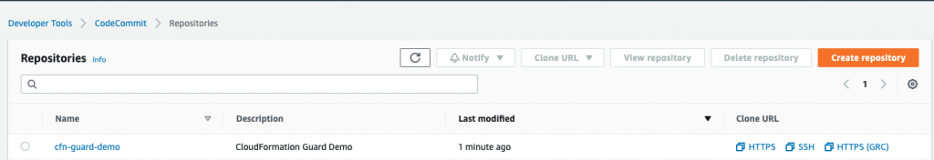

*CodeCommit Repository has been created*

### **Populating the CodeCommit repository**

Populate your repository with the following artifacts:

1. A buildspec.yml file. Modify the following code as per your requirements:

version: 0.2env: variables: # Definining CloudFormation Teamplate and Ruleset as variables - part of the code repo CF_TEMPLATE: "cfn_template_file_example.yaml" CF_ORG_RULESET: "cfn_guard_ruleset_example"phases: install: commands: - apt-get update - apt-get install build-essential -y - apt-get install cargo -y - apt-get install git -y pre_build: commands: - echo "Setting up the environment for AWS CloudFormation Guard" - echo "More info <https://github.com/aws-cloudformation/cloudformation-guard>" - echo "Install Rust" - curl <https://sh.rustup.rs> -sSf | sh -s -- -y build: commands: - echo "Pull GA release from github" - echo "More info <https://github.com/aws-cloudformation/cloudformation-guard/releases>" - wget <https://github.com/aws-cloudformation/cloudformation-guard/releases/download/1.0.0/cfn-guard-linux-1.0.0.tar.gz> - echo "Extract cfn-guard" - tar xvf cfn-guard-linux-1.0.0.tar.gz . post_build: commands: - echo "Validate CloudFormation template with cfn-guard tool" - echo "More information <https://github.com/aws-cloudformation/cloudformation-guard/blob/master/cfn-guard/README.md>" - cfn-guard-linux/cfn-guard check --rule_set $CF_ORG_RULESET --template $CF_TEMPLATE --strict-checksartifacts: files: - cfn_template_file_example.yaml name: guard_templates

1. An example of a [rule set](https://github.com/aws-cloudformation/cloudformation-guard/blob/master/cfn-guard/README.md) file (cfn_guard_ruleset_example) for CloudFormation Guard. Modify the following code as per your requirements:

#CFN Guard rules set example#List of multiple referenceslet allowed_azs = [us-east-1a,us-east-1b]let allowed_ec2_instance_types = [t2.micro,t3.nano,t3.micro]let allowed_security_groups = [sg-08bbcxxc21e9ba8e6,sg-07b8bx98795dcab2]#EC2 PoliciesAWS::EC2::Instance AvailabilityZone IN %allowed_azsAWS::EC2::Instance ImageId == ami-0323c3dd2da7fb37dAWS::EC2::Instance InstanceType IN %allowed_ec2_instance_typesAWS::EC2::Instance SecurityGroupIds == ["sg-07b8xxxsscab2"]AWS::EC2::Instance SubnetId == subnet-0407a7casssse558#EBS PoliciesAWS::EC2::Volume AvailabilityZone == us-east-1aAWS::EC2::Volume Encrypted == trueAWS::EC2::Volume Size == 50 |OR| AWS::EC2::Volume Size == 100AWS::EC2::Volume VolumeType == gp2

1. An example of a CloudFormation template file (.yaml). Modify the following code as per your requirements:

AWSTemplateFormatVersion: "2010-09-09"Description: "EC2 instance with encrypted EBS volume for AWS CloudFormation Guard Testing"Resources: EC2Instance: Type: AWS::EC2::Instance Properties: ImageId: 'ami-0323c3dd2da7fb37d' AvailabilityZone: 'us-east-1a' KeyName: "your-ssh-key" InstanceType: 't3.micro' SubnetId: 'subnet-0407a7xx68410e558' SecurityGroupIds: - 'sg-07b8b339xx95dcab2' Volumes: - Device: '/dev/sdf' VolumeId: !Ref EBSVolume Tags: - Key: Name Value: cfn-guard-ec2 EBSVolume: Type: AWS::EC2::Volume Properties: Size: 100 AvailabilityZone: 'us-east-1a' Encrypted: true VolumeType: gp2 Tags: - Key: Name Value: cfn-guard-ebs DeletionPolicy: SnapshotOutputs: InstanceID: Description: The Instance ID Value: !Ref EC2Instance Volume: Description: The Volume ID Value: !Ref EBSVolume

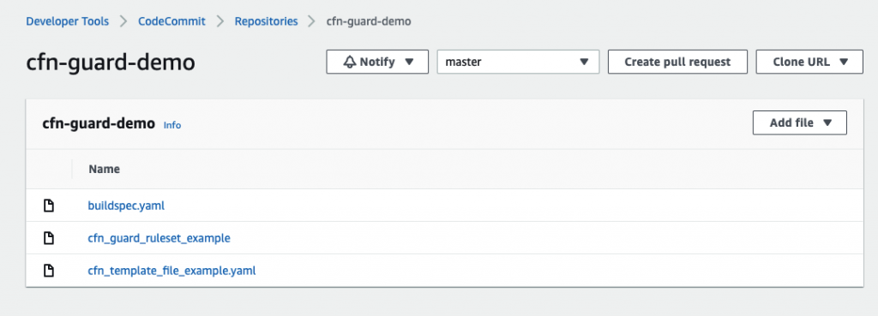

*Optional CodeCommit Repository Structure*

The following screenshot shows a potential CodeCommit repository structure.

## **Creating a CodeBuild project**

Our CodeBuild project orchestrates around CloudFormation Guard and runs validation checks of our CloudFormation templates as a phase of the CI process.

1. On the CodeBuild console, choose **Build projects**.
2. Choose **Create build projects**.
3. For **Project name**, enter your project name.
4. For **Description**, enter a description.

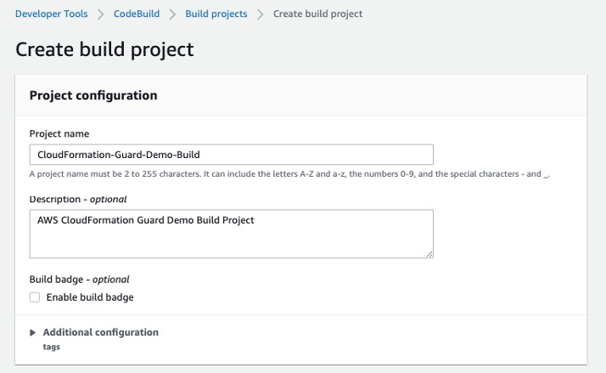

*Create CodeBuild Project*

1. For **Source provider**, choose **AWS CodeCommit**.
2. For **Repository**, choose the CodeCommit repository you created in the previous step.

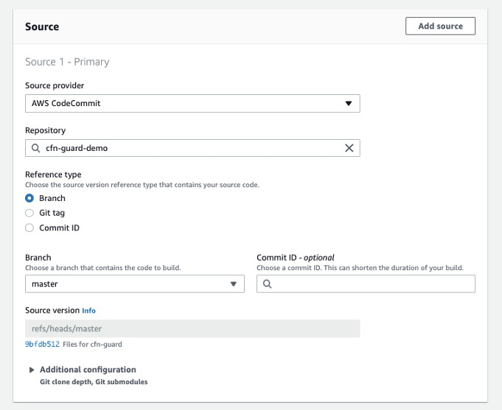

*Define the source for your CodeBuild Project*

To setup CodeBuild environment we will use managed image based on Ubuntu 18.04

1. For **Environment Image**, select **Managed image**.
2. For **Operating system**, choose **Ubuntu**.
3. For **Service role**¸ select **New service role**.
4. For **Role name**, enter your service role name.

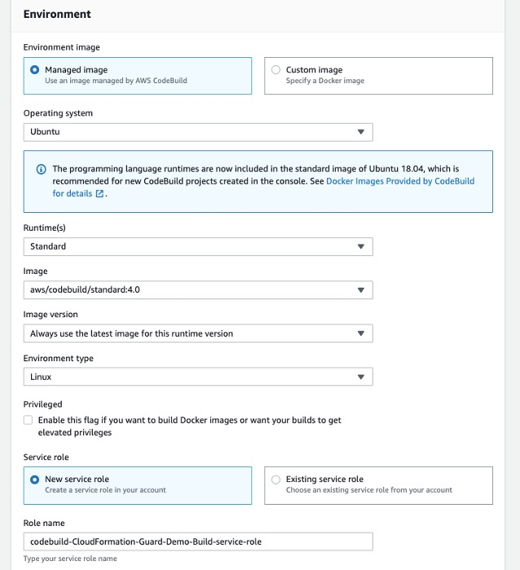

*Setup the environment, the OS image and other settings for the CodeBuild*

1. Leave the default settings for additional configuration, buildspec, batch configuration, artifacts, and logs.

You can also use CodeBuild with [custom build environments](https://aws.amazon.com/blogs/devops/extending-aws-codebuild-with-custom-build-environments/) to help you optimize billing and improve the build time.