Table of Contents

THE LIGHT OF BUDDHA
Volume 1

THE LIGHT OF BUDDHA
30 Timeless Stories of Wisdom, Compassion & Inner Peace
The Light of Buddha — Volume 1
VOLUME ONE
Compiled and Retold by Jaspal Singh

Publication Information
THE LIGHT OF BUDDHA
30 Timeless Stories of Wisdom, Compassion & Inner Peace
The Light of Buddha — Volume 1
Compiled and Retold by Jaspal Singh
English edition. This is a prepublication review edition; the publisher will finalise the imprint, publication date and applicable copyright notice before publication.
These stories are literary retellings of identified Buddhist texts, not transcripts of historical conversations. Descriptive staging, transitions and occasional interior perspectives are imaginative reconstruction. Teaching parables and extraordinary religious narratives are identified in the source notes.
The ancient texts and their modern translations have distinct rights histories. Modern translations remain subject to their respective terms. The English prose and short verse renderings prepared for this collection do not reproduce a modern translator’s extended text. References and acknowledgements appear in the source notes and bibliography.

Dedication
For those who make room for kindness,
and for those learning to begin again.

Introduction: A Light Carried into Ordinary Life
A person pauses before speaking. Someone offers food without asking what the gift will bring in return. A frightened mind learns to stay with the rustle of a forest. These are small movements, yet a life can turn upon them. Buddhist literature returns again and again to such moments: the instant in which habit loosens and another response becomes possible.
The thirty stories in this volume invite that kind of attention. They follow a search for freedom, then carry its questions into conversation, work, conflict, friendship, generosity and loss. Some unfold as encounters between the Buddha and people who came to him. Others draw upon images he used in teaching: a raft, a poisoned arrow, the strings of a lute. A few include gods, visions or extraordinary events. All ask the reader to look closely at suffering and at the ways people might cease adding to it.
Gautama Buddha lived in ancient northern India. Precise dates remain debated. The discourses preserved in the Pali Canon are indispensable witnesses to early Buddhist teaching, but they were transmitted through religious communities before being written down. They are not modern biographies or recordings of conversations. Their authority within Buddhism and their value for historical research are related questions, not identical ones. A canonical story can be spiritually important without every narrative detail being independently recoverable as history.
This volume therefore makes its sources visible. Each story ends with a note naming its principal text and explaining any significant limitation. All thirty selections are drawn from the Pali canonical tradition preserved in Theravada Buddhism. That is a deliberate focus for this first collection, not a claim that this one body of literature contains all Buddhist wisdom. Mahayana, Vajrayana and East Asian traditions preserve profound teachings and rich narrative worlds of their own. They deserve the same care in their own contexts rather than being blended into an imagined single voice.
The first part concerns the search that preceded teaching and the beginning of a community of practice. Its title, “The Prince Who Searched for Truth”, uses the familiar literary description of the Buddha’s early life. Readers should distinguish that inherited princely image from the more restrained autobiographical passages used here. The second part explores the mind’s habits and the discipline of speech. The third turns towards people whose lives, assumptions or aspirations are unsettled by an encounter. The final part brings the teaching towards the conditions no life escapes: pain, change, effort and death.
These are retellings in contemporary literary English. They do not reproduce a modern translation. Sensory description, pacing and some inward responses supply the connective tissue that a short ancient discourse may leave unstated. Such passages are imaginative, even when plausible. The narratives generally use indirect speech so that newly composed dialogue cannot be mistaken for the Buddha’s exact words. A story’s atmosphere belongs to this edition; its textual foundation is identified separately.
Between selected stories, brief Pali passages offer another rhythm of reading. The Roman-letter Pali is already a transliteration of the language; it is not a second, translated version. The accompanying English meanings are new renderings. They aim to be readable while acknowledging that a word such as dhamma, dukkha or nibbana carries more than a single English equivalent. These passages are canonical Theravada verses and a refuge formula. They are not presented as a catalogue of Buddhist mantras, nor as evidence that every later Buddhist liturgy was personally spoken by the historical Buddha.
Each “Wisdom to Remember” gathers a story’s central invitation. The practical reflections are suggestions, not tests of spiritual success. A person may need courage to act, rest to recover, another person’s help, or a boundary that protects them. Gentleness need not mean submission to abuse; patience need not mean refusing necessary change. Reading with compassion includes compassion towards one’s own circumstances.
You may read from beginning to end, or return to a story that meets the shape of a particular day. There is no need to manufacture serenity. Start with what is present: irritation, uncertainty, delight, fatigue. Notice what the story brings into view. Then consider one small action within reach. A teaching becomes more than a beautiful sentence when it changes how we meet the next person, the next difficulty, or the next unguarded moment of our own mind.

PART I: The Prince Who Searched for Truth

01. The Search No Teacher Could Finish
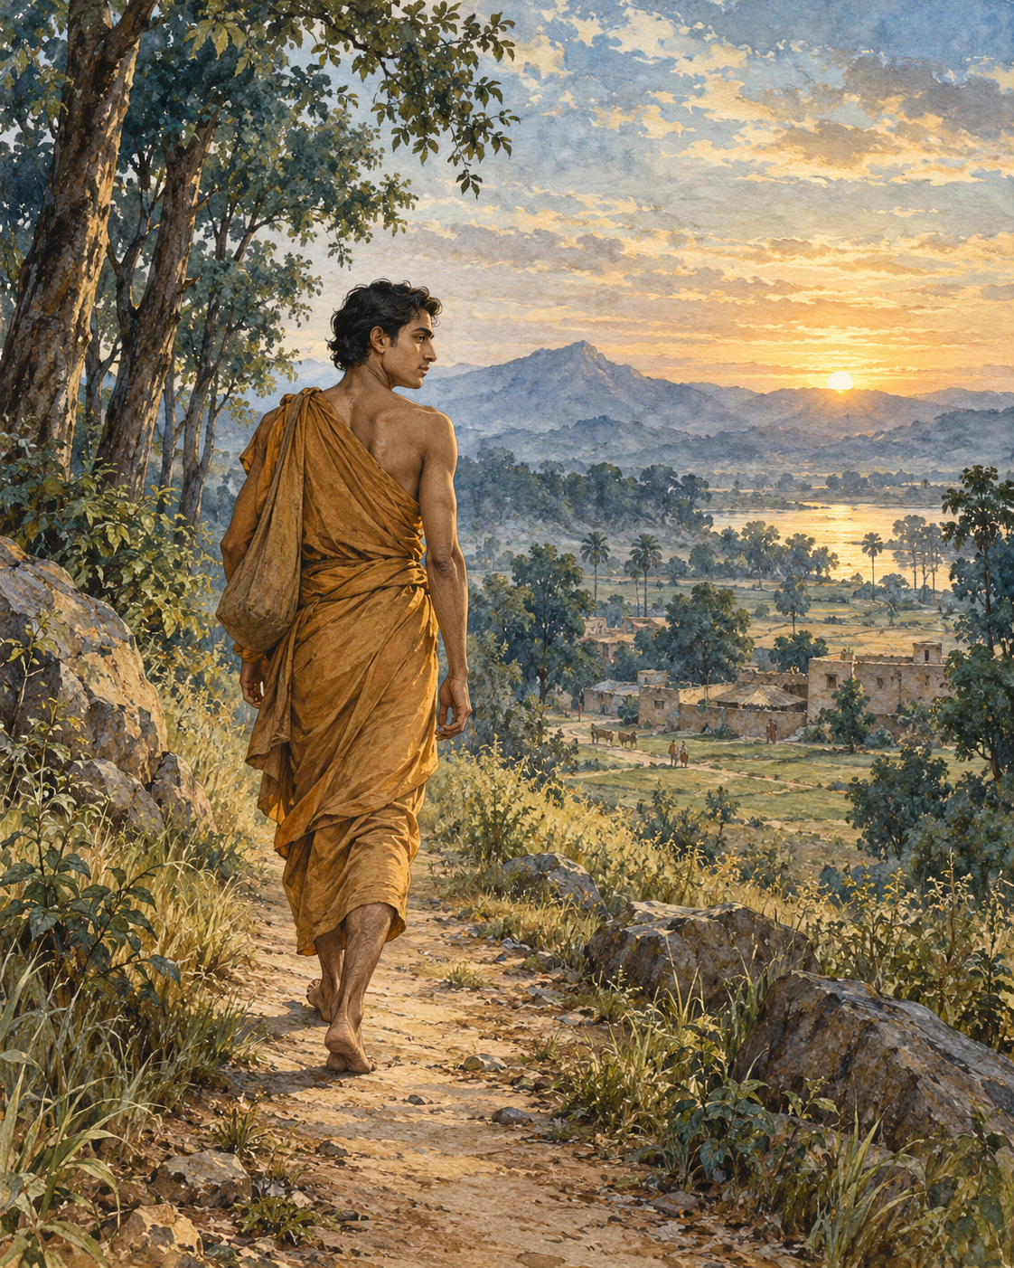
Before he became a teacher, Gotama had to learn how to leave a teacher.
He had already left his family. In the account he would later give, his parents wept as he cut his hair and beard, put on the robe of a wanderer and went into homelessness. He was young; the strength of youth was still with him. Yet youth could not answer the question that troubled him. Everything he might gather around himself was subject to change. People he loved would grow old. His own body would fall ill. What sort of safety could be built entirely from things that could not remain?
The roads of northern India carried other seekers. Some learned difficult disciplines; some pursued knowledge through meditation and debate. Gotama entered this world neither as an enemy of its teachers nor as someone already possessing the answers. He went to Alara Kalama and asked to learn.
He listened. He practised. The teaching was something to be tested in experience, not merely repeated from memory. In time he attained the meditative state associated with that school: the sphere of nothingness. Alara recognised his achievement. The student need no longer sit beneath the teacher; they could guide the community together.
For a homeless young man, it was a remarkable offer. Here were respect, companionship and a place in which his abilities were understood. Nothing in the account suggests that Alara mocked him or withheld knowledge. The offer was generous. Refusing it required no accusation against the person who made it.
But Gotama examined what he had attained. This refinement of consciousness was extraordinary, yet it was not the freedom he sought. It did not bring the final ending of the conditions that sustain suffering. He could not make it sufficient by being grateful for it. So he left.
Another community brought another attainment. With Uddaka Ramaputta he learned the discipline associated with Rama, reaching the sphere of neither perception nor non-perception. Once again his capacity was acknowledged. Once again leadership was placed within reach. He had come as a learner, and now the community could be entrusted to him.
The dilemma had become more difficult precisely because he had succeeded. Failure can send a person onwards with little hesitation. Success asks a subtler question: whether one is willing to stop searching because other people are satisfied with what one has become.
Gotama did not stay. The teaching had taken him far, but not to the end of his inquiry. He continued towards Uruvela, where he found a place suitable for striving: a pleasant stretch of country, a clear river and nearby villages where food could be obtained. Such ordinary necessities mattered. A search for liberation still unfolded in a body that needed shelter and nourishment.
He had gained knowledge from both communities. He did not need to erase that debt in order to recognise its limits. Nor could another person’s confidence complete the work that remained his own.
The river at Uruvela offered no certificate of arrival. There was ground on which to sit, water moving through the landscape and the unfinished question that had brought him from home. He settled there, prepared to begin again.

Wisdom to Remember
Gratitude for a teacher can coexist with an honest recognition that the search is unfinished.

A Reflection for Today
Consider a goal you have inherited from other people. Does achieving it meet the need that first made you pursue it? You can value what a school, mentor or profession has given you while reassessing your next step.

Source Note
Original literary retelling of MN 26, Ariyapariyesana Sutta, Pali Canon; Theravada textual transmission. Primary text and translation. Classification: canonical teaching narrative, not an independently verified historical transcript. No dialogue here is a verbatim canonical quotation. Scene-setting and interpretive transitions are original editorial reconstruction. This episode follows the early discourse rather than the later palace-escape biography. MN 26 does not name a horse, charioteer or sleeping palace household. The attainment taught by Uddaka is associated in the text with Rama.

02. The Shade He Remembered
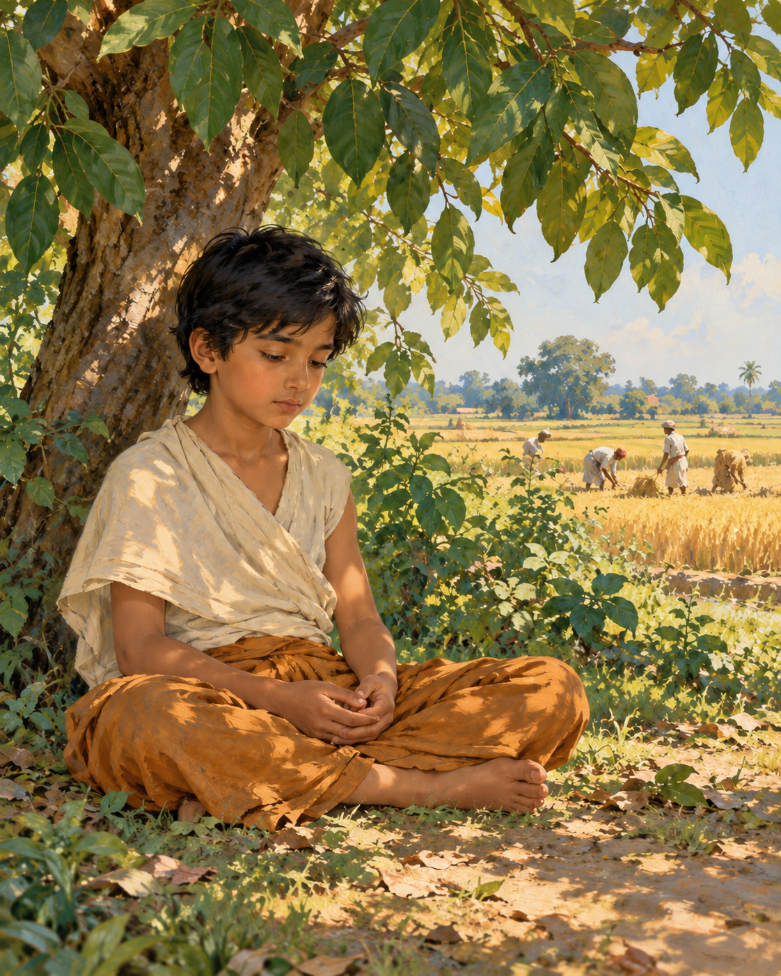
His body had become a record of everything he had refused it.
Gotama had reduced his food until the strength drained from his limbs. His skin clung tightly to his frame. When he touched his belly, the bones of his back seemed close beneath his hand. The austerities were not a passing experiment. He had committed himself to them with a determination so fierce that pain itself could appear to prove his sincerity.
There were other practices too: forceful efforts to subdue the mind and painful attempts to restrain the breath. He endured what the discourse describes in stark physical detail. Yet endurance was not awakening. He could survive an ordeal and still be bound by the confusion he had set out to end.
Five ascetics attended him. They expected that if anyone could discover the truth through such exertion, this relentless seeker would do so. Their presence gave the experiment a human weight. To change course would mean disappointing those who believed in him, not merely revising a private theory.
At the edge of his strength, another possibility returned through memory.
He remembered being young, seated beneath a rose-apple tree while his father was working. Away from the activity, his mind had entered a collected, joyful state, secluded from sensual pleasures and unwholesome qualities. The recollection did not offer another way to punish himself. It suggested that a certain kind of happiness might belong to the path.
That was the difficult discovery. He had treated pleasure as something to fear because desire so readily fastens upon it. But the remembered joy did not depend on possession or indulgence. Might he have been rejecting a helpful condition simply because it did not hurt?
He recognised this possibility as the way towards awakening. Then came a practical admission: a body so depleted could not sustain the work. The mind did not need a victim. It needed the support of sufficient food.
He began to eat solid nourishment again, including rice and porridge. The five companions saw what he was doing and lost their confidence. To them, he appeared to have abandoned the struggle. They left him.
From outside, the change could look like collapse. The man who had outlasted others in hardship now accepted food. Yet the deeper surrender had been his willingness to stop protecting a failed method. He no longer needed suffering to stand as evidence that he was serious.
As strength returned, he developed the collected states of meditation. The remembered shade became more than a lovely episode from childhood; it had corrected the direction of his effort. He pursued clarity without deliberately injuring the body that made practice possible.
The discourse carries the account onwards through the night of awakening. It describes knowledge of former lives, knowledge of beings passing according to their actions and, finally, the ending of the taints that sustain bondage. These are the tradition’s claims about liberation, not the rewards of starvation.
At the turning point of the story stands no public triumph. There is a memory, an honest judgement and the acceptance of food. The decisive courage is almost quiet enough to miss: after going so far in one direction, he was willing to turn.

Wisdom to Remember
An effort is not wise simply because it is painful. Practice must be judged by where it leads.

A Reflection for Today
Notice one place where you confuse exhaustion with commitment. Adequate food, rest and medical care can support serious work. This story concerns an extreme ascetic experiment; it is not advice to undertake fasting or breath restriction.

Source Note
Original literary retelling of MN 36, Mahasaccaka Sutta, Pali Canon; Theravada textual transmission. Primary text and translation. Classification: canonical teaching narrative, not an independently verified historical transcript. No dialogue here is a verbatim canonical quotation. Scene-setting and interpretive transitions are original editorial reconstruction. The childhood tree here is a rose-apple tree, not the Bodhi tree. This discourse describes the return to food but does not identify Sujata or narrate her milk-rice offering; those familiar details belong to other biographical traditions.

Interlude 1: A Direction for the Heart

Pali — Roman Transliteration
Buddhaṃ saraṇaṃ gacchāmi.
Dhammaṃ saraṇaṃ gacchāmi.
Saṅghaṃ saraṇaṃ gacchāmi.

English Meaning
To the Buddha I turn for refuge.
To the Dhamma I turn for refuge.
To the Saṅgha I turn for refuge.

Context and Significance
The first cycle of the Three Refuges. Khp 1 repeats the commitment a second and third time. In Theravada practice, refuge is a conscious orientation towards awakening, the teaching and the community of noble disciples. These three lines are an excerpt, not the full nine-line recitation.

Source and Attribution
Khp 1. Pali Canon, Khuddaka Nikaya; canonical text in the Theravada tradition. The Pali is already presented in Roman transliteration; there is no separate “transliteration” of an English translation. Punctuation, capitalisation, word division and the nasal sign have been regularised for this edition. The English is an original rendering prepared for this collection, not a reproduced modern translation. Ancient verse and modern editorial apparatus have different copyright status.
Source consulted: https://suttafriends.org/sutta/khp1/

03. The Cowherd of the Mind
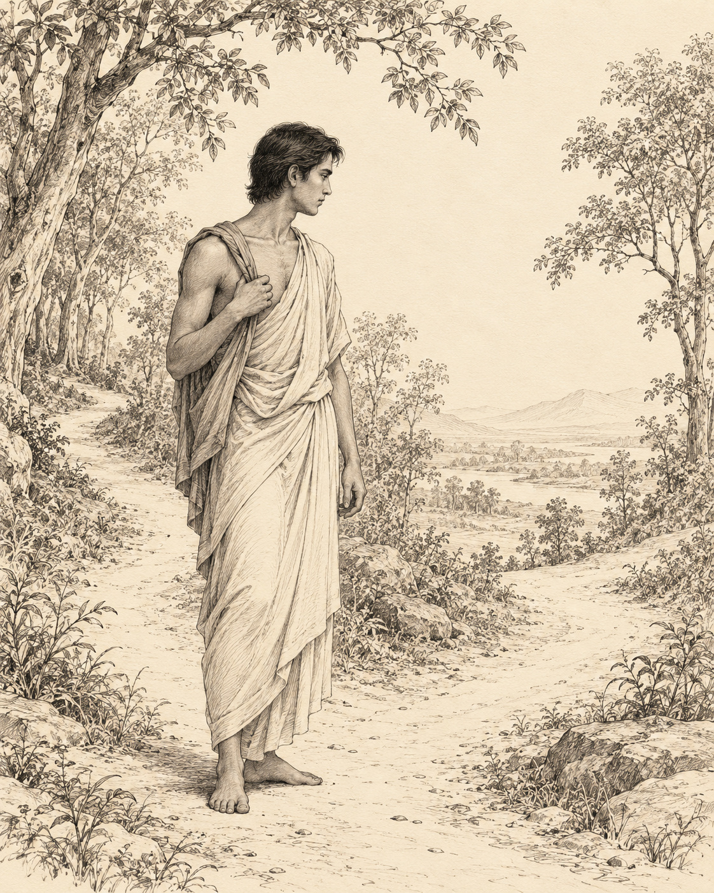
Long before he taught others to observe the mind, Gotama watched his own thoughts arrive.
Solitude did not guarantee that every thought would be peaceful. A person could sit away from a village and still carry a crowded world within: pleasures imagined and pursued, resentment revisited, impulses that made another being’s pain seem unimportant. Distance from noise was useful, but it could not do the work of understanding.
Before awakening, he made a distinction. On one side he placed thoughts of sensual desire, ill will and harming. On the other he placed thoughts of renunciation, goodwill and harmlessness. It was a plain division, concerned with the direction in which thinking carried him.
When a thought from the first group appeared, he examined its consequences. Would following it injure him? Would it injure someone else? Would it injure both? Did it help understanding, or crowd understanding out? By seeing the damage towards which it tended, he weakened its claim on his attention.
He did not need to turn the arrival of a thought into a verdict on his entire character. The work concerned what happened next. A thought could be recognised without being entertained, much as a traveller might notice a side road without taking it.
Later, when describing this training, he used an image from the fields. During the season when crops stood ready, a cowherd had to keep cattle from wandering into them. Carelessness could bring punishment or a fine. The danger was practical and visible: an animal’s appetite could destroy another household’s food.
So the cowherd stayed alert. There was a boundary to maintain. In the same way, Gotama understood the cost of unwholesome thinking and checked it before it spread through speech and action. A private resentment did not remain harmless merely because no one else could hear it.
But constant guarding was not the whole story. Thoughts of renunciation, goodwill and harmlessness caused neither his own affliction nor that of others. They opened room for understanding. He could allow them without the same fear of damage.
Here the picture changed. After the harvest, when the crops had been brought in, a cowherd could sit under a tree or in the open and remain aware of the cattle. The watchfulness continued, but its strain eased. There was no standing grain to protect from every wandering mouth.
Even wholesome thinking had a limit. If he kept thinking and examining without rest, the body could tire, and a tired body could unsettle the mind. Recognising this, he steadied attention. Good intentions were allowed to mature into collectedness rather than becoming an endless conversation with himself.
There was discipline in both movements: turning away from what led towards harm, and knowing when useful thought had done its work. The aim was not to fill every moment with virtuous sentences. It was to free the mind for a deeper seeing.
The field image leaves us with a patient figure whose attention changes as conditions change. Sometimes he must intervene; sometimes he can simply watch. He does not abandon the animals, and he does not drive them ceaselessly merely to prove that he is in charge. Care has become more exact than force.

Wisdom to Remember
What we repeatedly entertain becomes easier for the mind to follow.

A Reflection for Today
Choose one recurring thought and examine its likely effects before arguing about whether it is justified. If it feeds cruelty or resentment, redirect attention towards a specific harmless action. When reflection becomes tiring repetition, pause and let attention settle.

Source Note
Original literary retelling of MN 19, Dvedhavitakka Sutta, Pali Canon; Theravada textual transmission. Primary text and translation. Classification: canonical teaching narrative, not an independently verified historical transcript. No dialogue here is a verbatim canonical quotation. Scene-setting and interpretive transitions are original editorial reconstruction. The cowherds are similes used in the discourse, not witnesses to a documented encounter. This retelling combines the teaching and its field imagery without claiming a literal meeting between Gotama and a cowherd.

04. When the Forest Made a Sound
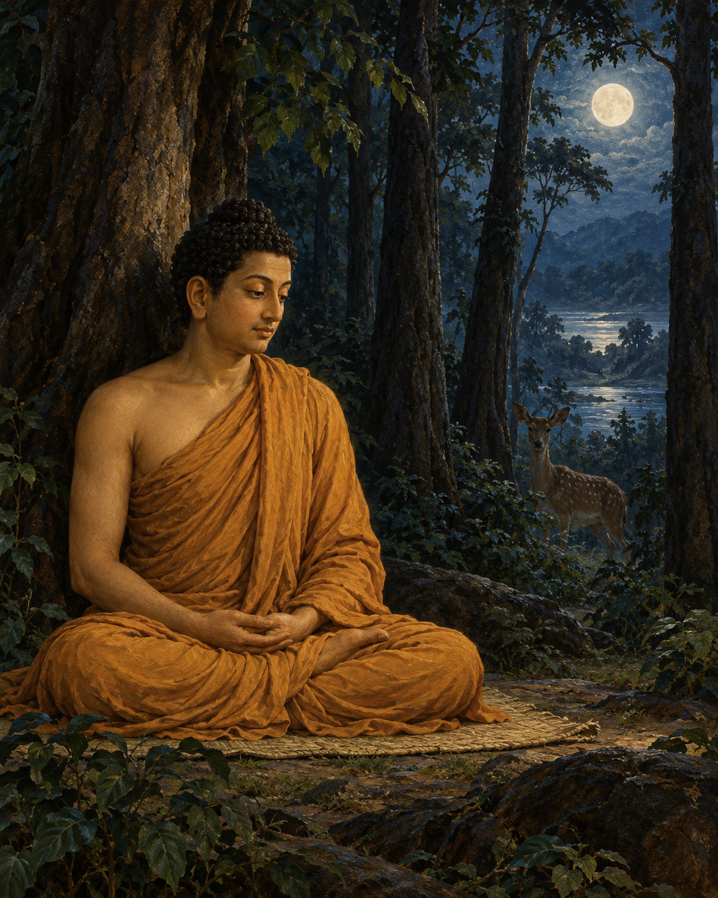
A sound travelled through the dark, and the forest was no longer merely a place of trees.
A deer might move nearby. A bird might dislodge a twig. Wind might trouble the leaves. In daylight, such things belonged to the ordinary life of the woods. Alone at night, the mind could give them a more alarming shape before the ear had finished listening.
The Buddha later spoke about this difficulty to Janussoni, a brahmin who understood that secluded places were not easy for an untrained mind. The Buddha did not dismiss the concern. He remembered his own practice before awakening, when he had deliberately stayed in remote places associated with dread.
He began with conduct. Someone who had harmed others or lived dishonestly carried more than a sleeping mat into solitude. Regret, concealment and hostile intention could accompany that person into the trees. Gotama examined himself instead of treating the forest as the sole source of danger.
He considered his actions, speech, intentions and livelihood. He considered whether he was seeking admiration or putting others down, whether he was heedless, sluggish or scattered. Confidence grew from the qualities he was cultivating. It was not the claim that nothing could happen to him. It was the knowledge that he was not knowingly feeding the causes of turmoil.
On nights especially associated with fear, he went to unsettling places: park shrines, forest shrines and shrines beneath trees. The account does not make him a conqueror arriving to challenge the inhabitants of another world. It shows a practitioner bringing attention to the moment when terror arose.
Then a noise came. Something moved, or fell, or rustled. Fear had its opening.
He chose to meet it in the posture in which it found him. If he was walking when fear arose, he would continue walking until he had subdued it. If standing, he remained standing. If sitting or lying down, he worked with it there. A change of posture would not become his automatic escape from the experience.
There is a particular steadiness in this account. He did not settle the matter by demanding that the night stop making sounds. The leaves could move. The animal could pass. The mind still had to learn what it was adding to those events.
His effort belonged to a larger training in energy, mindfulness, tranquillity and concentration. The encounter with fear was not an isolated test of toughness. Ethical discipline supported attention; attention supported collectedness. Each part gave strength to the others.
In later recollection he also spoke of the awakening that followed this sustained practice. Yet the forest episode remains close to a recognisable human moment: the instant between hearing something and knowing what it is. So much can rush into that small uncertainty.
The sound did not need to become an enemy. Nor did fear need to become a shameful secret. Both could be known. Whatever the woods contained, he was learning to remain present without letting the first surge of alarm govern every movement.
A twig could fall and remain a twig. Breath could continue. The night, with all its unclaimed spaces, could be inhabited without every shadow being given authority over the heart.

Wisdom to Remember
Courage can grow through careful preparation and a steadier relationship with fear.

A Reflection for Today
For an ordinary, manageable anxiety, notice the physical sensation before following the story it produces. Stay within safe limits. The Buddha’s solitary ascetic practice is not a prescription to remain in danger, ignore trauma responses or refuse professional support.

Source Note
Original literary retelling of MN 4, Bhayabherava Sutta, Pali Canon; Theravada textual transmission. Primary text and translation. Classification: canonical teaching narrative, not an independently verified historical transcript. No dialogue here is a verbatim canonical quotation. Scene-setting and interpretive transitions are original editorial reconstruction. This is a retrospective canonical practice account. It does not establish that forests were physically safe or that fear always results from wrongdoing. The ethical inventory is one element of this particular training, not a diagnosis of anxious people.

Interlude 2: Where the Mind Leads

Pali — Roman Transliteration
Manopubbaṅgamā dhammā, manoseṭṭhā manomayā;
Manasā ce paduṭṭhena bhāsati vā karoti vā,
Tato naṃ dukkhamanveti cakkaṃ va vahato padaṃ.

English Meaning
Mind comes before these experiences; mind leads them and gives them shape.
When someone speaks or acts with a corrupted mind,
suffering follows, as a wheel follows the foot of the draught animal.

Context and Significance
The opening verse connects the quality of intention with the suffering that follows speech and action. It should not be turned into the claim that thought alone manufactures every external event.

Source and Attribution
Dhp 1. Pali Canon, Khuddaka Nikaya; canonical text in the Theravada tradition. The Pali is already presented in Roman transliteration; there is no separate “transliteration” of an English translation. Punctuation, capitalisation, word division and the nasal sign have been regularised for this edition. The English is an original rendering prepared for this collection, not a reproduced modern translation. Ancient verse and modern editorial apparatus have different copyright status.
Source consulted: https://ancient-buddhist-texts.net/Buddhist-Texts/K2-Dhammapada-New/01-Yamaka.htm

05. The Lotuses Not Yet Open
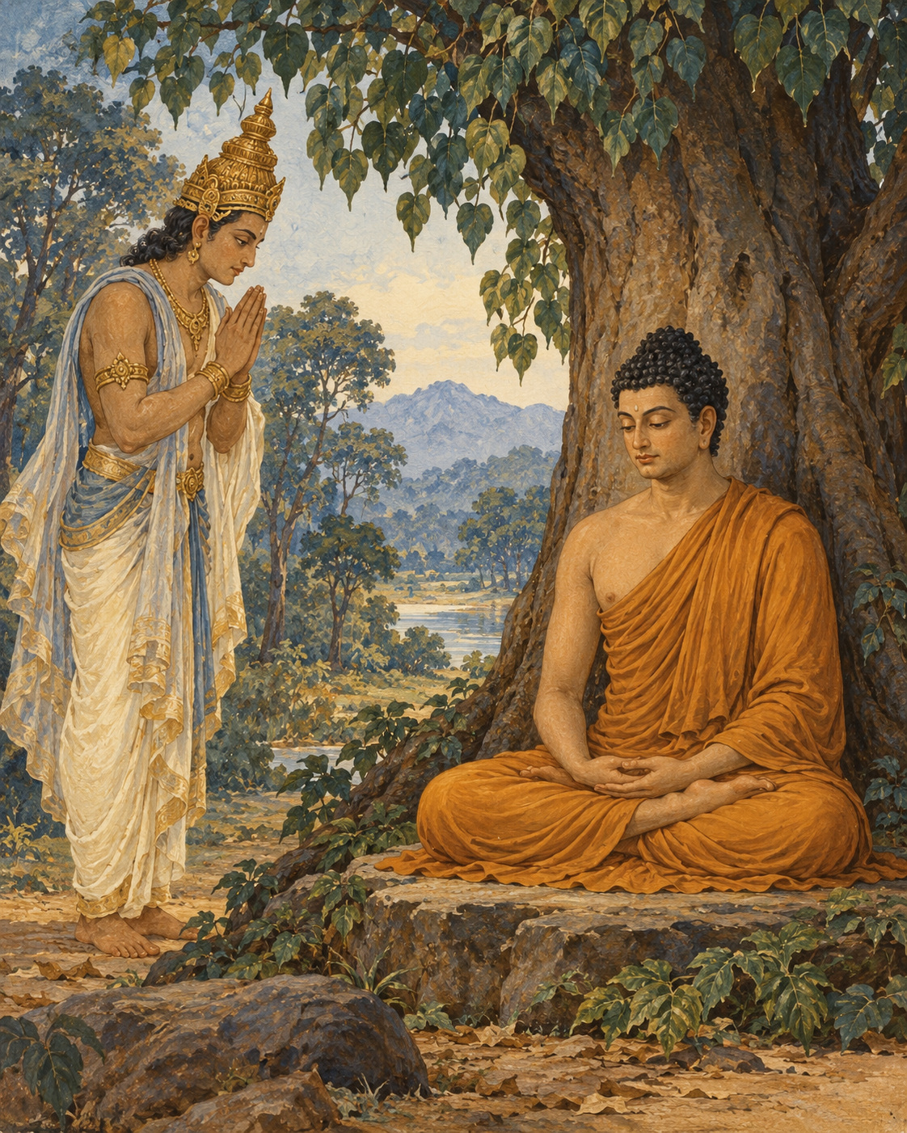
The teaching almost remained unspoken.
In the sacred narrative, the Buddha had awakened and was staying beside the Neranjara River, beneath the Goatherd’s Banyan. What he had realised was peaceful and profound. Yet understanding it had required more than cleverness, and communicating it would require more than finding agreeable words.
He considered the world into which he might speak. People delighted in what they could hold, protect and call their own. A teaching about the arising of things through conditions, and the release found through ending craving, would run against those habits. Someone might listen attentively and still hear only another way to acquire what they wanted.
If he taught and was not understood, the effort would be burdensome. His inclination turned towards remaining at ease rather than undertaking it.
Here the discourse opens beyond the human world. Brahma Sahampati, a celestial being, perceives this thought. To him, the possibility that the awakened Buddha might remain silent is a calamity. He appears before the Buddha, arranges his robe respectfully and kneels with joined hands.
His appeal does not deny that teaching will be difficult. It asks the Buddha to see the people for whom the difficulty need not be final. Some are less obscured than others. Without an opportunity to hear, even those capable of understanding may be left without the help they need.
Brahma’s presence belongs to the religious world of the text. He is not a messenger whom an archive can place on a dated road. Within the narrative, a celestial being bows to awakened wisdom and asks that it enter the sorrowing world. The scale is cosmic; the appeal is intimate. There may be someone who can understand.
The Buddha surveys living beings with compassion. They are not all alike. Their capacities differ, and so do the obstacles before them. Some are receptive; others are difficult to teach. He sees neither a universally hopeless humanity nor a world already prepared to agree with him.
The discourse offers the image of a lotus pond. Some flowers are still held beneath the water. Some have reached its surface. Others have risen clear. All have grown in the same element, but they do not occupy the same place within it.
One could look across such a pond and notice only the water. One could mistake the unopened flowers for flowers that would never open. The image allows a more patient judgement: what is not visible in full may still be developing.
The Buddha accepts the invitation to teach. He makes the possibility of hearing available to those who are willing to listen. Brahma recognises that his request has been answered, pays his respects and disappears from the scene.
The change is not that the teaching has suddenly become easy. The obstacles remain. Human attachment has not vanished, and no promise is made that every listener will understand. What changes is the willingness to speak into that uncertainty.
The pond holds flowers at many stages. Compassion does not wait until every one of them has reached the light. It attends to the possibility already present among them, including the possibility that would otherwise remain unseen.

Wisdom to Remember
Compassion notices capacities that discouragement can overlook.

A Reflection for Today
When explaining something valuable, consider who may be ready to hear one small part of it. Offer that part clearly and without pressure. Neither silence born of discouragement nor a demand for immediate agreement serves every listener.

Source Note
Original literary retelling of SN 6.1, Brahmayacana Sutta (The Request of Brahma), Pali Canon; Theravada textual transmission. Primary text and translation. Classification: canonical teaching narrative, not an independently verified historical transcript. No dialogue here is a verbatim canonical quotation. Scene-setting and interpretive transitions are original editorial reconstruction. This is a canonical supernatural narrative. Brahma Sahampati is a celestial figure in Buddhist cosmology, not the historical Buddha or a creator being endorsed as supreme. The lotus imagery belongs to the discourse; its interpretive expansion is editorial.

06. A Way Between the Extremes
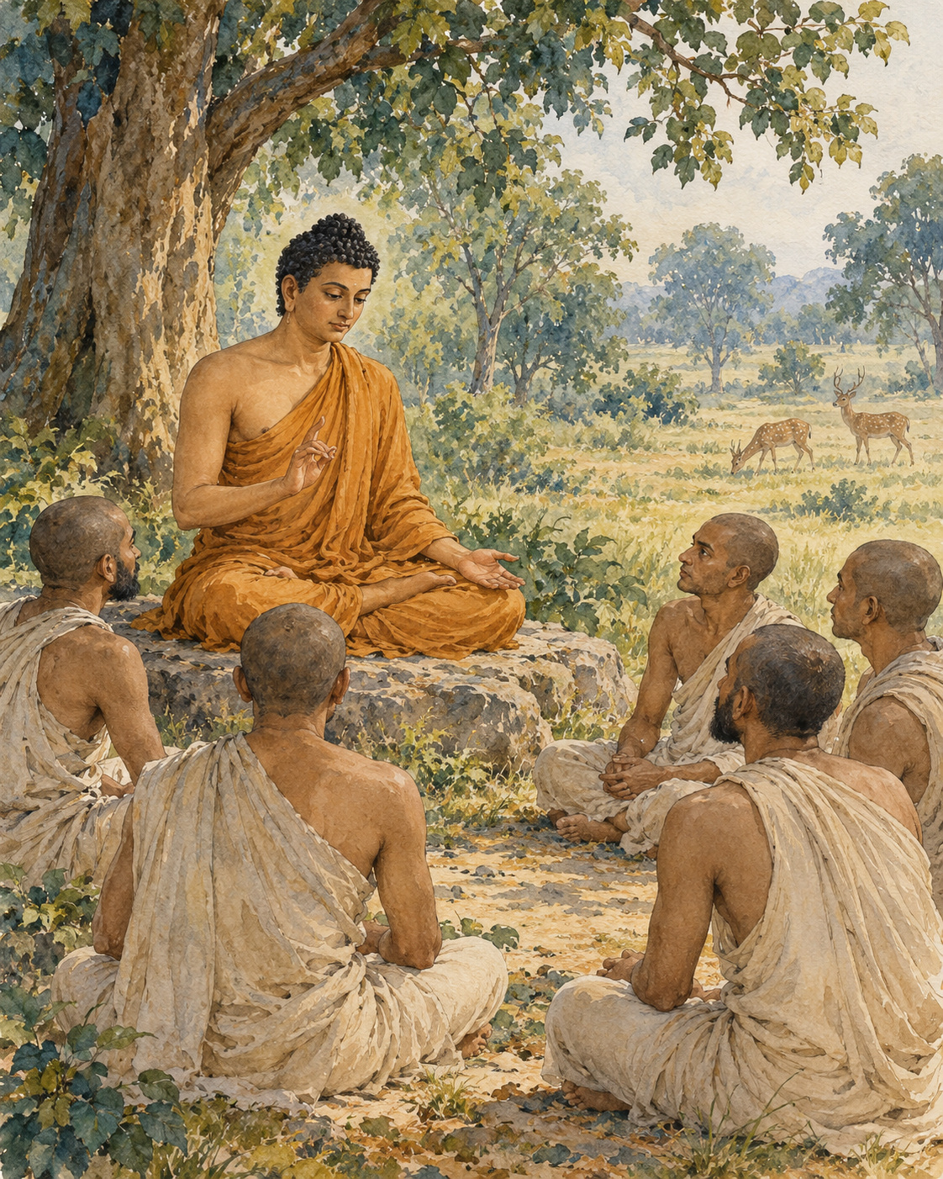
Five listeners sat before a teaching that would ask them to reconsider suffering itself.
The place was Isipatana, near Varanasi, in the Deer Park. The discourse remembers the Buddha addressing the group of five monks there. It does not begin with a promise that their lives would become pleasant if only they believed him. It begins by setting aside two ways of seeking release that fail to reach their aim.
One way pursues satisfaction through sensual indulgence. The other deliberately inflicts pain upon the body. The Buddha named both as extremes to be avoided by someone who had gone forth. A person could spend a life moving between them, looking for freedom first in gratification and then in punishment.
The way he taught required a different discipline. It included understanding and intention, speech and action, livelihood and effort, mindfulness and concentration. These eight factors formed a path to be cultivated. The middle way was not a vague preference for doing everything moderately; it was a training with direction and substance.
Then he turned to dukkha: the suffering and unsatisfactoriness bound up with clinging. Birth, ageing and death belonged to this account. So did separation from what was loved, contact with what was unwelcome and the frustration of not obtaining what was wanted. These were not accusations against human beings for feeling pain. They were experiences to be understood.
The next movement concerned the origin of suffering. Craving reached out towards pleasure, towards becoming, even towards non-becoming. It could fasten on one experience and then another, searching restlessly for something that would finally satisfy its demand.
But the account did not end with that restlessness. The cessation of craving was possible. There was release from its compulsive reach. And there was a way of practice leading towards that cessation: the same eightfold path he had introduced.
Each truth carried a task. Suffering was to be understood. Its origin was to be abandoned. Cessation was to be realised. The path was to be developed. Merely repeating four statements would not fulfil those tasks, any more than naming a road would carry a traveller along it.
The Buddha described his own understanding in relation to these responsibilities. He did not claim complete awakening until his knowledge of the truths, their tasks and their fulfilment was clear. The teaching asked for work because it arose from work already brought to completion.
As the five listened, Kondanna saw something decisive. Whatever comes into being is subject to ending. This was more than a prediction that pleasant moments would eventually fade. In the discourse it marks the arising of the Dhamma eye, an initial breakthrough in understanding.
The narrative then widens. Celestial beings announce that the wheel of the teaching has been set in motion. The announcement travels through the heavens; the world trembles and a great light appears. These are the sacred text’s expressions of the event’s significance.
At its human centre remain a teacher and five listeners. A path has been described, and one listener has begun to see. The suffering they knew has not been concealed beneath a consoling story. It has become something that can be met, understood and worked with.

Wisdom to Remember
The Four Noble Truths invite four kinds of work, not merely four beliefs.

A Reflection for Today
With a small current difficulty, distinguish the discomfort itself from the craving that may intensify it. Then choose one path factor to practise: honest speech, a harmless action or a few minutes of steady attention. Avoid blaming yourself for pain.

Source Note
Original literary retelling of SN 56.11, Dhammacakkappavattana Sutta, Pali Canon; Theravada textual transmission. Primary text and translation. Classification: canonical teaching narrative, not an independently verified historical transcript. No dialogue here is a verbatim canonical quotation. Scene-setting and interpretive transitions are original editorial reconstruction. Tradition identifies this as the first discourse. The celestial proclamation, earthquake and radiance are canonical sacred motifs, not independently established historical observations. Dukkha has a wider range than a single English equivalent can convey.

Interlude 3: A Care That Does Not Sleep

Pali — Roman Transliteration
Appamādo amatapadaṃ, pamādo maccuno padaṃ;
Appamattā na mīyanti, ye pamattā yathā matā.

English Meaning
Heedfulness is the way to the Deathless; heedlessness is the way to death.
The heedful do not die; the heedless are as though already dead.

Context and Significance
“Deathless” belongs to the Buddhist language of liberation. The verse does not promise that a careful person’s physical body will never die. Heedfulness is sustained ethical and contemplative care.

Source and Attribution
Dhp 21. Pali Canon, Khuddaka Nikaya; canonical text in the Theravada tradition. The Pali is already presented in Roman transliteration; there is no separate “transliteration” of an English translation. Punctuation, capitalisation, word division and the nasal sign have been regularised for this edition. The English is an original rendering prepared for this collection, not a reproduced modern translation. Ancient verse and modern editorial apparatus have different copyright status.
Source consulted: https://ancient-buddhist-texts.net/Buddhist-Texts/K2-Dhammapada-New/02-Appamada.htm

07. What the Hand Cannot Hold
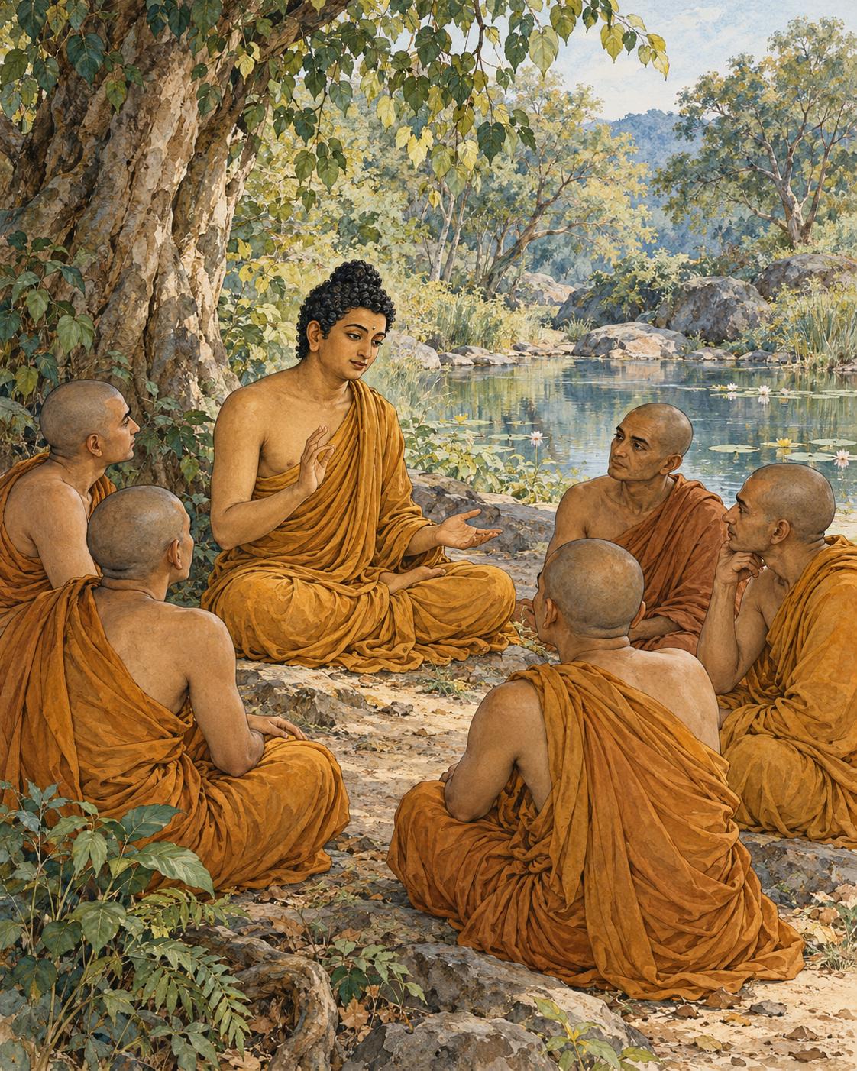
The body did not obey simply because someone called it mine.
At Isipatana, the Buddha addressed the five monks again. He directed their attention towards the very things people most readily take to be themselves: the body, feeling, perception, the formations of mind and consciousness. The teaching did not ask them to look for an unfamiliar object somewhere beyond experience. It asked them to examine what they were already depending on.
He began with form, the material body. If it were a self under complete command, it would not bring affliction. A person could decide exactly how it should be and make it so. Yet the body could become painful or unwell despite the urgency of the wish that it should not.
The same inquiry reached into feeling. Pleasure arose and changed. Pain arrived without permission. Neither could be made permanently obedient by insistence. Perception, which recognised and named the world, was also changing. Mental formations and consciousness likewise failed to provide the unalterable authority that possession seemed to promise.
The monks were not being instructed to despise these processes. A body could be cared for; a feeling could be known. But caring and knowing were different from finding an enduring, sovereign self within them.
The Buddha questioned them about permanence. Was the body lasting or subject to change? What about feeling, perception, formations and consciousness? They recognised impermanence in each. Whatever changed could not provide the secure foundation that clinging demanded of it.
The inquiry repeated itself, moving through the five groups. Its patience mattered. An idea about impermanence might be easy to accept while a particular pain, memory or opinion remained fiercely defended as the centre of oneself. The teaching left no single favoured corner unexamined.
It reached beyond the immediate moment. Past, future and present; internal and external; coarse and subtle; near and far: no form of these changing processes was to be exempted merely because it felt precious, impressive or intimate. The habit of identification was being questioned at its roots.
This was not an invitation to conclude that nothing mattered. The discourse described a release from the passion that appropriates experience. When a person no longer demands an unchanging self from what changes, that demand no longer has to be defended against every movement of life.
The five monks listened. The narrative records their minds becoming liberated from the taints through the ending of clinging. It presents this as complete release, not a brief spell of relaxation or an improved opinion of themselves.
For a modern reader, the full claim may be difficult to enter at once. The scene still asks a precise question. When something changes in body or mind, must every change become a threat to the owner we imagine standing behind it? The ancient inquiry does not settle for an encouraging answer. It asks for careful seeing.
In the grove, there was no object to carry away as proof of success. The release described was from appropriation itself. What had been treated as an unquestionable possession could be known as a changing process. The hand that demanded permanence no longer had to close around it.

Wisdom to Remember
Changing experience cannot provide an unchanging possession or a self under complete control.

A Reflection for Today
When a mood arises, try describing it as an experience rather than your whole identity: sadness is present, or anxiety is present. This modest exercise does not exhaust the teaching of not-self. It can help create room for care without turning every mood into a definition of who you are.

Source Note
Original literary retelling of SN 22.59, Anattalakkhana Sutta, Pali Canon; Theravada textual transmission. Primary text and translation. Classification: canonical teaching narrative, not an independently verified historical transcript. No dialogue here is a verbatim canonical quotation. Scene-setting and interpretive transitions are original editorial reconstruction. The five groups are the aggregates: form, feeling, perception, formations and consciousness. Not-self is a subtle Buddhist teaching, not a claim that persons do not matter or that suffering should be ignored. This retelling avoids presenting a disputed metaphysical slogan as the whole doctrine.

PART II: Lessons That Awaken the Heart

08. The Mirror Before the Deed
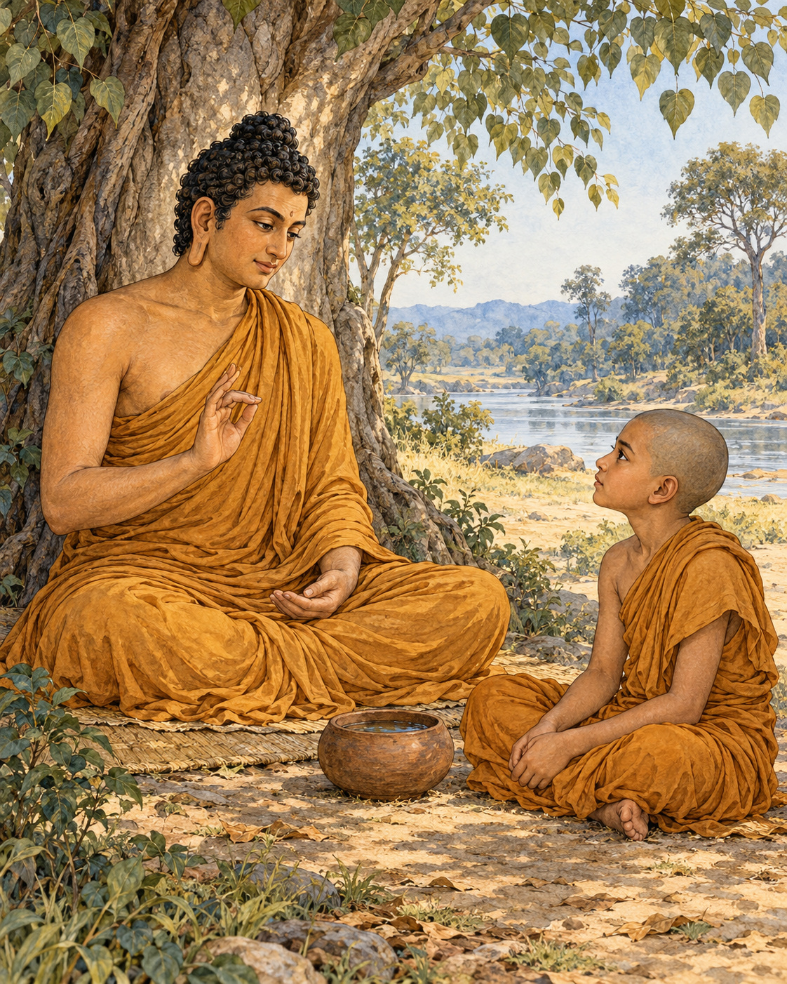
Rahula saw the Buddha approaching and prepared water for his feet.
The visit took place at Mango Stone, near Rajagaha. Rahula set out a seat, and after the Buddha had sat down and washed his feet, the younger monk paid his respects and settled to one side. The objects of welcome remained close at hand. The Buddha used them to begin a lesson that would reach far beyond the visit.
A little water remained in the dipper. He drew Rahula’s attention to it and linked its smallness to the spiritual life of someone who felt no restraint about deliberately lying. Then he threw away the remaining water, turned the dipper upside down and showed its emptiness. The successive gestures made the warning visible.
Truthfulness was not a decorative virtue added to an otherwise complete training. If a person was willing to conceal an action through deliberate falsehood, what would prevent that person from doing further harm? Rahula was to guard honesty even in play.
The Buddha then asked him about a mirror. What was it used for? Rahula understood: one looked into it in order to see. The teaching turned upon that ordinary act of examination. Actions of body, speech and mind were to be inspected repeatedly, rather than trusted merely because they belonged to the person performing them.
The first examination came before action. Rahula was to consider whether what he intended would hurt himself, another person or both. If it would, it was not to be done. If it was wholesome and did not lead towards such harm, he could undertake it.
But a good intention at the beginning did not remove the need to pay attention afterwards. While acting, he was to look again. An action that had seemed harmless might reveal its damage in the doing. If so, he should stop. To continue merely because he had already begun would be to put consistency above care.
There was a third examination after the deed. If an action of body or speech had caused harm, Rahula was to disclose it to his teacher or a knowledgeable companion in the spiritual life, and undertake restraint in future. The lesson on honesty now showed its practical force. Concealment would protect the mistake from correction.
For harmful mental action, the discourse prescribed recognising its danger and resolving not to repeat it. For actions found to be wholesome, there could be gladness and continued training. Reflection was not meant to make every memory a punishment. It could confirm what was worth cultivating as well as expose what needed to change.
The teaching placed responsibility in Rahula’s hands without pretending that he would never be mistaken. He was given a way to learn. Before, during and after: at each stage, attention could alter the direction of his conduct.
The water vessel had been emptied, but the lesson did not leave him with emptiness alone. There was something definite to practise the next time he spoke, reached for an object or followed a thought. The mirror was not there to praise him or condemn him. It was there so that he could look carefully enough to act differently.

Wisdom to Remember
Examine an action before, during and after it. Honesty makes correction possible.

A Reflection for Today
Before sending a difficult message, consider its likely harm and benefit. While writing, check whether anger has changed its purpose. Afterwards, be willing to correct an error openly. For complex decisions, seek advice rather than assuming reflection guarantees perfect foresight.

Source Note
Original literary retelling of MN 61, Ambalatthikarahulovada Sutta, Pali Canon; Theravada textual transmission. Primary text and translation. Classification: canonical teaching narrative, not an independently verified historical transcript. No dialogue here is a verbatim canonical quotation. Scene-setting and interpretive transitions are original editorial reconstruction. The discourse addresses Rahula but does not narrate a specific lie that triggered the visit. No mirror is said to be physically present: it is a teaching comparison. Retellings that invent an actual broken promise or lie should identify that addition.

Interlude 4: Training What Wanders

Pali — Roman Transliteration
Dunniggahassa lahuno yatthakāmanipātino,
Cittassa damatho sādhu, cittaṃ dantaṃ sukhāvahaṃ.

English Meaning
The mind is hard to hold, quick, alighting wherever it wishes.
It is good to train it: a trained mind brings happiness.

Context and Significance
Training here concerns cultivation, not hatred of one’s thoughts. The verse is an invitation to learn how attention and intention behave.

Source and Attribution
Dhp 35. Pali Canon, Khuddaka Nikaya; canonical text in the Theravada tradition. The Pali is already presented in Roman transliteration; there is no separate “transliteration” of an English translation. Punctuation, capitalisation, word division and the nasal sign have been regularised for this edition. The English is an original rendering prepared for this collection, not a reproduced modern translation. Ancient verse and modern editorial apparatus have different copyright status.
Source consulted: https://ancient-buddhist-texts.net/Buddhist-Texts/K2-Dhammapada-New/03-Citta.htm

09. The Question That Could Wait
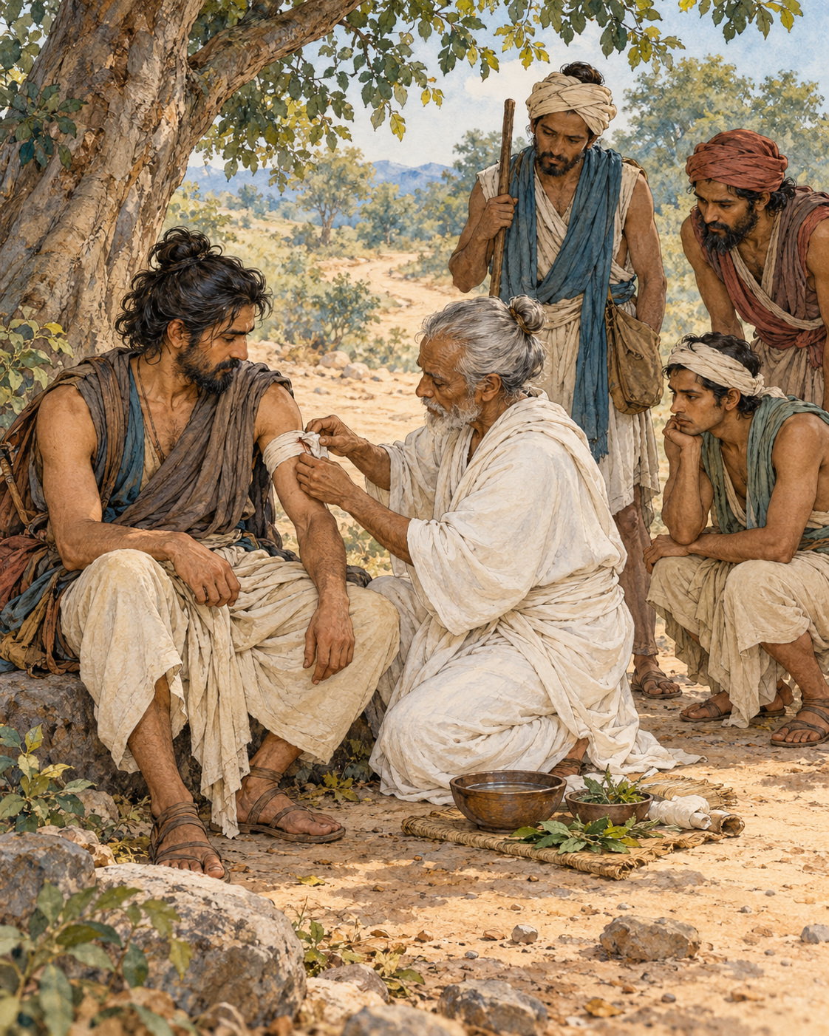
Malunkyaputta had decided that his unanswered questions could no longer wait.
Alone in meditation, the monk had been thinking about matters the Buddha had left undeclared. Was the world eternal or not? Was it limited or limitless? What was the relationship between life and body? What could properly be said of an awakened one after death? The questions had gathered force until he made his training conditional upon receiving answers.
He would ask the Buddha directly. If the answers were given, he would remain in the spiritual life. If they were not, he would leave.
That evening he approached the Buddha, paid his respects and explained his position. He did not ask timidly. If the Buddha knew, he should declare what he knew. If he did not know, Malunkyaputta thought, an admission of ignorance would be straightforward.
The Buddha first examined the agreement the monk believed existed between them. Had he promised Malunkyaputta answers to those questions as a condition of entering the training? Had Malunkyaputta entered upon such an understanding? No such promise had been made.
Then the Buddha offered a picture whose urgency left little room for abstraction.
A man had been struck by a poisoned arrow. His companions brought a surgeon to help him. But before allowing the arrow to be removed, the wounded man demanded information. Who had shot it? What was the attacker’s social standing, name and appearance? Where did he live? What kind of bow had been used? What were the arrow and its fittings made from?
The questions multiplied. Each answer could seem to justify another question, and each further question delayed the work for which the surgeon had come. The wounded man made complete information a condition of accepting treatment.
He would die before that condition was fulfilled.
The Buddha did not describe an actual patient whom Malunkyaputta could visit. He made the danger of misplaced conditions visible through a parable. The essential work could be postponed indefinitely by demanding that a different kind of inquiry be finished first.
Whether one adopted this view of the cosmos or that, birth, ageing, death, sorrow and distress still required attention. The Buddha taught a way towards their ending. The matters he had left undeclared did not lead to the goal of that training; the Four Noble Truths did. He distinguished the questions according to their role in liberation.
For Malunkyaputta, this shifted the ground beneath the ultimatum. His teacher had not offered to answer every conceivable question. He had offered a path addressing suffering and its cessation. Leaving that path would not, by itself, settle the questions that had unsettled him.
The discourse ends with Malunkyaputta receiving the teaching gladly. It records no final inventory of his private doubts, and there is no need to invent one. He had been shown a distinction on which he could act.
The surgeon in the parable still stands beside the wounded man, ready to do something useful. The unanswered questions remain unanswered. Yet one decision has become clearer: the arrow need not stay in the wound while the mind negotiates with the whole universe.

Wisdom to Remember
An unanswered question need not prevent the useful action that is already available.

A Reflection for Today
Ask whether a question must be settled before you can take the next helpful step. Some uncertainty requires investigation; some can coexist with action. In a health emergency, seek urgent care rather than using this parable as a substitute for medical judgement.

Source Note
Original literary retelling of MN 63, Culamalunkyovada Sutta, Pali Canon; Theravada textual transmission. Primary text and translation. Classification: canonical teaching narrative, not an independently verified historical transcript. No dialogue here is a verbatim canonical quotation. Scene-setting and interpretive transitions are original editorial reconstruction. The poisoned-arrow episode is an explicit parable, not a biographical event. The discourse distinguishes a particular set of speculative views from teachings directed towards liberation; it is not a rejection of science, curiosity or all philosophical inquiry.

10. A Calmness Put to the Test
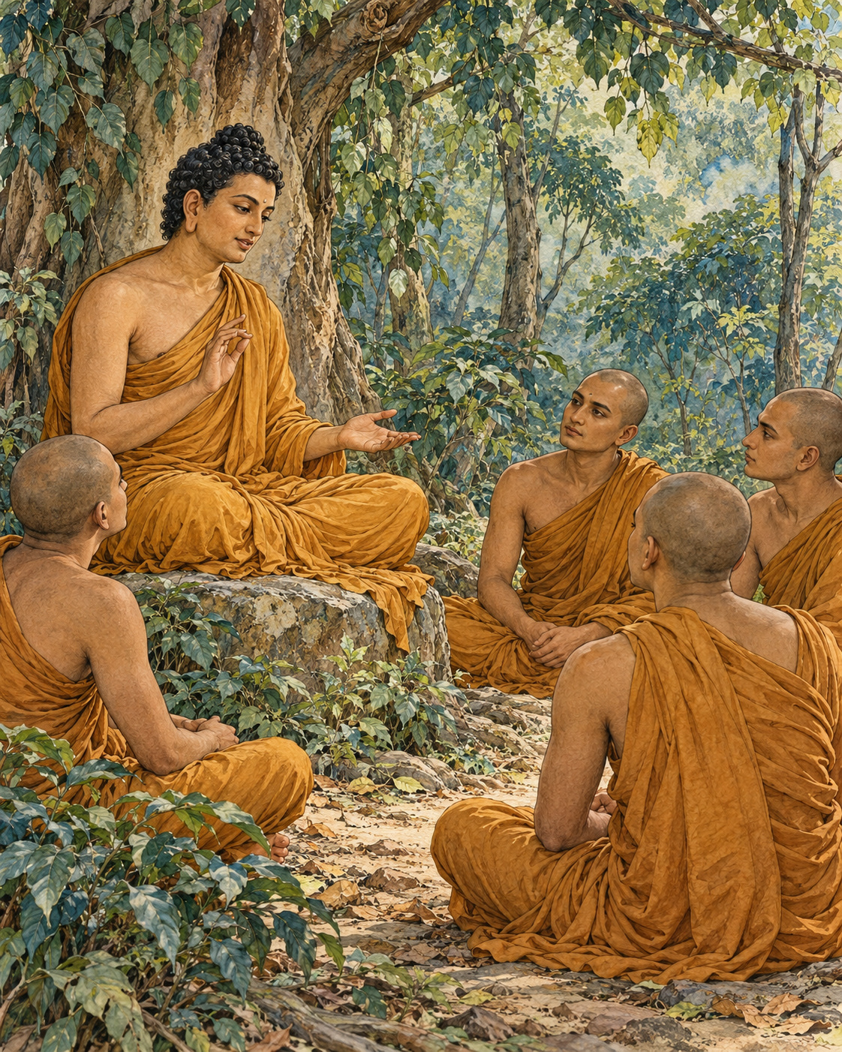
Everyone seemed to know that Vedehika was a gentle woman.
In the teaching story the Buddha told, her reputation had spread through Savatthi. People praised her composure and good temper. From outside the household, there appeared to be little reason to doubt them. The work was done, the household ran smoothly and its mistress had no visible occasion to lose control.
Kali, the enslaved woman who performed that work, wondered what the reputation really meant. She was capable and diligent. Was Vedehika free from anger, or did anger simply have no need to show itself while everything happened as she wished?
Kali decided to test the difference. One morning she rose later than usual.
Vedehika called to her and demanded an explanation. Kali offered none that would excuse the delay. The mistress frowned, displeased. The celebrated calm had already begun to narrow around a small inconvenience.
On another morning Kali rose later still. Again Vedehika questioned her. Again the answer brought no relief to the mistress’s anger. What had first appeared in a look now found its way into grumbling. Kali’s suspicion grew stronger: the anger had been present, waiting for conditions that would expose it.
The test continued. Vedehika’s response became violent. She seized a bar and struck Kali on the head, causing an injury. The story’s reversal was complete. A household praised for the gentleness of its mistress had become a place where a person under her power was harmed.
Kali went to the neighbours and showed what had happened. Vedehika’s reputation changed. The calm woman was now spoken of as cruel and quick-tempered. What the neighbourhood had admired had depended upon a servant’s constant efficiency and submission.
The Buddha directed the lesson towards the monks listening to him. A monk might appear agreeable while other people spoke pleasantly and his material needs were well supplied. Such ease did not yet show how he would meet correction or an unwelcome word. The training had to reach the point where circumstances stopped cooperating.
He described the many ways speech could arrive: at a suitable or unsuitable time, truthfully or falsely, kindly or harshly, helpfully or otherwise, with goodwill or hostility. The task was to prevent another person’s speech from becoming the occasion for hatred in one’s own mind.
The discourse developed this demand through powerful comparisons and, finally, the extreme simile that gives it its name. Even under a brutal attack with a saw, the monks were instructed to guard against hatred. This was a radical standard for their inner training, not a report of an attack that had happened to them.
Kali’s story keeps the teaching from becoming merely an attractive ideal. It places a vulnerable person in the path of someone else’s unexamined anger. The consequence is injury, not simply a loss of spiritual poise.
Vedehika’s good name could not protect Kali. Only a different response in the moment of frustration could have done that. A reputation for gentleness, however widely repeated, was no substitute for the difficult practice of becoming gentle when another person no longer pleased her.

Wisdom to Remember
Patience becomes visible when convenience and agreement fall away.

A Reflection for Today
Notice how you respond when someone with less power inconveniences you. Pause before speaking or acting. Non-hatred does not require remaining available for abuse: leave danger, protect vulnerable people and seek support when needed. Do not test another person through deliberate provocation.

Source Note
Original literary retelling of MN 21, Kakacupama Sutta, Pali Canon; Theravada textual transmission. Primary text and translation. Classification: canonical teaching narrative, not an independently verified historical transcript. No dialogue here is a verbatim canonical quotation. Scene-setting and interpretive transitions are original editorial reconstruction. Vedehika and Kali appear within a teaching story; they are not independently established historical persons. Kali is enslaved, not a freely employed servant. The story exposes abusive power and does not endorse slavery or blame its victim. The saw is an extreme hypothetical simile for monastic mental training, not an instruction to submit to violence.

Interlude 5: The Ending of Hostility

Pali — Roman Transliteration
Na hi verena verāni sammantīdha kudācanaṃ;
Averena ca sammanti, esa dhammo sanantano.

English Meaning
Hostilities never settle through hostility here.
Through non-hostility they settle: this is an enduring principle.

Context and Significance
Avera literally points to the absence of hostility. This verse supports the refusal to feed hatred; it does not require remaining in an unsafe situation or abandoning necessary protection.

Source and Attribution
Dhp 5. Pali Canon, Khuddaka Nikaya; canonical text in the Theravada tradition. The Pali is already presented in Roman transliteration; there is no separate “transliteration” of an English translation. Punctuation, capitalisation, word division and the nasal sign have been regularised for this edition. The English is an original rendering prepared for this collection, not a reproduced modern translation. Ancient verse and modern editorial apparatus have different copyright status.
Source consulted: https://ancient-buddhist-texts.net/Buddhist-Texts/K2-Dhammapada-New/01-Yamaka.htm

11. The Raft Left on the Shore
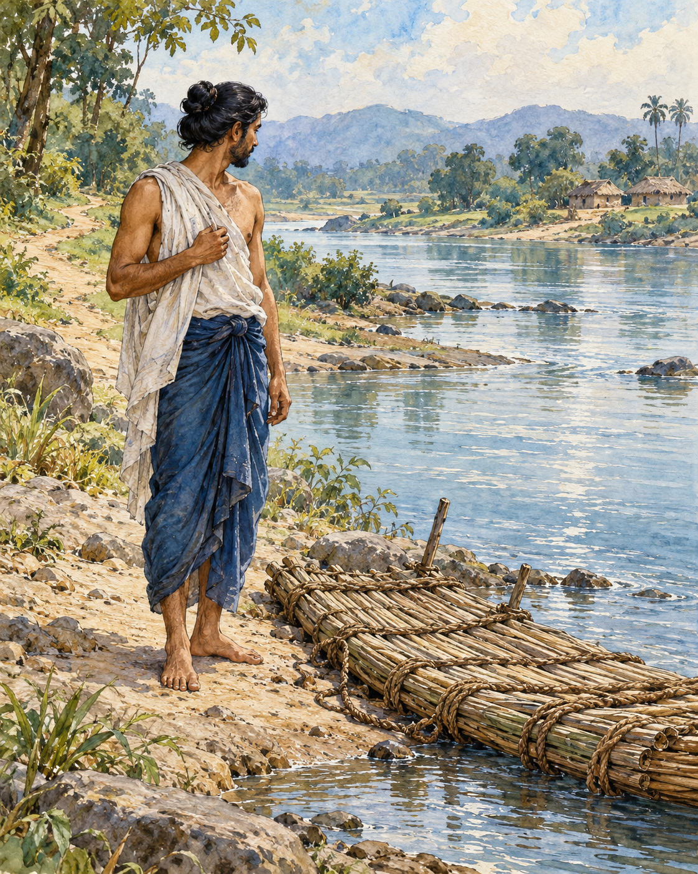
The water lay between the traveller and safety. On his own bank there was danger; on the opposite bank, the possibility of continuing his journey. There was no bridge. No ferryman came towards him. He could stand and wish for a crossing, or begin making one.
This was a traveller in a story the Buddha asked his listeners to imagine. The parable gives him no name or family history. What mattered was the difficulty before him, and what he would do with the means available.
He gathered what the bank offered: grass, branches, leaves and smaller lengths of wood. None was a boat in itself. Bound together, however, they could bear a person’s weight. He worked them into a raft, something serviceable rather than handsome. The task required judgement. Too little material would fail him; a collection left unbound would scatter as soon as he entered the water.
Then he put the raft to use. He crossed by his own effort, moving his hands and feet, depending on what he had made. The Buddha’s image contains both reliance and labour. The traveller did not reach safety merely by admiring his raft, declaring loyalty to it, or arguing that it was better than another traveller’s vessel. He had to enter the water.
At last he reached the farther bank. Now the danger that had made the raft necessary lay behind him. He could feel gratitude for its usefulness. Without it, he might still be staring across the current, unable to proceed.
But gratitude can become a curious kind of burden. Suppose, the Buddha asked, the man decided that such an excellent raft ought never to leave him. He might lift it onto his head or strap it across his back and set out along the road. Branches that had supported him in water would catch against the undergrowth. What had made movement possible would make each subsequent step harder.
The listeners could see the mistake. A raft was made for crossing. Carrying it everywhere would misunderstand its kindness, if a bundle of wood could be called kind. The wiser traveller would leave it on dry ground or set it afloat, and continue without the weight.
The Buddha brought the image back to his teaching. The Dhamma also had a purpose: it was to help people cross beyond suffering. Learning it well mattered. Practising it mattered. Yet turning it into a possession to defend, a source of superiority, or an argument to carry into every meeting could prevent the very freedom it was meant to serve.
The lesson was not permission to discard discipline whenever it grew inconvenient. A traveller still in the current who threw his raft away would hardly be wise. The question was whether a means was being used for its proper work, and whether attachment had quietly taken the place of understanding.
On the farther bank, in the simple space of the parable, the man could finally straighten his back. The raft remained a good raft. He did not need to despise it in order to let it go. He could honour what had helped him by walking freely into the country it had enabled him to reach.

Wisdom to Remember
A teaching fulfils its purpose through practice, not possession.

A Reflection for Today
Consider one practice or idea that has helped you. Ask whether you are using it to become kinder and clearer, or to establish that you are right. Let gratitude remain, while loosening the need to turn help into identity.

Source Note
Original literary retelling of Alagaddūpama Sutta, MN 22, preserved in the Pali Canon of the Theravada tradition. Canonical narrative; not an independently verified historical transcript. Read the source. No dialogue here is offered as a verbatim quotation. Sensory staging and transitions are literary reconstruction. The traveller and river belong to an explicit teaching simile, not an incident in the Buddha’s biography. This retelling concentrates on the raft section; it does not suggest abandoning the path before its work is accomplished.

12. The Gift Not Accepted
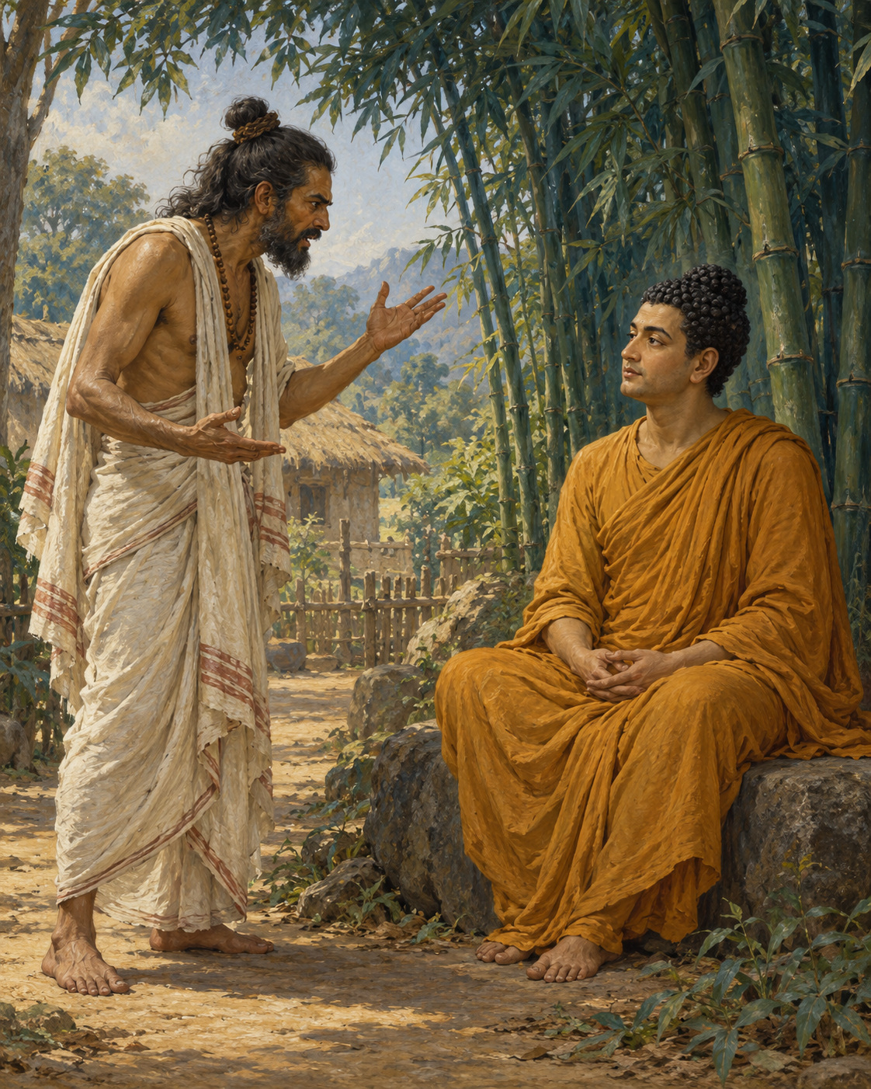
The brahmin arrived with something to give, though he had brought no food and carried no flowers. His offering was anger.
A man of the Bharadvaja clan had entered the Buddha’s community. When Akkosaka Bharadvaja heard the news, displeasure drove him to the Bamboo Grove near Rajagaha. There, among people who had come to train their minds, he poured out harsh accusations and insults.
In such an encounter, a familiar exchange waits to begin. One person strikes with words; the other answers. Each searches for a sharper sentence. Before long, neither remembers clearly what first mattered. The contest itself has become the reason to continue.
The Buddha did not enter that contest. He asked the brahmin about guests.
Did relatives and acquaintances sometimes visit his home? They did. Did he offer them food? Sometimes he did. If they declined the food, whose would it remain?
The answer was ordinary enough. An unaccepted meal stayed with the person who had prepared it. No complicated doctrine was needed to understand that.
The Buddha applied the household example to the encounter before them. The abuse had been offered, but he had not answered it with abuse. He had not joined the exchange. What the brahmin had brought therefore remained his own responsibility.
This was a firm answer. The Buddha neither called the anger good nor pretended that the words had not been spoken. He made their ownership clear. Someone else’s hostility did not oblige him to become hostile in return.
The brahmin had expected a different response. A person who arrives prepared for resistance can become unsettled when resistance fails to take its expected form. The Buddha’s composure was not the helpless silence of someone with nothing to say. He understood the proposed transaction and declined it.
The discourse goes on to distinguish restraint from defeat. Returning anger to anger would only worsen the encounter. Remaining attentive when another person is enraged can serve the welfare of both. The one who refuses retaliation protects the mind from being carried away; the angry person is given a chance to see something other than an enemy.
That chance mattered here. The man who had come to condemn the Buddha listened instead. The story closes with a change far greater than a polite apology: he asked to enter the monastic life. In the canonical account, through diligent practice, he eventually attained liberation.
We should not hurry past the distance between those two moments. The account does not make an insult itself a spiritual accomplishment. Nor does it suggest that a calm answer always changes another person. The brahmin still had to recognise his condition, choose a different life, and undertake the work of training.
Yet the opening had been made possible by a refusal. No one had won the argument the angry visitor intended to have, because that argument had never been allowed to take possession of the meeting.
In the Bamboo Grove, an unwanted gift remained unaccepted. The person who had brought it discovered that he did not have to keep offering it. He could set down his anger and ask, with the same mouth that had cursed, how to begin again.

Wisdom to Remember
You can recognise hostility without making it your own.

A Reflection for Today
When a message provokes you, pause before replying. Name what is happening, decide what boundary is needed, and answer only when you can do so usefully. Restraint can include ending an unsafe exchange or seeking help.

Source Note
Original literary retelling of Akkosa Sutta, SN 7.2, preserved in the Pali Canon of the Theravada tradition. Canonical narrative; not an independently verified historical transcript. Read the source. No dialogue here is offered as a verbatim quotation. Sensory staging and transitions are literary reconstruction. The conversion and attainment are claims within the canonical account. Refusing retaliation does not require tolerating abuse or remaining in danger.

Interlude 6: The Work Before Us

Pali — Roman Transliteration
Na paresaṃ vilomāni, na paresaṃ katākataṃ;
Attano va avekkheyya katāni akatāni ca.

English Meaning
Do not dwell on others’ faults, or on what they have and have not done.
Look instead at your own actions and omissions.

Context and Significance
The verse redirects scrutiny towards personal responsibility. It does not forbid recognising injustice or holding harmful conduct accountable.

Source and Attribution
Dhp 50. Pali Canon, Khuddaka Nikaya; canonical text in the Theravada tradition. The Pali is already presented in Roman transliteration; there is no separate “transliteration” of an English translation. Punctuation, capitalisation, word division and the nasal sign have been regularised for this edition. The English is an original rendering prepared for this collection, not a reproduced modern translation. Ancient verse and modern editorial apparatus have different copyright status.
Source consulted: https://ancient-buddhist-texts.net/Buddhist-Texts/K2-Dhammapada-New/04-Puppha.htm

13. Seeds in an Unseen Field
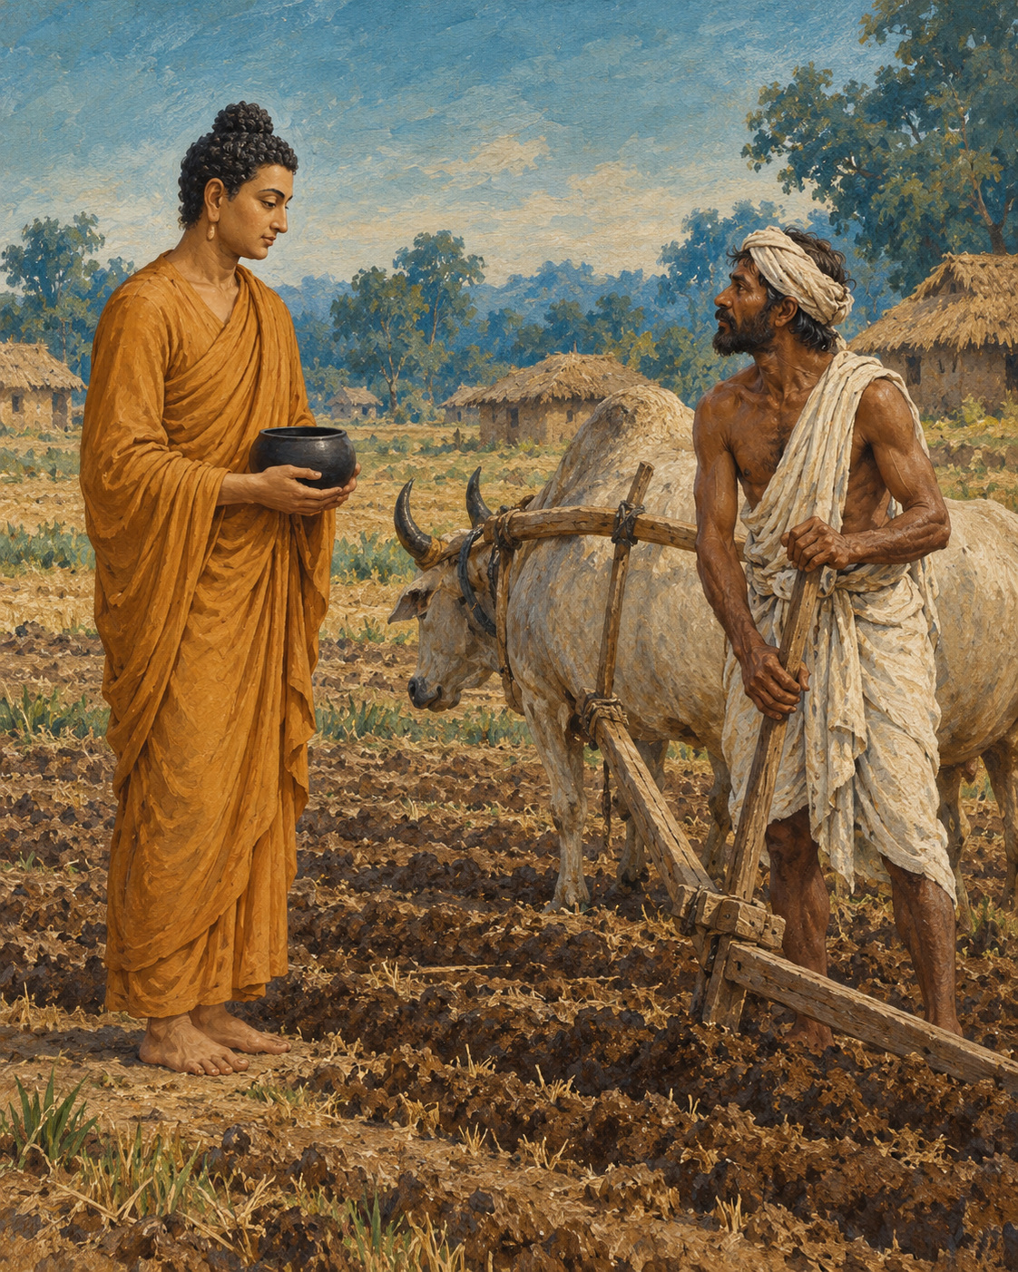
Sowing time made work visible everywhere. The fields around Ekanala in Magadha were being prepared, and the brahmin Kasi Bharadvaja had a great number of ploughs at work. The livelihood of many people depended on seed meeting soil at the proper season.
The Buddha arrived while food was being distributed. Wearing his robes and carrying his bowl, he stood aside for alms. To the farmer, the contrast seemed plain: some people laboured, while this mendicant waited to be fed.
Bharadvaja challenged him. He himself ploughed and sowed before eating. Why should the ascetic not do the same?
It was a question with the weight of ordinary fairness behind it. Food did not spring into bowls without somebody’s effort. The farmer knew the equipment, labour and risk that stood between an empty field and a harvest. Looking at the visitor, he saw no plough and no oxen.
The Buddha answered through the farmer’s own craft. He too cultivated, he explained, although the work could not be inspected by looking for a yoke upon his shoulder.
His description gave the tools familiar inward counterparts. Confidence began the work like seed. Discipline nourished it like rain. Understanding and mindfulness made the work accurate. Truth helped clear what should not be growing. Energy carried the practice forward towards release from suffering.
The image did not erase the farmer’s knowledge. It depended on it. Anyone who had struggled with a field understood that wishing was insufficient. A harvest asked for repeated attention, appropriate tools and persistence when the work was tiring. Inner cultivation required no less seriousness.
Bharadvaja’s response changed. He recognised that the man before him was speaking of labour with a different object, and offered him a generous bowl of milk-rice. A moment earlier he had questioned whether the visitor deserved food at all. Now he wished to honour him.
But the Buddha did not accept this particular offering. Food obtained as a reward for reciting verses, he explained, was not the way he lived. Teaching was not to become a performance purchased by a meal. He directed the farmer to make an offering in another way.
Then comes the story’s marvel. When the milk-rice is disposed of as instructed, it hisses and steams in the water, as though something fiercely heated had been plunged into it. The farmer watches in astonishment. Approaching the Buddha once more, he bows down, expresses his confidence in the teaching and asks to become a monk. The encounter that began with a challenge about earning a meal has become a request for an entirely different way of living.
The human turn, however, remains intelligible. A man who first measured effort by the presence of farming implements had been invited to notice another kind of work. The invitation did not belittle his skill. It enlarged his understanding of what effort might accomplish.
Bharadvaja went on to practise earnestly and, the discourse tells us, attain liberation. He did not merely admire an elegant comparison. He entered the field of his own conduct and began to tend it.
Outside, sowing season would still demand seed, rain and capable hands. Within, another cultivation had become possible: steady attention to the habits from which suffering grows, and patient labour towards a harvest no granary could contain.

Wisdom to Remember
The mind also needs cultivation; intention becomes fruitful through sustained care.

A Reflection for Today
Choose one inward task for the week: truthful speech, patient listening, or noticing resentment before acting. Treat it as regular work. Look for a small change in conduct rather than an impressive spiritual experience.

Source Note
Original literary retelling of Kasi Bhāradvāja Sutta, SN 7.11, preserved in the Pali Canon of the Theravada tradition. Canonical narrative; not an independently verified historical transcript. Read the source. No dialogue here is offered as a verbatim quotation. Sensory staging and transitions are literary reconstruction. A parallel is Sutta Nipāta 1.4. The steaming milk-rice is a supernatural canonical motif. The agricultural comparison does not imply that material labour is inferior or unnecessary.

14. The Village of Questions
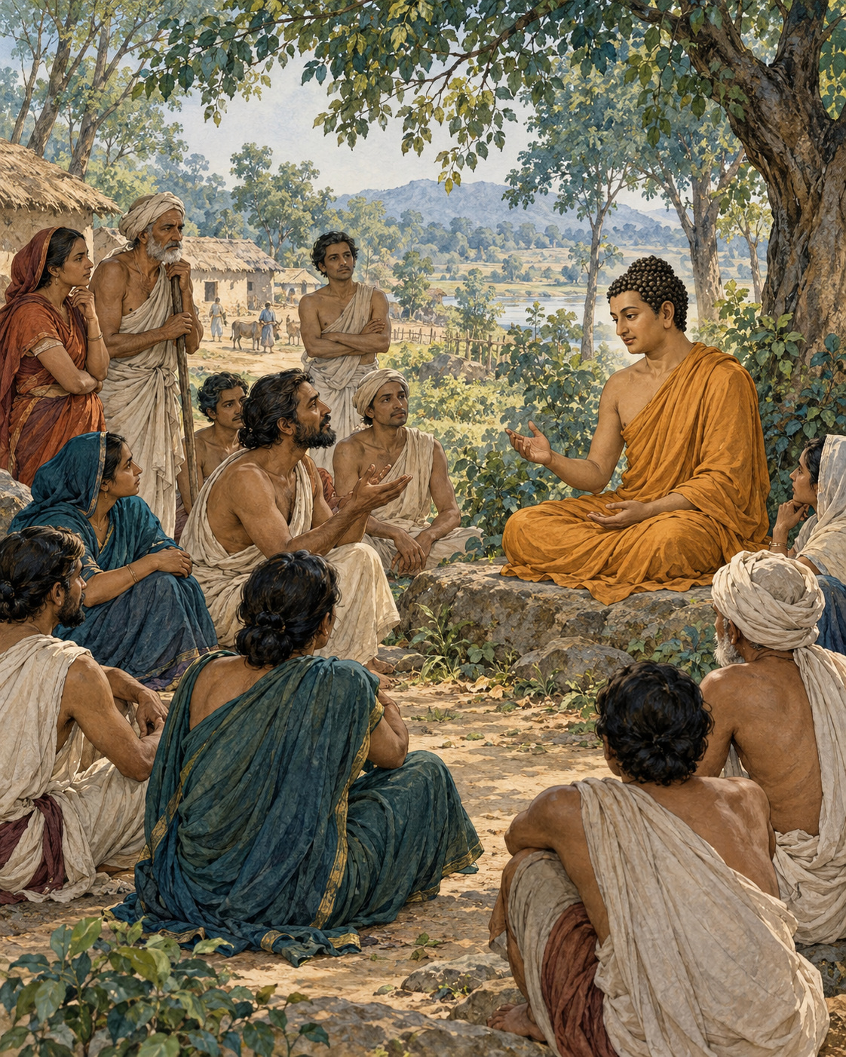
The people of Kesaputta had heard many confident voices. One visiting teacher praised his own doctrine and dismissed the others. Another arrived, equally certain, to reverse the judgement. Each account of truth seemed to come with an account of everyone else’s error.
When the Buddha reached their town, the Kalamas came to meet him. They did not all greet him in the same way. Some bowed, some exchanged courtesies, some introduced themselves, and some sat quietly. Even the manner of their arrival allowed room for difference.
Their question was direct. With so many teachers contradicting one another, how could they know whom to trust?
The Buddha did not shame them for uncertainty. In circumstances like these, uncertainty made sense. He also did not demand that his reputation settle the matter. The problem needed a more careful response than replacing one unquestioned authority with another.
He cautioned them against relying solely on what had been repeated, inherited, written down, reasoned out, or accepted because a revered teacher said it. A convincing argument could still serve confusion. A treasured tradition could be misunderstood. Confidence in a speaker did not remove the need to examine what the teaching did to a life.
Then he brought the discussion down from competing systems to recognisable human experience. What happened when greed possessed a person? Did it bring benefit or harm? They could consider what greed made people willing to do: take what was not given, deceive, injure, and encourage others towards the same conduct.
Hatred could be examined in the same way. So could delusion. The Kalamas did not need to settle every question about the universe before recognising that these states could bring suffering. Nor were they asked to make private preference the only judge. They were to consider whether qualities were blameworthy, whether wise people criticised them, and what consequences followed when those qualities were lived out.
The examination also worked in the other direction. Freedom from greed, hatred and delusion made a different manner of living possible. A person not driven by these forces could refrain from harming and could encourage others towards care.
The teaching opened further into goodwill, compassion, appreciative joy and equanimity, extending beyond the small circle of people one happened to favour. The test of a view was no longer merely whether it defeated a rival view. It was also whether the person who held it could inhabit the world with a mind less governed by hostility.
The Buddha described assurances available to such a person, including peace of conscience amid uncertainty about the workings of another life. Ethical practice did not have to wait until every metaphysical dispute had been resolved. There was work to do in the life already being lived.
The Kalamas’ questions had not been brushed away. They had been given a direction: examine, learn from the wise, observe effects, and abandon what brings harm. This was more demanding than believing whichever teacher spoke most beautifully. It asked them to become responsible participants in understanding.
At the end of the discourse, they expressed trust in the Buddha and his teaching. The trust had grown through examination rather than through a demand to stop examining. Their town had received another visitor, but this meeting offered something quieter than another contest of certainty: a way to begin testing the heart.

Wisdom to Remember
Let understanding grow through honest examination, wise counsel and the consequences of practice.

A Reflection for Today
Before adopting advice, ask what it encourages you to become. Does it strengthen greed, resentment or confusion? Seek informed criticism as well as confirmation. Personal conviction becomes more reliable when it can withstand careful examination.

Source Note
Original literary retelling of Kesamutti or Kālāma Sutta, AN 3.65, preserved in the Pali Canon of the Theravada tradition. Canonical narrative; not an independently verified historical transcript. Read the source. No dialogue here is offered as a verbatim quotation. Sensory staging and transitions are literary reconstruction. Some editions number this AN 3.66. The discourse is not a licence to believe whatever feels right or to reject all expertise; it includes the judgement of the wise and the effects of conduct.

Interlude 7: A Rock in the Wind

Pali — Roman Transliteration
Selo yathā ekaghano vātena na samīrati,
Evaṃ nindāpasaṃsāsu na samiñjanti paṇḍitā.

English Meaning
As a solid rock is not stirred by the wind,
so the wise are not shaken by blame and praise.

Context and Significance
Equanimity is steadiness amid changing evaluations. It can coexist with listening carefully to useful criticism.

Source and Attribution
Dhp 81. Pali Canon, Khuddaka Nikaya; canonical text in the Theravada tradition. The Pali is already presented in Roman transliteration; there is no separate “transliteration” of an English translation. Punctuation, capitalisation, word division and the nasal sign have been regularised for this edition. The English is an original rendering prepared for this collection, not a reproduced modern translation. Ancient verse and modern editorial apparatus have different copyright status.
Source consulted: https://ancient-buddhist-texts.net/Buddhist-Texts/K2-Dhammapada-New/06-Pandita.htm

15. Words Worth Speaking
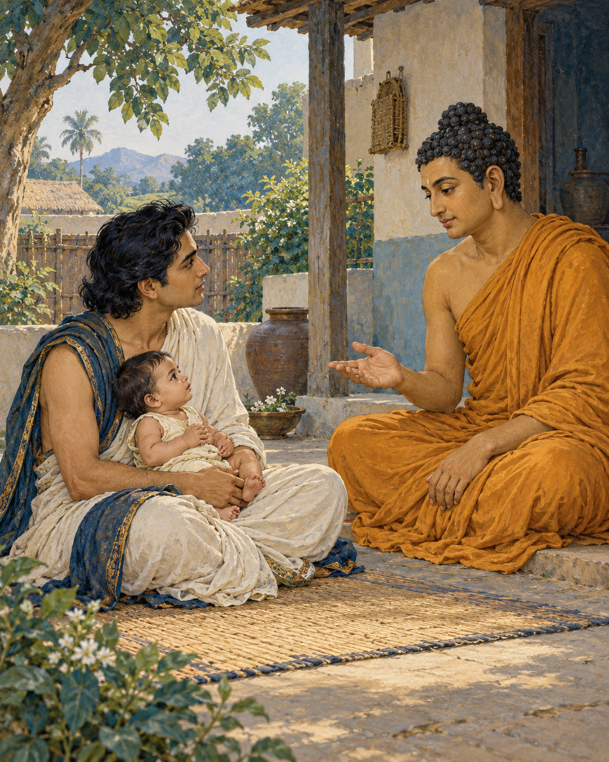
Prince Abhaya came prepared with a question designed to leave no comfortable answer. Would the Buddha ever say something unpleasant to another person?
If he answered yes, he might be accused of behaving like anyone who spoke hurtfully. If he answered no, the prince could point to stern words already attributed to him. The dilemma had been suggested by Nigantha Nataputta, leader of the community known to Buddhists as the Niganthas. Abhaya was to carry it into the meeting and win a public victory.
He first invited the Buddha and three companions to a meal at his home. When the meal was finished, the question was asked. A child lay on the prince’s lap. The conversation might have remained a contest over consistency, but that small presence gave it a different centre.
The Buddha did not accept the question’s simple division. There was more to consider than whether words pleased or displeased. He asked the prince to imagine the child putting a dangerous object into his mouth.
What would Abhaya do?
He would remove it. If it would not come out easily, he would hold the child’s head and carefully work it free, even if that caused bleeding. The reason was compassion. Leaving the object where it was would spare immediate distress while allowing greater harm.
This was an imagined emergency, not an injury that actually happened in the room. But the prince understood its force. A caring action could be unwelcome to the person receiving it. Tenderness was not always identical with making the present moment pleasant.
The Buddha then explained how he considered speech. Falsehood had no place in it. Even a true statement was not automatically worth saying. If it offered no benefit, its truth alone did not make its utterance wise. Where words were both true and beneficial, timing still mattered, whether the listener would find them welcome or unwelcome.
The standard left little room for the pleasure of a clever attack. A cutting observation could be accurate and still serve only the speaker’s appetite for victory. Conversely, a necessary warning could be painful without being cruel. Compassion required care about what the words would do, rather than simple devotion to either bluntness or politeness.
The prince had brought an intellectual trap. Now he was speaking about the well-being of a child in his own arms. The shift did not humiliate him. It allowed something he already understood about care to illuminate a subject he had approached as a debating exercise.
He asked another question. Did the Buddha prepare answers beforehand, anticipating the questions that learned people would bring? The Buddha responded through another familiar skill: an expert in the parts of a chariot could recognise and explain them when asked. Knowledge thoroughly understood did not need to be manufactured anew for every encounter.
By the end, Abhaya expressed his confidence in the teaching. He asked to be remembered as a lay follower who had taken refuge. There was no need to summon witnesses to announce a defeated opponent.
The child remained the quiet measure within the story. Before speaking, one might ask what kind of hand the sentence resembles: a hand reaching to protect, or one reaching to wound. The difference cannot be settled by sweetness of tone alone. It lies in truth, usefulness, understanding and the patient choice of time.

Wisdom to Remember
Speak with truth and benefit in view, and give the moment its due care.

A Reflection for Today
Before a difficult conversation, write down what needs to be said and why. Remove sentences whose main purpose is punishment. Choose a time when the other person can listen, while keeping necessary warnings clear.

Source Note
Original literary retelling of Abhayarājakumāra Sutta, MN 58, preserved in the Pali Canon of the Theravada tradition. Canonical narrative; not an independently verified historical transcript. Read the source. No dialogue here is offered as a verbatim quotation. Sensory staging and transitions are literary reconstruction. The choking child is a hypothetical example. No intention to use or pinch the infant is assigned to Abhaya here: that detail belongs to later commentary, not the canonical narrative used in this retelling.

PART III: Compassion That Changes Lives

16. The Man Who Stopped
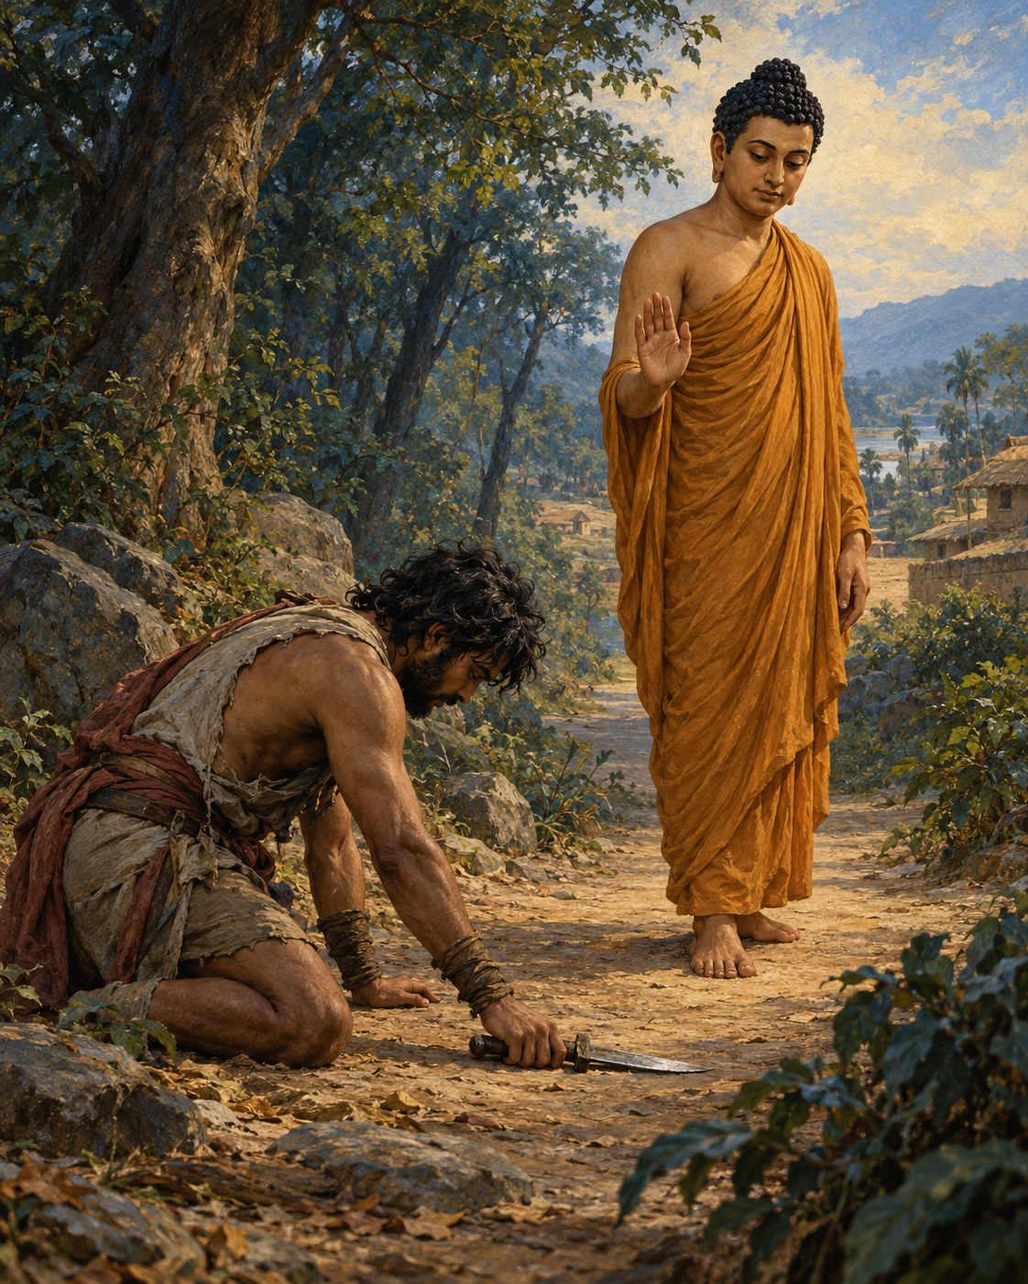
Cowherds, shepherds and farmers watched the lone mendicant take the road towards the forest. They called out warnings. Beyond lay the territory of Angulimala. Groups of men had been unable to pass safely; a solitary traveller would seem an easy victim.
The Buddha continued. Behind the name Angulimala stood killings, deserted settlements and fear. People had lost those they loved. The bandit’s name recalled a grisly garland made from his victims, and the road ahead carried the threat of more deaths.
When he saw the Buddha, Angulimala took his weapons and pursued him. What followed is told as a miracle: although the bandit ran at full speed, he could not overtake the Buddha, who walked at an ordinary pace. The distance would not close. Physical strength, on which he had depended, could not deliver the person before him into his power.
At last Angulimala called for the mendicant to stop. The answer turned the command back upon him. The Buddha had stopped harming living beings; the pursuer had not. One man’s feet were moving, but violence no longer directed his life. The other had halted on the road while the movement of cruelty continued within him.
Angulimala listened. He threw away his weapons and asked to enter the monastic life. The Buddha admitted him. A person who had made others afraid now undertook a discipline founded on restraint.
The change was startling enough that King Pasenadi, arriving with armed men to deal with the bandit, struggled to recognise the quiet monk before him. The king had expected a danger requiring force. He found a man whose life had been redirected through the Buddha’s teaching.
Another meeting revealed a different use for his presence. He saw a woman suffering in childbirth and was moved by her distress. At the Buddha’s instruction, he returned with a solemn statement of truth concerning his life since entering the noble discipline: from that beginning, he had not intentionally taken life. The story tells of well-being for the mother and her child after his return.
The distinction mattered. He could not truthfully claim a harmless past. He could speak truthfully about a changed commitment. Compassion did not depend on pretending that the earlier life had never happened.
Through diligent, secluded practice, Angulimala attained liberation, the discourse tells us. Still, the people of Savatthi remembered him. On an alms round, a clod struck his body, then a stone, then a broken piece of pottery. He returned to the Buddha injured, his bowl broken and his robe torn. The Buddha urged him to endure, explaining his suffering in terms of the consequences of past actions.
The robe had not restored those who had died. Nor had his change obliged the bereaved to forget. His alms rounds now took him unarmed among people who had reason to fear and hate him. He could no longer answer their anger with the violence that had once made him powerful. The discipline he had entered had to reach even this difficult meeting between his present life and the suffering he had caused.
At the turning point on the forest road, stopping meant more than standing still. It meant ceasing to feed the intention that had carried him from one act of harm to another. The weapons could be thrown aside in a moment. The rest of his life had to become the meaning of that gesture.

Wisdom to Remember
Change begins when harm stops; its sincerity is shown in the life that follows.

A Reflection for Today
Think of a harmful pattern you can interrupt today. Name a concrete action, accept its consequences, and seek appropriate help or accountability. Forgiveness cannot be demanded from those who were hurt.

Source Note
Original literary retelling of Aṅgulimāla Sutta, MN 86, preserved in the Pali Canon of the Theravada tradition. Canonical narrative; not an independently verified historical transcript. Read the source. No dialogue here is offered as a verbatim quotation. Sensory staging and transitions are literary reconstruction. The pursuit involves explicit supernatural power; the childbirth blessing is a religious narrative, not medical advice. Later accounts of Angulimala’s childhood and teacher are not included. The retelling does not propose immunity from law or erase victims.

Interlude 8: The Greater Victory

Pali — Roman Transliteration
Yo sahassaṃ sahassena saṅgāme mānuse jine,
Ekañca jeyya attānaṃ, sa ve saṅgāmajuttamo.

English Meaning
Someone might conquer a thousand times a thousand people in battle.
The person who conquers just one—themselves—is the greatest victor.

Context and Significance
The battle image is redirected towards mastery of harmful impulses. It is not an invitation to treat one’s body or emotions as enemies.

Source and Attribution
Dhp 103. Pali Canon, Khuddaka Nikaya; canonical text in the Theravada tradition. The Pali is already presented in Roman transliteration; there is no separate “transliteration” of an English translation. Punctuation, capitalisation, word division and the nasal sign have been regularised for this edition. The English is an original rendering prepared for this collection, not a reproduced modern translation. Ancient verse and modern editorial apparatus have different copyright status.
Source consulted: https://ancient-buddhist-texts.net/Buddhist-Texts/K2-Dhammapada-New/08-Sahassa.htm

17. The Fire That Knows No Caste
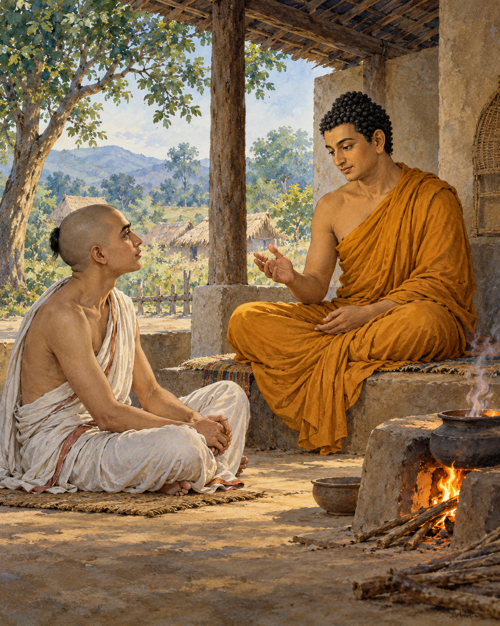
Assalayana was sixteen, learned and reluctant. A group of brahmins wanted him to debate the Buddha, who taught that spiritual purity was possible for people of all four social classes. They considered the young scholar capable of challenging that claim.
He knew the scriptures expected of him. He also knew that the Buddha would not be an easy opponent. He tried to decline. The older men urged him again, and eventually he went with a company of brahmins to meet the teacher near Savatthi.
The conversation began courteously. Assalayana stated the position he had been sent to defend: brahmins alone were superior and pure, heirs of a sacred birth that set them above other people.
The Buddha answered with questions rooted in things that could be observed. Brahmin women conceived, gave birth and nursed their children. The ordinary facts of human birth did not disappear beneath a claim of exceptional origin. Why should a declaration of superiority overrule the shared conditions of life?
Assalayana held to the inherited position. The Buddha continued patiently. In some neighbouring societies, social arrangements differed; people could pass between the status of an enslaved person and a master. An order that appeared fixed in one place was not understood everywhere in the same way.
Then came the question of conduct. If a person killed, stole, lied and acted cruelly, would birth protect that person from the consequences? Assalayana could not reasonably reserve moral accountability for the supposedly lower classes. Wrongdoing remained wrongdoing, whoever committed it.
And if someone refrained from harm and cultivated a good life, was that goodness available only to a brahmin? Again, the young scholar acknowledged what the question made plain. People of every class could act well. Members of every class could develop a mind of goodwill.
The Buddha offered an image of fire. Imagine people from different classes kindling flames from different materials. Would a fire made by someone of high birth burn with a special brightness, while another person’s fire failed to give heat? The usefulness of the flame did not obey the rank of the hands that kindled it.
A simple physical comparison exposed the strain in the larger argument. If fire could not be made superior by ancestry, why assume that moral and contemplative capacities belonged to ancestry alone? The discussion moved through other examples, repeatedly returning attention from social assertions to the conditions of actual human life.
Assalayana grew quiet. He sat with lowered shoulders and bowed head, unable to sustain his earlier confidence. There is discomfort in that moment. To lose an argument before one’s elders can feel like losing the ground beneath one’s feet.
The Buddha did not leave him there merely as a defeated boy. The discourse continues with an account about brahmins of the past whose pride was also questioned. Assalayana was being invited into a longer examination, not singled out as uniquely foolish. He eventually expressed trust in the Buddha’s teaching.
No society is transformed by a single courteous debate. The inequalities around these men did not vanish when their conversation ended. But something essential had been stated: birth was no substitute for conduct, and no barrier could make compassion the exclusive property of one group.
The young scholar had arrived carrying a claim about who could be pure. He left with a harder and more hopeful possibility: that the worth of a life had to be cultivated, and that the capacity to begin was shared.

Wisdom to Remember
Human dignity and the capacity for goodness do not depend on inherited rank.

A Reflection for Today
Notice where a label changes the respect you offer someone: occupation, wealth, accent or family background. In your next encounter, make room for the person beyond the label. Fairness becomes real through ordinary choices.

Source Note
Original literary retelling of Assalāyana Sutta, MN 93, preserved in the Pali Canon of the Theravada tradition. Canonical narrative; not an independently verified historical transcript. Read the source. No dialogue here is offered as a verbatim quotation. Sensory staging and transitions are literary reconstruction. This is a selected retelling of a longer debate. Ancient four-class terminology does not map neatly onto every later caste system. The fire is a hypothetical comparison, not a hearth literally described at the meeting.

18. A Night in the Potter’s Shed
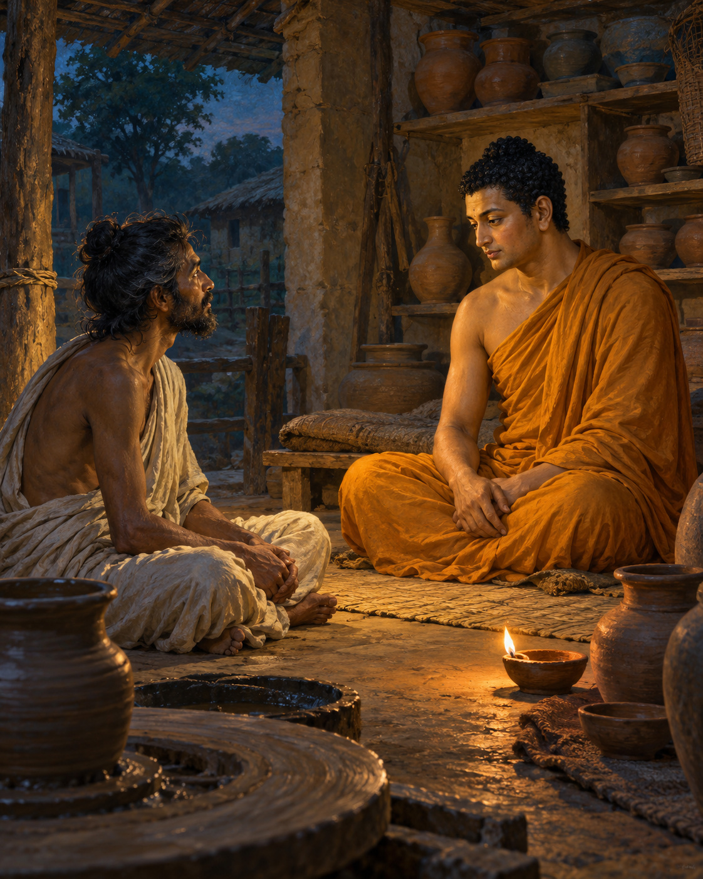
The potter did not offer a palace. He offered space in a shed, with one condition: another wanderer was already staying there, and the newcomer should ask his permission.
The Buddha had come to Rajagaha while travelling through Magadha. He accepted the condition and approached the man inside. The shed was spacious, the other wanderer replied; his guest could stay.
The man was Pukkusati. He had left home out of confidence in the Buddha, whose reputation had reached him, but he had never met the teacher himself. He did not recognise the person now sharing his shelter.
The two settled down to meditation. The Buddha spread grass, sat upright and established mindfulness. Pukkusati also spent much of the night in practice. Nothing in the arrangement demanded ceremony. One traveller had made room for another.
Observing his companion’s sincerity, the Buddha began a conversation. For whose sake had Pukkusati left home? Who was his teacher? The wanderer explained his confidence in Gotama, the awakened teacher he hoped to follow. Asked whether he would recognise him, he admitted that he would not.
The Buddha did not first announce his identity. He offered a teaching, and Pukkusati agreed to listen. The night became a lesson in the elements, sensation, awareness and the work of letting go.
Human experience could be examined through six elements: solidity, fluidity, heat, motion, space and consciousness. What seemed so insistently one’s own could be examined as changing conditions. A person did not need to deny experience in order to stop fastening the claim of ownership onto everything that appeared within it.
The teaching was exacting. It moved beyond comfort and beyond a promise of pleasant feeling. Even refined states required understanding. Peace could not be secured by clinging to a delicate experience and insisting that it remain. Wisdom, truthfulness, relinquishment and calm were to be cultivated together.
As Pukkusati listened, recognition came. This was no ordinary fellow wanderer explaining another man’s doctrine. The teacher for whom he had left home was sitting beside him. He rose, arranged his robe respectfully and acknowledged the mistake of having addressed the Buddha simply as a companion.
The Buddha accepted the acknowledgement. Pukkusati asked for full ordination. Did he have a complete bowl and set of robes? He did not. He went to obtain the necessary requisites.
While he was searching, a runaway cow killed Pukkusati. The night of understanding was not followed by the long apprenticeship a reader might expect. When the monks later asked about him, the Buddha declared that he had reached the stage of non-returning and would attain final liberation without returning to this world.
The religious assurance belongs to the canonical story. The sudden death keeps the narrative from becoming a promise that spiritual sincerity guarantees ordinary safety. Insight does not bargain away the vulnerability of a human body.
What remains in the shed is a meeting made possible by hospitality. Pukkusati had not recognised a famous face; he had offered room to a stranger and listened carefully. For one night, in a place meant for a potter’s work, he encountered the teaching he had travelled to find. The account grants no second evening. That first act of welcome had been enough to let the meeting begin.

Wisdom to Remember
Attend to what is true before you; wisdom need not arrive in a recognisable form.

A Reflection for Today
Give someone your full attention without first measuring their status. Listen carefully, while retaining good judgement. Also consider one worthwhile task you have postponed as though time were guaranteed.

Source Note
Original literary retelling of Dhātuvibhaṅga Sutta, MN 140, preserved in the Pali Canon of the Theravada tradition. Canonical narrative; not an independently verified historical transcript. Read the source. No dialogue here is offered as a verbatim quotation. Sensory staging and transitions are literary reconstruction. Pukkusati’s death and declared spiritual destination are retained from the canonical narrative. Later royal-biographical details are excluded. The six elements are contemplative categories here, not a modern scientific account of matter.

Interlude 9: A Reliable Guardian

Pali — Roman Transliteration
Attā hi attano nātho, ko hi nātho paro siyā?
Attanā va sudantena nāthaṃ labhati dullabhaṃ.

English Meaning
You are your own guardian: who else could be such a guardian?
Through training yourself well, you find a protection difficult to obtain.

Context and Significance
The conventional language of “self” expresses responsibility in practice. It is not a declaration of an eternal soul and does not deny the importance of teachers and mutual care.

Source and Attribution
Dhp 160. Pali Canon, Khuddaka Nikaya; canonical text in the Theravada tradition. The Pali is already presented in Roman transliteration; there is no separate “transliteration” of an English translation. Punctuation, capitalisation, word division and the nasal sign have been regularised for this edition. The English is an original rendering prepared for this collection, not a reproduced modern translation. Ancient verse and modern editorial apparatus have different copyright status.
Source consulted: https://ancient-buddhist-texts.net/Buddhist-Texts/K2-Dhammapada-New/12-Atta.htm

19. Soma’s Answer
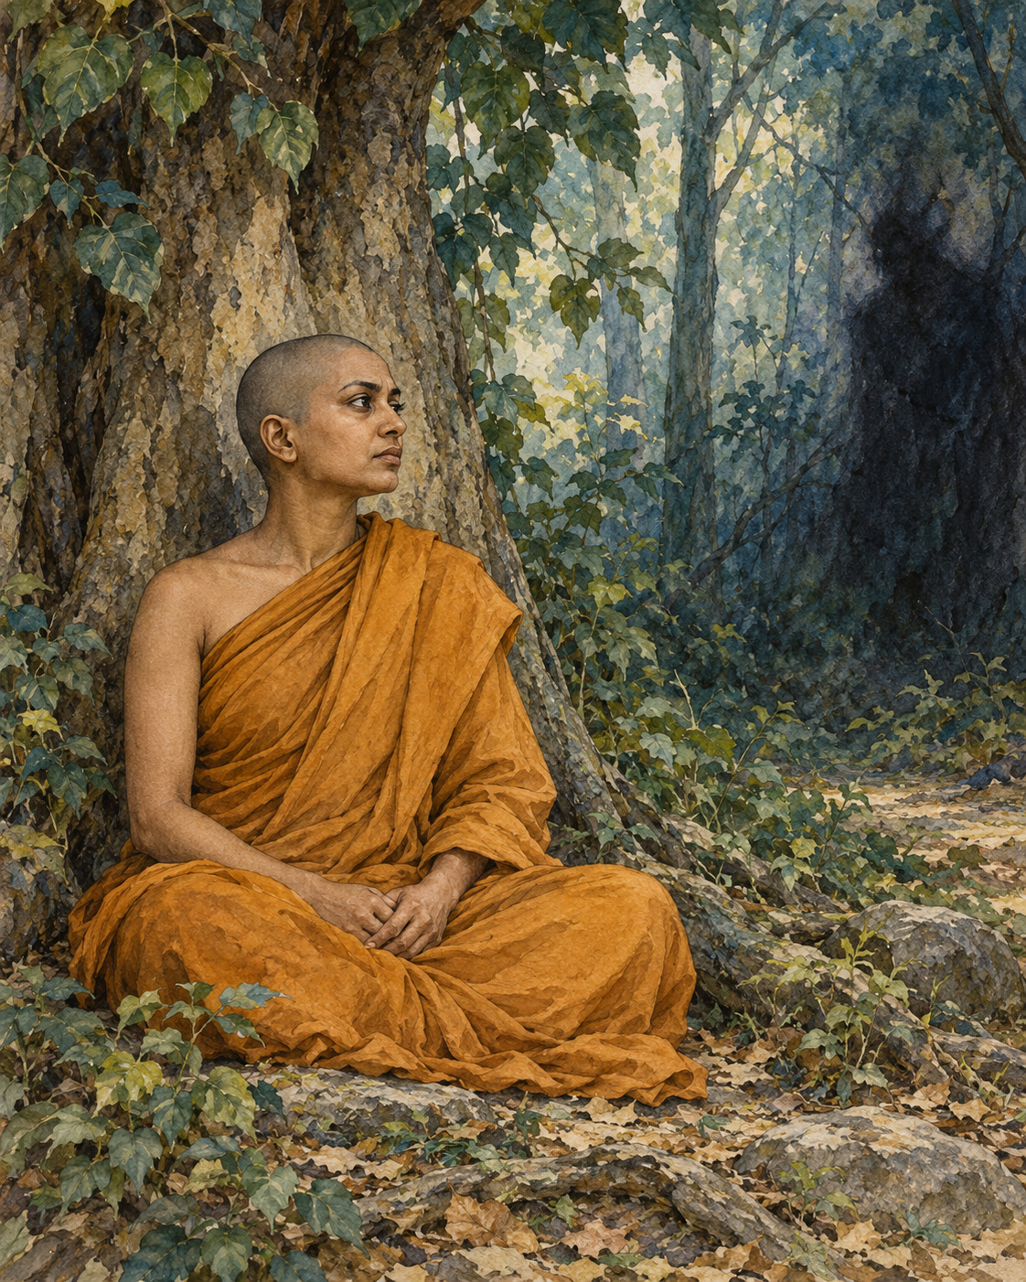
After her alms round in Savatthi, Soma ate and went to the Blind Men’s Grove. She was a bhikkhuni, a woman who had entered the Buddhist monastic life. Beneath a tree she sat down for the day’s meditation.
A grove can shelter attention without sealing a person away from difficulty. The world does not become harmless because someone closes her eyes. The story gives the interruption a name and a voice: Mara, the adversary who seeks to disturb liberation.
He approached with a familiar weapon. The state sought by seers was too difficult, he suggested, for a woman of limited understanding. The insult reduced her before considering her practice. Her sex, in his argument, had already decided what she could attain.
The disparagement was meant to enter her meditation and make itself at home. She was to think about her supposed inadequacy instead of attending to the work before her. It would be enough, perhaps, to make her hesitate: to turn a quiet interval of practice into another attempt to justify her right to practise at all.
Soma recognised the interruption. She considered who could be speaking in this way and understood it as Mara’s attempt to frighten and unsettle her. Recognition gave her room to answer without taking his measure of her as her own.
Her reply did not ask for a special exception. It questioned the relevance of the insult itself. What did womanhood have to do with a mind well composed, with knowledge established and the teaching understood? The qualities needed for liberation were not replaced by a social judgement about gender.
She went further. A mind fastening itself to the thought of being a woman, a man, or a fixed identity of any kind offered Mara something to seize. In the direction her practice was taking, those claims could be seen rather than obeyed. She did not need to construct a grander image of herself in order to defend against a smaller one.
Mara found that she knew him. Disappointed, he disappeared. The encounter ended without a struggle for the last word. Soma had seen what was being attempted, and the attempt had failed. Her meditation had not required her to make an enemy of the whole world. It had required her to recognise this voice, in this moment, and not yield her understanding to it.
The words had found no foothold. Their promise of certainty—that her birth had already settled her possibilities—could no longer pass for knowledge. She had answered from the qualities being developed in practice: composure, discernment and an understanding that did not need to be granted by the voice opposing her. What he had called impossible was the very work she was doing.
The grove returns, in the reader’s imagination, to its ordinary quiet. There is a woman beneath a tree, and there is work she has chosen to do. The judgement brought against her has not defined the reach of that work. In this small canonical scene, wisdom is allowed to speak in her voice, and the voice that tried to silence it has nothing left to add.

Wisdom to Remember
Another person’s prejudice does not determine the capacity of your mind.

A Reflection for Today
When you notice an inherited judgement about who can learn, lead or belong, examine it. Support someone’s real opportunity to practise or contribute. If the judgement is directed at you, seek allies as well as inward steadiness.

Source Note
Original literary retelling of Somā Sutta, SN 5.2, preserved in the Pali Canon of the Theravada tradition. Canonical narrative; not an independently verified historical transcript. Read the source. No dialogue here is offered as a verbatim quotation. Sensory staging and transitions are literary reconstruction. Mara’s encounter is a canonical supernatural narrative, not a documented historical event. Reading Mara psychologically is an interpretive option. Soma’s answer concerns liberation and does not erase the material effects of gender discrimination.

20. A King Learns Enough
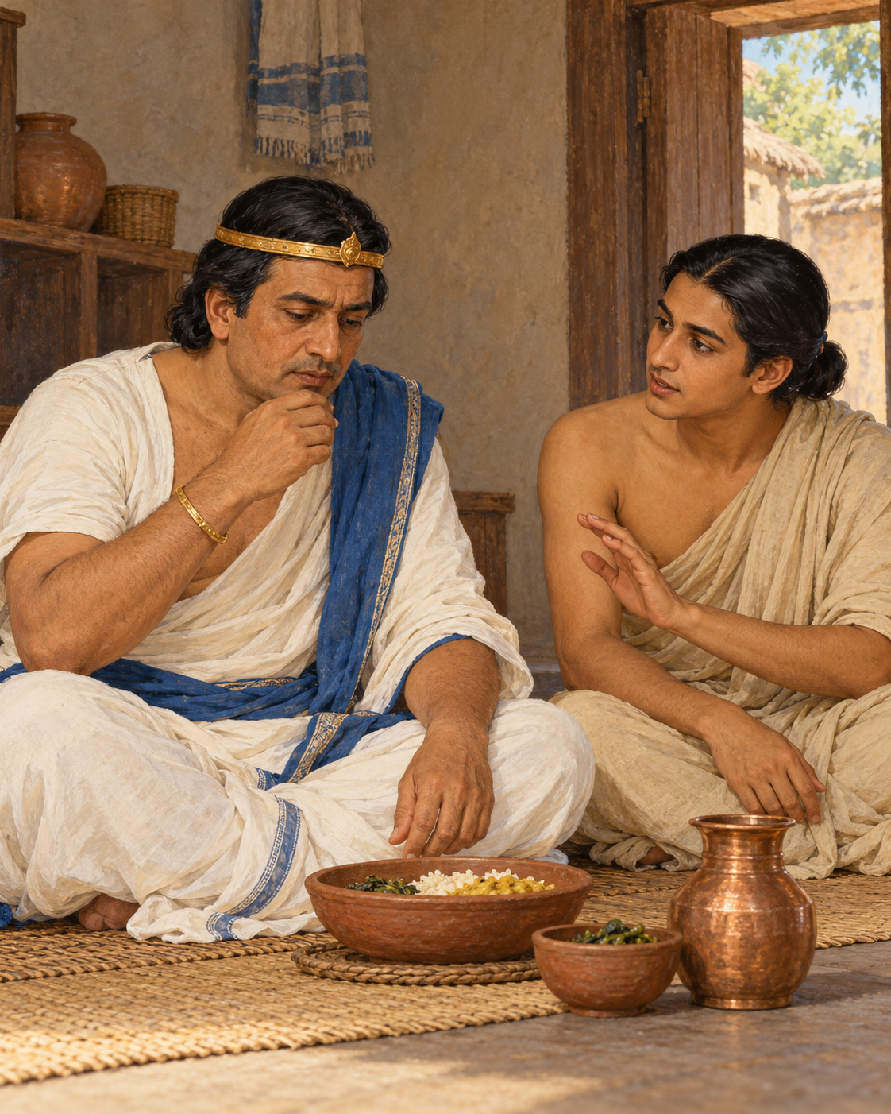
King Pasenadi had eaten, but the meal had not left him at ease. When he visited the Buddha, he was breathing heavily after a large quantity of food. The encounter began with a body announcing what royal dignity might have preferred to conceal.
A king could command a generous table. He could arrange for dishes to appear, reward those who served him and expect his wishes to be fulfilled. Yet command over a household did not automatically bring understanding of his own appetite. Abundance could become uncomfortable when no clear sense of enough stood beside it.
The Buddha noticed his condition and offered a verse about mindfulness and moderation in eating. The advice connected attention at the meal with a reduction in bodily discomfort and care for life. It gave the king something practical to remember when the next meal arrived.
Sudassana, a young brahmin, was standing behind him. Pasenadi turned to the attendant and asked him to learn the verse from the Buddha, then recite it during the king’s meals. He promised a regular payment for the service.
The request had a modest wisdom of its own. An intention formed after discomfort can fade when appetite returns. The king did not rely solely on remembering that afternoon’s regret. He placed a reminder where the old habit would happen, and entrusted another person with helping him hear it.
Sudassana learned the verse. At meals, its teaching returned to the king’s attention. The repeated reminder met him where a general resolution might have been forgotten: with the food before him and the opportunity to eat more still within reach. The change came by degrees. Pasenadi gradually reduced the amount he ate.
Gradual change matters in this little story. Pasenadi did not display his seriousness by refusing all nourishment. Nor did the Buddha praise a punishing struggle against the body. The direction was towards moderation: receiving food with awareness of what sustained him, rather than allowing availability to decide the measure.
Over time, the account says, the king became more physically comfortable. He touched his limbs and expressed gratitude for the Buddha’s concern, recognising benefit in the present life as well as in the spiritual life to come.
It is easy to treat a king’s meal as a small subject beside teachings on suffering and liberation. But a day is built out of small occasions. Eating, speaking, resting and taking what is offered are places where intention becomes behaviour. A practice that never reaches those occasions would remain distant from the person attempting to live it.
The king’s position also gave the scene a particular gentleness. He was not required to defend the size of his meal or demonstrate that his discomfort was beneath notice. He could hear advice, ask for support and change an ordinary habit. His dignity did not depend on having been wise already.
The food was still there to nourish him. He had learned to receive it with a clearer sense of measure. Sudassana’s small task had helped make that possible: a few remembered words, spoken when the king most needed to remember them.
When Pasenadi later remembered the help he had received, he recognised compassion in something as practical as a reminder at dinner. A teaching had travelled from the Buddha’s presence to the table where it was needed. There it became a pause, a choice, and eventually a different way of taking enough.

Wisdom to Remember
A clear intention becomes stronger when everyday conditions help you remember it.

A Reflection for Today
Choose one ordinary habit you want to approach with greater care. Place a gentle reminder at the relevant moment and invite suitable support. With food, attend to your individual needs; this story is not medical or dietary guidance.

Source Note
Original literary retelling of Doṇapāka Sutta, SN 3.13, preserved in the Pali Canon of the Theravada tradition. Canonical narrative; not an independently verified historical transcript. Read the source. No dialogue here is offered as a verbatim quotation. Sensory staging and transitions are literary reconstruction. The source identifies Sudassana as a young brahmin; some other tellings call him a prince or substitute Uttara. No exact modern dietary quantity or guaranteed health effect is inferred from the ancient account.

Interlude 10: The Shape of the Teaching

Pali — Roman Transliteration
Sabbapāpassa akaraṇaṃ, kusalassa upasampadā;
Sacittapariyodapanaṃ, etaṃ buddhāna sāsanaṃ.

English Meaning
Refrain from every harmful deed; bring what is skilful to fulfilment;
clear your own mind: this is the instruction of the Buddhas.

Context and Significance
The verse joins restraint, positive cultivation and purification of mind. The plural “Buddhas” belongs to Buddhist tradition and should not be silently changed to a single speaker’s modern slogan.

Source and Attribution
Dhp 183. Pali Canon, Khuddaka Nikaya; canonical text in the Theravada tradition. The Pali is already presented in Roman transliteration; there is no separate “transliteration” of an English translation. Punctuation, capitalisation, word division and the nasal sign have been regularised for this edition. The English is an original rendering prepared for this collection, not a reproduced modern translation. Ancient verse and modern editorial apparatus have different copyright status.
Source consulted: https://ancient-buddhist-texts.net/Buddhist-Texts/K2-Dhammapada-New/14-Buddha.htm

21. Fields of Generosity
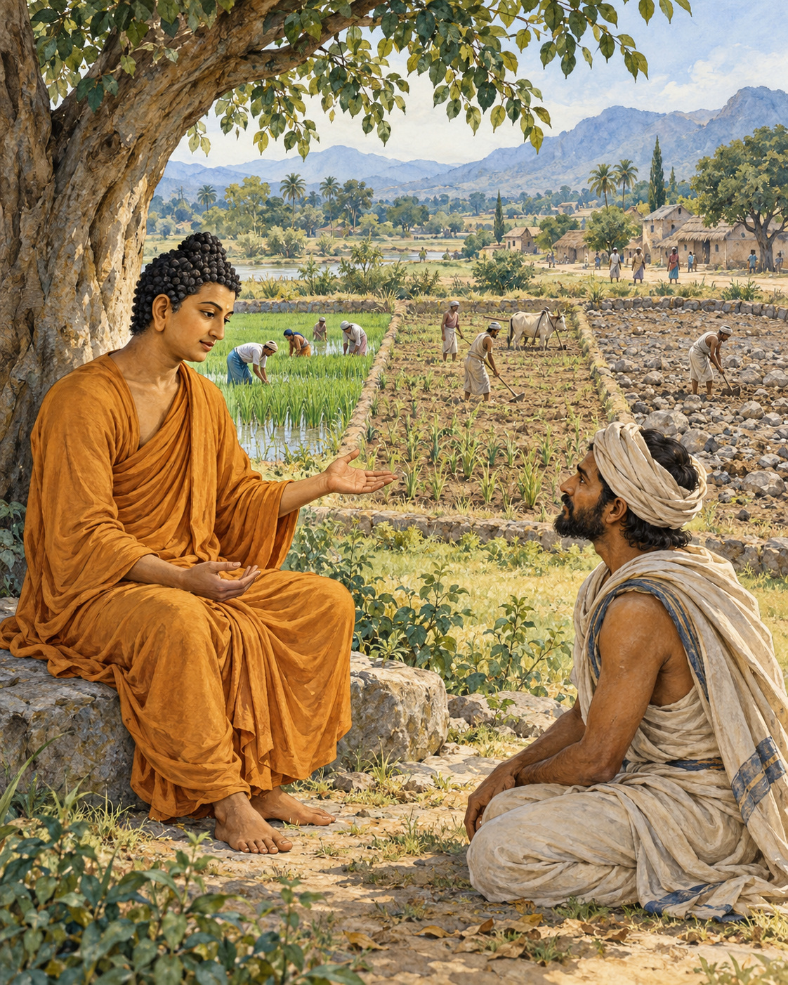
A chief came to the mango grove with a question that sounded almost like an accusation.
The Buddha was staying near Nalanda, in a grove belonging to Pavarika. Asibandhaka’s son approached him, offered the customary greeting, and sat nearby. He wanted to know whether the Buddha truly felt compassion for every living being. When the Buddha affirmed that he did, the chief pressed the difficulty. Why, then, did he teach some people at greater length than others?
It was an uncomfortable question, and a necessary one. Compassion could appear partial when measured by the time a teacher gave to different listeners. A person hearing only a short instruction might reasonably wonder whether those receiving more were also loved more.
The Buddha answered with the work of a farmer. Imagine three fields, he suggested. One has good soil. Another is middling. The third is poor ground, sandy and salty. A farmer has seed to sow and must decide where to begin.
The chief understood such a choice. The best field would be planted first, the average field next. The poor field might be planted afterwards, or might not. Yet even there, something useful could grow: fodder for the animals, if not a harvest for the household.
The Buddha then explained his comparison. The monks and nuns who had committed their lives to the training were like the first field. Lay followers were like the second. Ascetics and religious teachers following other paths were like the third. The image reflected their different relationships to his teaching, rather than a claim that some lives possessed greater worth.
He taught all three groups the whole way of practice, from its beginning through its development to its fulfilment. The monastic and lay followers had taken the teaching as their refuge and would shape their lives around it. For those outside his community, even one sentence understood might contribute to their lasting well-being.
The poor field had not disappeared from the farmer’s concern.
Then came another image, closer to the household. Imagine three water jars: one sound and watertight, one whole but porous, and one both porous and cracked. Someone bringing water would fill the vessel best able to hold it before turning to the others.
Again, the chief could see the practical sense. Yet water put into the damaged jar need not be entirely wasted. It might still serve for washing dishes. A vessel did not have to be perfect before it could be of use.
The two comparisons answered the same worry from different directions. Teaching required attention to what a person could receive, remember, and practise. Giving everyone precisely the same explanation would not necessarily give everyone the same help. A long discourse could pass straight through an unwilling listener; a single sentence might remain for years in someone who had seemed unreachable.
The chief had arrived questioning the Buddha’s compassion. He left having declared himself a lay follower. The account does not tell us which sentence changed his mind, or whether the fields or the jars stayed with him longer.
It leaves us instead with the teacher’s reason for speaking even where understanding seemed least likely. Something might be received. Something might take root. The chance of that small beginning was enough to keep the conversation open.

Wisdom to Remember
Compassion attends to what each person can receive. A small understanding can still matter greatly.

A Reflection for Today
When helping someone learn, ask what would be useful now. Offer a manageable beginning rather than measuring generosity only by the amount of advice you give. This principle should never become an excuse to dismiss a learner as permanently incapable.

Source Note
Original retelling of SN 42.7, Khettūpama Sutta, especially sections 1–5: SuttaCentral. Pali canon; Theravada transmission; canonical teaching encounter with two similes. The subject is the giving of instruction, not a ranking of recipients of material donations. The imagery belongs to the text; the narrative framing and interpretation are editorial. This is not a transcript or an independently established historical report. No modern translation is quoted.

22. Eight Measures of Freedom
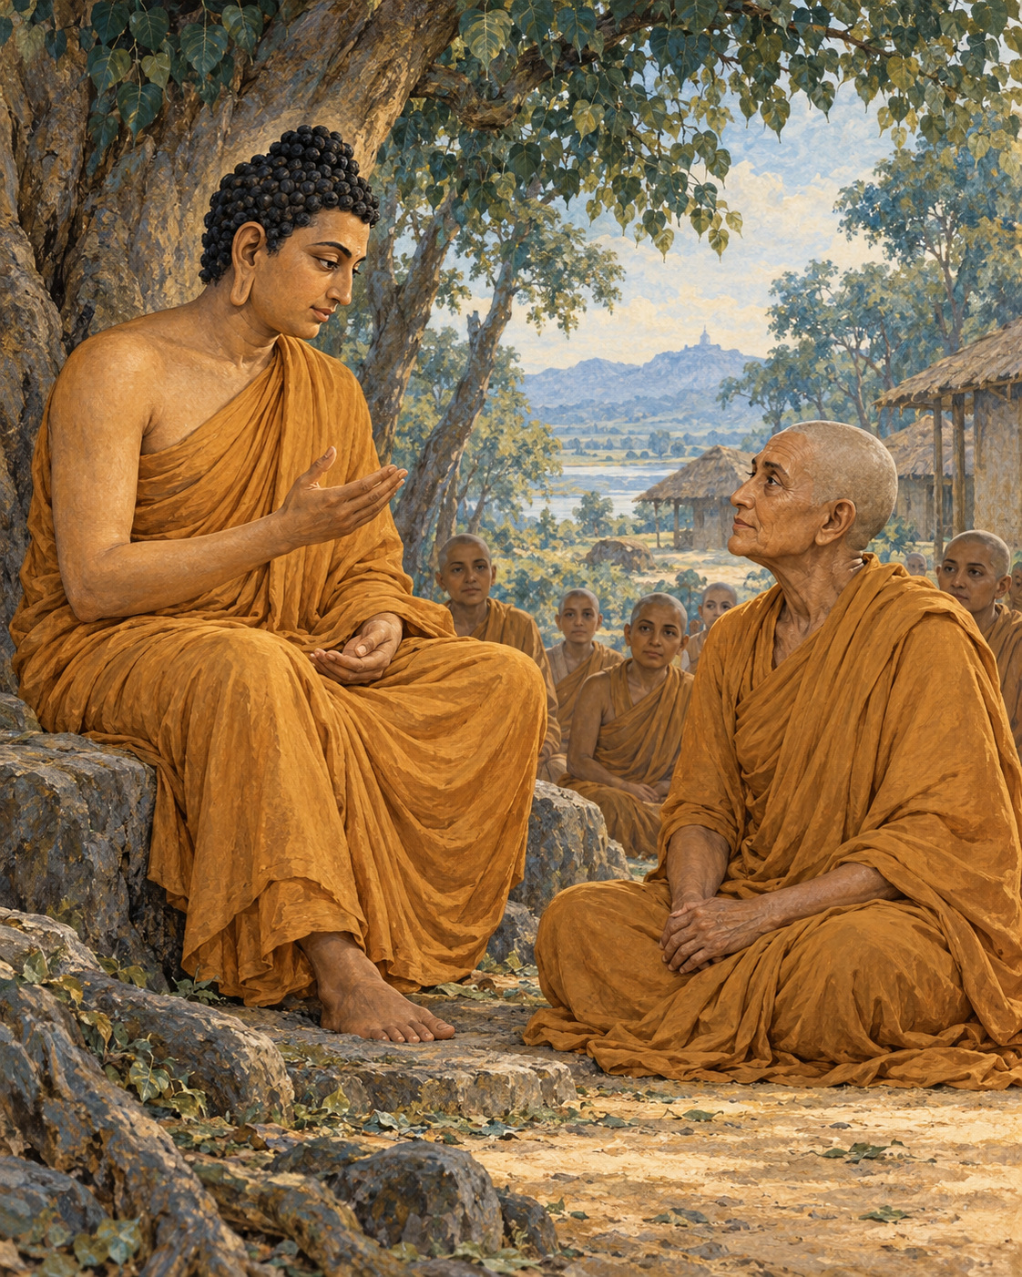
Gotami did not ask for a teaching that would occupy an afternoon. She asked for one that could accompany her into solitude.
The Buddha was staying near Vesali, in the hall with the peaked roof in the Great Wood. Mahapajapati Gotami came to him, bowed, and stood respectfully nearby. Her request was brief: would he give her an instruction concise enough to remember, something she could put to work while living apart, attentive and determined?
She was not asking to be entertained by wisdom. She wanted a way to practise when the teacher was no longer sitting in front of her.
The answer gave her a means of recognition. Certain qualities, the Buddha explained, lead in one direction; others lead in its opposite. She could learn to distinguish his teaching by the direction in which it carried a life.
Did a practice intensify craving, or help craving loosen? Did it fasten the mind more tightly to its bonds, or make release possible? Did it encourage further accumulation, or a willingness to relinquish? These were not questions about the grandeur of an argument. They concerned the changes that could actually be observed in a person.
Then the instruction moved through the more familiar habits of daily living. Did the practice multiply wishes, or help someone live with fewer? Did it keep dissatisfaction alive, or cultivate contentment? Did it draw a person continually into a crowd, or support the quiet needed for understanding?
The last measures were equally practical. Did it encourage idleness, or summon energy? Did it make someone burdensome to others, or help them live with greater consideration?
Eight pairs; eight ways of finding one’s bearings.
What led towards craving, bondage, accumulation, multiplying wants, discontent, crowding, laziness, and burdening others was not the teaching and training he intended. What led in the opposite direction could be recognised as his instruction.
Gotami had asked for something short. The answer was short enough to retain and demanding enough to occupy a lifetime. It offered no shortcut around honesty. She would have to notice the results of what she cultivated, including results that contradicted her hopes for herself.
A person could appear very disciplined while becoming harder to live with. Another could collect impressive teachings while remaining unable to relinquish a minor grievance. The measures would ask what was happening beneath those appearances. A cherished practice could be examined with the same care as an unfamiliar one.
The instruction also refused to confuse freedom with collapse. Contentment stood beside energy, and simplicity beside responsibility. To want less did not mean to stop making an effort. To seek seclusion did not mean making other people carry every practical difficulty. The qualities belonged together, checking one another against easy misunderstandings.
The brief canonical account does not describe Gotami’s next hour. It does not tell us which of the eight measures first exposed a habit she wished to change. We need not invent such a moment to understand what she received.
She had come seeking guidance for life away from the teacher. She was given questions she could bring to any action, any instruction, any claim of spiritual progress. Even in solitude, she would not have to judge the path by its name alone. She could look at where it was taking her.

Wisdom to Remember
Judge a practice by what it cultivates in a life: less grasping, greater care, and sustained effort towards freedom.

A Reflection for Today
Choose one of the eight measures for the coming week. Notice, without self-punishment, whether a familiar habit increases discontent or makes enough feel possible. Make one practical adjustment and observe its effects.

Source Note
Original retelling of AN 8.53, Saṅkhitta Sutta, also titled Gotamī Sutta: SuttaCentral. Pali canon; Theravada transmission; canonical instruction to Mahapajapati Gotami. The eight contrasts are paraphrased. The fourth is rendered here as many wishes/few wishes; English translations differ in phrasing. No ordination controversy or later biography is imported into this short encounter. Reflective examples are original commentary, not reported events. No canonical dialogue is reproduced verbatim.

23. Nanda Comes Home to Himself

Nanda had left home, but a moment at the doorway kept following him.
He remembered a young Sakyan woman looking up while her hair was only partly arranged. She had asked him to return soon. In the monastery, among men who had chosen renunciation, he continued returning to that unfinished moment instead. His body had come to the grove; his longing had remained at home.
At last he told other monks that he could no longer endure the training. He intended to leave.
The news reached the Buddha, who summoned him and asked what troubled him. Nanda answered without concealing the cause. He missed the woman and could not settle into the life he had undertaken.
At this point the canonical account enters the world of religious marvel. It tells how the Buddha took Nanda by the arm and brought him to the heaven of the Thirty-three. This is the text’s sacred narrative, not a journey that historical research can establish.
There Nanda saw celestial women whose beauty overwhelmed the memory he had cherished. Asked to compare them with the woman at home, he answered with a harshness that exposed how quickly desire could abandon its object. The person who had seemed incomparable a moment before was suddenly dismissed. His longing had not become kinder or wiser. It had merely found something more dazzling.
The Buddha assured him of these celestial companions, and Nanda agreed to persevere in the training. A heavenly reward now seemed sufficient reason to remain a monk.
When they returned, the other monks learned of the arrangement. They mocked him as someone working for wages, someone whose religious life had been bought. Their ridicule stung. The account does not require us to imitate it, or to believe that humiliation is always helpful. It records the discomfort that finally sent Nanda into solitude.
Alone, he applied himself with care and determination. Here the story changes its scale. Celestial splendour recedes; the work is the work of attending, understanding, and relinquishing. Nanda no longer appears before us as an admirer bargaining for possession. The text describes him practising until he attained arahantship: freedom from the defilements and from the bondage of further rebirth.
His transformation was not the satisfaction of his earlier bargain. It was release from needing the bargain at all.
The account says that a deity brought news of Nanda’s attainment to the Buddha, who also knew it directly. When morning came, Nanda visited him. He no longer wanted to hold the Buddha to the promise of celestial companions. The undertaking could be set aside.
The Buddha explained that it had already ceased to bind him when Nanda’s mind became free of clinging.
The remembered doorway had once seemed to contain everything Nanda wanted. Heaven had then seemed to contain still more. Each prospect had offered happiness as something to obtain, and each had made the present life into a means of reaching somewhere else.
Now there was no further demand to present. The young woman did not need to become less beautiful; heaven did not need to become less splendid. Nanda’s freedom lay in the ending of the grasping that had made every beauty into a promise he had to collect.
He had returned to the teacher without asking for anything.

Wisdom to Remember
A change of desire is not yet freedom from desire. The deeper change is learning to release the demand to possess.

A Reflection for Today
Notice one reward that seems to justify postponing your life. Ask what kind of care or meaningful effort remains worthwhile even if that reward never arrives. Let this be an inquiry, not a judgement against ordinary affection.

Source Note
Original retelling of Udāna 3.2, Nanda Sutta: SuttaCentral. Pali canon; Theravada transmission; canonical religious narrative containing supernatural travel, celestial beings, and a report of arahantship. These elements are not presented as independently verified history. The text’s objectification of women and the monks’ mockery are acknowledged without endorsing them; its degrading comparison is not reproduced. Psychological transitions and narrative emphasis are editorial. No modern translation or purported verbatim historical dialogue is reproduced.

Interlude 11: Patience Without Injury

Pali — Roman Transliteration
Khantī paramaṃ tapo titikkhā,
Nibbānaṃ paramaṃ vadanti buddhā;
Na hi pabbajito parūpaghātī,
Samaṇo hoti paraṃ viheṭhayanto.

English Meaning
Patient endurance is the highest austerity;
the Buddhas call nibbana supreme.
One who harms others is no true renunciant;
one who torments others is no contemplative.

Context and Significance
This canonical verse links spiritual discipline to non-injury. Its praise of endurance cannot justify abuse inflicted by a teacher or anyone else.

Source and Attribution
Dhp 184. Pali Canon, Khuddaka Nikaya; canonical text in the Theravada tradition. The Pali is already presented in Roman transliteration; there is no separate “transliteration” of an English translation. Punctuation, capitalisation, word division and the nasal sign have been regularised for this edition. The English is an original rendering prepared for this collection, not a reproduced modern translation. Ancient verse and modern editorial apparatus have different copyright status.
Source consulted: https://ancient-buddhist-texts.net/Buddhist-Texts/K2-Dhammapada-New/14-Buddha.htm

PART IV: Wisdom for Every Day

24. The Second Arrow

The first arrow had already struck. The question was whether another would follow it.
To explain the difference between an untrained mind and a mind instructed in the path, the Buddha asked his listeners to consider something they shared. Both experienced pleasant feelings. Both experienced painful feelings. Both knew feelings that were neither especially pleasant nor painful. Learning the teaching did not give a person a different kind of body, sealed against discomfort.
Where, then, did the difference lie?
He offered the image of someone wounded by an arrow, then struck by a second. The second wound did not heal the first. It added another pain to the one already present.
So it could be with bodily suffering. Someone experiencing physical pain might become overwhelmed by grief, agitation, and resistance. The body hurt; the mind then suffered over the hurt. What had begun as one affliction acquired another, and the person had to bear both.
This was a simile, not the report of an injured stranger brought before the Buddha. Its force came from the simplicity of its picture. No listener needed to know the name of the wounded person to recognise how readily distress could multiply.
The teaching went further than asking someone to endure a difficult sensation. When pain arrived, an untrained person resisted it. Seeking escape, they might reach for sensual pleasure because they knew no other way out. A brief relief could then become another attachment. The mind moved between refusing what it disliked and clutching what it hoped would rescue it.
Even neutral feeling could remain misunderstood. Without clear attention, the ordinary texture of experience passed unexamined, leaving ignorance in place. Pleasant, painful, and neutral feelings could all become occasions for bondage when they were met without understanding.
The trained disciple still felt the first arrow. Physical pain remained physical pain. But the disciple did not build the same additional suffering around it. Rather than being carried entirely into resistance or a desperate search for pleasure, the mind understood feeling more clearly: its arising, its passing, its attraction, its danger, and the possibility of release.
The distinction was not between a person who felt and a person who had become numb. It was between different ways of knowing what was felt.
Imagine, within the simile, how much care the first wound already required. It needed to be noticed rather than denied. Adding another arrow could only make that work more difficult. In the same way, attention to pain was not a refusal of help. The teaching concerned the mind’s relationship to suffering, not an instruction to leave a wound untreated.
The Buddha’s comparison did not demand that a beginner possess the steadiness of a fully trained disciple immediately. It disclosed what the training was for. A person could begin to recognise the movement from pain into resistance, from resistance into grasping, and learn not to follow every movement as though it were inevitable.
The first arrow might be beyond recall. It had happened; it hurt. Yet the teaching allowed a possibility beside the hurt: the mind need not always add to what the body was already carrying.
There was still something to learn, even there.

Wisdom to Remember
Pain deserves care. Understanding can gradually reduce the suffering added by resistance and clinging.

A Reflection for Today
During a manageable discomfort, gently distinguish the sensation from the thoughts gathering around it. Seek appropriate care and support. This practice is not a test of character, and distress, trauma, or illness is never evidence of spiritual failure.

Source Note
Original retelling and exposition of SN 36.6, Sallattha Sutta, sections 1–4: SuttaCentral. Pali canon; Theravada transmission; canonical teaching with an arrow simile, not a historical injury narrative. The surrounding imagined scene and contemporary cautions are editorial. The text contrasts bodily pain with added mental distress and examines attachment to all three kinds of feeling. It is not a medical claim or a guarantee of pain relief. No verbatim canonical dialogue is used.

25. Victory Without Peace
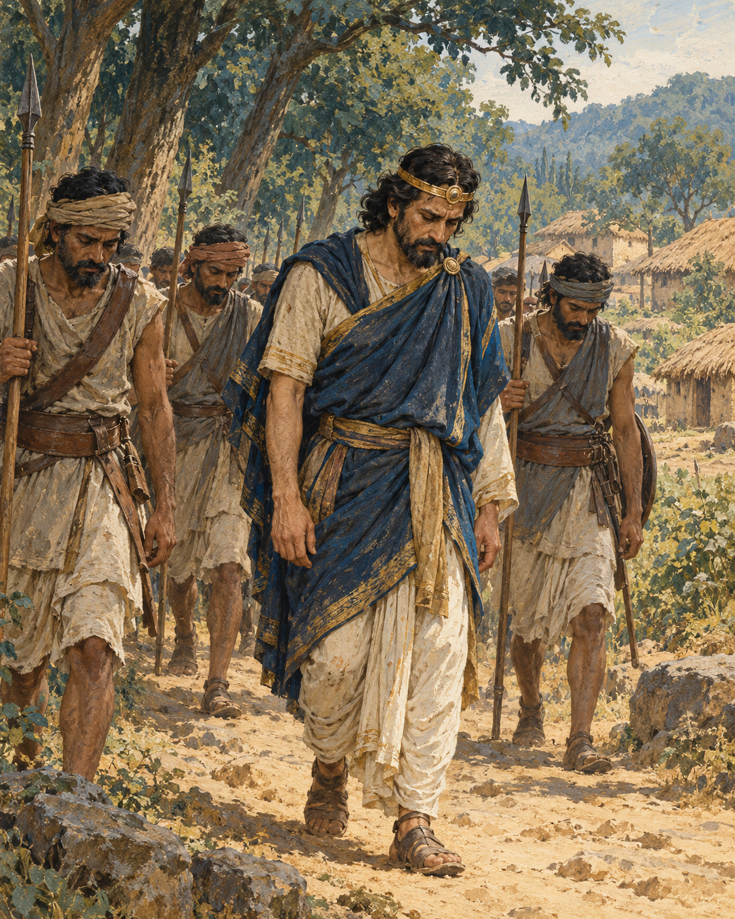
The army came home, and the king came home with it. Victory did not.
Ajatasattu, ruler of Magadha, had raised an army and advanced towards Kasi, against King Pasenadi of Kosala. Pasenadi heard of the movement and gathered his own forces. The two kings met in battle. Ajatasattu prevailed, and the defeated Pasenadi withdrew to his capital at Savatthi.
The canonical account gives the event with little ornament. It does not supply the noise of the fighting, the words exchanged before it, or a count of the dead. Its brevity leaves the defeat starkly visible: a king had gone out to contest a territory and had returned unable to secure it.
In Savatthi, the event became news that travelled with the ordinary movements of the day. Monks entered the city in the morning carrying their bowls. They went from household to household for food, close enough to civic life to hear what had happened. After eating and returning from their alms round, they approached the Buddha and reported the battle.
Their account named the kings and described the outcome. An army had attacked; another had answered; one ruler had won and the other had fallen back. It was the kind of report that could invite an immediate judgement about strength, strategy, or the changing fortune of kingdoms.
The Buddha spoke first about the company the kings kept. Ajatasattu had harmful friends and companions, he said, whereas Pasenadi had good ones. Yet the presence of good companions did not erase the immediate suffering of military defeat. That night Pasenadi would rest badly.
The observation allowed no easy equation between goodness and worldly success. A person could have good friends and still lose a battle. Someone surrounded by bad counsel could still win one. The result on the field did not settle the deeper question of how a life should be lived.
Then the Buddha turned from the two kings to the wider pattern. Winning gave rise to hostility. Losing brought distress. There was ease for those who had become peaceful and relinquished the contest between victory and defeat.
The teaching reached beyond the king who had retreated. The victor’s position was not the same as peace. His success existed in a relationship with another person’s humiliation, and that relationship could keep hostility alive. To have won did not mean that the cause of conflict had ended.
Pasenadi’s unrest that night belongs to the text. We need not invent what he thought as he lay down. The account does not give his private regrets, his plans, or any reply he made to the teaching. It also does not end by awarding him a compensating triumph.
Instead, it leaves the reader with a difficult possibility. One may prevail and remain bound to rivalry. One may lose and be consumed by it. To become free of the contest requires an understanding that the contest itself cannot provide.
The monks had brought news of which king held the advantage. They received a teaching about why neither outcome, by itself, could give the heart its rest. Beyond the defeated ruler’s troubled night lay another kind of accomplishment: learning how to live without making an enemy’s defeat the condition of one’s own peace.

Wisdom to Remember
Success does not automatically end hostility. Peace asks what we are cultivating in the struggle to prevail.

A Reflection for Today
Recall a disagreement you are still trying to win. Identify the practical issue that needs resolution, then distinguish it from the desire to humiliate the other person. A firm boundary or fair remedy can be pursued without feeding that desire.

Source Note
Original retelling of SN 3.14, Saṅgāma Sutta, the first battle discourse: SuttaCentral. Pali canon; Theravada transmission; canonical account involving historical rulers, not an independently corroborated battle report. Pasenadi’s defeat and return to Savatthi belong to this discourse. His later capture and release of Ajatasattu occur in SN 3.15 and are deliberately not imported here. The narrative uses indirect discourse; descriptions of the report’s implications are editorial commentary.

26. Five Things to Remember
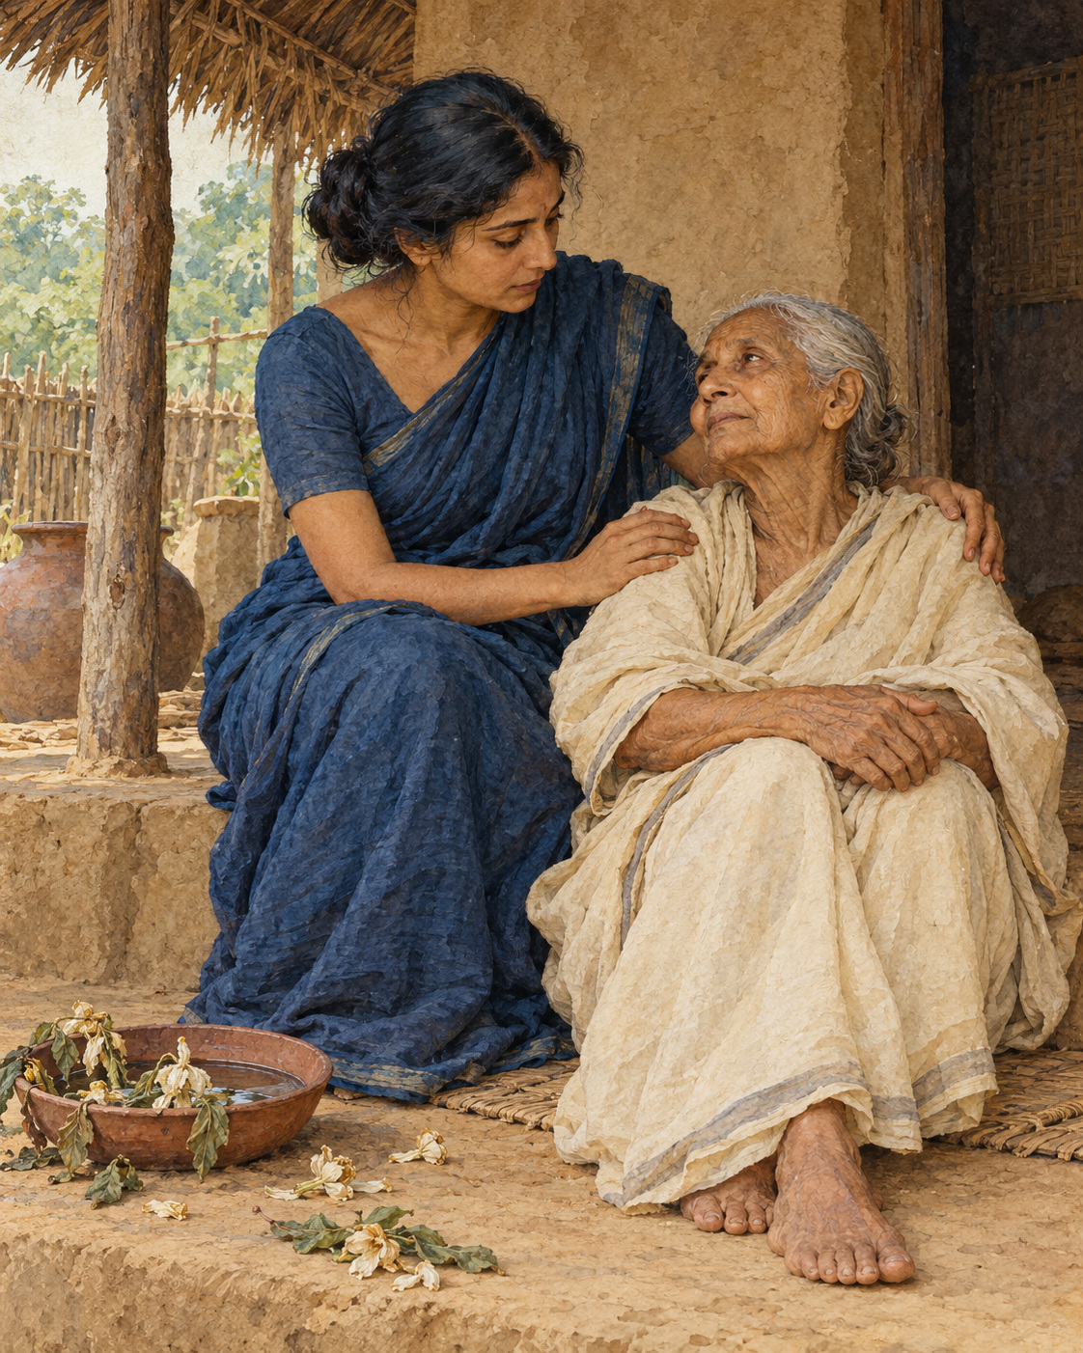
The teaching was for women and men, for people with households and people who had left them. No one had to wait for a particular robe, age, or station in life before beginning.
The Buddha set out five matters to remember often. They concerned things so familiar that a person might pass years without looking at them steadily: ageing, illness, death, separation, and the consequences of action.
A young person could know that old age existed while living as though it belonged permanently to somebody else. Someone in good health could see sickness everywhere and still feel inwardly exempt. A person surrounded by the business of a full day could acknowledge death in principle while assuming there would always be time later to mend what mattered.
The first three recollections brought those distant possibilities closer. The body was subject to ageing and illness. Life would end. These were not punishments singled out for an unfortunate few. They belonged to the conditions of being alive.
The fourth recollection concerned everything held dear. Whatever was loved would be subject to separation and change. Affection could not make people, places, or possessions permanent. Remembering this was meant to weaken the grasping that could turn love into harmful conduct, rather than to make love itself impossible.
The fifth concerned responsibility. A person would inherit the consequences of their actions. Choices made through body, speech, and mind were not weightless simply because the moment of making them had passed.
Together, the recollections challenged several kinds of carelessness. Pride in youth could make another person’s frailty seem contemptible. Pride in health could encourage recklessness or indifference. Confidence in continued life could make cruelty appear affordable. Attachment could justify wrongdoing in the name of protecting what was loved. Forgetting the consequences of action could make all these habits easier to repeat.
The Buddha described regular recollection as a way to diminish such conduct, even where it had not yet been completely abandoned. There was room in the instruction for gradual change. A person could begin where they were, without pretending to possess a wisdom they had only just encountered.
Then the contemplation widened. The disciple was to recognise that these conditions were not merely personal. Other beings too were subject to ageing, sickness, death, separation, and the results of their actions. What could first sound like an inventory of private vulnerability became a recognition of shared existence.
The frail person on the road was no longer evidence of a fate reserved for strangers. The neighbour grieving a separation was not inhabiting an entirely different world. The same uncertainty ran through every household, including one’s own.
This recognition could support the development of the path. The text places the recollections within the work of loosening the bonds that keep suffering alive. They were not offered simply as sombre thoughts to carry through the day.
Nor did remembering death require knowing its date. The uncertainty was itself enough to give weight to the present choice: whether to speak truthfully, whether to repair harm, whether to show care while care could still be received.
There was much that a person could not keep. There was still much they could do. The five recollections brought those two truths into the same field of attention.

Wisdom to Remember
What is fragile deserves care. What we choose deserves attention.

A Reflection for Today
Read the five subjects slowly, stopping if the exercise becomes overwhelming. Choose one act of care that follows naturally: contact someone, arrange needed support, or correct an unkind word. Reflection becomes useful through the life it helps you live.

Source Note
Original literary exposition of AN 5.57, Upajjhaṭṭhāna Sutta, especially sections 1–7 and the succeeding universal recollections: SuttaCentral. Pali canon; Theravada transmission; canonical instruction, not a biographical episode. The illustrative everyday situations are original applications, not ancient reported events. Kamma here means morally consequential action; this retelling does not claim that every illness or misfortune results from a person’s past wrongdoing. No modern translation is quoted.

Interlude 12: The Wealth of Enough

Pali — Roman Transliteration
Ārogyaparamā lābhā, santuṭṭhiparamaṃ dhanaṃ;
Vissāsaparamā ñātī, nibbānaṃ paramaṃ sukhaṃ.

English Meaning
Health stands foremost among gains; contentment among riches.
Trust is the finest kinship; nibbana is the highest happiness.

Context and Significance
This praise of health and contentment is a value statement, not a judgement on people living with illness or poverty. Liberation remains distinct from ordinary comfort.

Source and Attribution
Dhp 204. Pali Canon, Khuddaka Nikaya; canonical text in the Theravada tradition. The Pali is already presented in Roman transliteration; there is no separate “transliteration” of an English translation. Punctuation, capitalisation, word division and the nasal sign have been regularised for this edition. The English is an original rendering prepared for this collection, not a reproduced modern translation. Ancient verse and modern editorial apparatus have different copyright status.
Source consulted: https://ancient-buddhist-texts.net/Buddhist-Texts/K2-Dhammapada-New/15-Sukha.htm

27. A Single Fortunate Day

A day could be spent in places the body had never gone.
Someone seated beneath a tree might return inwardly to a long-vanished season, rearranging its details, wishing to inhabit an earlier self. Another might live among imagined conditions not yet arrived, waiting for a future body, a future feeling, a future life to make the present one complete.
At Jeta’s Grove, near Savatthi, the Buddha gave the monks a teaching about a life no longer carried away in those directions. He began in verse, then explained its meaning. Its traditional title is difficult to render precisely, but its concern is clear: how to use this available day and night with understanding.
The past had already gone. The future had not yet come. What had arisen in the present could be known clearly, without being swept away by it. The work called for diligence now, because no one could bargain for the certainty of tomorrow.
That teaching might sound, at first, like an instruction simply to stop remembering or planning. The Buddha’s explanation was more exact. He described being drawn into the past through delight in what one had been: a particular body, certain feelings, perceptions, intentions, or states of consciousness. The mind gathered around these remembered experiences and made a home there.
The future could attract the same movement. A person imagined becoming someone with a certain appearance, certain pleasures, certain experiences. Desire reached towards the picture and began to inhabit it, although the day itself had not arrived.
The problem was not the bare existence of memory or foresight. It was the delighted clinging that carried a person away.
Yet simply remaining interested in the present did not complete the instruction. The present could also become a place of attachment. Body and feeling, perception and intention, consciousness itself could be mistaken for an enduring self, or treated as the possessions or dwelling place of such a self.
The Buddha described the instructed disciple as knowing these experiences without making those identifications. Attention belonged together with insight. A passing feeling did not have to become a definition of the whole person. A thought did not have to become a permanent address.
The teaching thus asked for something subtler than enjoying whatever happened next. One could be fully occupied by present pleasure and still be entangled. One could notice each sensation and still insist that it confirmed an unchanging identity. Clear seeing included learning how experience was being claimed.
Then the verse returned. The listeners heard again the urgency of practising while the opportunity was available. Its mention of death did not reveal a secret timetable. It reminded them that delay could not make an agreement with mortality.
The discourse records no dramatic interruption and no named listener whose life changed before sunset. Its scene is a teacher giving instruction and disciples listening. The drama belongs to the ordinary mind, which can spend so much of its brief life elsewhere.
A fortunate day, in this account, need not be free from difficulty. It need not produce an event worth telling the whole village. Its value lies in the care with which experience is understood and the persistence with which the path is cultivated.
The day already at hand was enough to begin.

Wisdom to Remember
Use the present with clear understanding, without turning the past, the future, or this passing moment into something to cling to.

A Reflection for Today
When a memory or imagined future captures your attention, name it gently. Return to one useful action available now. Planning and remembering remain valuable; notice when they cease to guide your life and begin to replace it.

Source Note
Original retelling and exposition of MN 131, Bhaddekaratta Sutta, sections 1–10: SuttaCentral. Pali canon; Theravada transmission; canonical discourse combining verse with analysis. The title has varied English renderings, including One Fine Night and A Single Excellent Night; the story title is editorial. The account concerns non-clinging to the five aggregates, not merely present-moment enjoyment. The opening examples are imagined applications. No canonical verse or dialogue is reproduced verbatim.

28. The Lute String
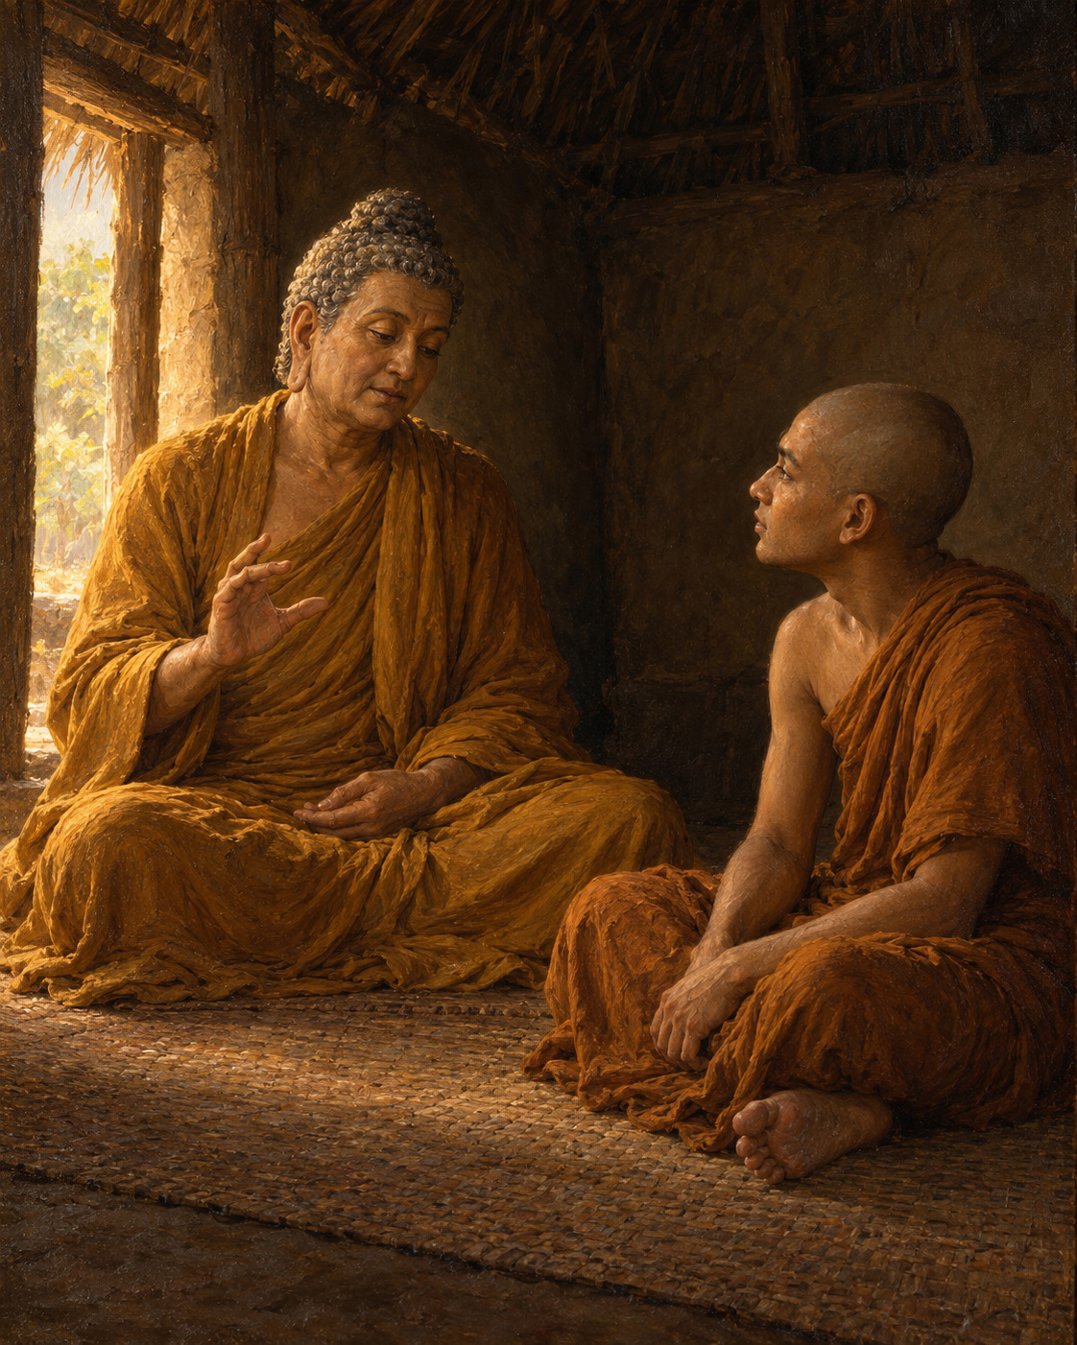
Sona had given the practice his energy. He could not understand why freedom had not followed.
He was staying in the Cool Grove near Rajagaha, while the Buddha was on the nearby Vulture’s Peak. In solitude, a discouraging thought took shape. He counted himself among the most energetic disciples, yet his mind was still not released from clinging. His family had wealth. Perhaps he should give up the monastic training, return home, enjoy that wealth, and support good works as a layperson.
The thought was not simply a wish for comfort. It contained the exhaustion of someone who had tried hard and could no longer see what the effort was accomplishing.
The canonical narrative says that the Buddha knew Sona’s thoughts and appeared before him through extraordinary power. Such a meeting belongs to the text’s religious world; its miraculous manner is not something a modern historian can verify.
Once they were seated, the Buddha asked Sona about his intention to leave. Sona acknowledged it. The teacher then turned to something his disciple already understood: music.
Before becoming a monk, Sona had been skilled with a stringed instrument. What happened, the Buddha asked, when its strings were drawn too tight? Could it be played well? Sona knew that it could not. And what happened when the strings were too loose? That, too, spoiled the instrument’s capacity to sound properly.
But when the tension was adjusted, neither excessive nor insufficient, the instrument could be played.
Here was a form of knowledge that did not depend on guessing what the teacher wanted to hear. Sona had learned it through his own hands and ears. Pulling harder was not always an improvement. Releasing all tension was not a solution either. Skilled attention found the condition in which the work became possible.
The Buddha applied the comparison to effort. Too much force could produce agitation. Too little could lead to idleness. Sona was to establish an appropriate balance, bringing the faculties into harmony and recognising what the situation required.
He did not need to abandon the path because the one way he had been pushing along it had proved unfruitful. He needed to learn another quality of effort.
Sona took up the instruction. Living apart, attentive and resolved, he developed the balance the Buddha had described. The discourse reports that he attained arahantship, the goal of the monastic path. His practice had not ended with discouragement, nor had it succeeded through escalating the same strain.
Afterwards he visited the Buddha and spoke about the qualities to which a liberated person was devoted: relinquishment, seclusion, harmlessness, the ending of craving and grasping, and a mind free from confusion. He explained these as expressions of release, rather than performances undertaken to satisfy other people’s expectations.
The musician’s understanding had helped him hear an error in his approach. His difficulty had seemed to demand either more force or complete departure. The teaching opened a third possibility: responsive, well-adjusted practice.
A string needed enough tension to sound. It did not need to suffer every possible tightening. Sona’s renewed effort became fruitful when it was guided by understanding, and he no longer had to mistake the amount of strain for the measure of his sincerity.

Wisdom to Remember
Wise effort responds to conditions. Persistence becomes more useful when it learns balance.

A Reflection for Today
Consider one task in which harder effort is producing only agitation. Adjust one condition: the pace, the length of a session, the support available, or the time for recovery. Observe the effect before deciding that you must either force yourself further or give up.

Source Note
Original retelling of AN 6.55, Soṇa Sutta, especially sections 1–10: SuttaCentral. Pali canon; Theravada transmission; canonical religious narrative and teaching. The Pali vīṇā refers to an ancient stringed instrument, often translated as lute or harp; the precise construction is not fixed here. The instrument is recalled in conversation, not stated to be physically present. Any illustration of it is a visual metaphor. The Buddha’s extraordinary arrival is identified as a textual religious claim; no verbatim dialogue is used.

29. The Acrobats’ Balance
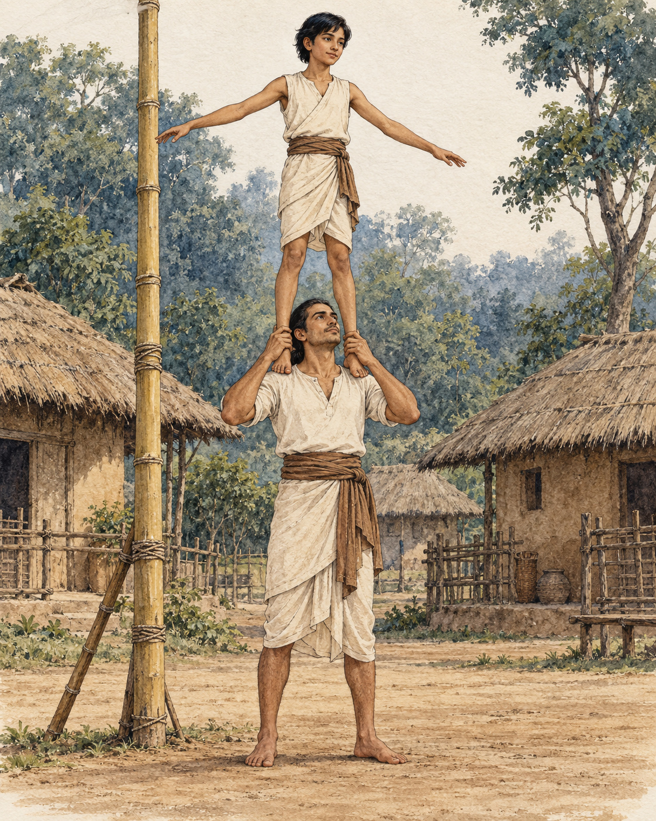
High above the ground, good intentions were not enough. Each movement had to be steady.
While staying near Sedaka, in the country of the Sumbhas, the Buddha told his monks about a pole acrobat and an apprentice named Medakathalika. The teacher had set up a bamboo pole and asked the apprentice to climb it, taking a position on his shoulders. The apprentice obeyed.
The performance required both skill and trust. They hoped to display their craft, receive payment, and return safely to the ground. A successful act would not be measured only by whether the spectators were impressed. Both performers needed to come down unharmed.
The teacher proposed a plan. The apprentice should watch over him, while he watched over the apprentice. In this way, he thought, each could protect the other and the performance would succeed.
The answer came from above. The apprentice disagreed. The teacher should attend to himself, and the apprentice would do the same. By each taking proper care of their own part, they could perform skilfully and descend in safety.
The Buddha endorsed the apprentice’s understanding.
The tale is brief, but it turns on a precise distinction. If the teacher failed to maintain his own balance while anxiously monitoring the person overhead, his concern would not prevent a fall. If the apprentice became absorbed in the teacher’s movements and neglected their own footing, the danger would increase for both. Their responsibility to each other included responsibility for the work only each could do.
The correction did not make the performers independent. They were plainly sharing the same risk. It explained how each could contribute to the other’s safety within that dependence.
The Buddha then brought the image into the practice of mindfulness. A person wishing to protect themselves should cultivate it. A person wishing to protect others should cultivate it too. Care of oneself and care of others could support each other, rather than standing as rival obligations.
He explained both directions. Through developing and practising mindfulness, a person protected others by attending to themselves. Through patience, harmlessness, loving-kindness, and sympathy, a person protected themselves by attending to others.
The second direction mattered as much as the first. The teaching did not end with the apprentice’s insistence on personal steadiness. It also named the qualities with which one person should meet another. Someone could not claim to be wisely protecting themselves while using that claim to justify cruelty or neglect.
The acrobats needed a balance that could be enacted, not merely admired. In the same way, mindfulness had to become practice, and concern for others had to become patience and care. Neither side of the teaching could safely be left to intention alone.
The text does not tell us how many spectators gathered, how much the performers earned, or what praise followed their descent. It gives the moment before those outcomes, when a teacher learned something useful from an apprentice.
For a little while, their whole livelihood depended on getting that understanding right. Each had a task the other could not perform on their behalf. Each also had a life the other could help to protect. The steadiness that served one would serve them both.

Wisdom to Remember
Taking responsibility for your own conduct can protect others. Patience and kindness towards others can also protect you.

A Reflection for Today
In a demanding relationship, identify your own part clearly: your attention, boundaries, speech, or preparation. Attend to that work while remaining kind to the other person. You cannot control every outcome, and you need not carry responsibility for another person’s harmful choices.

Source Note
Original retelling of SN 47.19, Sedaka Sutta, sections 1–3: SuttaCentral. Pali canon; Theravada transmission; canonical illustrative tale embedded in a teaching on mindfulness and mutual protection. Medakathalika’s gender differs across English interpretations; this retelling uses “the apprentice” without deciding it. The exact pole arrangement is difficult to reconstruct, so the illustration is interpretive. The tale is not offered as an independently documented performance. No direct dialogue or modern translation is quoted.

Interlude 13: Seeing Change Clearly

Pali — Roman Transliteration
Sabbe saṅkhārā aniccā ti, yadā paññāya passati,
Atha nibbindatī dukkhe—esa maggo visuddhiyā.

English Meaning
When one sees with wisdom that all conditioned formations are impermanent,
one grows disenchanted with suffering: this is the path to purification.

Context and Significance
Saṅkhārā here means conditioned formations, not simply every thing without qualification. Disenchantment loosens fascination and clinging; it is not contempt for life.

Source and Attribution
Dhp 277. Pali Canon, Khuddaka Nikaya; canonical text in the Theravada tradition. The Pali is already presented in Roman transliteration; there is no separate “transliteration” of an English translation. Punctuation, capitalisation, word division and the nasal sign have been regularised for this edition. The English is an original rendering prepared for this collection, not a reproduced modern translation. Ancient verse and modern editorial apparatus have different copyright status.
Source consulted: https://ancient-buddhist-texts.net/Buddhist-Texts/K2-Dhammapada-New/20-Magga.htm

30. The Last Journey
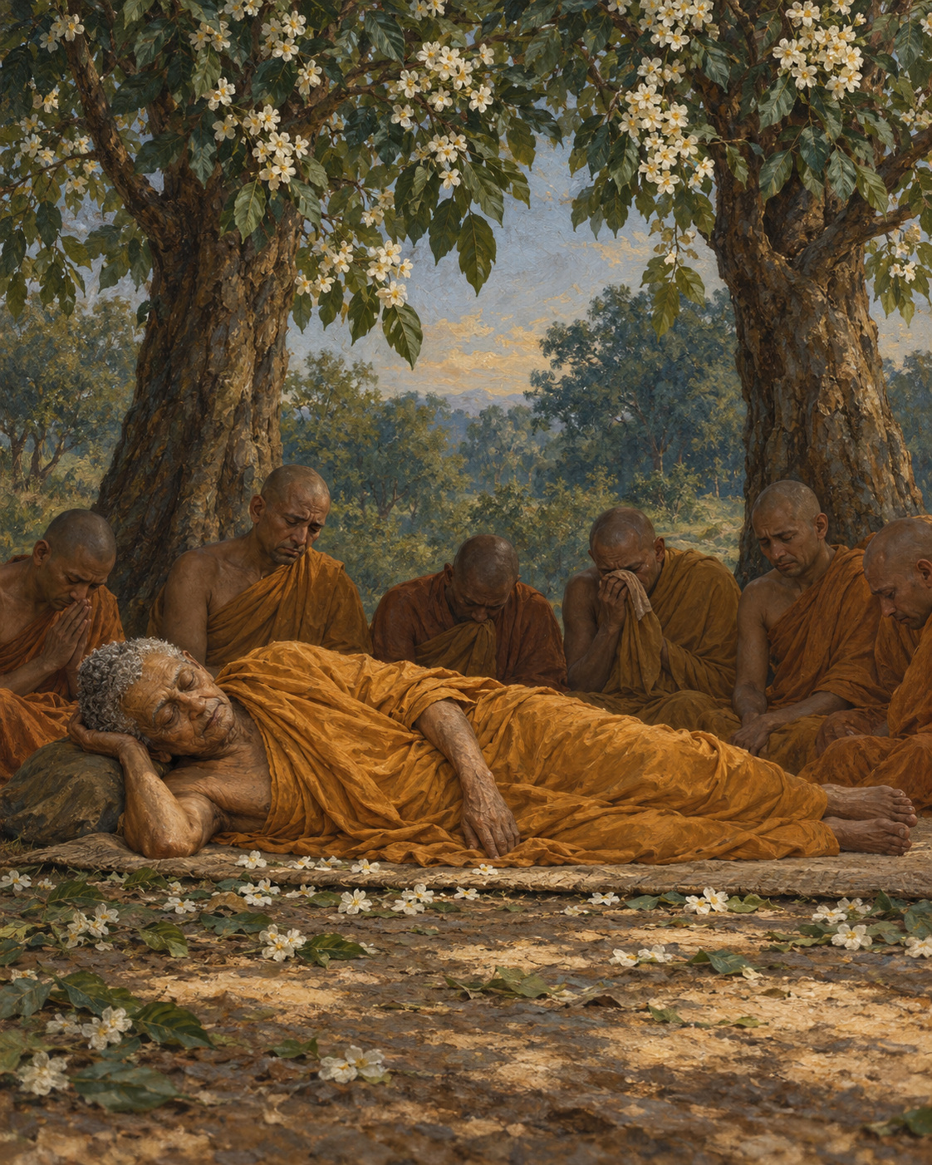
The journey had become a succession of places where an old man needed to rest.
The great discourse of the Buddha’s final passing follows him through towns and groves, meetings and instructions. Within its long sacred account, the body of the teacher becomes unmistakably frail. He experiences illness and pain. He needs water. A folded robe makes a place to sit beside the road.
Ananda attends him. The work of companionship is practical: arranging a resting place, answering a request, remaining near. The teacher who has guided so many people is not portrayed as beyond the body’s need for help.
After accepting a meal from Cunda, the Buddha becomes gravely ill and continues towards Kusinara. Later he thinks of the donor, who might be made to feel responsible for what followed. He instructs Ananda to reassure Cunda, describing the offering as especially fortunate. Even amid his own weakness, he makes provision for another person’s peace of mind.
The account does not allow us to identify the disputed dish with certainty or to diagnose the illness across the centuries. Its human emphasis is clearer: kindness must not be turned into an occasion for needless remorse.
At last the travellers reach the sal grove of the Mallas, near Kusinara. Ananda prepares a resting place between two trees. The Buddha lies on his right side, mindful and aware.
The text surrounds this moment with sacred marvels: flowers blooming out of season, heavenly offerings and music. It also directs attention beyond ceremonial honour. Those who practise according to the teaching, the Buddha explains, honour him in the fullest way. What matters is not only what falls from the branches, but how those who remain will live.
Ananda withdraws and weeps. He has not completed his own training, and the teacher who has shown him such kindness is about to die. When the Buddha learns where he has gone, he calls for him.
He reminds Ananda that separation from what is dear cannot be prevented. But he does not answer his grief with an abstract lesson alone. He acknowledges the devoted care Ananda has given him through body, speech, and mind, and encourages him to continue diligently. The attendant’s years of service are seen and named.
There are still people to receive and questions to answer. The discourse describes the Buddha allowing a final inquirer to approach, and later offering the assembled monks opportunities to raise any remaining uncertainty. Even near the end, teaching remains an act of attention to the people before him.
He tells Ananda that the teaching and discipline will guide the community after his passing. His final instruction reminds the monks that conditioned things are subject to dissolution and urges diligent practice.
Then, in the account’s description, he enters and emerges from successive meditative states before his final passing. Some disciples grieve openly. Others remain composed in their understanding of impermanence. The text preserves both responses beside the same loss.
There is no promise that those who loved him will never feel the absence. What remains is the path he taught, and the possibility of walking it. Ananda will still have work to do. So will the community. The last journey reaches its end, and the care it has taught must continue through other hands.

Wisdom to Remember
Impermanence makes care urgent. A teaching is honoured through the life it helps us practise.

A Reflection for Today
Think of someone whose guidance has helped you. Choose one quality you can carry forward through action. If you are grieving, let remembrance include both gratitude and sorrow; neither has to cancel the other.

Source Note
Original selective retelling of DN 16, Mahāparinibbāna Sutta, especially the final meal and reassurance to Cunda, the sal grove, Ananda’s grief, and final instructions and passing: SuttaCentral. In the Vajira/Story reference edition, these occur at 4.14–25, 4.56, 5.1–6, 5.33–35, 5.53–68, and 6.1–17; section numbering differs by edition. Pali canon; Theravada transmission; canonical sacred biography with supernatural elements, preserved in a text shaped through transmission rather than a modern eyewitness record. The composition of sūkaramaddava, the final meal, is disputed; no identification or medical diagnosis is asserted. Final instructions are paraphrases, not quotations. Scene selection and connective prose are original editorial work.

Closing Reflection: What We Carry Forward
The road through these stories ends, but the conditions they describe remain close at hand. Praise arrives and leaves. The body asks for care. Plans meet events they did not foresee. We discover how quickly a grievance can become a companion and how quietly generosity can change a room.
The Buddha’s teaching, as represented in these sources, asks for more than admiration. It invites examination. What happens when a thought is repeatedly entertained? What happens when speech becomes more careful? What changes when another person’s dignity matters as much as our own desire to prevail? These questions can be approached in a household, a workplace, a crowded street or a quiet hour.
No reader needs to carry thirty lessons at once. Choose one practice small enough to remember. Before sending a difficult message, pause. When receiving help, acknowledge it. When effort becomes harsh, examine its balance. When pain appears, seek appropriate care and notice whether blame is adding another burden. These actions do not remove every difficulty. They may help us meet difficulty with less confusion and less harm.
The people in these stories do not all arrive by the same road. Some ask questions. Some resist. Some mistake desire for purpose or status for worth. Their variety leaves room for our own unfinished lives. The task is not to resemble a perfect picture of a spiritual person. It is to understand more clearly what we are doing, and to become more willing to change it.
Leave the book, when you are ready, for the ordinary world in which kindness has work to do. The next opportunity may be modest. It may ask only for a truthful word, an attentive silence, or the decision to begin again without contempt. Such things are easy to overlook. They are also how a teaching acquires a human home.

Glossary
Anatta (Pali: anattā). Not-self; the absence of an enduring, independently controllable self in the phenomena examined by Buddhist teaching. It is not simply a claim that a person does not exist.
Arahant. A person understood in early Buddhist teaching to have realised liberation and ended the causes of renewed birth.
Bodhi. Awakening. “Bodhi tree” names the tree traditionally associated with the Buddha’s awakening.
Bodhisatta. Pali designation for a being on the path to Buddhahood, used of the Buddha before awakening. Sanskrit: bodhisattva; the term has a wider doctrinal development in Mahayana traditions.
Brahma (Brahmā). A celestial being or class of beings within Buddhist cosmology, not an eternal creator in the Buddhist account.
Buddha. An awakened one; in this volume usually Gautama, known in Pali as Gotama.
Dhamma. Teaching, truth, practice, quality or phenomenon, according to context. Sanskrit: dharma.
Dukkha. Suffering, distress or the unsatisfactory character of conditioned experience; its meaning varies with context.
Jhana (jhāna). A cultivated meditative absorption or collected state, described in graded forms in early Buddhist texts.
Kamma. Intentional action and its ethical significance. Sanskrit: karma. It should not be used to blame someone for suffering whose causes we do not know.
Karuna (karuṇā). Compassion: concern for suffering and the wish that it be relieved.
Mara (Māra). A figure opposing awakening in Buddhist narrative; also associated with death, temptation and obstruction. Interpretations differ.
Metta (mettā). Goodwill or loving-kindness, cultivated without restricting it to people one already likes.
Nibbana (nibbāna). Liberation: the extinguishing of greed, hatred and delusion. Sanskrit: nirvana. It is not merely a pleasant mood.
Pali (Pāli). The language of the Theravada canon; its texts were transmitted in several scripts. Roman-letter Pali in this book uses scholarly diacritics.
Sangha (saṅgha). Community; often the monastic community, or the community of noble disciples in the refuge formula. Context matters.
Sati. Mindfulness or recollection; within the Buddhist path it works alongside ethical conduct, effort and understanding.
Sutta. A discourse in the Pali tradition. Sanskrit: sutra.
Theravada. A living Buddhist tradition prominent in Sri Lanka and parts of Southeast Asia, preserving a Pali canon.
Vinaya. The monastic discipline and the canonical collection that preserves its rules and narratives.

A Gentle Guide to Pronunciation
Pronunciation varies across Buddhist communities. These English approximations are aids to reading, not a substitute for learning from a knowledgeable teacher or listening to a community’s chanting. Pali has no single exclusive national script; the Roman letters here are a transliteration.
Say a approximately as the first vowel in “about”, i as in “sit”, and u as in “put”, with regional English differences in mind. A bar marks length: ā, ī, ū are held longer, approximately “ah”, “ee”, “oo”. E and o are generally pure vowels rather than English glides. Pronounce each syllable clearly.
C resembles “ch” in “church”; j resembles “j” in “joy”; ñ resembles “ny” in “canyon”; ṅ is the “ng” in “sing”. Ṃ indicates a nasal sound whose realisation varies with context and chanting tradition. A dot under ṭ, ḍ, ṇ, or ḷ indicates a sound made with the tongue drawn farther back than its undotted counterpart.
In kh, gh, ch, jh, ṭh, ḍh, th, dh, ph and bh, the h indicates an accompanying breath. Thus th is not the English sound in “thin”, and ph is not “f”. Doubled consonants are given additional duration.
Approximate reading aids: Buddha, BOOD-dha, with a light breath after d; Dhamma, DHAM-ma; Saṅgha, SANG-gha; mettā, MET-taa; nibbāna, nib-BAA-na; saraṇa, sa-ra-na, with the n made farther back. These capital letters help English readers find a rhythm; they do not prescribe a universal Pali stress rule.
For the refuge phrase, take it slowly: Buddhaṃ saraṇaṃ gacchāmi — bud-dhaṃ / sa-ra-ṇaṃ / gac-chā-mi. Give the long ā time to sound. A respectful, unhurried recitation matters more than imitating an imagined exotic accent.

Reading the Source Notes
The abbreviations in this volume identify collections of the Pali Canon: DN, Digha Nikaya; MN, Majjhima Nikaya; SN, Samyutta Nikaya; AN, Anguttara Nikaya; Ud, Udana; Dhp, Dhammapada; Khp, Khuddakapatha. The names are given without full diacritics here for ease of reference. A number after MN or DN names a discourse; SN and AN references ordinarily give a group or book followed by a discourse number. Numbering can vary between editions, particularly in the Anguttara Nikaya.
“Canonical” means that a passage belongs to the received canon of a Buddhist tradition. It does not mean that modern historical investigation has independently established every event. The source notes distinguish reported encounters, teaching similes and religious narratives where that distinction matters. Literary staging in this edition should not be cited as evidence for ancient Indian life.
The online source links lead to texts or responsible repositories, not a promise that all linked translations may be freely republished commercially. Modern English translations were consulted as research aids, not licensed wholesale for this edition. The short English verse meanings were composed anew. The ancient Pali passages are identified separately from the editorial work of the modern editions used to check them.
This volume’s selection is deliberately concentrated in the Pali canon. It does not assign Theravada ownership to teachings shared in other Buddhist textual traditions, and it does not claim a comparative survey of all surviving versions. Readers wishing to go further should compare translations and consult scholarship on transmission, genre and historical setting.
The project’s research register records source retrieval and unresolved checks in more detail. An independent Pali reader and a qualified Buddhist scholar should review the renderings and attributions before publication; that review has not been represented as complete.

Bibliography

Text Repositories and Verse Editions
SuttaCentral. Pali root texts, translations and parallels for the canonical discourses cited in the individual source notes. https://suttacentral.net/
Ancient Buddhist Texts. Ānandajoti Bhikkhu’s Dhammapada: A New Edition, including readings and variant notes. The original-language chapters were used to check the Pali interludes. https://ancient-buddhist-texts.net/Buddhist-Texts/K2-Dhammapada-New/index.htm
Dhammatalks.org. Thanissaro Bhikkhu’s Khuddakapatha, especially Khp 1, “Going for Refuge”. Consulted for the identity and liturgical structure of the refuge passage; its modern translation is not reproduced as a whole. https://www.dhammatalks.org/suttas/KN/Khp/
Sutta Friends. Khp 1, “Saraṇagamanaṁ”. Pali refuge formula and translation for comparison. https://suttafriends.org/sutta/khp1/
A story-by-story verification register accompanies the production project. These repositories contain distinct works under distinct copyright or licensing terms. Availability online is not equivalent to permission for commercial reproduction.

Discourses Underlying the Stories
Listed in story order. The research translations are by Thanissaro Bhikkhu, except DN 16, translated by Sister Vajira and Francis Story. These editions were consulted to identify ancient material; their extended English prose is not reproduced. Accessed 23 October 2026.
- MN 26. Ariyapariyesana Sutta. English translation consulted; canonical Pali tradition.
- MN 36. Mahasaccaka Sutta. English translation consulted; canonical Pali tradition.
- MN 19. Dvedhavitakka Sutta. English translation consulted; canonical Pali tradition.
- MN 4. Bhayabherava Sutta. English translation consulted; canonical Pali tradition.
- SN 6.1. Brahmayacana/Ayacana Sutta. English translation consulted; canonical Pali tradition.
- SN 56.11. Dhammacakkappavattana Sutta. English translation consulted; canonical Pali tradition.
- SN 22.59. Anattalakkhana Sutta. English translation consulted; canonical Pali tradition.
- MN 61. Ambalatthikarahulovada Sutta. English translation consulted; canonical Pali tradition.
- MN 63. Culamalunkyovada Sutta. English translation consulted; canonical Pali tradition.
- MN 21. Kakacupama Sutta. English translation consulted; canonical Pali tradition.
- MN 22. Alagaddupama Sutta. English translation consulted; canonical Pali tradition.
- SN 7.2. Akkosa Sutta. English translation consulted; canonical Pali tradition.
- SN 7.11. Kasibharadvaja Sutta. English translation consulted; canonical Pali tradition.
- AN 3.65. Kesamutti/Kalama Sutta. English translation consulted; canonical Pali tradition.
- MN 58. Abhayarajakumara Sutta. English translation consulted; canonical Pali tradition.
- MN 86. Angulimala Sutta. English translation consulted; canonical Pali tradition.
- MN 93. Assalayana Sutta. English translation consulted; canonical Pali tradition.
- MN 140. Dhatuvibhanga Sutta. English translation consulted; canonical Pali tradition.
- SN 5.2. Soma Sutta. English translation consulted; canonical Pali tradition.
- SN 3.13. Donapaka Sutta. English translation consulted; canonical Pali tradition.
- SN 42.7. Khettupama/Desana Sutta. English translation consulted; canonical Pali tradition.
- AN 8.53. Samkhitta/Gotami Sutta. English translation consulted; canonical Pali tradition.
- Ud 3.2. Nanda Sutta. English translation consulted; canonical Pali tradition.
- SN 36.6. Sallatha Sutta. English translation consulted; canonical Pali tradition.
- SN 3.14. Pathamasangama Sutta. English translation consulted; canonical Pali tradition.
- AN 5.57. Upajjhatthana Sutta. English translation consulted; canonical Pali tradition.
- MN 131. Bhaddekaratta Sutta. English translation consulted; canonical Pali tradition.
- AN 6.55. Sona Sutta. English translation consulted; canonical Pali tradition.
- SN 47.19. Sedaka Sutta. English translation consulted; canonical Pali tradition.
- DN 16. Mahaparinibbana Sutta. English translation consulted; canonical Pali tradition.

Scholarly Context
Anālayo, Bhikkhu. “The Buddha’s Pre-awakening Practices and Their Mindful Transformation.” Mindfulness 12 (2021): 1892–1898. https://doi.org/10.1007/s12671-021-01646-0
Anālayo, Bhikkhu. “The Buddha’s Awakening.” Mindfulness 12 (2021): 2141–2148. https://doi.org/10.1007/s12671-021-01649-x
“Buddha.” Internet Encyclopedia of Philosophy. https://iep.utm.edu/buddha/
Contextual sections of these works informed the distinction between canonical recollection, later biography and historical reconstruction. No exhaustive survey of scholarship is claimed.

About This Series
The Light of Buddha presents Buddhist narrative and teaching in accessible English, with source notes that distinguish ancient text, inherited tradition and modern retelling. Volume 1 draws its thirty selections from the Pali Canon. Its purpose is to invite thoughtful reading and compassionate practice while preserving the differences between literary imagination and historical evidence.

About the Compiler
Compiled and Retold by Jaspal Singh
Jaspal Singh is credited as compiler and reteller of The Light of Buddha — Volume 1.

