Integrating Velocity-Based Training Into ACL Rehabilitation
Written by:
Andreas Bjerregaard: Physiotherapist, Section of Sports Traumatology, Department of Orthopedic Surgery, Copenhagen University Hospital Bispebjerg, Copenhagen, Denmark.
Pedro Castellón Sánchez : Physiotherapist, MSc, MBA · Senior Client Success Manager at VALD and First Physiotherapist for the Saudi National Men’s Team.
Abbreviations:
VBT= Velocity based training
ACLR = Anterior cruciate ligament reconstruction
The aim of this blogpost are to share clinical experience on how to integrate velocity based training (VBT) to to guide exercise intensity, make decisions from one session to the next, manage fatigue, and to improve explosive performance after anterior cruciate ligament reconstruction (ACLR).
“How much weight can I lift after my ACLR?”

Three weeks after ACLRwith an allograft, a patient asked me a question that changed how we approached his training: “How much weight can I lift?” Before his injury, he had been a competitive bodybuilder and an experienced coach, squatting and deadlifting +250kg. Therefore, a pair of 2x10 kg dumbbells would barely challenge him. We needed to find a meaningful training stimulus with respect to the biological healing, postoperative restrictions, or his knee general response to exercises. we started his return to squat with sit to stand from a box equal to 90 degree knee flexion. Adding VBT device to the movement, we could estimate how quickly he would stand up. With a graded exposure approach we added a barbell in a front squat position. The VBT transdurer then tracked the load we were able to apply from early in his rehab. Instead of talking about an estimated percentage of 1RM, we had a conversation around which velocity we would allowed in this early stage and with this range of motion. To keep the motivation high we allowed less than 70% of 1RM. In this case he had to look for the speed per repetition rather than a number of reps.
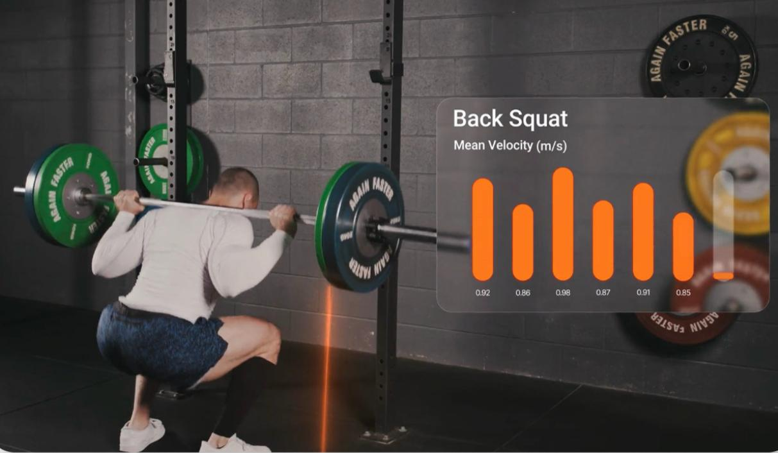
NEED VIDEO OF BOX SQUAT WITH THE BARBELL. No DEEPER THAN 90 KNEE FLEXION.
What is velocity-based training?
Velocity-based training (VBT) is a method of prescribing and monitoring resistance training by measuring how fast a weight is lifted. The principle is simple: as the weight increases, the lifting velocity generally decreases. This relationship is known as the load–velocity relationship [2,3].
By using a velocity measurement device, such as a linear position transducer, we can measure lifting speed in meters per second (m/s). This information helps us estimate the relative training intensity (% of 1RM).
Why use VBT during ACLR?
After ACLR, restoring quadriceps and hamstring strength is a major goal. But finding the right load is not straightforward. Too little resistance may fail to stimulate adaptation; too much may increase pain, swelling, or knee irritability. We often prescribe strength work as a percentage of one-repetition maximum (1RM), yet a patient’s capacity can change with fatigue, sleep, recovery, and symptoms. In the earlier stages, maximal testing may also be inappropriate. RIR (reps in reserve) is also used, but patients new to daily training often struggle to judge it accurately, which can push them harder than intended..
VBT adds to that conversation. If we know how fast someone moves a given weight, we can estimate relative intensity and adjust the session to their performance that day. The “velocity number” therefore helps the patients to understand what a lighter, moderate, and heavier efforts actually feel like. This is called autoregulation.
Imagine a patient who normally squats 60 kg at 0.80 m/s. On another day, the same load moves at only 0.65 m/s. That does not automatically mean that the patient is weaker, but it gives us a reason to check how the patient feels, and whether the planned session still makes sense. Rather than forcing the original load, we can adapt the training target.

Which velocity metrics do we look at?

To keep this easy to follow, we explain these metrics using the squat as our reference exercise. The same ideas apply later to other lifts, but the squat makes the phases of the movement clearer.
Three metrics are particularly relevant when applying VBT:
- Peak velocity: This is the highest speed reached during the upward movement of the squat. It tells us how fast the barbell moved at its fastest point.
- Mean velocity: This is the mean speed throughout the entire upward movement, from the bottom of the squat until we reach standing. It includes both acceleration, and the braking phase, just before standing position.
- Mean propulsive velocity: This is the mean speed during the propulsive portion of the upward movement. Unlike concentric mean velocity, it excludes the final braking phase, when you slow the movement down, as you approach the standing position in a squat. This can be very useful in the intermediate phases of rehab to tell apart two athletes who look similar on mean velocity yet have different levels of strength.

Three uses of VBT in ACL rehab:
Assessment, monitoring and load adjustment

Over time, we found that velocity is useful not only for choosing the load, but also for deciding what kind of session to deliver. A simple reference squat can act as a daily “thermometer”: the same exercise, the same load, and the same velocity metric, compared with previous sessions.
In our clinical experience, VBT has three complementary purpose that work together from one session to the next: Assessment, monitoring and load adjustment
Assessment: We build an individual load–velocity profile, usually from the squat, to understand how that patient moves across a range with different sub-max loads. Fx 20kg, 30kg and 40kg. From that profile we can estimate relative intensity and approximate 1RM without relying on frequent maximal testing.
Monitoring: Each session we use a daily squat “thermometer”: the same fixed reference load for 3×5 repetitions with maximal intended concentric speed, tracking concentric mean velocity against that patient’s recent sessions. This tells us how ready they are today before we decide what the strength work should look like.
Load adjustment: Rather than locking the session to a fixed percentage of 1RM, we prescribe by a target velocity within a set. Then we use a velocity-loss threshold within the set to decide the numbers of repetitions.
Assessment: Choosing a training load from lifting velocity
We can use lifting velocity to estimate relative training intensity without repeatedly testing maximal strength. However, velocity is exercise-specific. Because this article centers on the squat as our reference exercise, the velocities we discuss are best read in that context. Other exercises (for example a deadlift) can show different bar speeds at the same percentage of 1RM. In this example, the velocity is influenced by the weight on the barbell and the athlete body weight whereas during the deadlift, the load are moved from the floor without the bodyweight. Therefore, 70% of 1RM in a squat are performed at 0.77m/s, whereas in the deadlift 70% of 1RM are performed at 0.62m/s (Table 1).
Relative load | Back squat | Deadlift
50% 1RM | 1.06 m/s | 0.87 m/s
60% 1RM | 0.91 m/s | 0.75 m/s
70% 1RM | 0.77 m/s | 0.62 m/s
80% 1RM | 0.62 m/s | 0.50 m/s
90% 1RM | 0.47 m/s | 0.37 m/s
Table 1. Example values from an individual load–velocity profile reported by Forelli et al. [1].
Speed zones: from moving fast to lifting heavy
To make the force–velocity relationship easier to understand, we describe three broad zones: speed-strength, strength-speed, and absolute strength. Light loads can generally be moved faster, while heavy loads move more slowly. These zones help us explain the goal of a session, but their percentages and velocities are approximate and differ between exercises and individuals [1, 2].
Relative load | Strength quality | Velocity and training emphasis
0–40% 1RM | Speed-strength | Approximately 1.0–1.5 m/s Relatively light loads moved at high velocity. The emphasis is on producing force quickly, rather than lifting a heavy weight.
40–70% 1RM | Strength-speed | Approximately 0.75–1.0 m/s Moderate loads moved relatively quickly. The goal is to develop high force production while maintaining substantial movement velocity.
70–100% 1RM | Absolute strength | Slower lifting velocities; approximately 0.3 m/s at 100% 1RM for lower-body movements in the figure. Heavy resistance training where the primary emphasis is on producing high levels of force.

Monitoring: Our daily test: a practical “thermometer”
In clinical practice, we introduce VBT once the patient demonstrates good squat depth and with a movement quality.
A typical session starts with a warm-up before moving into three sets of five back squats. These are performed with maximal intended concentric speed at a fixed reference load. For example, 20, 30, and 40 kg barbell, depending on the person. With VBT we then track concentric mean velocity, and compare it with that patient’s recent sessions.
If the reference load moves at a similar or faster velocity than usual, and the knee is responding well, we may continue with the planned strength session. If it moves noticeably more slowly, we have two options: change the session towards lower-demand exercises, such as mobility,or reduce the load to match another intended training velocity. We prefer to interpret the number alongside pain, swelling, movement quality, and the patient’s injury history and lifting experience.
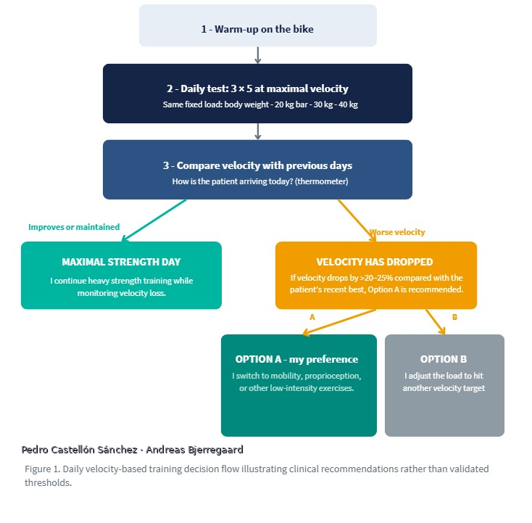
Figure 1. Practical daily VBT decision flow illustrates a decision process, not a validated ACLR algorithm.
Load adjustment: Knowing when to stop: velocity loss within a set
Consider a squat set in which the first repetition is lifted at 0.80 m/s. Each repetition becomes a little slower. In this example, 0.64 m/s represents a 20% velocity reduction from 0.80 m/s. A patient could stop at that point even if more repetitions were originally planned or if less reps were planned, he could have continued until he reached the 20% drop in velocity.

Repetition | Velocity
1 | 0.80 m/s
2 | 0.78 m/s
3 | 0.75 m/s
4 | 0.72 m/s
5 | 0.68 m/s
6 | 0.64 m/s

Table 2. Illustrative squat set: velocity decreases from 0.80 to 0.64 m/s, equivalent to 20% velocity loss relative to the fastest repetition.
In practice, this means we do not always have to insist on completing a fixed number of repetitions. We can set a velocity-loss limit and stop the set when performance drops beyond it.
NEED VIDEO OF BACK SQUAT AND SHOWING THE SCREEN WITH 20% VELOCITY LOSS
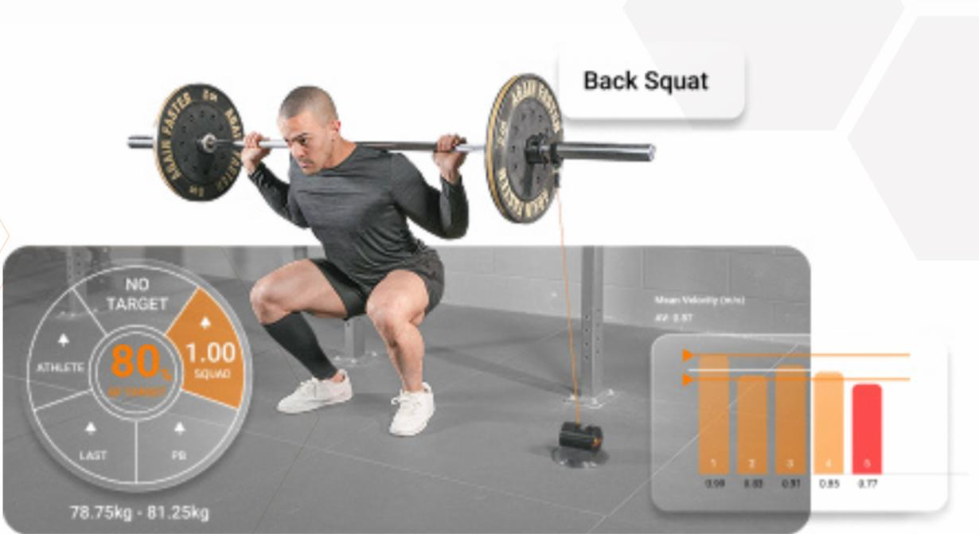
The chosen velocity loss depends on the goal of the exercise. Lower velocity loss generally means less fatigue, while higher velocity loss produces more fatigue and requires longer recovery. As shown in Figure 2, a 25% velocity loss would stop the set after 7 repetitions, while a 50% loss would allow 10 repetitions. We usually decribe 20% velocity loss in our ACLR rehabilitation.

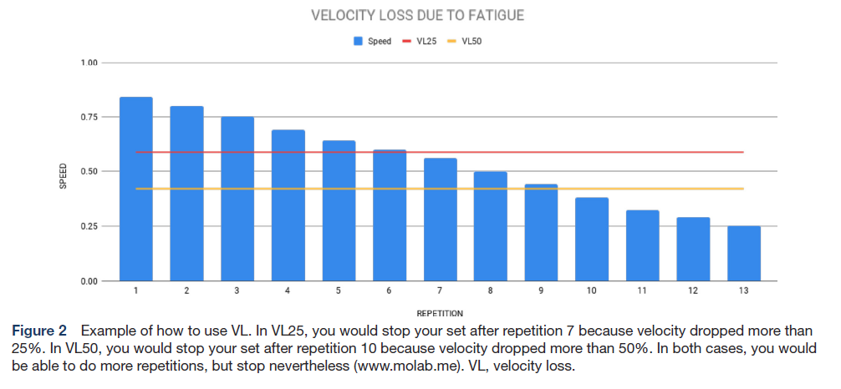
How we progress VBT across ACLR rehabilitation?

In our clinical practice, we gradually progress from lighter resistance towards heavier strength work while introducing faster exercises as the patient meets the relevant criteria. The time frames below illustrate one approach; they are not automatic clearance dates or a validated ACLR protocol.
- 0–3 months: Building strength and training tolerance
During approximately the first 3 months, we generally emphasize controlled resistance training below 70% of estimated 1RM, with the aim of rebuilding strength and loading tolerance. Surgical restrictions, symptoms, and exercise selection take priority over any percentage target.
- 3–6 months: Increasing strength and introducing strength-speed
Between approximately 3–6 months, we may introduce faster strength-speed work. Again using the squat as our main reference exercise. We aim for a mean concentric velocity of approximately 0.75–1.00 m/s, depending on the training goal, while maintaining good movement quality. while maintaining good movement quality. As the patient progresses, we may introduce more explosive exercises,That velocity can also mark our entry point for adding more load to the squat. At this stage we can start building an initial force–velocity profile to map strength zones for that individual. Mean propulsive velocity may be useful here, because — as explained earlier — it tends to be more accurate with lighter loads. As the patient progresses, we may introduce more explosive exercises.
where mean propulsive velocity can help us monitor the speed of the movement without including the final braking phase before standing position.
- From approximately 4.5 months: Developing explosive performance
From around 4.5 months, when the athlete meets the relevant strength and movement criteria, we continue refining the force–velocity (load–velocity) profile.
From around 4.5 months, when the athlete meets the relevant strength and movement criteria, this is a good point to start thinking in a force–velocity (load–velocity) profile for that patient, still with the squat as our main reference. Mean concentric velocity can help us be more accurate with the lighter loads we often use at this stage. Velocity loss remains a key tool to manage fatigue in the set while we keep progressing running, plyometrics, or change of direction. We also keep using velocity in the warm-up as our daily readiness check or ¨thermometer¨ with the same fixed-load..
We may also introduce loaded squat jumps, for that, we prefer peak velocity (it tends to be more accurate in the literature), though mean propulsive velocity can also be used.
From around 4.5 months, we continue refining the load–velocity profile to improve load prediction. We use velocity loss to managing fatigue within a set. We may also introduce loaded squat jumps, using mean propulsive velocity to monitor the propulsive portion of the movement together with the peak velocity.
The daily readiness during the warm-up set may be using the thermometer with the same fixed-load 3 × 5 reference sets described earlier.
- After 6 months: Maximal strength and power
After 6 months, we often include heavier strength work at or above 85% of 1RM alongside continued power training, provided the patient is ready for it. We use velocity mainly for load prediction based on each individual profile, and as a training tool for velocity loss and feedback.

Clinical case example:
From rebuilding strength to producing force quickly

Later in rehabilitation we also want the athlete to produce force rapidly when jumping. We may use velocity feedback during loaded squat jumps to choose a load that still allows fast movement. If our clinical goal is to improve concentric impulse in a countermovement jump (CMJ), we can train with loaded jumps and keep velocity around 0.75–1.00 m/s.
NEED VIDEO OF CMJ WITH A TRAPBAR BARBELL GETTING INTO 0.75–1.00 m/s.
Another example. We recently worked with a young tennis player who was 11 months post-ACLR. She had 90% limb symmetry during isokinetic strength testing on the Biodex. One of our goals is to improve her ability to generate force rapidly during the triple extension (hip, knee and ankle) of a jump (also known a the propulsion impulse 2 (P2) performed during a CMJ) and thereby contribute to better performance during her tennis serve.
We target this with an explosive split squat progressing into a single-leg calf raise. We positioned the safety bars to establish a consistent starting position for the concentric phase, allowing her to focus on accelerating the barbell upwards as quickly as possible. We targeted a movement velocity to me between 1.00-0.75– m/s. VBT help us reach the intended intensity in the exercise.
NEED VIDEO OF SPLIT SQUAT WITH THE BARBELL ON SAFETY BARS AND FOCUS ON THE P2.
What we want readers to take away

For us, VBT creates the conversation around training intensity when the patient is asking, “How much weight can I lift after ACL reconstruction?”. Is the patient moving it as expected today? Are we underloading or overloading, are repetitions slowing because fatigue is accumulating, and is it time to emphasize heavier strength or faster movement? What zone should be targeted at different exercises. The goal with VBT is not simply to lift more weight, but deliver the target training stimulus at the right time.

References
1. Forelli F, Mazeas J, Nielsen-Le Roux M, et al. Knee strengthening after orthopedics surgery: A comprehensive analysis using key performance indicators to guide physical therapists. F1000Research. 2025;13:1118. https://doi.org/10.12688/f1000research.156922.2
2. Forelli F, Marine P, Moiroux-Sahraoui A, et al. Velocity-based training in mid- and late-stage rehabilitation after anterior cruciate ligament reconstruction: A narrative review and practical guidelines. BMJ Open Sport & Exercise Medicine. 2025;11:e002503. https://doi.org/10.1136/bmjsem-2025-002503
3. Weakley J, Mann B, Banyard H, McLaren S, Scott T, Garcia-Ramos A. Velocity-based training: From theory to application. Strength & Conditioning Journal. 2021;43(2):31–49. https://doi.org/10.1519/SSC.0000000000000560
4. González-Badillo JJ, Rodríguez-Rosell D, Sánchez-Medina L, et al. Short-term recovery following resistance exercise leading or not to failure. International Journal of Sports Medicine. 2016;37(4):295–304.
5. Randell AD, Cronin JB, Keogh JW, Gill ND, Pedersen MC. Effect of instantaneous performance feedback during 6 weeks of velocity-based resistance training on sport-specific performance tests. Journal of Strength and Conditioning Research. 2011;25(1):87–93.
6. Forelli F, Riera J, Marine P, et al. Implementing velocity-based training to optimize return to sprint after anterior cruciate ligament reconstruction in soccer players: A clinical commentary. International Journal of Sports Physical Therapy. 2024;19:355–365. https://doi.org/10.26603/001c.92704
Further reading
Andreas Bjerregaard: Practical considerations for force-velocity strength training in rehabilitation — https://andreasphysioblog.com/?p=3637
Andreas Bjerregaard: Previous article on velocity-based resistance training — https://andreasphysioblog.com/?p=3116
VALD Performance: Velocity-Based Training 101 — https://valdperformance.com/news/velocity-based-training-101
VALD Performance: Using VBT to Autoregulate and Individualize Resistance Training — https://valdperformance.com/news/using-vbt-to-autoregulate-and-individualize-resistance-training

