9.2. Sampling Distributions
Example:
Suppose we sample 500 times and let
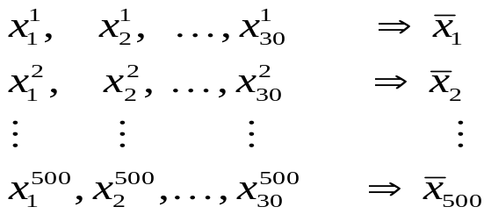
be 500 simple random samples of 30 managers. Let  be the random variable representing the average salary of a random sample of 30 managers. Then, 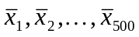 are 500 possible values of . Note there are .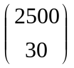 possible for random variable .

Properties of :
Let be the random variable representing the average of a random sample. Then,
- For finite population with population size N and the sample size n, then the standard deviation of is
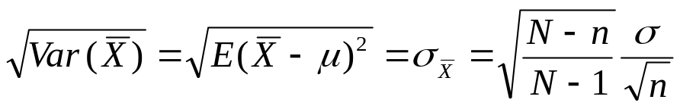.
For infinite population (the infinite population size),
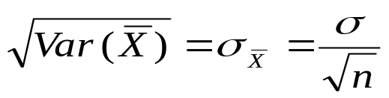.

Note: as 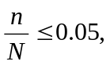 then 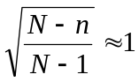. Thus, 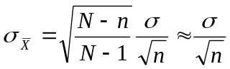. That is, the standard deviation of for the finite population is approximately equal to the one for the infinite population.

Sampling Distribution of :
As 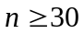 or the population is normally distributed, then
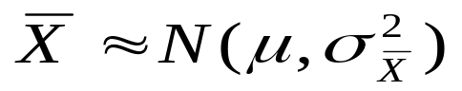
, where 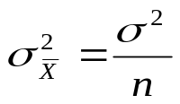. Thus, for some constants 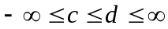,
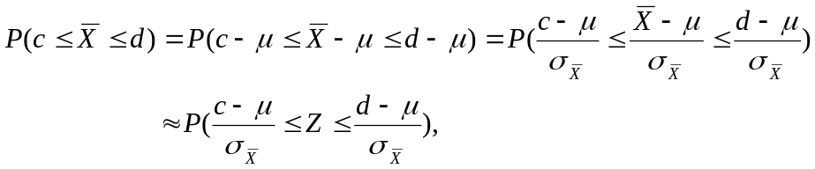
where Z is the standard normal random variable.

Example:
What is the probability of the difference between the sample mean and the population mean will be less or equal to 500 as the sample size 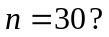
[solution]
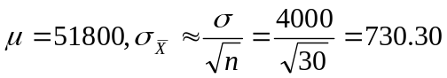. Thus,
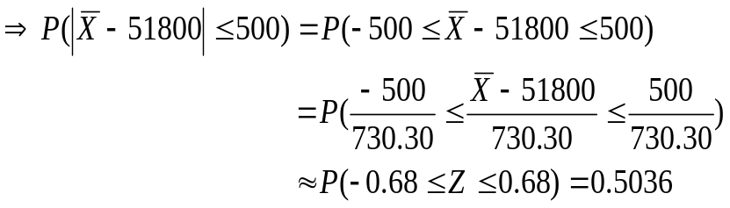
 There is 50.36% chance that the difference between the sample mean and the population mean is not more than 500.

Sample Size and Sampling Distribution:
Since 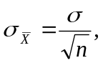 increasing the sample size will decrease the standard error!! Thus, the larger the sample size is, the larger 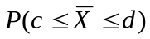 is (since the interval 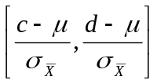 is larger than the one with smaller sample size)!!

Example (continue):
What is the probability of the difference between the sample mean and the population mean will be less or equal to 500 as the sample size 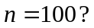
[solution]
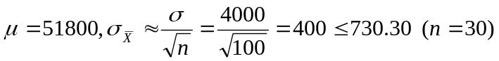. Thus,
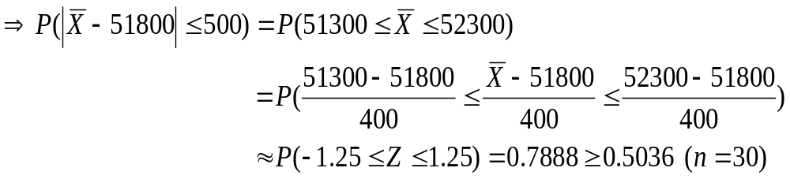
As the sample size increases to 100, there is 78.88% chance that the difference between the sample mean and the population mean is not more than 500. That is, the larger sample size will provide a higher probability that the value of the sample mean will be within a specific distance of the population mean.

Example:
The average lifetime of a light bulb is 3000 hours with a standard deviation of 696 hours. A simple random sample of 36 bulbs is taken.
- What are the expected value, standard deviation, and shape of the sampling distribution of ?
- What is the probability that the average life time in the sample will be between 2670.56 and 2809.76 hours?
- What is the probability that the average life time in the sample will be equal to or greater than 3219.24 hours?
- What is the probability that the average life time in the sample will be equal to or less than 3180.96 hours?
- How large of a sample needs to be taken to provide a 0.01 probability that the average life time in the sample will be equal to or greater than 3219.24 hours

[solution:]
(a) 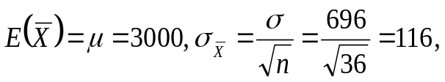
bell shape like normal distribution.
(b)
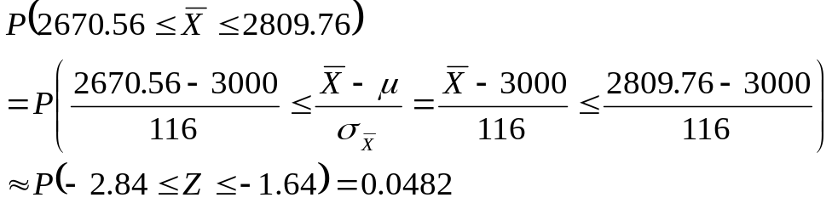
(c)
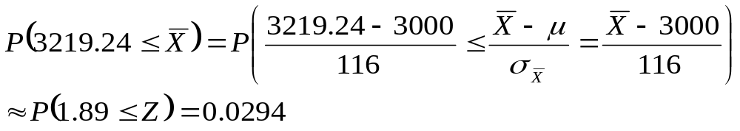
(d)
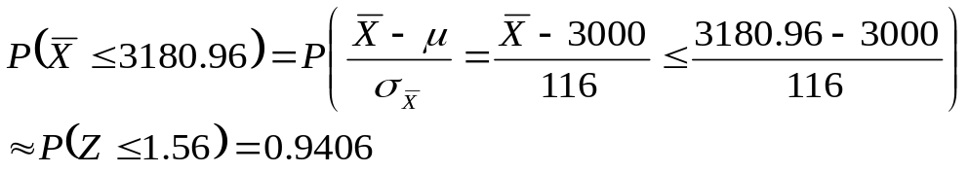
(e)
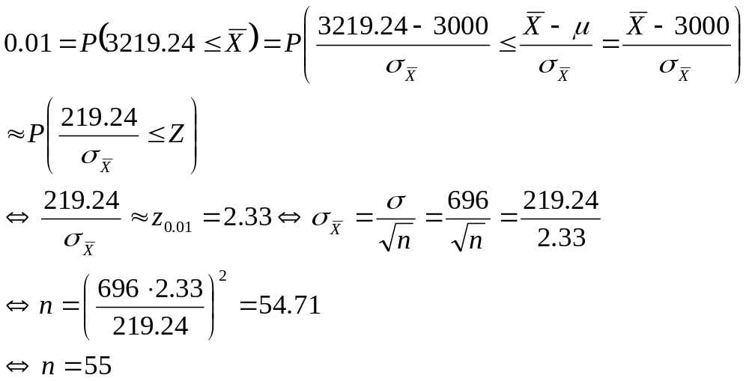

Example :
MNM Corporation gives each of its employees an aptitude test. The scores on the test are normally distributed with a mean of 75 and a standard deviation of 15. A simple random sample of 25 is taken from a population of 500.
- What is the probability that the average aptitude test score in the sample will be between 70.14 and 82.14?
- What is the probability that the average aptitude test score in the sample will be equal to or greater than 82.68?
- Find a value, C, such that P(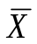 ≥ C) = .015.
[solution:]
(a) Since 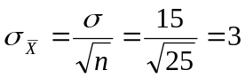,
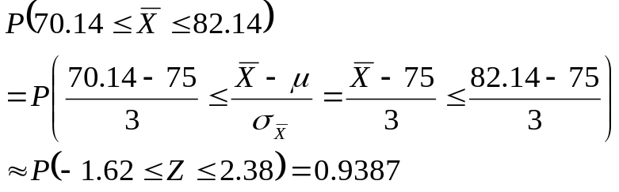
(b)
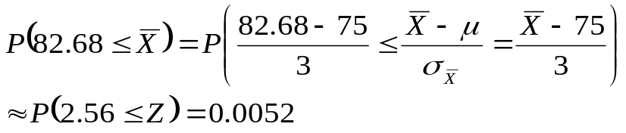
(c)
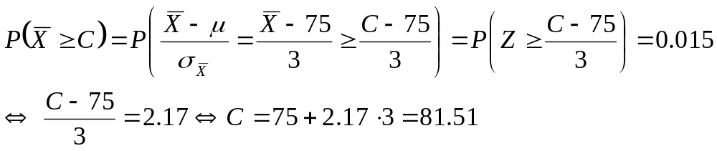

Example:
A population has a standard deviation of 16.
(a) As the sample size 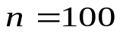, what is the probability that a sample mean will be within 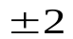 of the population mean (the sampling error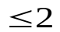)?
(b) Suppose the probability that a sample mean will be within of the population mean is 0.9. What is the sample size n?
[solution:]
(a)
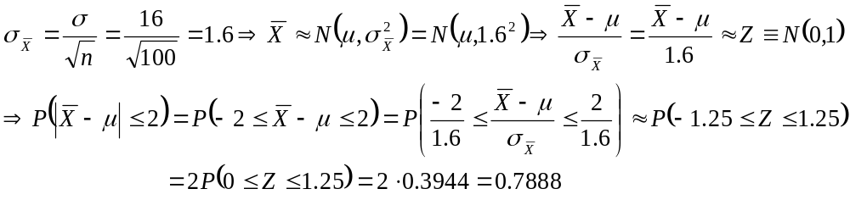
(b)

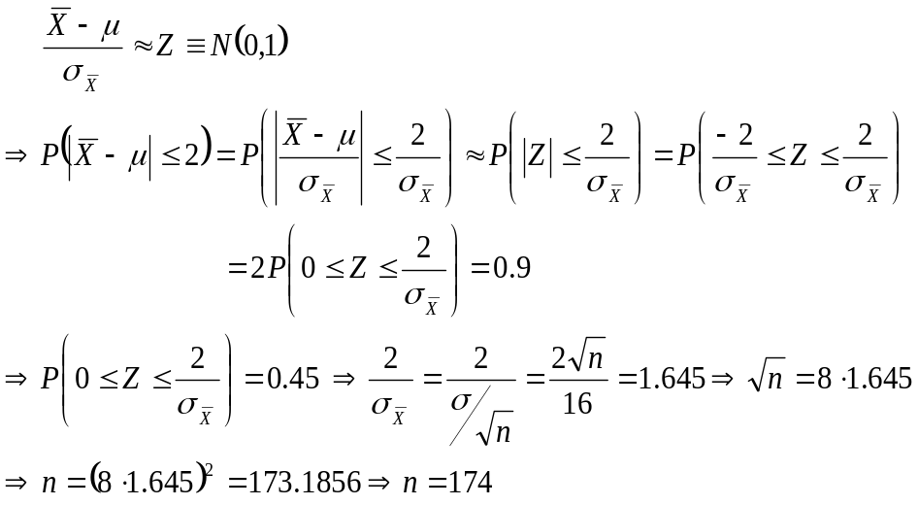
Properties of 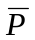:
Let be the random variable representing the proportion of a random sample (the sample proportion of a random sample is one possible value of ). Then,
- For finite population with population size N and the sample size n, then the standard deviation of is
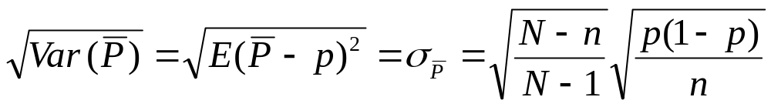.
For infinite population (the infinite population size),
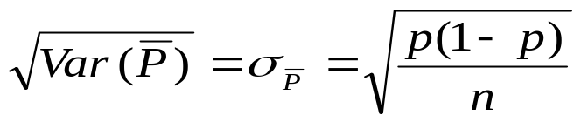.

Note:
As then . Thus, 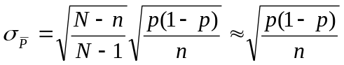. That is, the standard deviation of for the finite population is approximately equal to the one for the infinite population.

Sampling Distribution of :
As 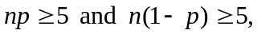
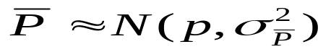
, where 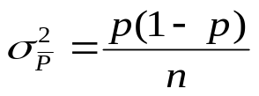. Thus, for some constants 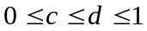
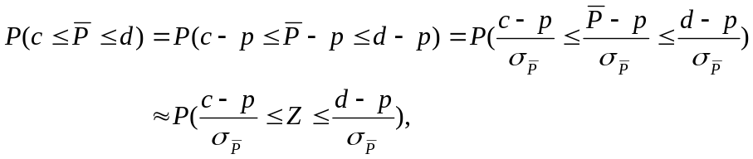
where Z is the standard normal random variable.

Note: Since 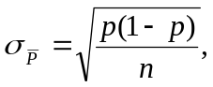 increasing the sample size will decrease the standard error!! Thus, the larger the sample size is, the larger 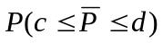 is (since the interval 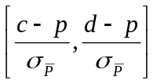 is larger than the one with smaller sample size)!!
Example (continue):
What is the probability of the difference between the sample proportion and the population proportion will be less or equal to 0.05 as the sample size What is the probability as we increase the sample size to 100?
[solution]
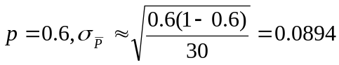. Thus,
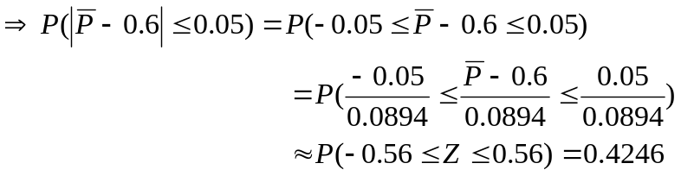
There is 42.46% chance that the difference between the sample proportion and the population proportion is not more than 0.05 as .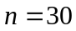.
As sample size is increased to 100, then 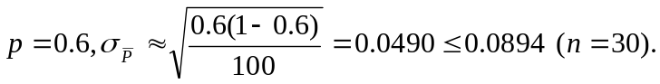Thus,
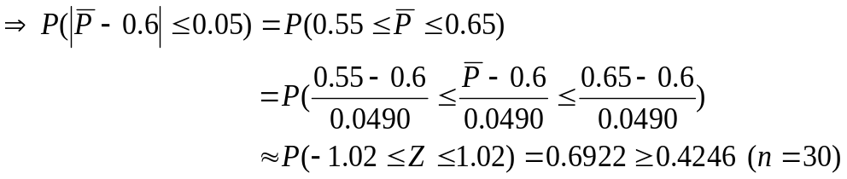
There is 69.22% chance that the difference between the sample proportion and the population proportion is not more than 0.05 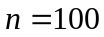. That is, the larger sample size will provide a higher probability that the value of the sample proportion will be within a specific distance of the population proportion.
Example:
A new soft drink is being market tested. It is estimated that 60% of consumers will like the new drink. A sample of 96 taste-tested the new drink.
(a) Determine the standard error of the proportion
(b)What is the probability that equal to or more than 70.4% of consumers will indicate they like the drink?
(c) What is the probability that equal to or more than 30% of consumers will indicate they do not like the drink?
[solution:]
(a) 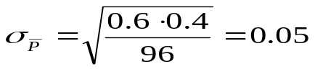
(b)
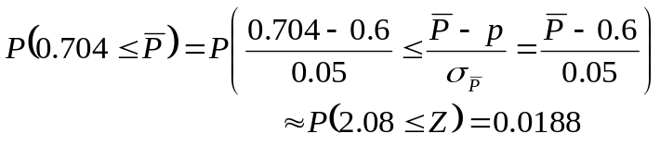
(c) We need to compute the probability that less than 70% of consumers will indicate they like the drink?
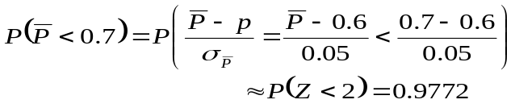
Example:
What is the most important factor for business travelers when they are staying in a hotel? According to USA Today, 74% of business travelers state that having a smoke-free room is the most important factor. Assume that the population proportion is 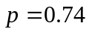 and that a sample of 200 business travelers will be selected.
- What is the probability that the sample proportion will be within 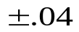 of the population proportion?
- Suppose the probability that a sample proportion will be within 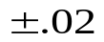 of the population mean is 0.9. What is the sample size n?
[solution:]
(a)
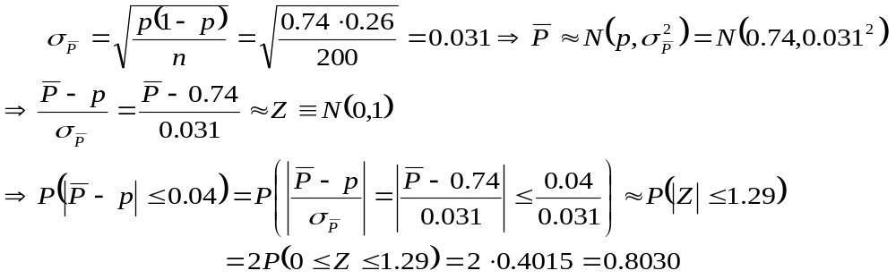
(b)
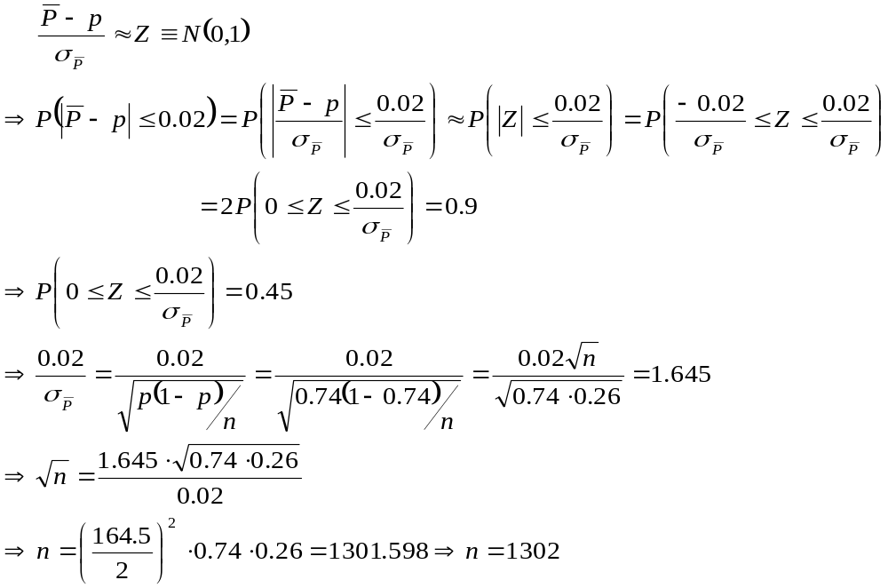

Online Exercise:
Exercise 9.2.1
Exercise 9.2.2

