# Sold By: Flipkart Internet Private Limited ,

**Ship-from Address:** Buildings Alyssa, Begonia & Clover, Embassy Tech Village, Outer Ring Road, Devarabeesanahalli Village, Bengaluru, Bengaluru, Karnataka, IN - 560103, CIN: U51109KA2012PTC066107

**GSTIN** - 29AACCF0683K1ZD

**Invoice Number** # BFFKA25030048872

# Order ID: OD330976234110643100

**Order Date:** 12-04-2024

**Invoice Date:** 12-04-2024

# Billing Address

Abhiram Suresh BN223B,Souparnika,Ayodhya Nagar, Pongumoodu,SKM P O,Trivandrum, Thiruvananthapuram 695017 Kerala Phone: xxxxxxxxxx

|  |  |  |  |  |  |  |
| --- | --- | --- | --- | --- | --- | --- |
| **Description** | **Qty** | **Gross Amount ₹** | **Discount** | **Taxable value ₹** | **IGST**  **₹** | **Total ₹** |
| SAC: 998599 Offer Handling Fee | 1 | 49.00 | 0.00 | 41.53 | 7.47 | 49.00 |
| 1. [IMEI/Serial No:  NHQMFSI0044051D228**7600** ] |  |  |  |  |  |  |
| **IGST:** 18.0 % |  |  |  |  |  |  |
| **Total** | **1** | **49.00** | **0.00** | **41.53** | **7.47** | **49.00** |

Grand Total ₹ **49.00**

Flipkart Internet Private Limited

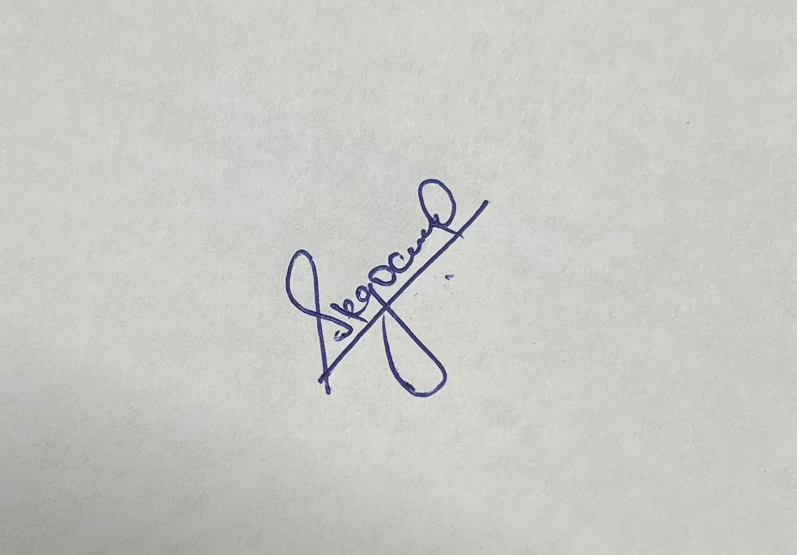

Authorized Signatory



Regd. office: Flipkart Internet Private Limited , Buildings Alyssa, Begonia & Clover, Embassy Tech Village, Outer Ring Road, Devarabeesanahalli Village, Bengaluru, Bengaluru, Karnataka - 560103 CIN: U51109KA2012PTC066107

Contact Flipkart: 044 - 66904500 || [www.flipkart.com/helpcentre](http://www.flipkart.com/helpcentre)

**E. & O.E.** page 1 of 1

# Sold By: Health & Happiness Private Limited ,

**Ship-from Address:** Sy no 696, Gundlapochampally Village, Medchal Mandal, Ranga Reddy Dist , Secundrabad, Telangana 501401, Secundrabad , Telangana, India - 501401, IN-TS

**GSTIN** - 36AADCH8449J1Z5

**Invoice Number** # FAABKQ2500001535

# Order ID: OD330976234110643100

**Order Date:** 12-04-2024

**Invoice Date:** 12-04-2024

**PAN:** aadch8449j

**CIN:** U52100HR2016PTC073827

# Bill To

**Abhiram Suresh** BN223B,Souparnika,Ayodhya Nagar, Pongumoodu,SKM P O, Trivandrum.

Thiruvananthapuram 695017 Kerala

Phone: xxxxxxxxxx

# Ship To Abhiram Suresh

BN223B,Souparnika,Ayodhya Nagar, Pongumoodu,SKM P O, Trivandrum.

Thiruvananthapuram 695017 Kerala

Phone: xxxxxxxxxx

*Keep this invoice and manufacturer box for warranty purposes.

|  |  |  |  |  |  |  |  |
| --- | --- | --- | --- | --- | --- | --- | --- |
| Total items: 1 |  | | | | | | |
| **Product** | **Title** | **Qty** | **Gross** | **Discounts** | **Taxable** | **IGST ₹** | **Total ₹** |
|  |  |  | **Amount ₹** | **/Coupons ₹** | **Value ₹** |  |  |
| Gaming Laptops | **Acer Aspire 7 (2023) Intel** | 1 | 57990.00 | -7000.00 | 43211.86 | 7778.14 | 50990.00 |
| FSN: | **Core i5 12th Gen 12450H -** |  |  |  |  |  |  |
| COMGP8QVTK3EQDXE  HSN/SAC: 84713010 | **(16 GB/512 GB SSD**  **/Windows 11 Home/4 GB** |  |  |  |  |  |  |
|  | **Graphics/NVIDIA GeForce** |  |  |  |  |  |  |
|  | **RTX 3050/144 Hz) A715-** |  |  |  |  |  |  |
|  | **76G Gaming Laptop** |  |  |  |  |  |  |
|  | Warranty: 1 Year Onsite Warranty |  |  |  |  |  |  |
|  | 1. [IMEI/Serial No: |  |  |  |  |  |  |
|  | NHQMFSI0044051D228**7600** ] |  |  |  |  |  |  |
|  | **IGST:** 18.0 % |  |  |  |  |  |  |
|  | **Shipping And Handling Charges** | 1 | 40.00 | -40.00 | 0.00 | 0.00 | 0.00 |
|  | **Total** | **1** | **58030.00** | **-7040.00** | **43211.86** | **7778.14** | **50990.00** |
|  |  |  |  |  | Grand Total | ₹ | **50990.00** |

Health & Happiness Private Limited

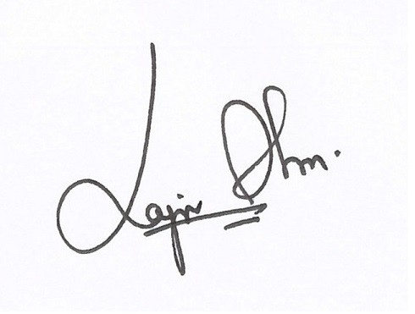

Authorized Signatory



**Returns Policy***: At Flipkart we try to deliver perfectly each and every time. But in the off-chance that you need to return the item, please do so with the* **original Brand box/price tag, original packing and invoice** *without which it will be really difficult for us to act on your request. Please help us in helping you. Terms and conditions apply.*

The goods sold as are intended for end user consumption and not for re-sale.

Regd. office: Health & Happiness Private Limited , Unit No.1001, 10th Floor, Park Centra Sector-30, GURUGRAM, HARYANA - 122001

Contact Flipkart: 044 - 66904500 || [www.flipkart.com/helpcentre](http://www.flipkart.com/helpcentre)

**E. & O.E.** page 1 of 1