Zad.1

Zad. 2



Zad. 3

Zad. 4

Zad. 5

Zad. 6



Zad. 7

Zad. 8



Zad. 9

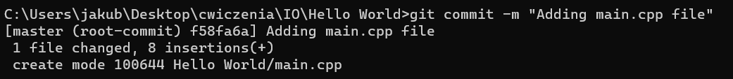

Zad. 10

Zad. 11

Zad. 12

Zad. 13

Zad. 14

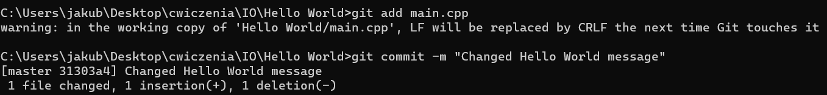

Zad. 15



Zad. 16

Zad. 17

Zad. 18

Zad. 19

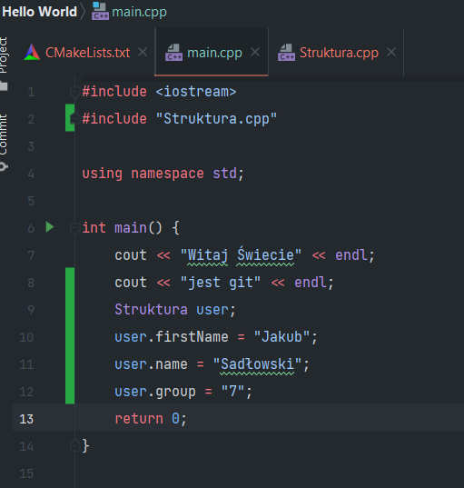

Zad. 20

Zad. 21

Zad. 22

Zad. 23

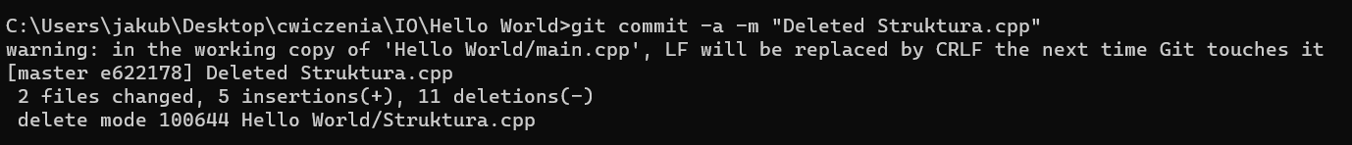

Zad. 24

