FECHA: 12/02/2020

DAC&P

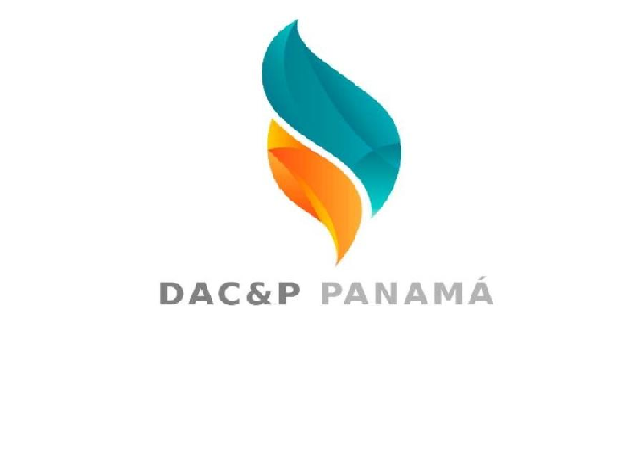 RESIVO

VENDEDORA: KEISHA

CLIENTE: BODEGAS AMERICA

|  |  |  |  |
| --- | --- | --- | --- |
| PRODUCTOS | CANTIDAD | VALOR U | VALOR TOTAL |
| LYSOL | 3 | 8 | 24 |
| ALCOHOL | 1 | 3 | 3 |
| QUIRURGICA NEGRA | 3 | 4,50 | 13.50 |
| TOTAL | $40.50 | | |

FORMA DE PAGO:

__________________________ ___________________________

FIRMA ENTREGA FIRMA RECIBE