FECHA: 11/09/2020

DAC&P

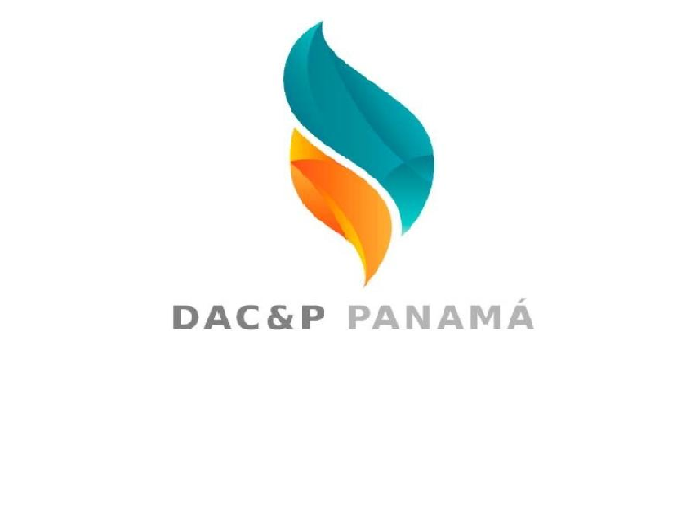 RESIVO

VENDEDORA: KEISHA

CLIENTE: BODEGAS AMERICA

|  |  |  |  |
| --- | --- | --- | --- |
| PRODUCTOS | CANTIDAD | VALOR U | VALOR TOTAL |
| QUIRURGICA NEGRA | 2 | 4.50 | 9 |
| ALCOHOL | 4 | 2.50 | 10 |
| QUIRURGICA CELESTE 3 PLIEGUES | 2 | 3 | 6 |
| KN 95 SIN VALVULA | 20 | 0.90 | 18 |
| LYSOL 19 ONZAS | 2 | 11 | 22 |
| TOTAL | $65 | | |

__________________________ ___________________________

FIRMA ENTREGA FIRMA RECIBE