Agustines Jane Rikki S. October 11, 2019

TM 191-HRO 191 Activity #1

**ACTIVITY #1 Flowcharts and Pseudocodes**

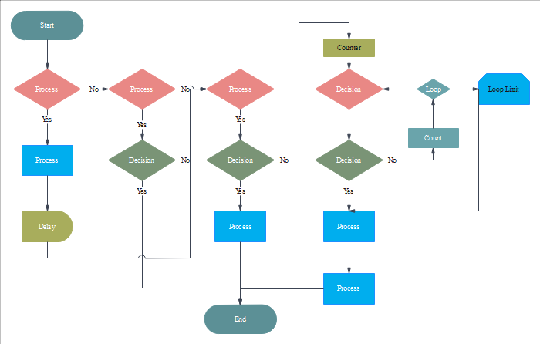

*Figure 1.0 Flowchart*

Flowchart is a type of graph that speaks to a calculation, work process or procedure. The flowchart demonstrates the means as boxes of various Kinds, and their order by associating the boxes with arrows. This diagrammatic portrayal illustrates an answer model to a given issue. Flowcharts are utilized in breaking down, planning, recording or dealing with a procedure or program in different fields.the fundamental objective is to make a rough draft of an answer for a coding issue. The sort of shapes found in the flowchart relies upon what articulations the software engineer needs to make. It focuses on the configuration of a system, including the various processes, decision points within a system, flows of control, data stores and documents and is essential in the development of information systems as it helps analyse processes, programs and systems and depicts a logical flow of activities events and processes. This allows developers to do three things: verify the algorithm's correctness before writing code, visualize how the code will ultimately be written, and communicate and document the algorithm with other developers and even non-developers. Flowcharts may be used in conjunction with other tools, such as pseudo-code, or may be used by it to communicate a module's ultimate design, depending on the level of detail of the flowchart. (wiki, 2019)

Flowcharts are utilized in structuring and documenting basic procedures or projects. Like other kinds of outlines, they help picture what is happening and accordingly help comprehend a procedure, and maybe additionally find more subtle highlights inside the procedure, similar to blemishes and bottlenecks. There are various sorts of flowcharts: each type has its own arrangement of boxes and documentations. The two most regular sorts of boxes in a flowchart are:

* a preparing step, as a rule called movement, and meant as a rectangular box.
* a choice, normally meant as a diamond.

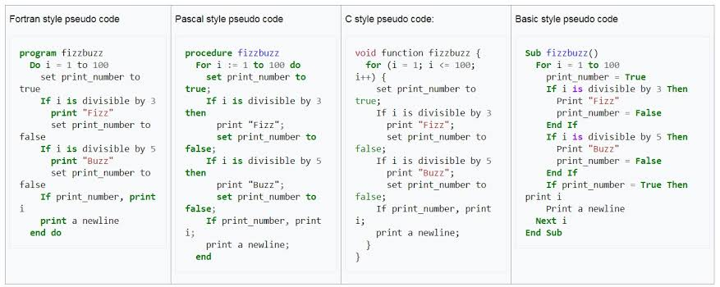A flowchart is portrayed as "cross-useful" when the outline is isolated into various vertical or level parts, to depict the control of various hierarchical units. An image showing up in a specific part is inside the control of that authoritative unit. A cross-useful flowchart enables the creator to accurately find the obligation regarding playing out an activity or settling on a choice, and to demonstrate the duty of each authoritative unit for various pieces of a solitary procedure. (Jackson, 2017)

*Figure 2.0 Pseudocodes*

It is a casual elevated level description of the working standard of a PC program or other calculation. It utilizes the structural conventions of an ordinary programming language, yet is expected for human perusing as opposed to machine perusing. Pseudocode regularly precludes subtleties that are fundamental for machine comprehension of the calculation, for example, factor announcements, framework explicit code and a few subroutines. (Zobel, 2019)The programming language is enlarged with characteristic language description details, where advantageous, or with smaller scientific documentation. The purpose behind using pseudocode is that it is simpler for individuals to understand than customary programming language code, and that it is a proficient and condition autonomous description of the key standards of a calculation. It is usually utilized in course books and logical productions that are archiving different calculations, and furthermore in arranging of PC program improvement, for drawing out the structure of the program before the genuine coding happens.There are some alternatives to Pseudocode. Some of them are [Flowcharts, drakon-charts and Unified Modified Language (UML) charts](https://www.lucidchart.com/pages/what-is-a-flowchart-tutorial). They will serve the purpose but they comparatively require more resources. (Bennett, 2019)

This is done to identify top level flow errors, and understand the programming data flows that the final program is going to use. This definitely helps save time during actual programming as conceptual errors have been already corrected. Firstly, program description and functionality is gathered and then pseudocode is used to create statements to achieve the required results for a program. Detailed pseudocode is inspected and verified by the designer’s team or programmers to match design specifications. Catching errors or wrong program flow at the pseudocode stage is beneficial for development as it is less costly than catching them later. Once the pseudocode is accepted by the team, it is rewritten using the vocabulary and syntax of a programming language. The purpose of using pseudocode is an efficient key principle of an algorithm. It is used in planning an algorithm with sketching out the structure of the program before the actual coding takes place.

The Advantages of Pseudocodes are it is understood by the programmers of all types.It also enables the programmer to concentrate only on the algorithm part of the code development.  
And It cannot be compiled into an executable program. Example, Java code : if (i < 10) { i++; } pseudocode :if i is less than 10, increment i by 1. (Zobel, 2019)

Also it is a comments placed inside of programs in order to produce ease of readability. We use pseudocode not only for ourselves but for others that are working with us or will be working on the same project at a later date. There are no syntax rules for how a comment must be written, but it must be written using either forward slashes or forward/back slash with an asterisk at both its beginning and ending. When the computer hit a comment, it skips over it and proceeds to the code; this is why it is important to add those front/back slashes and asterisks when appropriate (answers.com, 2019)

# Bibliography

*answers.com.* (2019, october 12). Retrieved october 12, 2019, from answers: https://www.answers.com/Q/What_are_the_importance_of_flowchart_in_programming

Bennett, C. (2019). *economictimes.indiatimes.* Retrieved october 12, 2019, from Economic Times: https://economictimes.indiatimes.com/definition/pseudocode

Doyle, C. (2013, february 26). *wordpress.* Retrieved october 12, 2019, from eterna lsunshine of the is mind: https://eternalsunshineoftheismind.wordpress.com/2013/02/25/importance-of-flowcharts-when-developing-information-systems/

Jackson, D. (2017, september 28). *medium.com.* Retrieved october 12, 2019, from Medium: https://medium.com/@andremj013090/pseudocode-and-its-importance-5f71e38a0d95

*wiki.* (2019, september 24). Retrieved october 12, 2019, from wikipedia: https://en.wikibooks.org/wiki/Programming_Fundamentals/Flowcharts

Zobel, J. (. (2019, october 9). *wiki.* Retrieved october 12, 2019, from wikipedia: https://en.wikipedia.org/wiki/Pseudocode