Agustines Jane Rikki S. PROGCON

BSTM 191 Ms. Jen Arroyo

Flowgorithm Exercises Discussion

M1. Adding Two Numbers

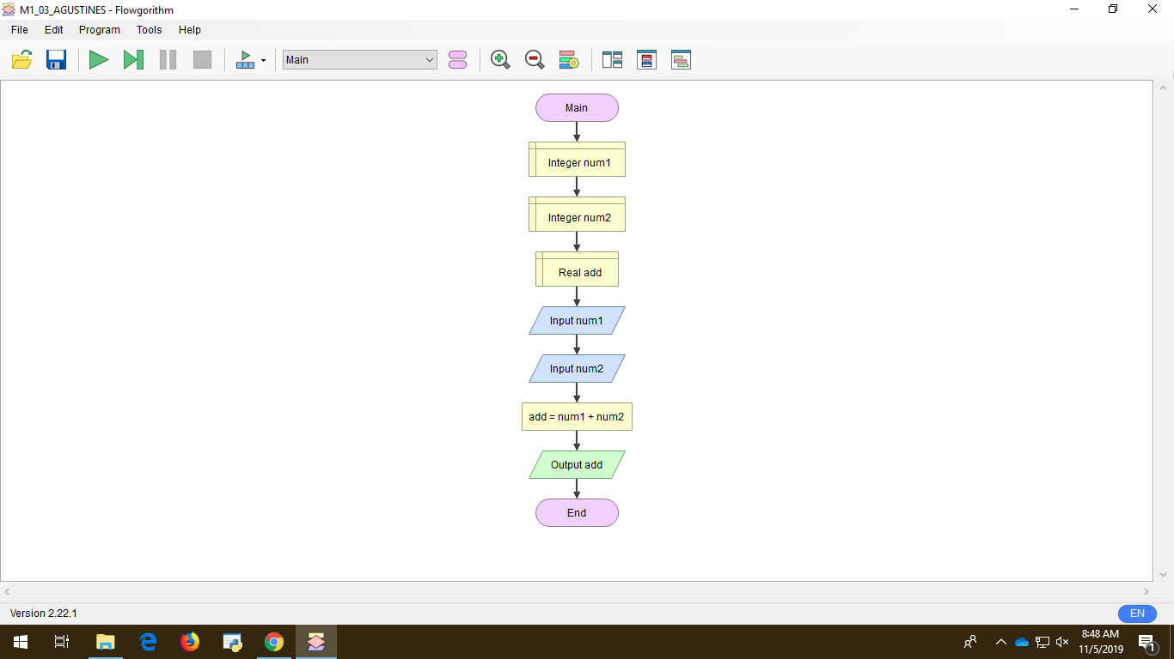

Discussion: In doing my flowchart in adding two numbers, first declare to give the integer Number 1 and Number 2, next is declare the Real add then input Number 1 and Number 2. Add the sum Number 1 and Num 2 After that Output Add and after that you’ll get the answer then end and run the program.

M2. Getting the Area of a Circle using Radius and Diameter

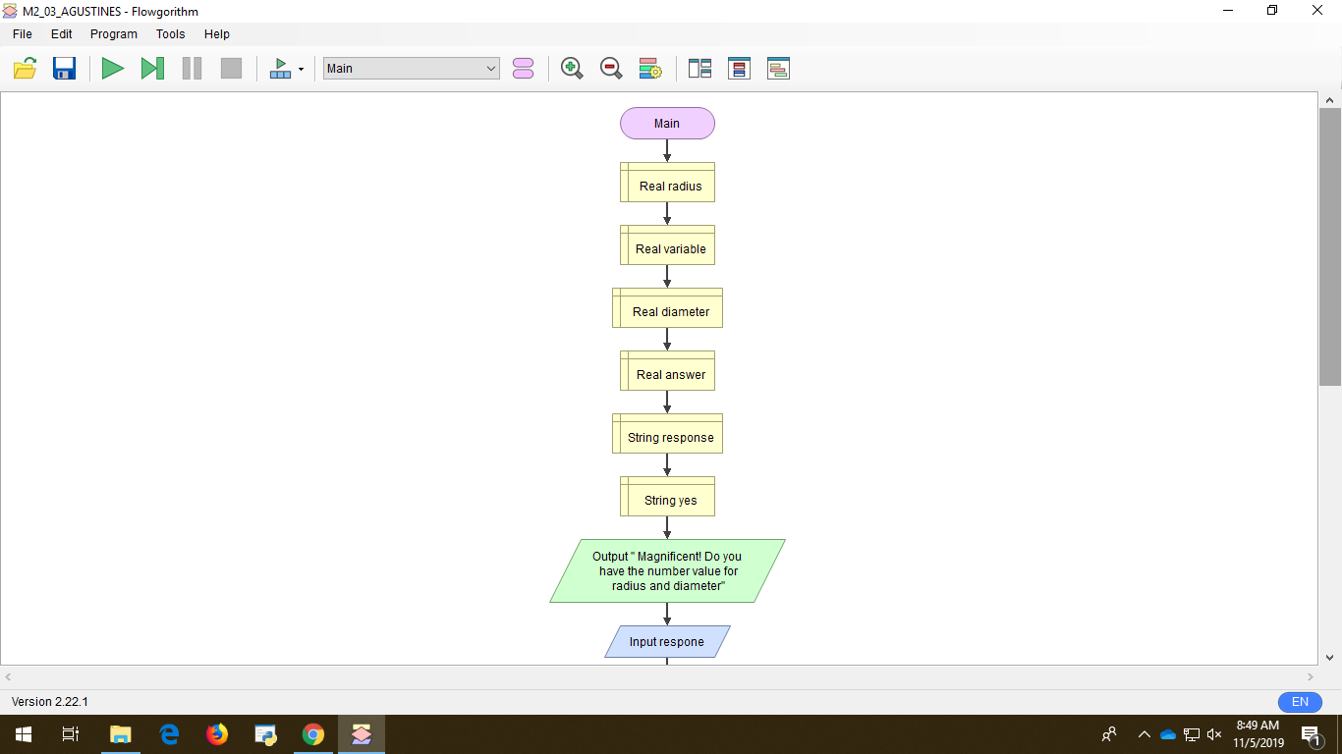

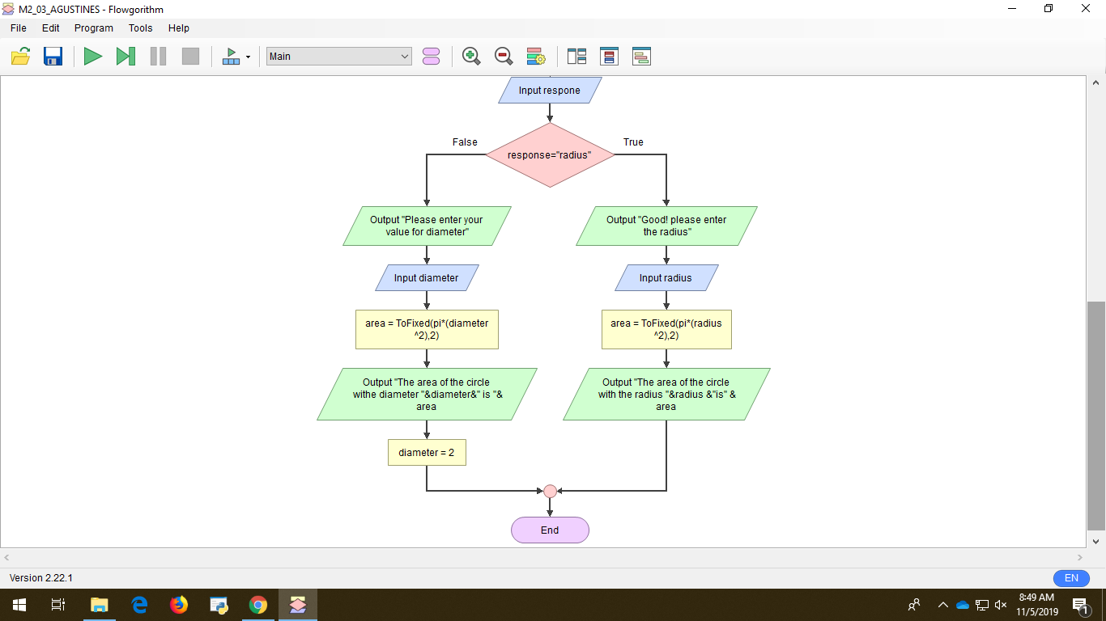

Discussion: In getting the area of a circle using Radius and Diameter, First I declare everything that is needed and not known to the software. Next, I declare again Response and Yes with String. After that is Output and asked “do you have a value of radius and diameter?” after that insert Input Response. Next one is to create a decision if it is true or false. If it is false it will use the diameter and if it is true it will be going to use Radius and you will go into some progress after that you will be getting the response, and end it. After that run the program again for any mistakes and fix it.