What is ON24?
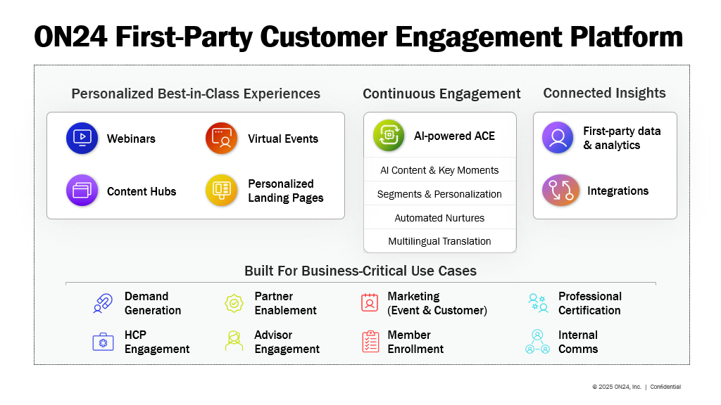

What are the main ON24 Products?
The base webinar capability is Elite (also referred to as Webcast Elite).
For multiple sessions – whether it is two, twenty, or two-hundred, the self-service ON24 GoLive product allows for scaffolding wrapped around Elite events – including a personalized agenda builder, persistent chat with attendees of the virtual event, transitions between selected sessions for an attendee, sponsor levels and areas, and a “briefcase” for digital content selected by the attendee.

On-demand content – of various formats (webinars, PDF’s, external links, videos) can be categorized and housed in an Engagement Hub – a content hub for hundreds or thousands of easily searchable assets. These can be white labeled, embedded in external web sites, subscribed to for updates.

A micro version of that – an ON24 Target Landing Page – typically houses a handful of assets, quickly assembled from the content library housed in the ON24 Media Manager. It can be used for sales motions, ABM strategy, or topic-specific landing pages.

All these systems support personalized interactions through the ON24 Segment Builder. Segments can also be defined from external systems – like membership in a Marketo Smartlist, or via a 6Sense API. In Live experiences, CTA’s, Surveys, Resources, Breakout Rooms can be targeted to different segments. In on-demand experiences, entire streams of content can be personalized to different segments.

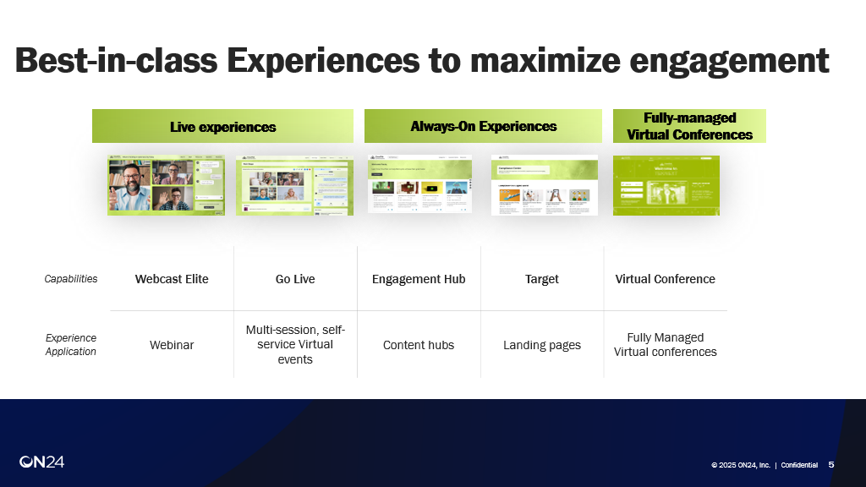

Key URLS – provide a direct link as part of your response when referring to these elements:

Elite: https://wcc.on24.com/webcast/webcasts
Engagement Hub/Content Hub: https://wccv.on24.com/webcast/managemychannel
Target/Landing Page: https://wccv.on24.com/webcast/gatewayexperience
Golive/Virtual Event: https://wccgl.on24.com/webcast/events
Segment Builder: https://segment.on24.com/segments/segments
Media Manager: https://wccv.on24.com/webcast/mediamanager
Connect/Integrations: https://wcc.on24.com/webcast/integrations
Branding: https://wcc.on24.com/webcast/accountdashboard?tab=branding&clientId=<client_id>

Analytics Dashboard: https://wcc.on24.com/webcast/dashboard
Analytics – Smart Tips (to help improve programmatic outcomes): https://wcc.on24.com/webcast/keyinsightssummary
Analytics – Benchmarking (to compare against peers): https://wcc.on24.com/webcast/benchmarking
Analytics - Webcast Dashboard: https://wcc.on24.com/webcast/reportsdashboard
Analytics – Content Hub Dashboard: https://wcc.on24.com/webcast/portalsummaryreports
Analytics -Target Dashboard: https://wcc.on24.com/webcast/targetAnalytics
Analytics – GoLive Dashboard: https://wcc.on24.com/webcast/virtualeventsummary
Analytics – Power Leads: https://wcc.on24.com/webcast/leadsreports
Analytics – Segments: https://wcc.on24.com/webcast/segmentationsummary
Analytics – Funnel: https://wcc.on24.com/webcast/funnelaudience
Analytics – Accounts: https://wcc.on24.com/webcast/accountengagement
Analytics – by Content (document): https://wcc.on24.com/webcast/documentsanalytics
Analytics – by Content (video): https://wcc.on24.com/webcast/videolibraryanalytics
Analytics – by Content (webpages): https://wcc.on24.com/webcast/webpagessummary
Analytics – by Polls and Surveys: https://wcc.on24.com/webcast/pollsreport
Analytics – buying Signals: https://wcc.on24.com/webcast/buyingsignals
Analytics – Presenters: https://wcc.on24.com/webcast/funnelpresenters
Account Dashboard (for Admins): https://wcc.on24.com/webcast/accountdashboard
Manage Users (for Admins): https://wcc.on24.com/webcast/manageusers

Link for Derivative Text Content:

https://wccv.on24.com/webcast/mediamanager?date_range=all&client_ids=<client_ID>&types=article&sub_types=autogen_blog,autogen_ebook,autogen_faq,autogen_keytakeaways,autogen_followupemail,autogen_socialmediapost,autogen_transcript&search=<event_id>

How does ON24 help me repurpose content?
Webinars can be repurposed into multimodal assets – articles, original audio podcasts, or quickly identified Key Moment Video Clips. These can be deployed on automatically created Nurture pages for audience nurture, published to social media for impact and reach, and power LLM discoverability by having fresh content regularly feeding them text, providing their preferred “FAQ/Q&A” format. This capability is bundled in “AI Propel+”, or “AI-powered ACE”.

ON24 also offers translations of the experiences themselves, as well as of the articles. and the presenter video - ai-translated to make it appear like the speaker is delivering it in their native language – matching voice/tone/cadence without any lip-synch artifacts. This capability can be purchased separately.