- Created a git repository and uploaded a file in it.
I have created a git repository with a file awsq3.txt in it and the url of the git repository is:
https://github.com/jsaiteja/jenkins
- Created an s3 bucket named bucket-7262019.
- Created three ec2 instances. One for master and two for slave nodes.
- Installed java-1.8.0 and then, jenkins also on the master instance.
- Generated public and private keys by command
ssh key-gen -t rsa
- Copy the public key of master instance and pasted in the authorized keys file of other two slave nodes.
- The two slave node instances are added to the master Known hosts using the command
ssh username@hostname
- Start the jenkins service (systemctl jenkins start).
- Login with the username&password on jenkins console.
- Go to new node and create two newnodes.
- Specify SSH username with key and copy the private key from the master and paste it there. Specify the ip addresses of both slave nodes.Credentials are also to be set.
- Now master and two slave nodes are created as shown in the screenshot below.

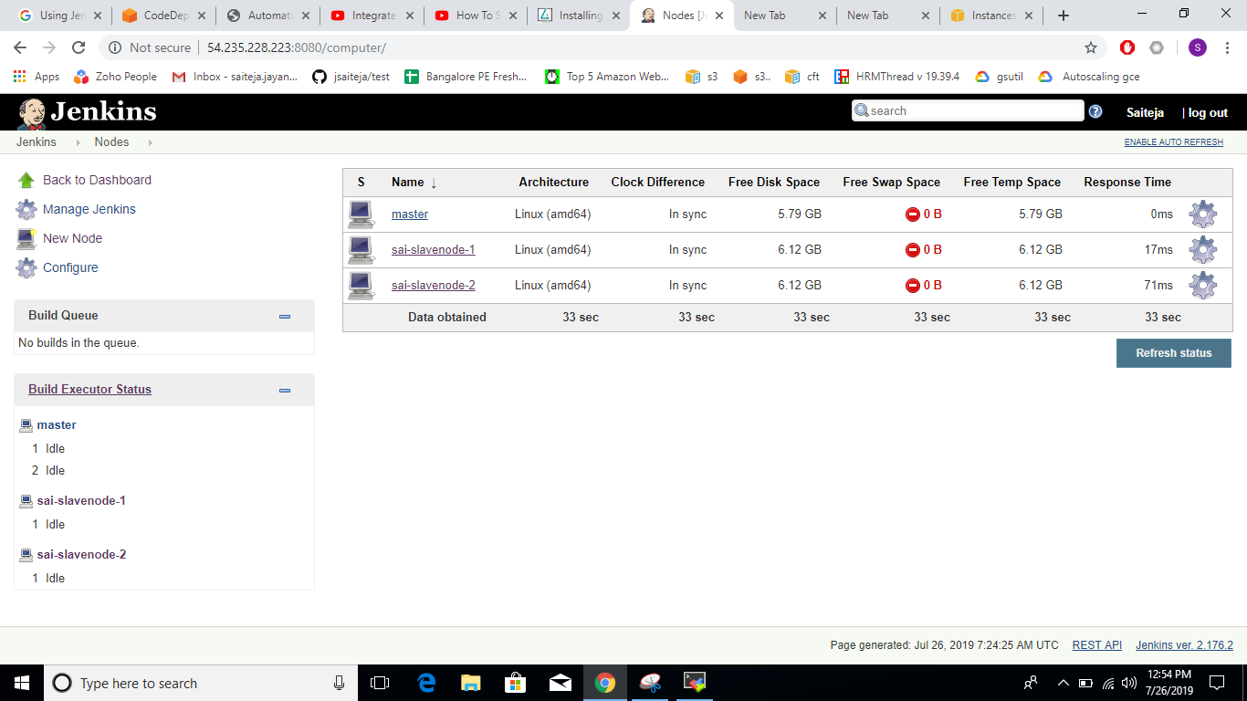

- Now create two jobs . One job for getting the required file from git repository and other job for deploying the file in the S3 bucket that is specified.
- Before this amazon s3 plugins also should be installed.
- For job1 specify the source code management as shown below.
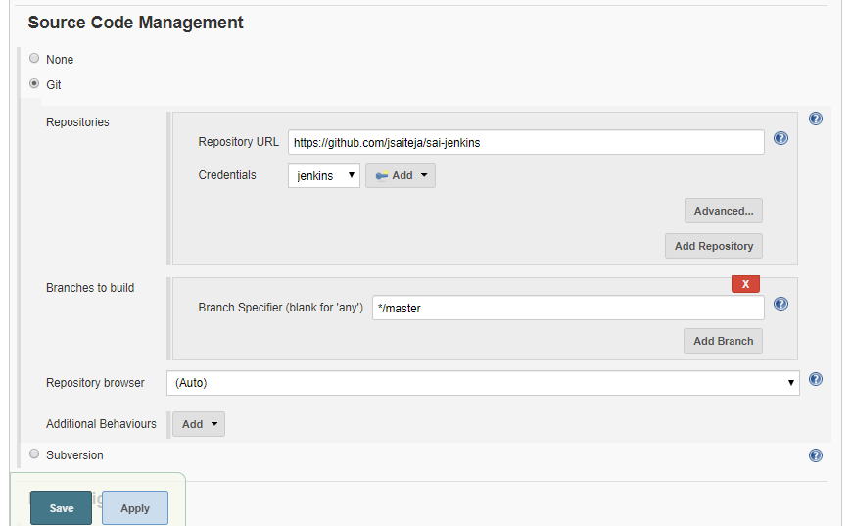

Also in the post build actions select projects to build as job2.

- Job2 is performs deployment of the file in s3 bucket. It has to be configured as shown below.

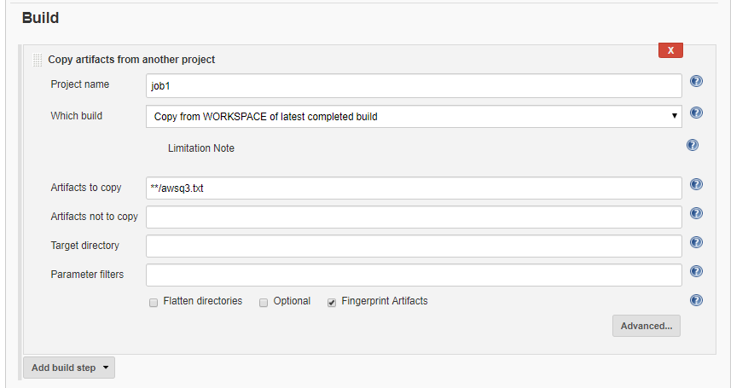

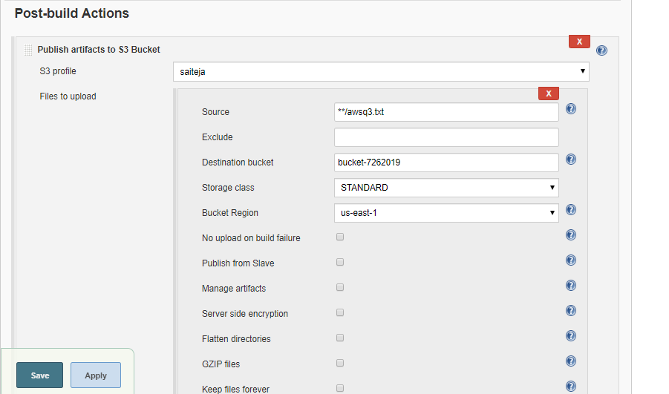

- After building job1,job2 also get built and a file is copied(awsq3.txt) from git repo to s3 bucket.

