Q1

- Create a Dockerfile to create nginx image.
The code in Dockerfile is as follows:

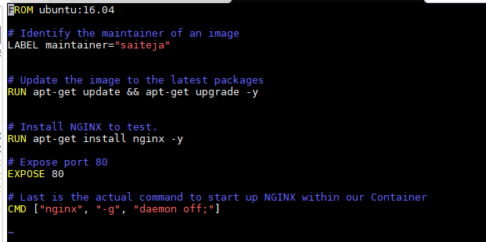

- sudo docker build -t myimage .
This command is used to build an nginx image with name myimage

- docker run -d -p 8080:80 myimage
This command is used to run myimage and publish the port 8080.

- Inorder to get the image id to execute it, run docker ps command

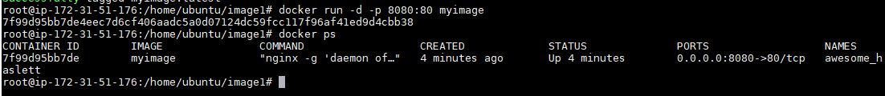

- docker exec -it 7f99d95bb7de /bin/bash
The above command is used inorder to execute bash on it.

- To install nano run the command
apt-get install nano

- To push this image into dockerhub, login into docker by entering username & password. Then, run the following commands.

docker tag ae75988d41a7 jsaiteja/myimage:firstpush (specify tag name)
docker push jsaiteja/myimage

