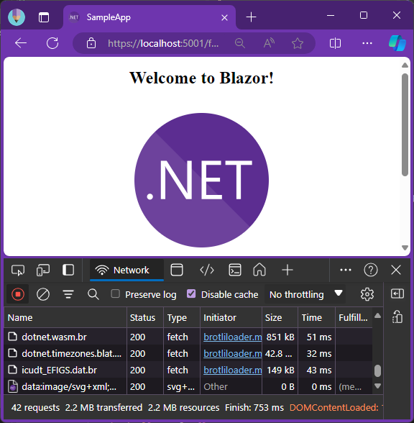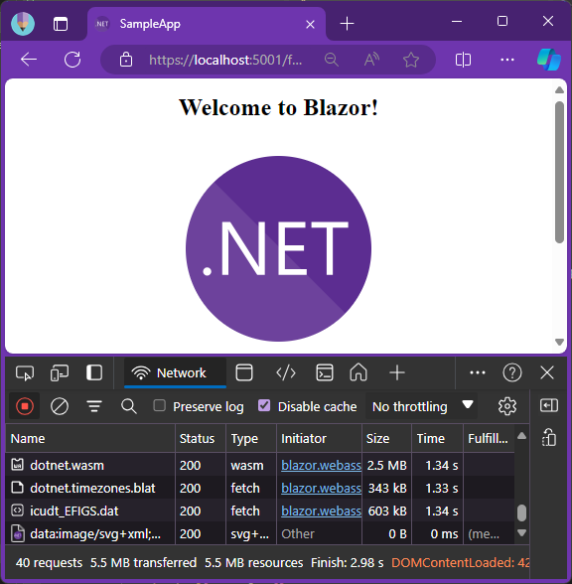

**After**

**2.2MB  
transferred**

**Before**

**5.5MB  
transferred**

$ dotnet add package BlazorWasmBrotliLoader.Build

$ dotnet publish