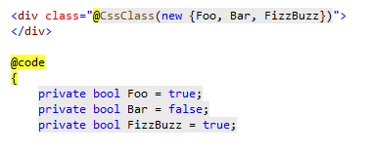

Write a code in .razor file like this…

Then you will get this rendering!

