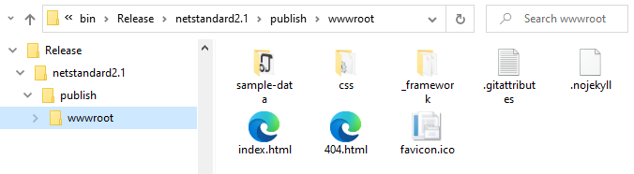

Add

Add

Copy from  
index.html

Rewrite  
base URL

$ dotnet add package PublishSPAforGitHubPages.Build

$ dotnet publish -c:Release **-p:GHPages=true**