Experiment – 12
Question:
Demonstrate virtualization by Installing Type-2 Hypervisor in your device, create and configure VM image with a Host Operating system (Either Windows/Linux), using VMware workstation.
Answer:
AIM: To demonstrate virtualization by installing a Type-2 Hypervisor and creating a virtual machine using VMware Workstation.
SOFTWARE REQUIRED: VMware Workstation 17, Ubuntu ISO, Host OS: Windows
PROCEDURE:
STEP 1: Launch VMware Workstation
Click Start → VMware Workstation 17
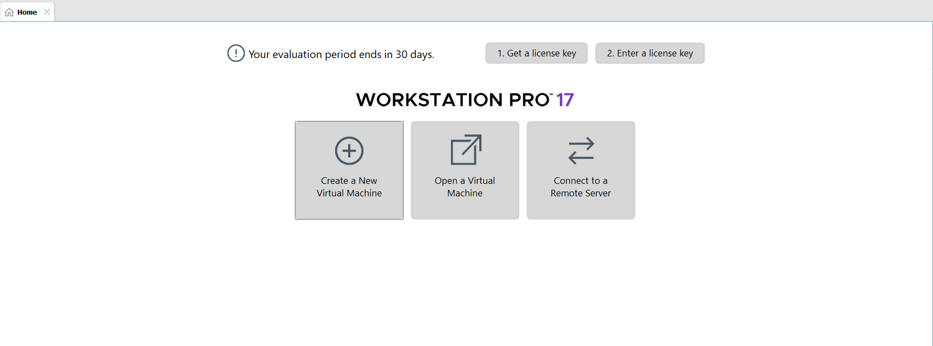
STEP 2: Verify Type-2 Hypervisor
VMware runs on top of the host OS, so it is a Type-2 Hypervisor
STEP 3: Create Virtual Machine
Click Create a New Virtual Machine
Select Typical (recommended) → Next
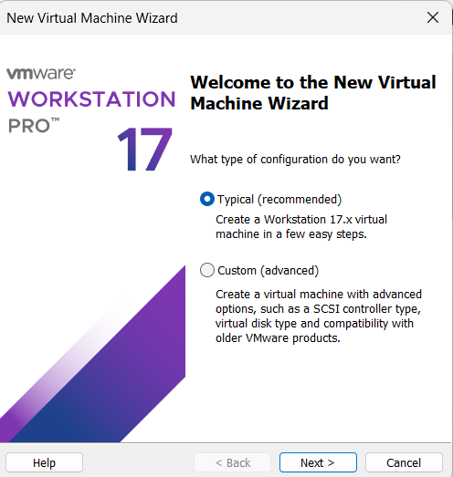
STEP 4: Select OS Installer
Choose Installer disc image file (ISO)
Browse and select Ubuntu ISO
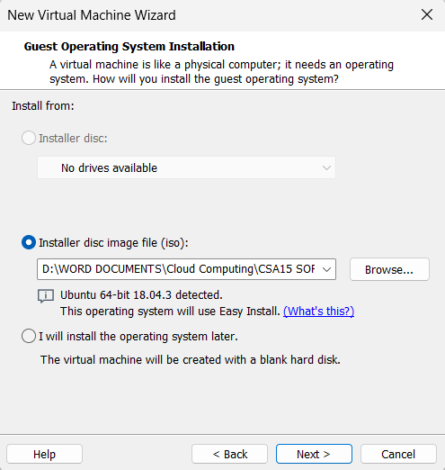
STEP 5: Select Guest OS
Guest OS: Linux
Version: Ubuntu
STEP 6: Name VM & Location
VM Name: Virtual Machine Ex-12
Choose location → Next
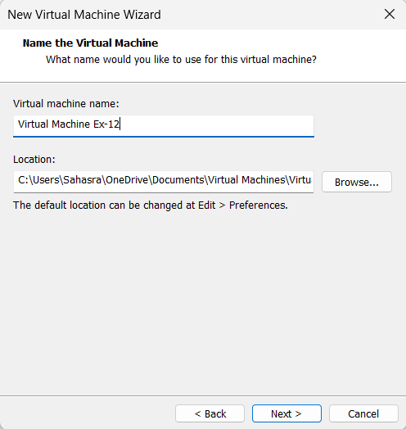
STEP 7: Finish Installation
Click Finish
Ubuntu starts installing automatically
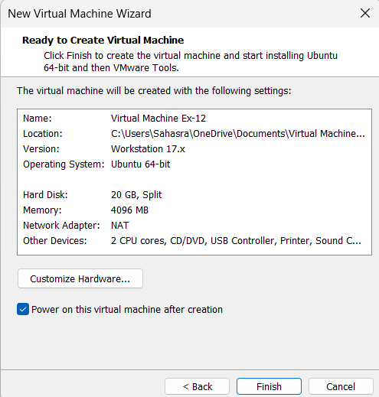
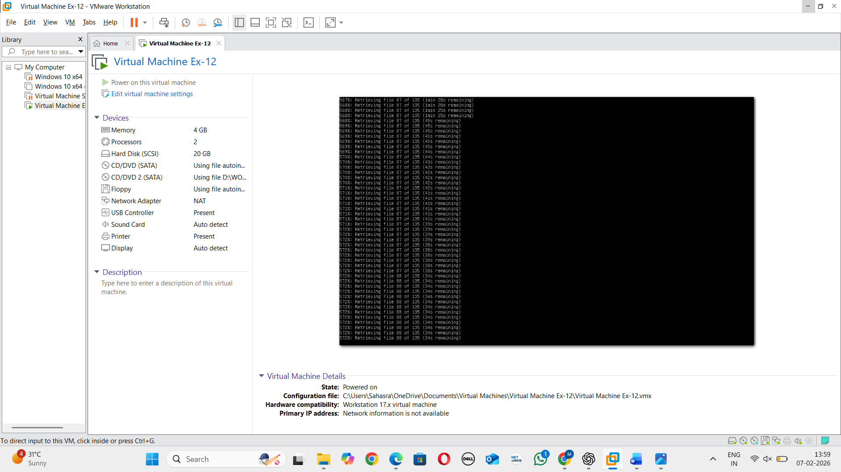
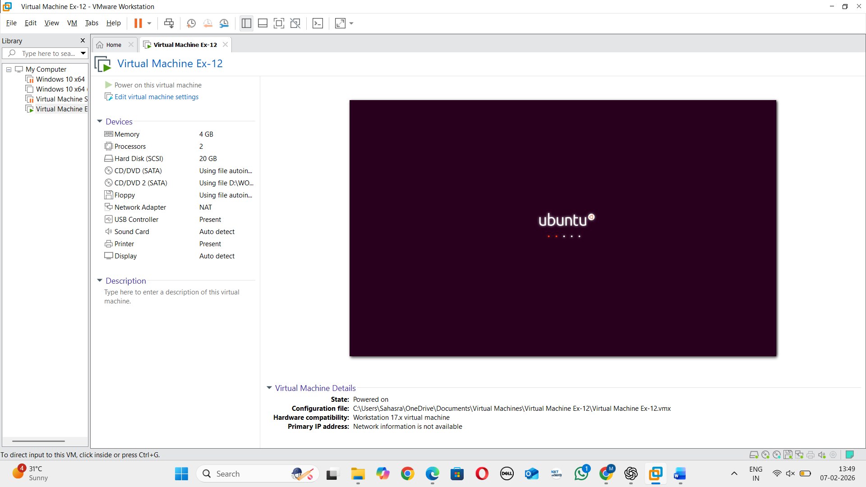

RESULT: Virtualization is successfully demonstrated using VMware Workstation Type-2 Hypervisor.

