Experiment – 14
Question:
Create a Virtual Hard Disk and allocate the storage using Vmware Workstation.
Answer:
AIM: To create and allocate a virtual hard disk using VMware Workstation.
SOFTWARE REQUIRED: VMware Workstation 17, Ubuntu ISO, Host OS: Windows
PROCEDURE:
STEP 1: Launch VMware Workstation
Click Start → VMware Workstation 17

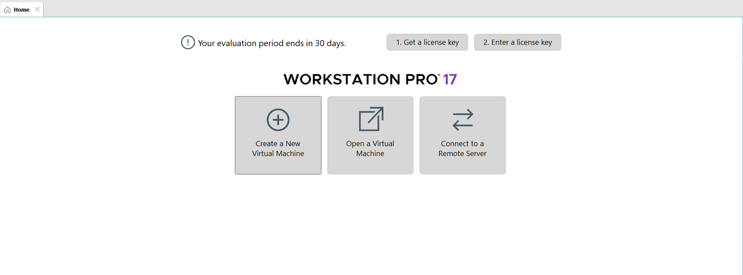

STEP 2: Create Virtual Machine
Click Create a New Virtual Machine
Select Typical (recommended) → Next
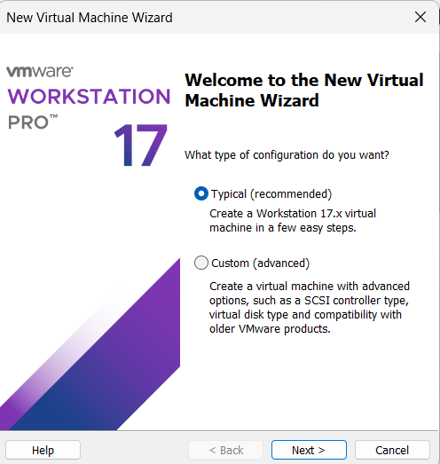

STEP 3: Select OS Installer
Choose Installer disc image file (ISO)
Browse and select Ubuntu ISO

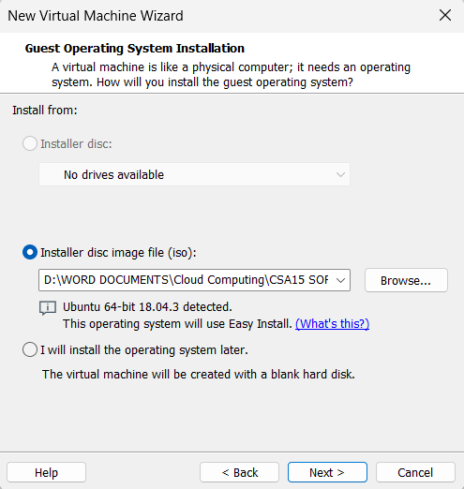

STEP 4: Name VM & Location
VM Name: Virtual Machine Ex-14
Choose location → Next
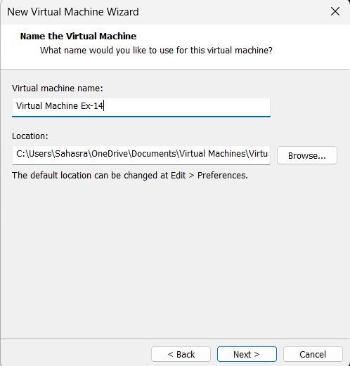

STEP 5: Configure Disk
Click Hard Disk
Set disk size to 10 GB
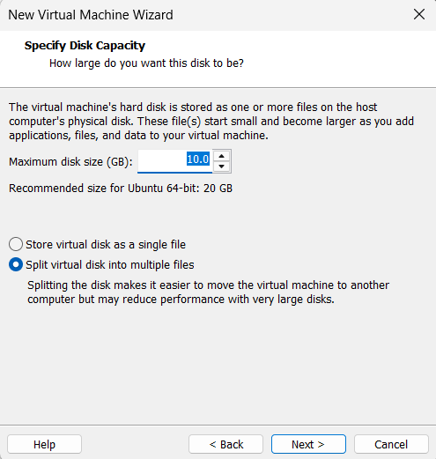

STEP 6: Finish Installation
Click Finish
Ubuntu starts installing automatically
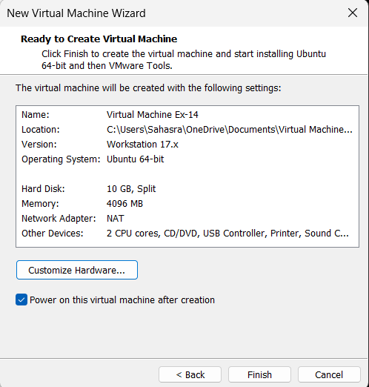
STEP 7: Save & Start VM
Click OK
Power ON the VM
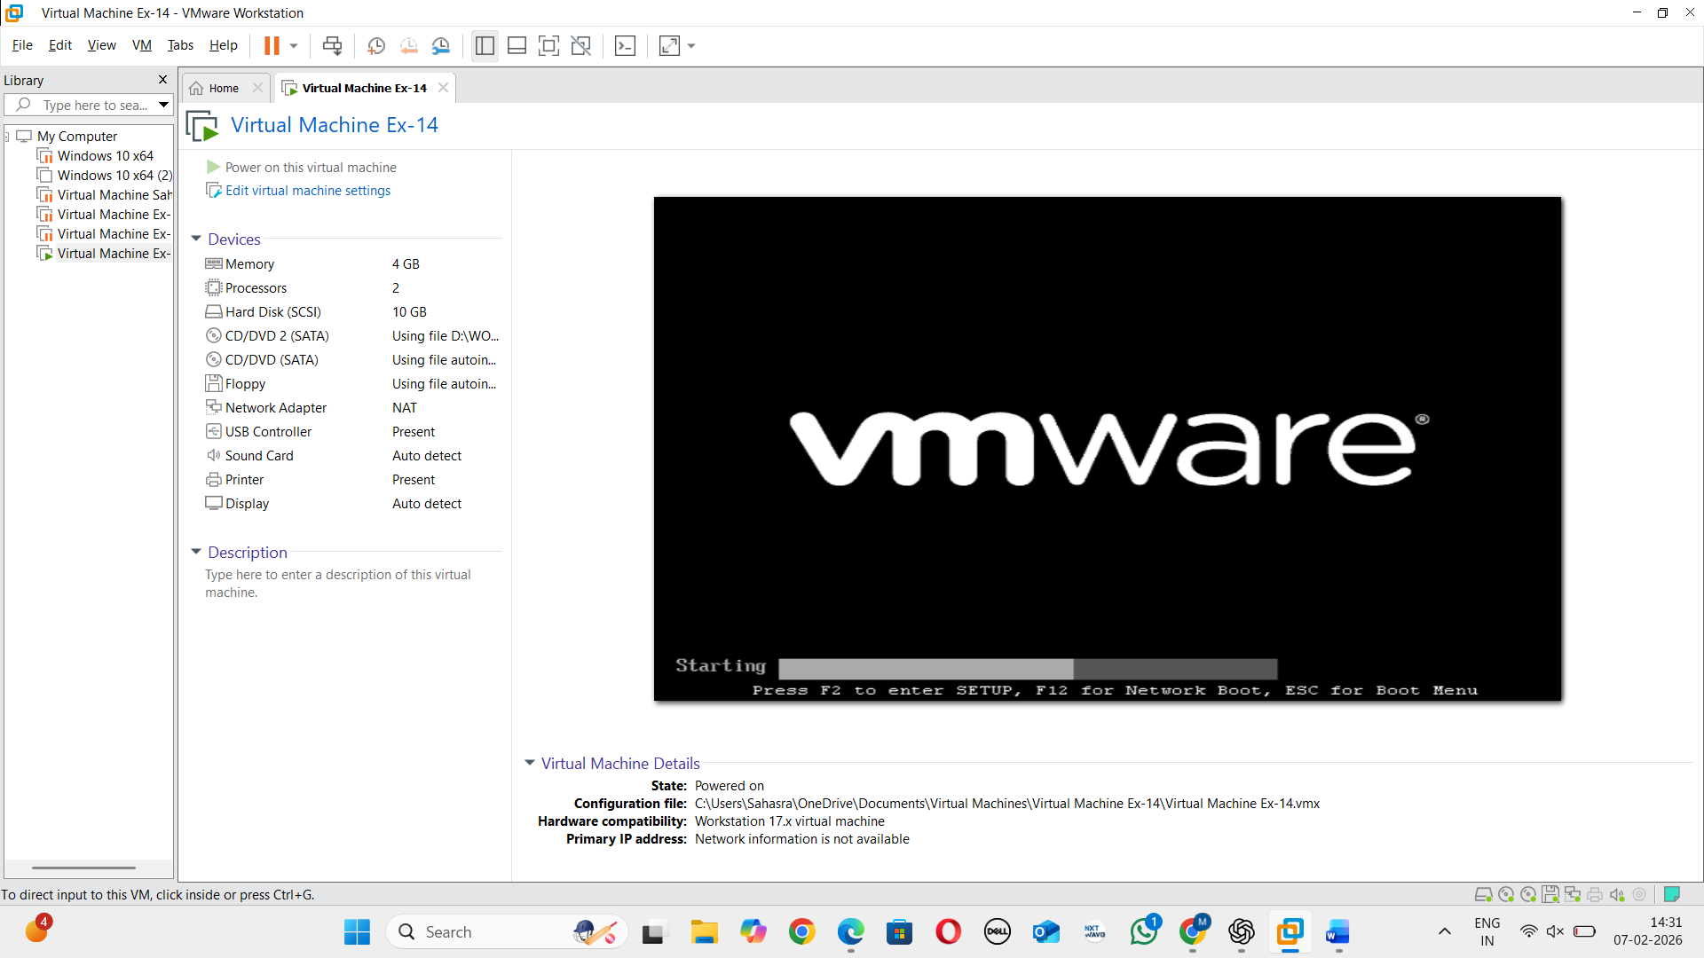
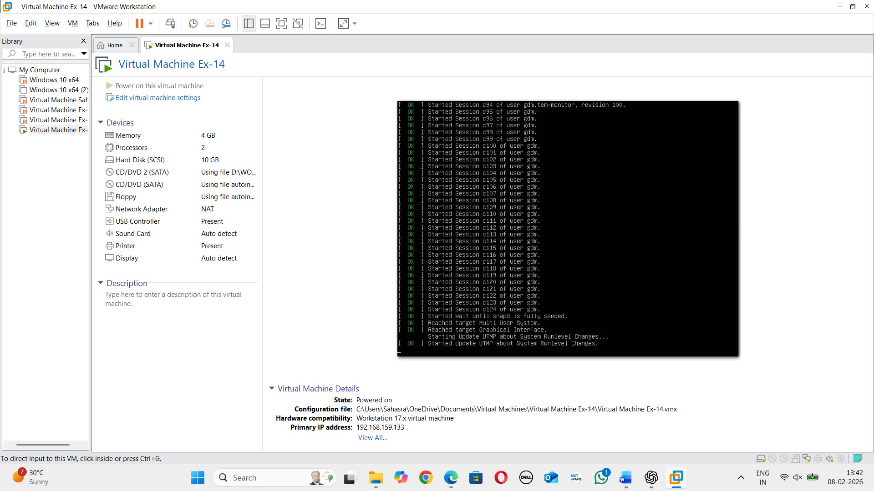

RESULT: A virtual hard disk is successfully created and allocated.

