Experiment – 15
Question:
Create a Snapshot of a VM and Test it by loading the Previous Version/Cloned VM using Vmware workstation.
Answer:
AIM: To create and test snapshots in VMware Workstation.
SOFTWARE REQUIRED: VMware Workstation 17, Ubuntu ISO, Host OS: Windows
PROCEDURE:
STEP 1: Launch VMware Workstation
Click Start → VMware Workstation 17

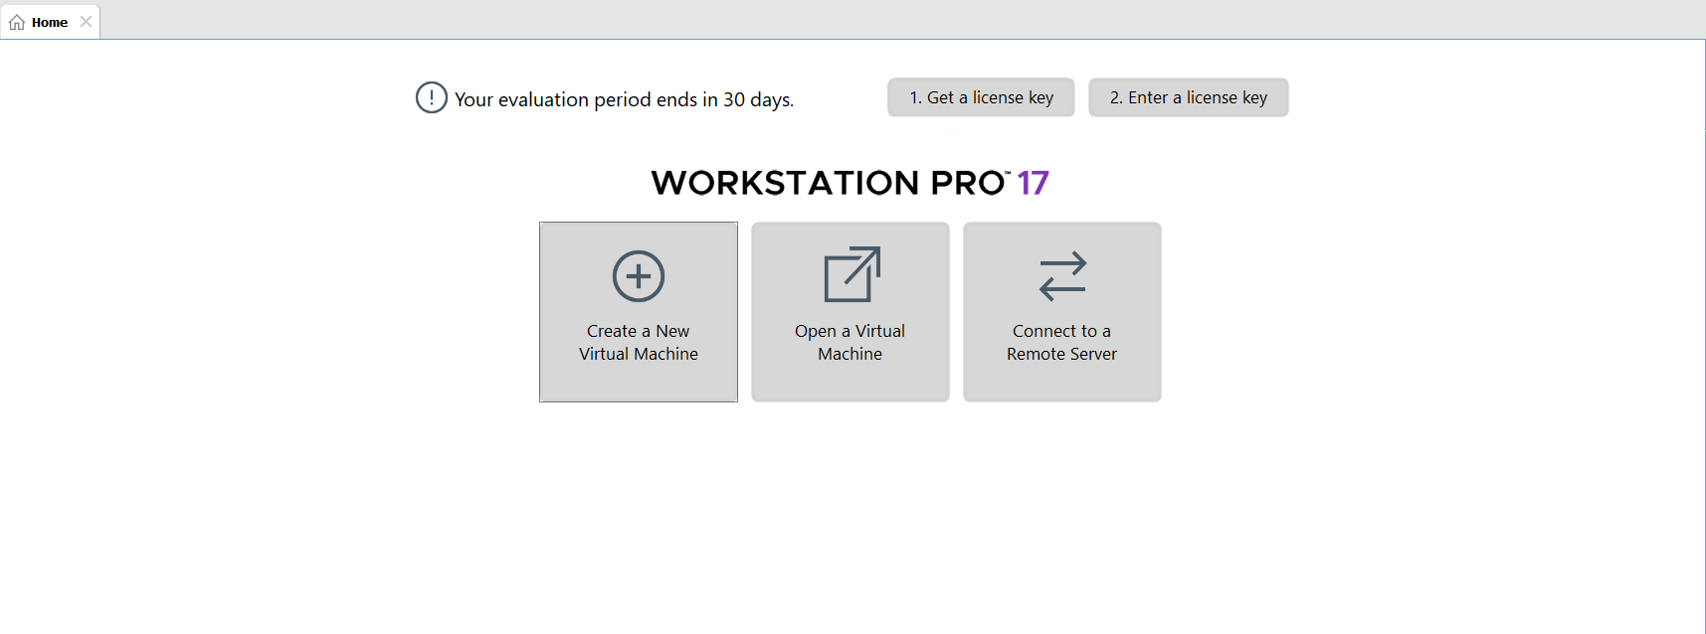

STEP 2: Create Virtual Machine
Click Create a New Virtual Machine
Select Typical (recommended) → Next
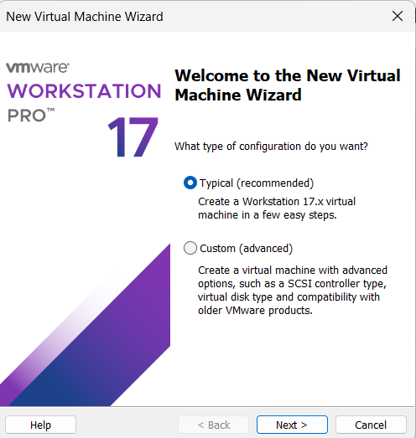

STEP 3: Select OS Installer
Choose Installer disc image file (ISO)
Browse and select Ubuntu ISO

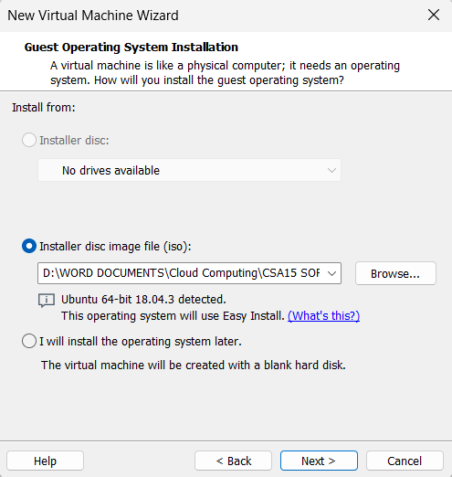

STEP 4: Name VM & Location
VM Name: Virtual Machine Ex-15
Choose location → Next
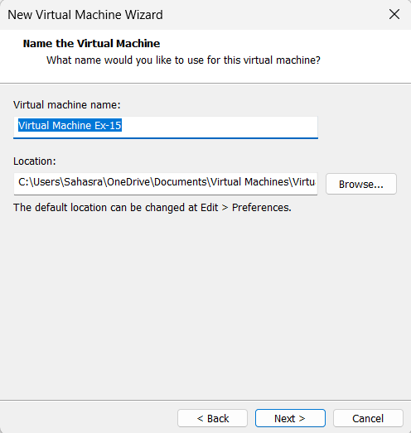

STEP 5: Finish Installation
Click Finish
Ubuntu starts installing automatically
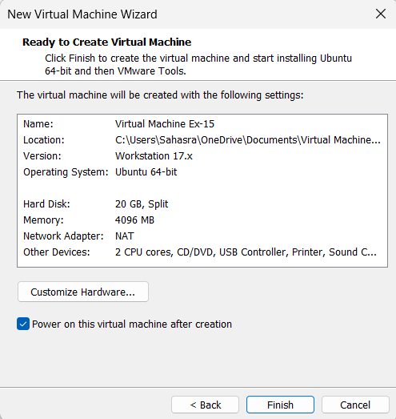

STEP 7: Save & Start VM
Click OK
Power ON the VM
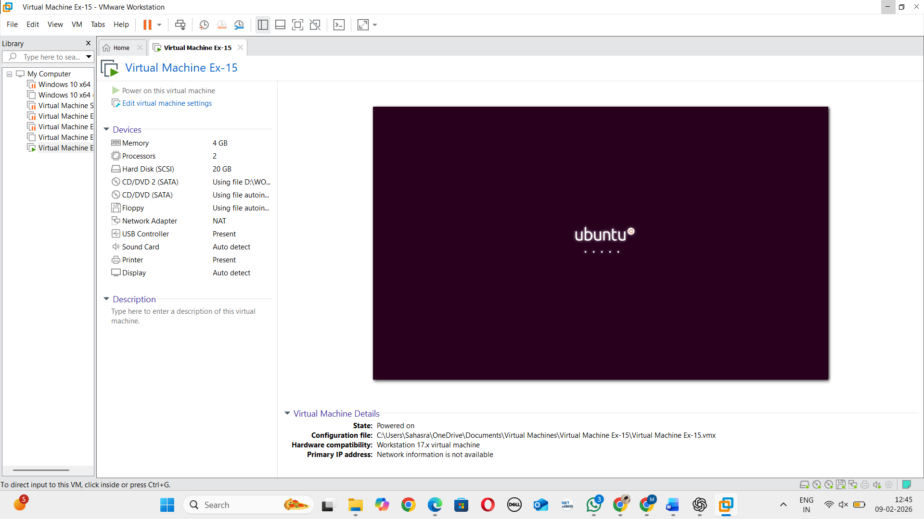

STEP 8: Create Snapshot
Go to VM → Snapshot → Take Snapshot
Name: Snapshot1
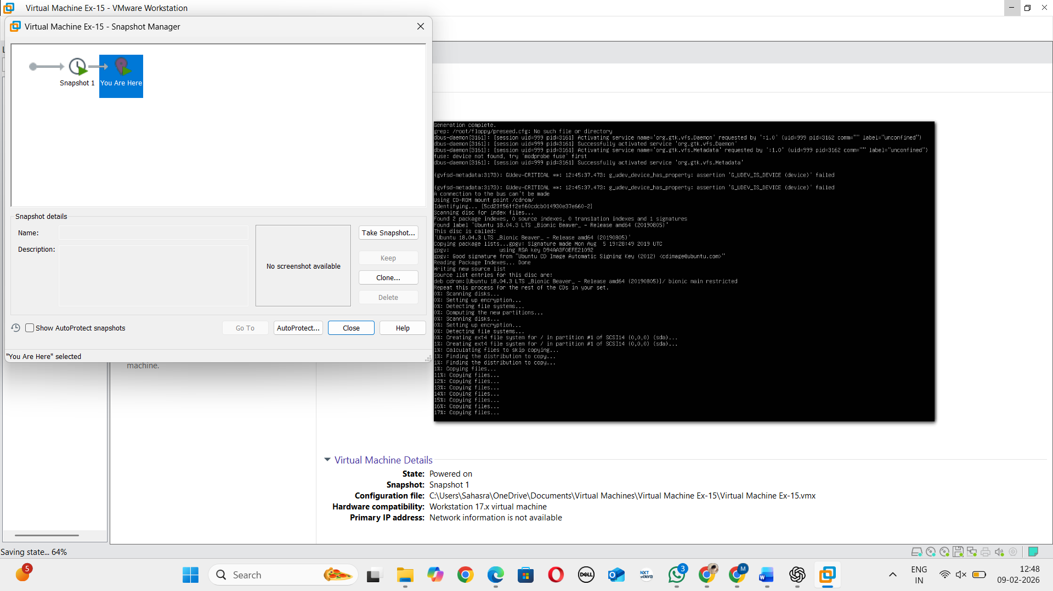
STEP 9: Make Changes in VM
Go to Desktop
Create a New Folder
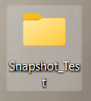
STEP 10: Create Snapshot
Go to VM → Snapshot → Take Snapshot
Name: Snapshot2
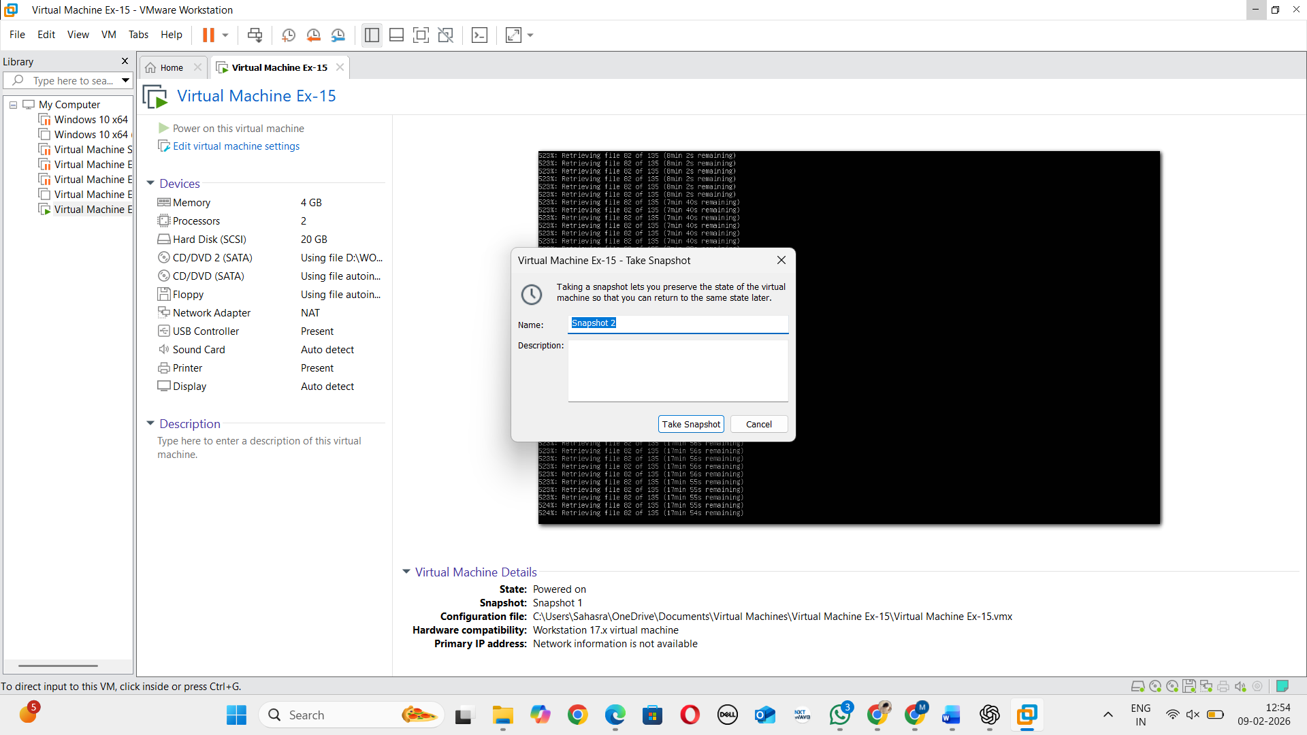

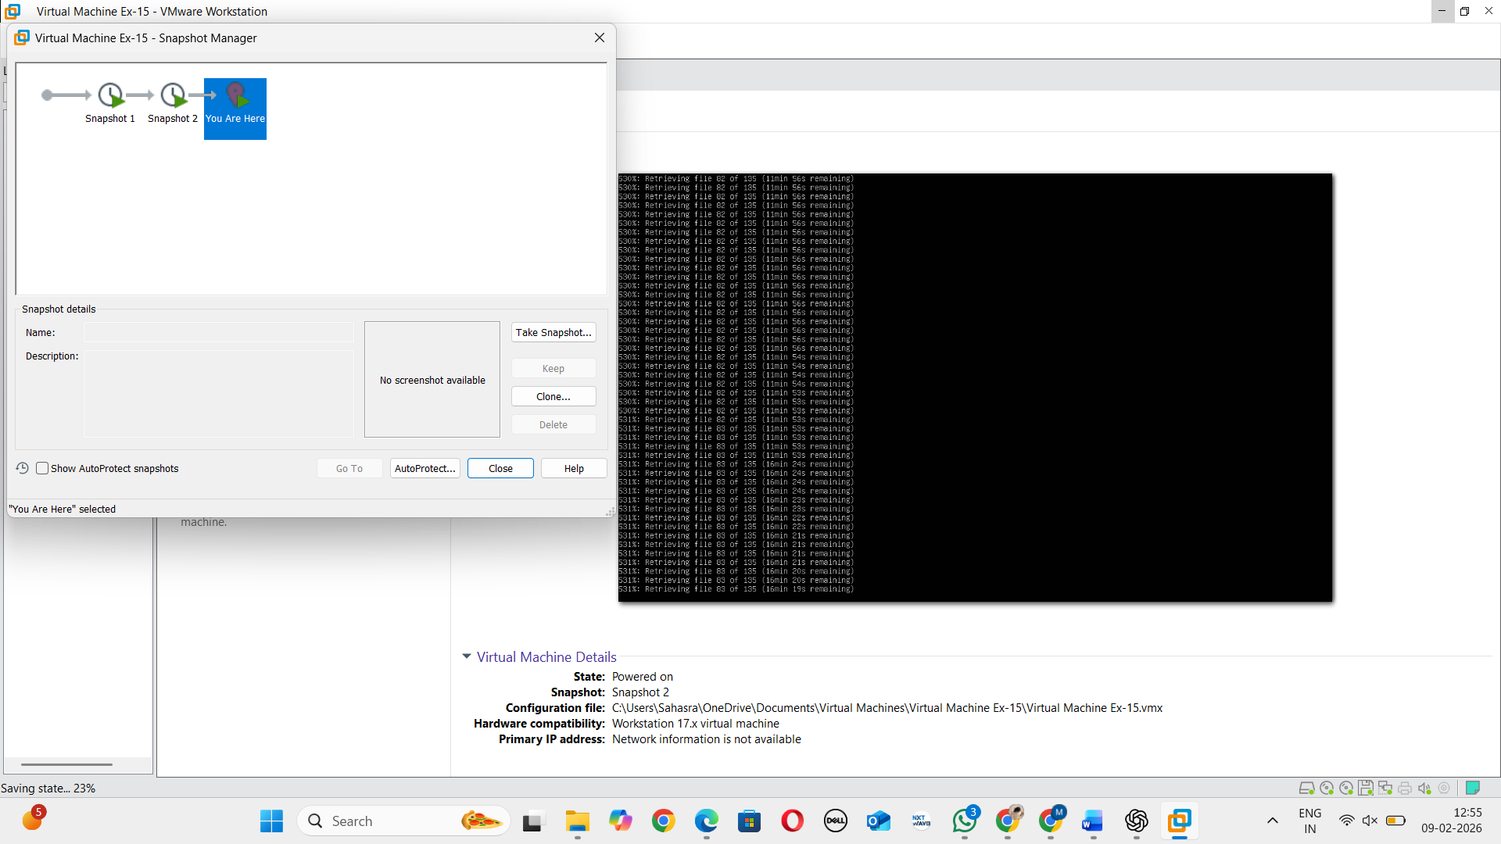

STEP 11: Revert Snapshot
Go to VM → Snapshot → Revert to Snapshot

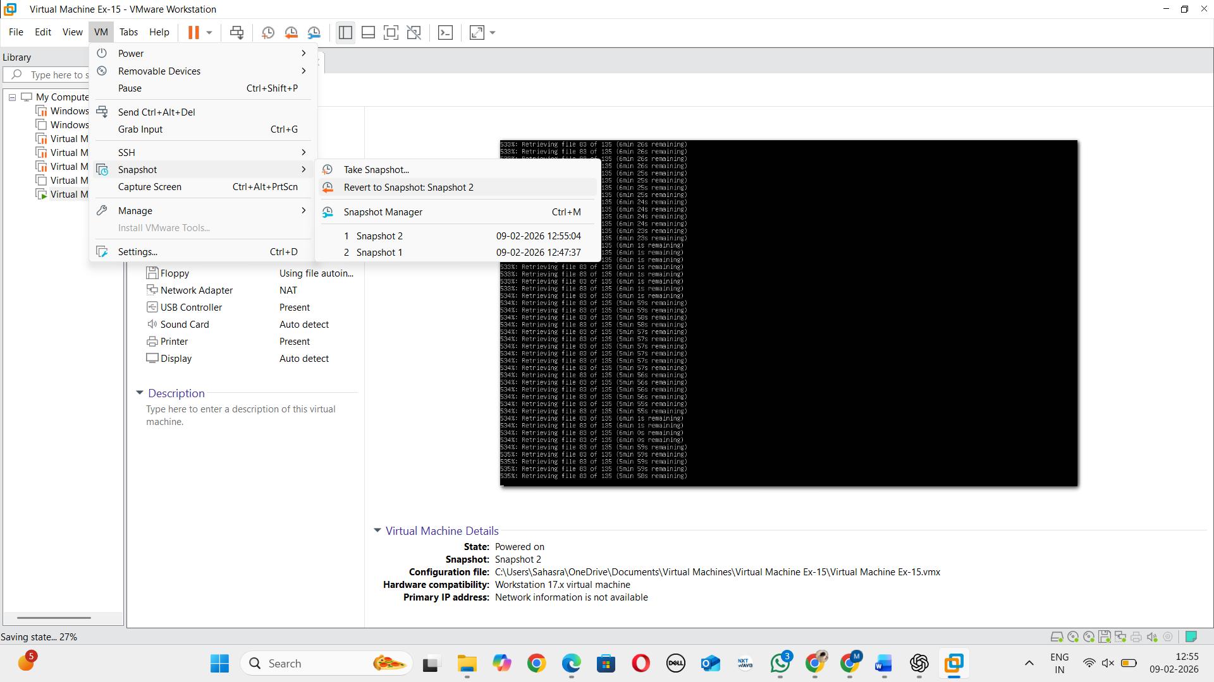

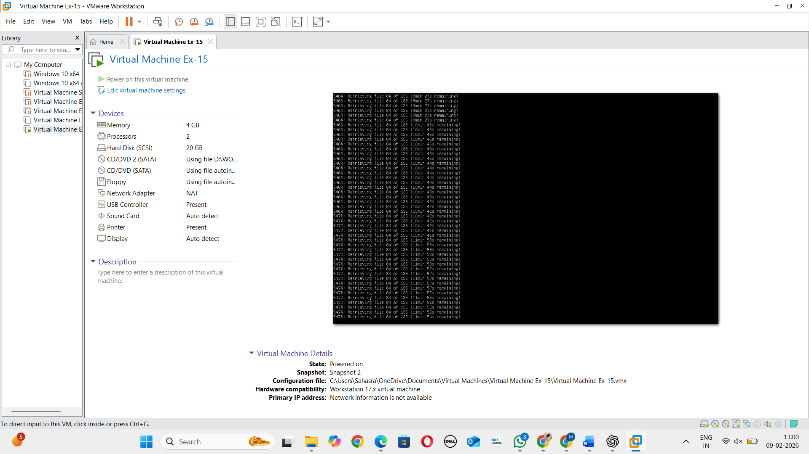

RESULT: Snapshot creation and rollback is successfully verified.

