Experiment – 1

Question:
Create a simple cloud software application and provide it as a service using any Cloud Service Provider to demonstrate Software as a Service (SaaS).
Answer:
AIM: To create and deploy a simple cloud software application using Zoho Creator and provide it as a Software as a Service (SaaS) application.
PROCEDURE:
Step1: Open the Zoho Creator website and sign in using a valid Zoho account.
Step 2: Create a new application by selecting the Create from Scratch option.
Step 3: Choose Web Application and provide an application name.
Step 4: Create a simple form with basic fields such as name, email, and description.
Step 5: Save the form and enable cloud access for the application.
Step 6: Share the application link with users to allow online access and usage.
Step 7: The software has been created.

IMPLEMENTATION:
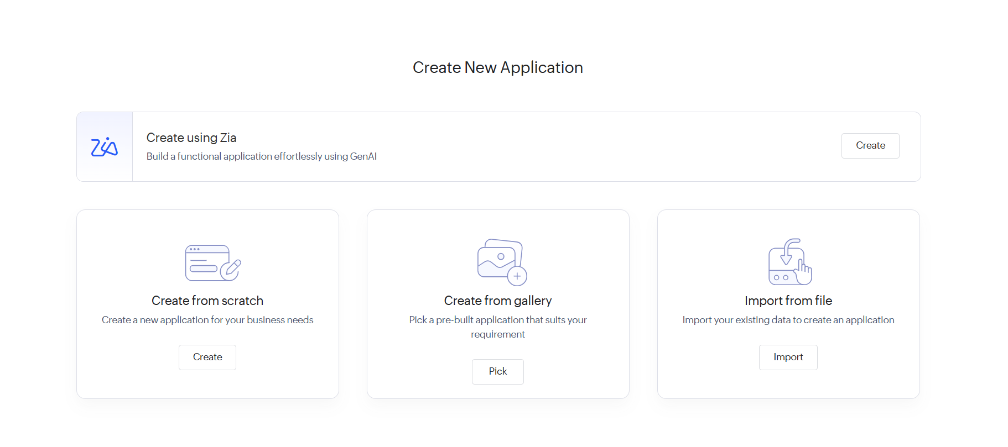
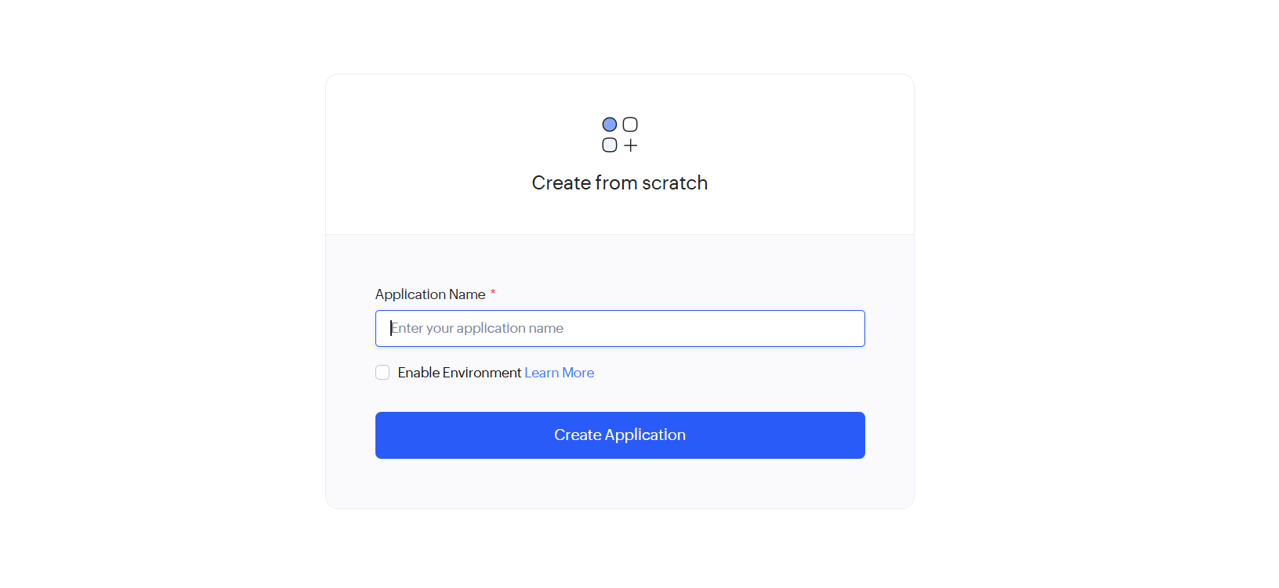
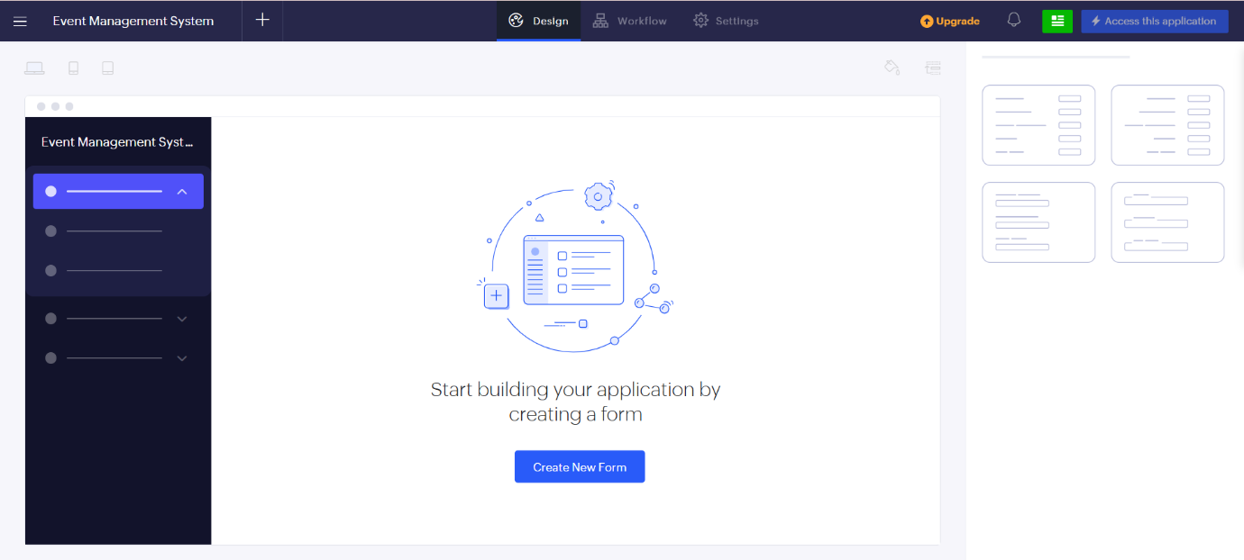
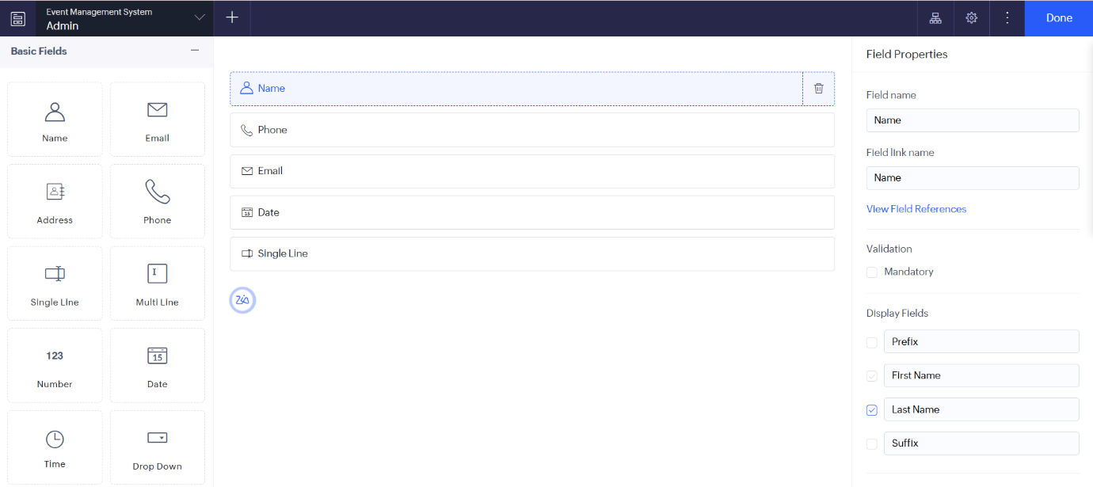

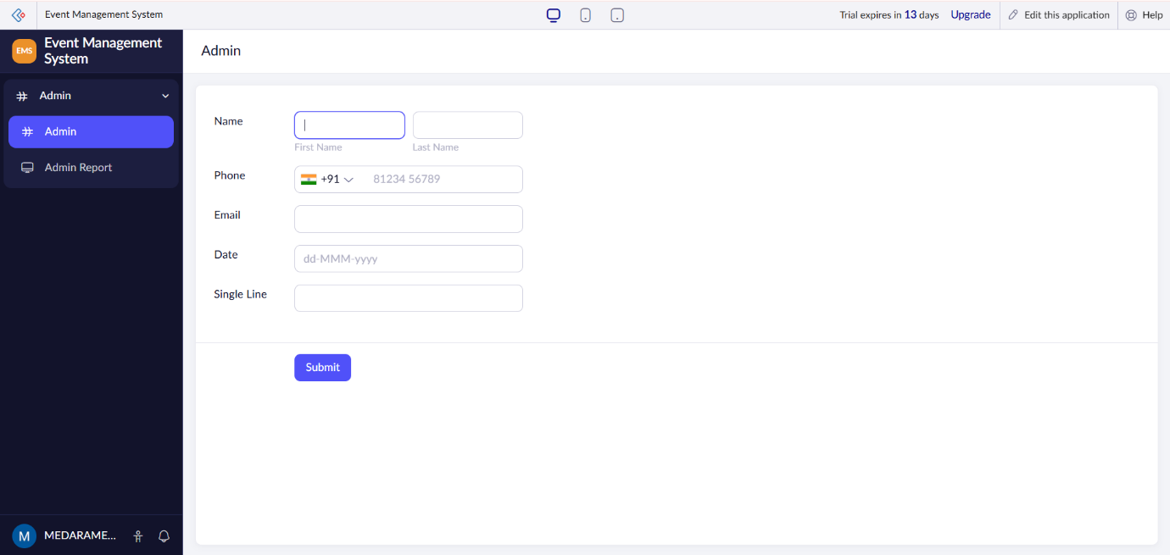

RESULT: A simple cloud-based software application is successfully created and delivered as a SaaS application, allowing users to access and use the application through the internet.

