Experiment – 2

Question:
Create a simple cloud software application for Flight Reservation System using any Cloud Service Provider to demonstrate SaaS.
Answer:
AIM: To design and implement a Flight Reservation System as a cloud-based SaaS application using Zoho Creator.
PROCEDURE:
Step1: Log in to Zoho Creator and create a new application from scratch.
Step 2: Create a Flight Details form to store flight information such as source, destination, time, and fare.
Step 3: Create a Passenger Details form to store passenger personal information.
Step 4: Create a Reservation / Booking Details form and add lookup fields to connect passengers and flights.
Step 5: Configure basic workflows to update booking status automatically.
Step 6: Publish the application and enable cloud access for users.
Step 7: The software has been created.

IMPLEMENTATION:
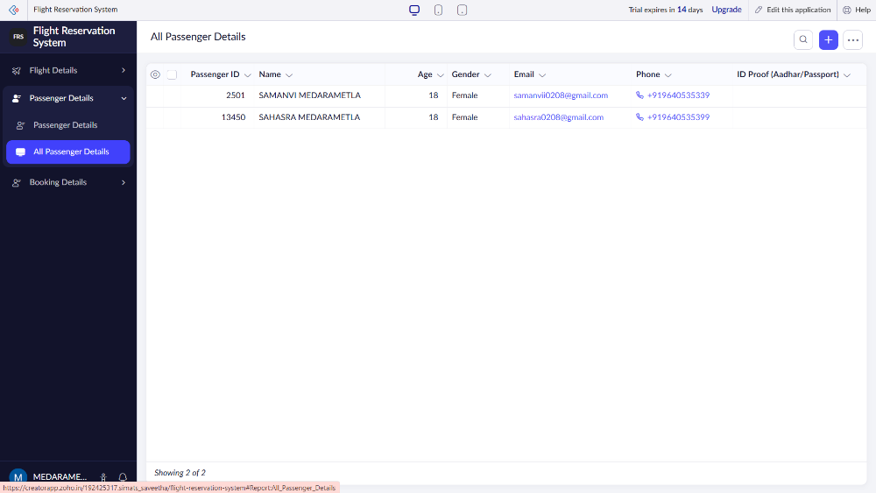
Flight Reservation System

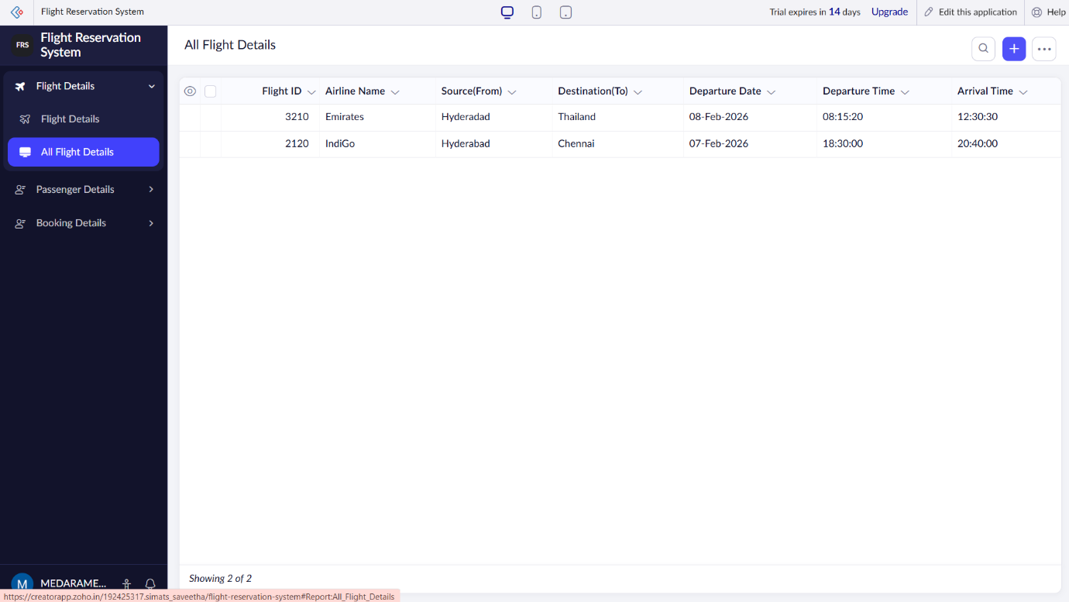

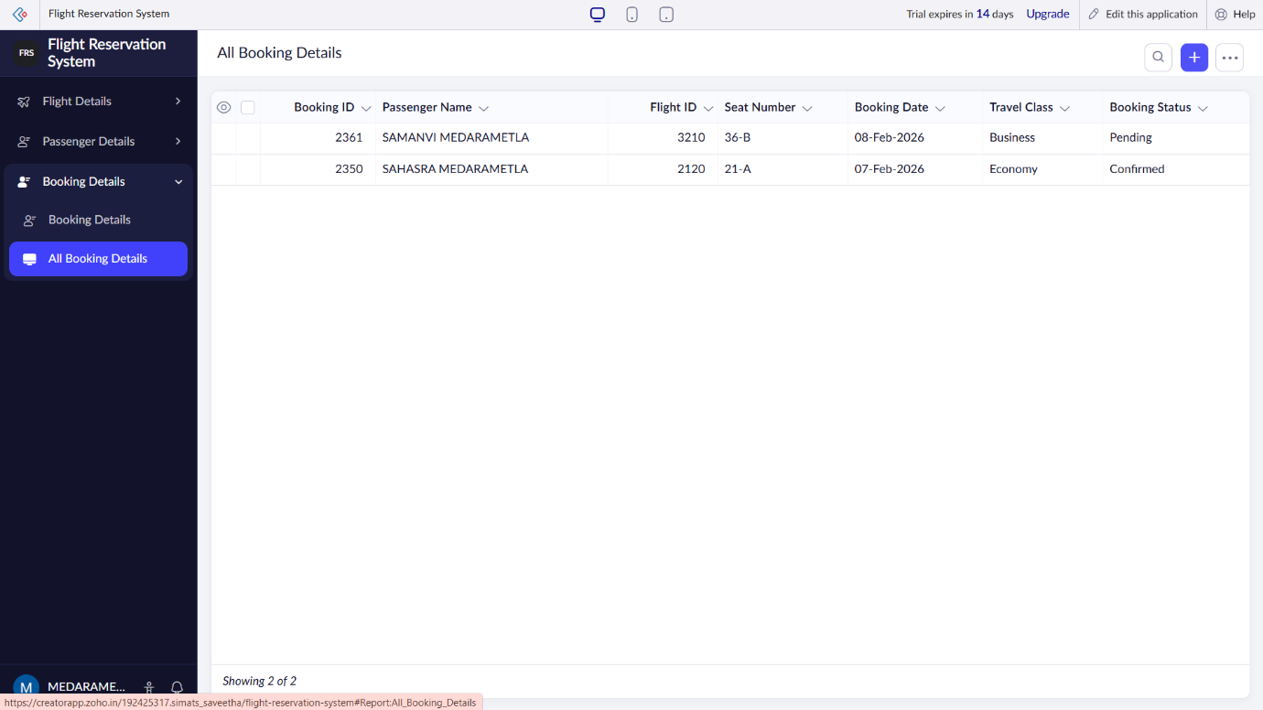

RESULT: A cloud-based Flight Reservation System is successfully implemented as a SaaS application, enabling users to book and manage flight reservations online.

