Experiment – 3

Question:
Create a simple cloud software application for Property Buying & Rental process (In Chennai city) using any Cloud Service Provider to demonstrate SaaS.
Answer:
AIM: To develop a Property Buying and Rental Management System for Chennai city as a SaaS application using Zoho Creator.
PROCEDURE:
Step 1: Sign in to Zoho Creator and create a new cloud application.
Step 2: Create a Property Details form with fields such as location, property type, price, and availability status.
Step 3: Create an Owner Details form to store property owner information.
Step 4: Create a Buyer / Tenant Details form and link it with property details using lookup fields.
Step 5: Configure workflows to update property status when it is sold or rented.
Step 6: Deploy the application as a cloud service for user access.
Step 7: The software has been created.
IMPLEMENTATION:

Property Buying & Rental System
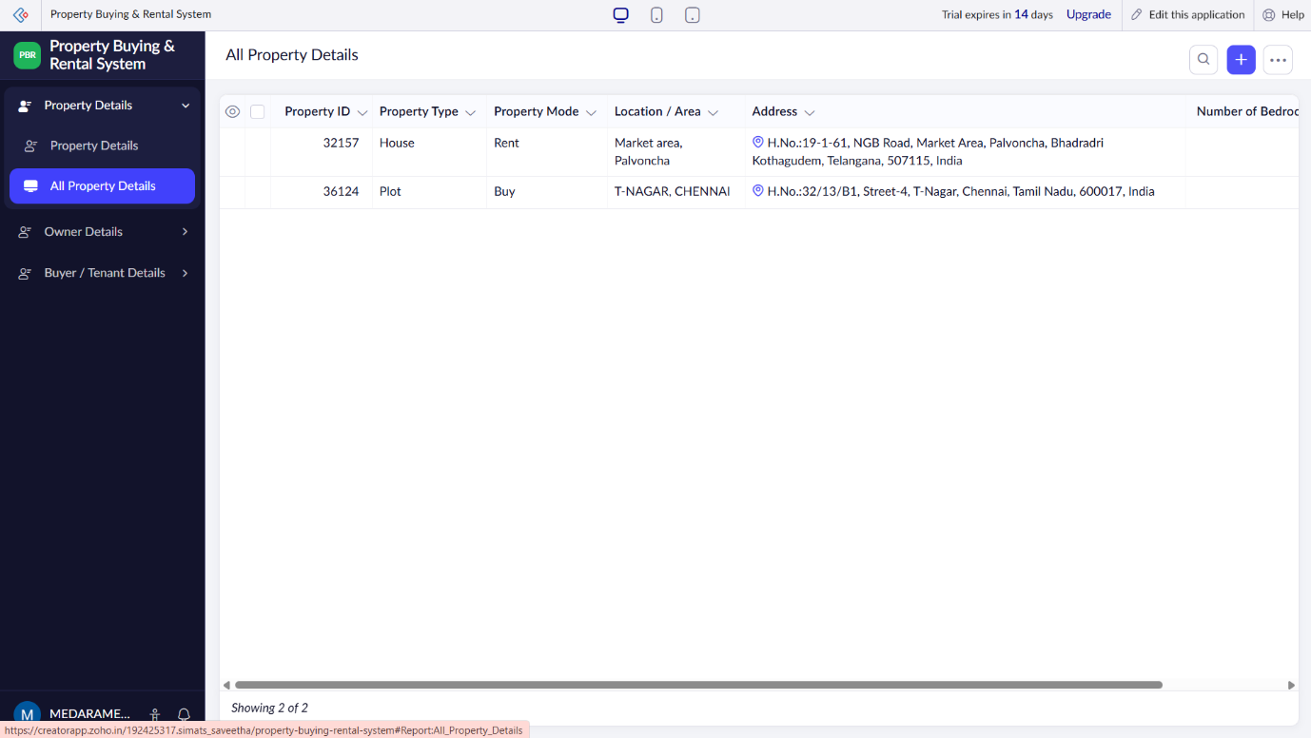

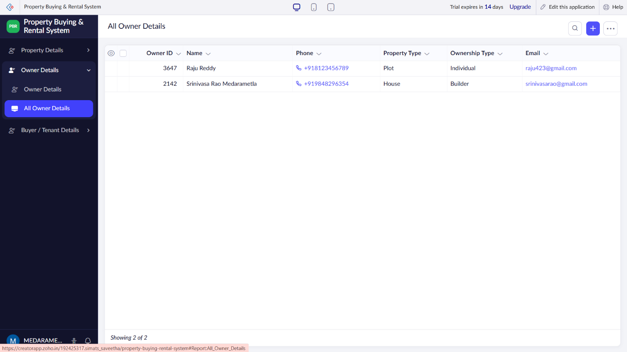
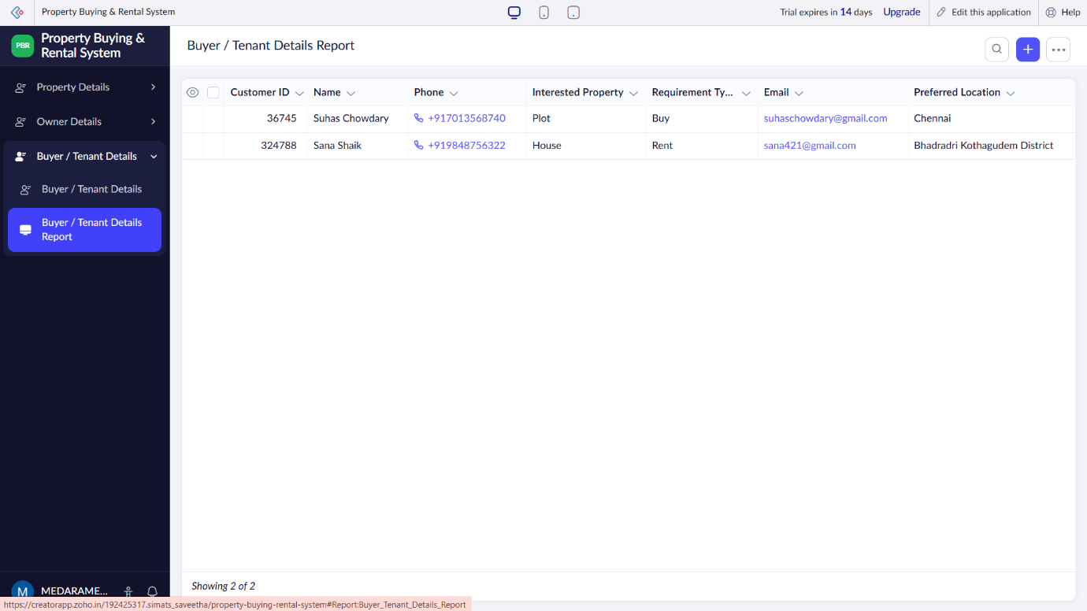

RESULT: A cloud-based Property Buying and Rental System for Chennai city is successfully developed and delivered as a SaaS application, enabling online property management and customer handling.

