Experiment – 4

Question:
Create a simple cloud software application for Car Booking Reservation System using any Cloud Service Provider to demonstrate SaaS.
Answer:
AIM: To create a Car Booking Reservation System as a cloud-based SaaS application using Zoho Creator.
PROCEDURE:
Step1: Access Zoho Creator and create a new application.
Step 2: Create a Car Details form to manage vehicle information and availability.
Step 3: Create a Customer Details form to store user information.
Step 4: Create a Booking / Reservation Details form and link cars and customers using lookup fields.
Step 5: Configure workflows to calculate booking charges and update booking status.
Step 6: Publish the application for cloud-based access.
Step 7: The software has been created.
IMPLEMENTATION:

Car Booking Reservation System

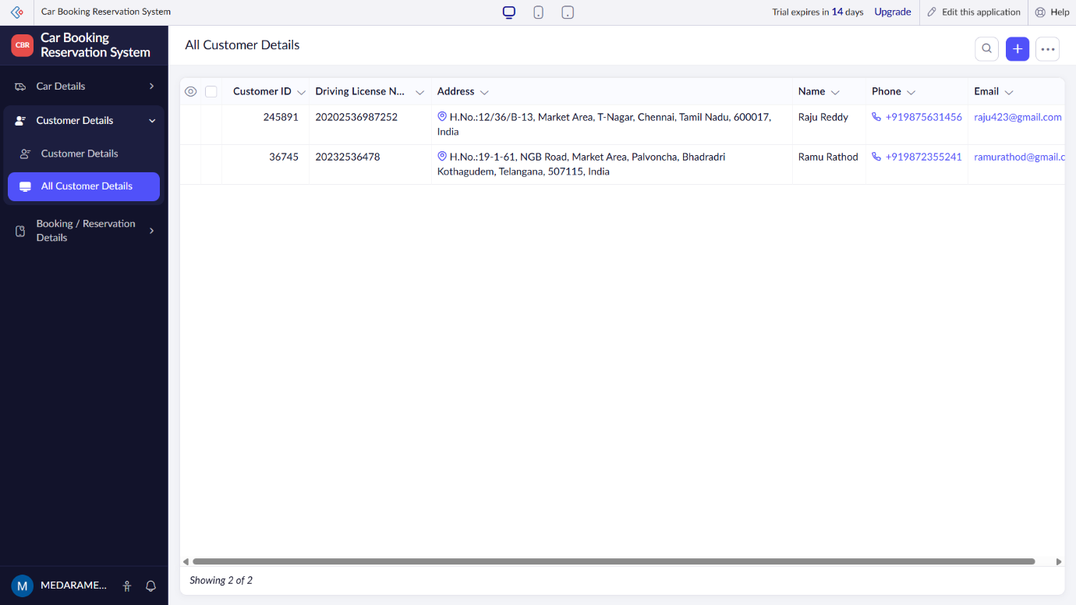

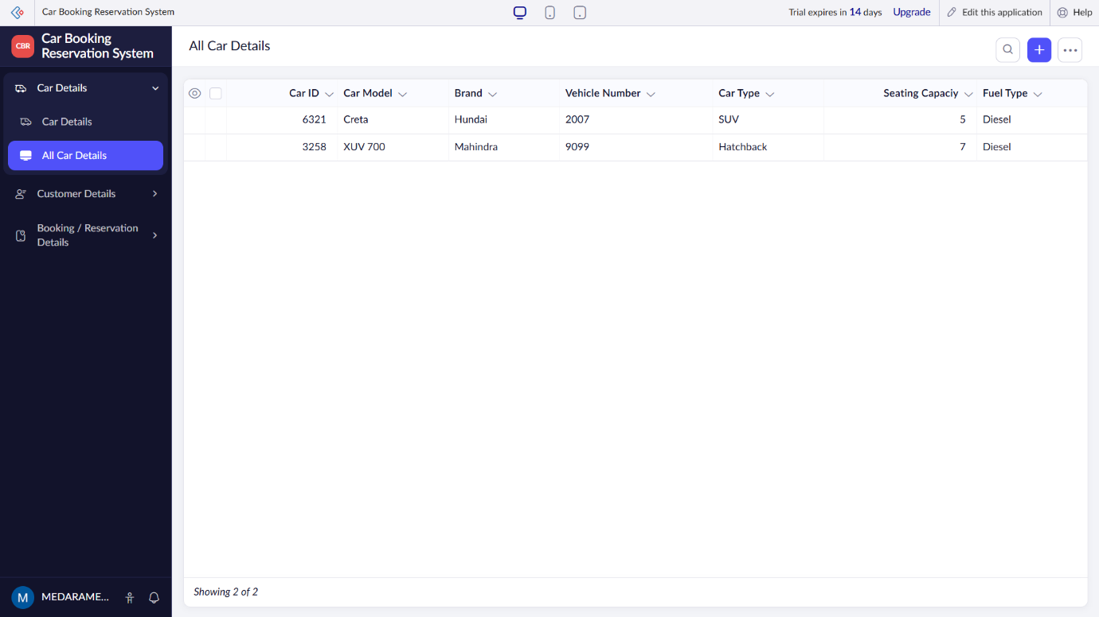
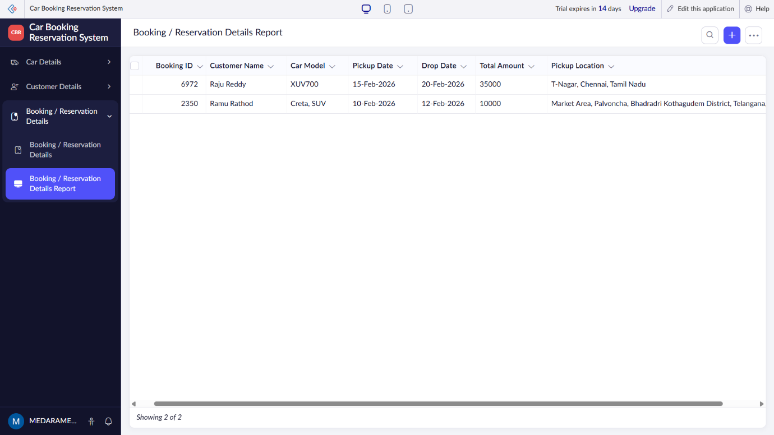

RESULT: A cloud-enabled Car Booking Reservation System is successfully created as a SaaS application, allowing users to reserve cars online.

