Experiment – 5

Question:
Create a simple cloud software application for Library book reservation system for SIMATS library using any Cloud Service Provider to demonstrate SaaS.
Answer:
AIM: To design and deploy a Library Book Reservation System for SIMATS Library as a SaaS application using Zoho Creator.
PROCEDURE:
Step1: Log in to Zoho Creator and create a new application from scratch.
Step 2: Create a Book Details form to store book information and availability.
Step 3: Create a Member Details form to manage student and staff records.
Step 4: Create a Book Reservation / Issue Details form with lookup fields to link members and books.
Step 5: Configure workflows to update book availability and due dates.
Step 6: Deploy the application as a cloud-based service for library users.
Step 7: The software has been created.

IMPLEMENTATION:

Library Book Reservation System.

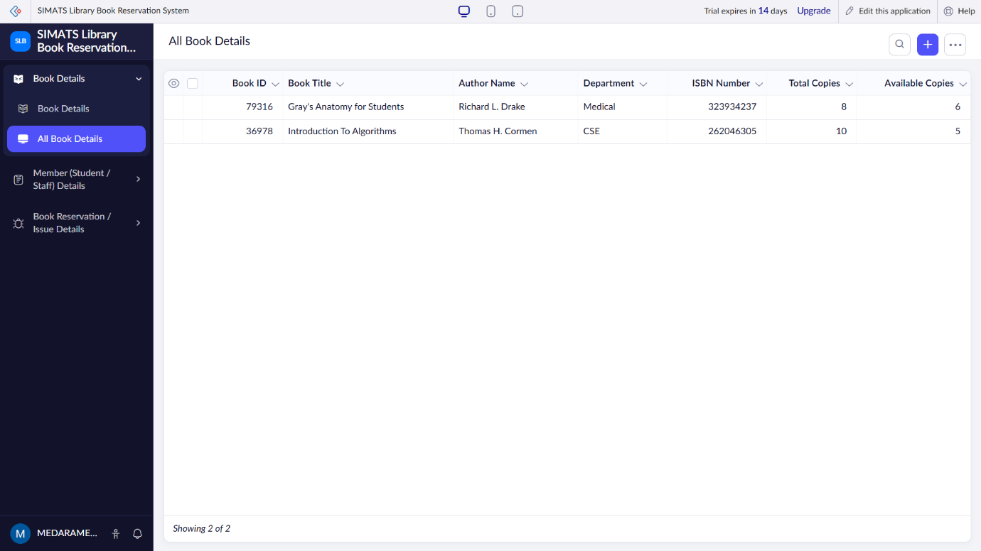

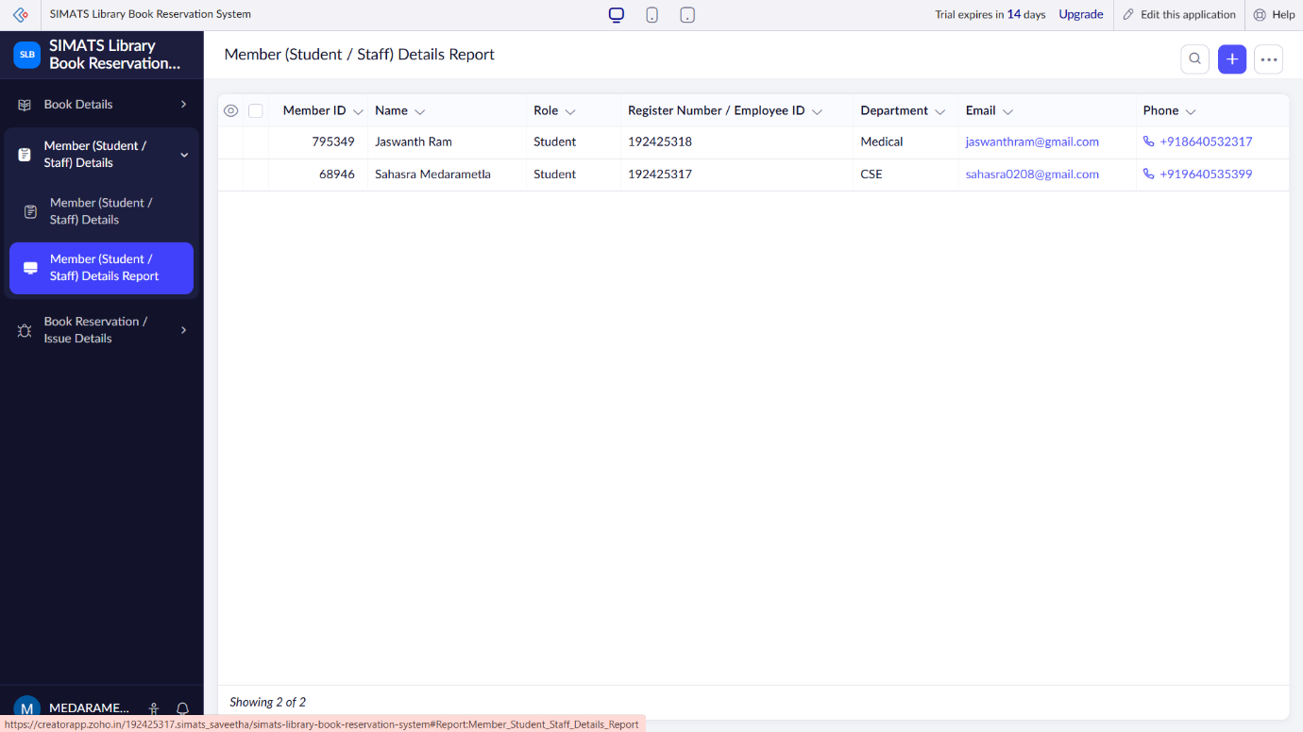
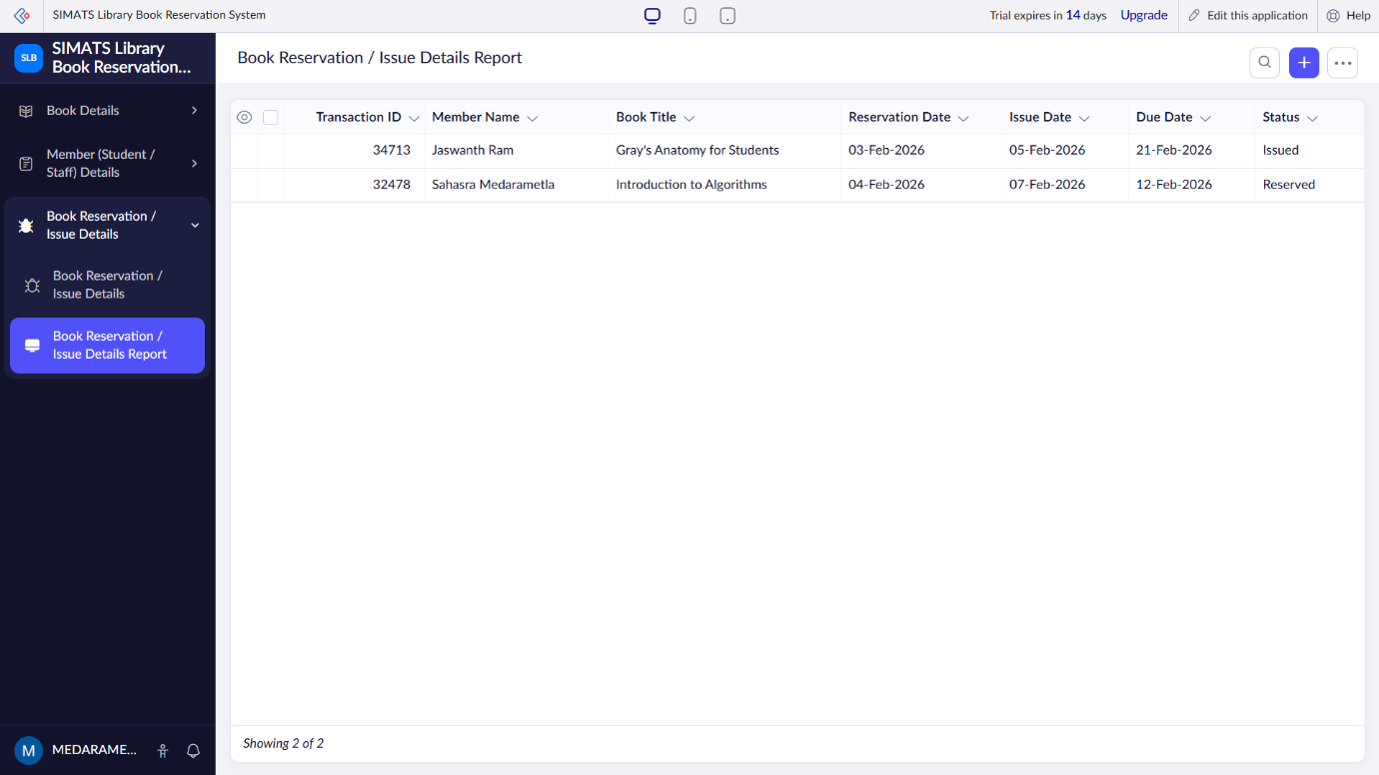

RESULT: A SIMATS Library Book Reservation System is successfully implemented as a SaaS application, enabling efficient online book reservation and management.

