Experiment – 6

Question:
Create a simple cloud software application for Hospital Management system for SIMATS library using any Cloud Service Provider to demonstrate SaaS.
Answer:
AIM: To create and deploy a Hospital Management System for SIMATS as a cloud-based Software as a Service (SaaS) application using Zoho Creator.
PROCEDURE:
Step1: Open the Zoho Creator website and sign in using a valid Zoho account.
Step 2: Create a new application by selecting the Create from Scratch option.
Step 3: Choose Web Application and provide an appropriate application name.
Step 4: Create a Doctor Details form to store doctor information such as name, specialization, and contact details.
Step 5: Create a Patient Details form to store patient information such as name, age, gender, and contact number.
Step 6: Create an Appointment Details form and use lookup fields to link doctors and patients.
Step 7: Configure basic workflows to manage appointment status and scheduling.
Step 8: Publish the application and enable cloud access so users can use the system online.
Step 9: The software has been created.

IMPLEMENTATION:
Hospital Management system

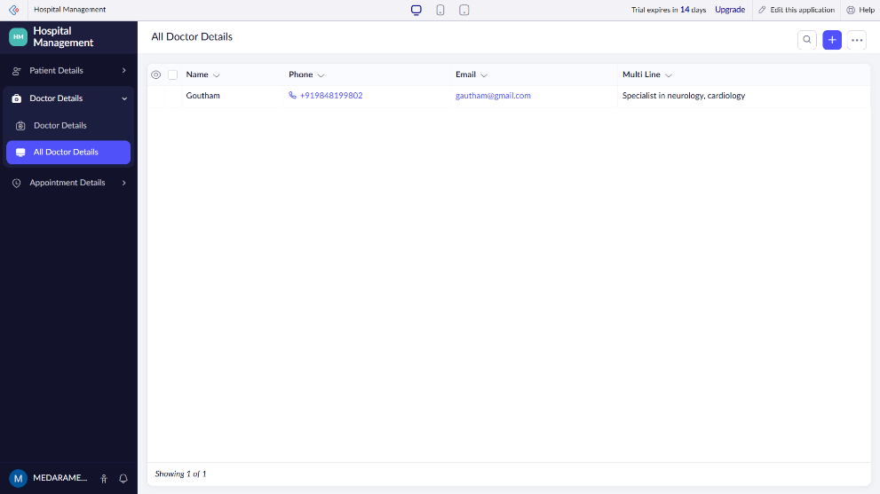

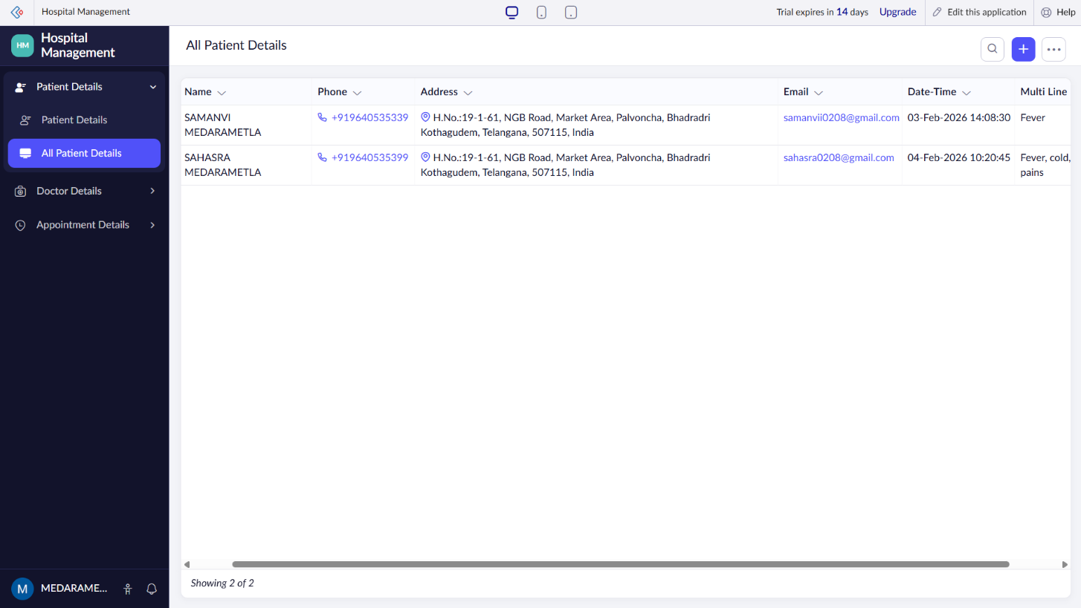

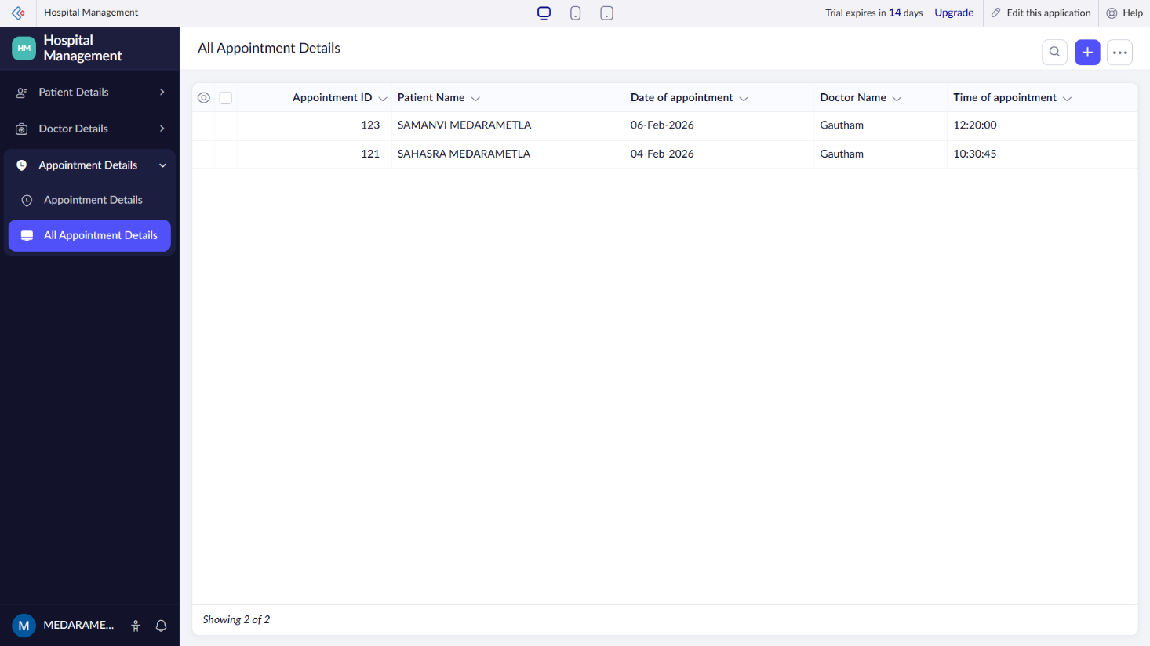

RESULT: A cloud-based Hospital Management System for SIMATS is successfully created and delivered as a SaaS application, enabling efficient online management of doctors, patients, and appointments through the internet.

