DATABASE MANAGEMENT SYSTEMS
MINI PROJECT REPORT
CAR SHOWROOM MANAGEMENT SYSTEM
Submitted by:
[Your Name]
[Roll No. / Reg. No.]
[Class / Semester]
[College / Institute Name]
[Department Name]
Academic Year: [20XX - 20XX]

1. Introduction
Car showrooms deal with a continuous flow of information involving vehicle suppliers, incoming stock, vehicle categories, customers, and sales orders across multiple branches. Managing this manually is error-prone and inefficient. A Car Showroom Management System is a database-driven application designed to organize, store, and manage this information systematically, ensuring accuracy, faster retrieval, and better decision-making.
This mini project focuses on the database design phase of such a system — starting from requirement analysis, moving through ER modeling, relational schema design, normalization, and finally implementation using SQL.

2. Objectives
- To analyze the requirements of a car showroom's data management needs.
- To design an Entity-Relationship (ER) diagram identifying entities, attributes, relationships, keys, and cardinalities.
- To convert the ER diagram into a relational schema.
- To apply normalization to eliminate data redundancy.
- To implement the schema using SQL (DDL and DML).
- To write sample queries demonstrating retrieval of useful information.

3. Problem Statement / Scenario
A Car Showroom Management System is used to maintain information about suppliers, vehicle deliveries, vehicle inventory, vehicle models, customers, showroom branches, and sales orders. Registered suppliers deliver vehicles, which are stored in vehicle inventory according to their model. Customers place sales orders through showroom branches. The system keeps track of all deliveries, orders, and vehicle stock for efficient management.

4. ER Diagram
The Entity-Relationship diagram below models the system using Chen notation — rectangles represent entities, ovals represent attributes (double ovals for multivalued, dashed for derived), diamonds represent relationships, and underlined attributes denote primary keys.
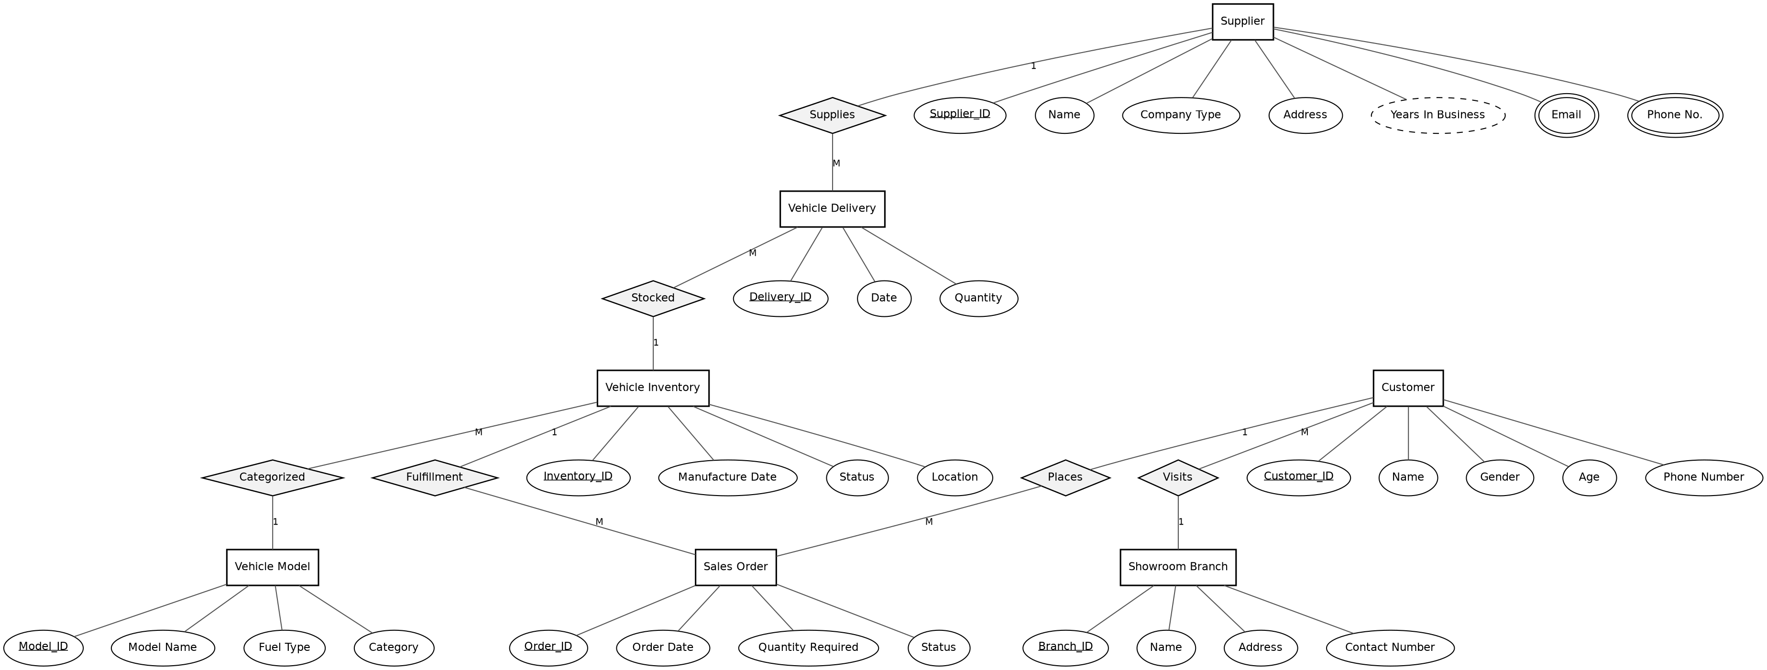

5. Entities and Their Attributes

5.1 Supplier
Stores the details of every registered vehicle supplier/manufacturer.
- Supplier_ID (Primary Key)
- Name
- Company_Type
- Address
- Years_In_Business (Derived)
- Email (Multivalued)
- Phone_No (Multivalued)

5.2 Vehicle Delivery
Stores details of every delivery made by a supplier.
- Delivery_ID (Primary Key)
- Date
- Quantity

5.3 Vehicle Inventory
Stores all vehicle units currently available in the showroom.
- Inventory_ID (Primary Key)
- Manufacture_Date
- Status (Available / Sold / Reserved)
- Location

5.4 Vehicle Model
Stores different vehicle models maintained by the showroom.
- Model_ID (Primary Key)
- Model_Name
- Fuel_Type
- Category

5.5 Sales Order
Stores details of vehicle orders placed by customers.
- Order_ID (Primary Key)
- Order_Date
- Quantity_Required
- Status

5.6 Customer
Stores details of customers purchasing vehicles.
- Customer_ID (Primary Key)
- Name
- Gender
- Age
- Phone_Number

5.7 Showroom Branch
Stores details of branches associated with the showroom.
- Branch_ID (Primary Key)
- Name
- Address
- Contact_Number

6. Keys

6.1 Primary Keys
Entity | Primary Key
Supplier | Supplier_ID
Vehicle Delivery | Delivery_ID
Vehicle Inventory | Inventory_ID
Vehicle Model | Model_ID
Sales Order | Order_ID
Customer | Customer_ID
Showroom Branch | Branch_ID

6.2 Foreign Keys
Table | Foreign Key | References
Vehicle Delivery | Supplier_ID | Supplier(Supplier_ID)
Vehicle Delivery | Inventory_ID | Vehicle Inventory(Inventory_ID)
Vehicle Inventory | Model_ID | Vehicle Model(Model_ID)
Sales Order | Customer_ID | Customer(Customer_ID)
Sales Order | Branch_ID | Showroom Branch(Branch_ID)
Sales Order | Inventory_ID | Vehicle Inventory(Inventory_ID)

7. Relationships and Cardinality
Relationship | Entities Involved | Cardinality
Supplies | Supplier ↔ Vehicle Delivery | 1 : M
Stocked | Vehicle Delivery ↔ Vehicle Inventory | M : 1
Categorized | Vehicle Inventory ↔ Vehicle Model | M : 1
Fulfillment | Vehicle Inventory ↔ Sales Order | 1 : M
Places | Customer ↔ Sales Order | 1 : M
Visits | Customer ↔ Showroom Branch | M : 1

8. Relational Schema
The ER diagram is mapped to the following relational schema. Underlined attributes are primary keys; italicized attributes are foreign keys.
- Supplier (Supplier_ID, Name, Company_Type, Address, Est_Year)
- Supplier_Email (Supplier_ID, Email)
- Supplier_Phone (Supplier_ID, Phone_No)
- Vehicle_Model (Model_ID, Model_Name, Fuel_Type, Category)
- Vehicle_Inventory (Inventory_ID, Model_ID, Manufacture_Date, Status, Location)
- Vehicle_Delivery (Delivery_ID, Supplier_ID, Inventory_ID, Delivery_Date, Quantity)
- Showroom_Branch (Branch_ID, Name, Address, Contact_Number)
- Customer (Customer_ID, Branch_ID, Name, Gender, Age, Phone_Number)
- Sales_Order (Order_ID, Customer_ID, Branch_ID, Inventory_ID, Order_Date, Quantity_Required, Status)

9. Normalization
Each table in the schema is checked against the first three normal forms:

1NF (First Normal Form)
All attributes hold atomic (single) values. Multivalued attributes of Supplier — Email and Phone Number — were removed into separate tables (Supplier_Email, Supplier_Phone) to satisfy 1NF.

2NF (Second Normal Form)
All tables use single-column primary keys (or, where composite, all non-key attributes depend on the whole key), so there is no partial dependency.

3NF (Third Normal Form)
No non-key attribute depends on another non-key attribute. For example, in Vehicle_Inventory, Status and Location depend only on Inventory_ID — not on Model_ID — so the schema satisfies 3NF.

10. SQL Implementation
The following SQL script creates the database schema with appropriate primary key and foreign key constraints:
CREATE TABLE Supplier (
Supplier_ID VARCHAR(10) PRIMARY KEY,
Name VARCHAR(100) NOT NULL,
Company_Type VARCHAR(50),
Address VARCHAR(200),
Est_Year DATE
);

CREATE TABLE Supplier_Email (
Supplier_ID VARCHAR(10),
Email VARCHAR(100),
PRIMARY KEY (Supplier_ID, Email),
FOREIGN KEY (Supplier_ID) REFERENCES Supplier(Supplier_ID)
);

CREATE TABLE Supplier_Phone (
Supplier_ID VARCHAR(10),
Phone_No VARCHAR(15),
PRIMARY KEY (Supplier_ID, Phone_No),
FOREIGN KEY (Supplier_ID) REFERENCES Supplier(Supplier_ID)
);

CREATE TABLE Vehicle_Model (
Model_ID VARCHAR(10) PRIMARY KEY,
Model_Name VARCHAR(100) NOT NULL,
Fuel_Type VARCHAR(20),
Category VARCHAR(50)
);

CREATE TABLE Vehicle_Inventory (
Inventory_ID VARCHAR(10) PRIMARY KEY,
Model_ID VARCHAR(10) NOT NULL,
Manufacture_Date DATE,
Status VARCHAR(20),
Location VARCHAR(100),
FOREIGN KEY (Model_ID) REFERENCES Vehicle_Model(Model_ID)
);

CREATE TABLE Vehicle_Delivery (
Delivery_ID VARCHAR(10) PRIMARY KEY,
Supplier_ID VARCHAR(10) NOT NULL,
Inventory_ID VARCHAR(10) NOT NULL,
Delivery_Date DATE NOT NULL,
Quantity INT,
FOREIGN KEY (Supplier_ID) REFERENCES Supplier(Supplier_ID),
FOREIGN KEY (Inventory_ID) REFERENCES Vehicle_Inventory(Inventory_ID)
);

CREATE TABLE Showroom_Branch (
Branch_ID VARCHAR(10) PRIMARY KEY,
Name VARCHAR(100) NOT NULL,
Address VARCHAR(200),
Contact_Number VARCHAR(15)
);

CREATE TABLE Customer (
Customer_ID VARCHAR(10) PRIMARY KEY,
Branch_ID VARCHAR(10) NOT NULL,
Name VARCHAR(100) NOT NULL,
Gender VARCHAR(10),
Age INT,
Phone_Number VARCHAR(15),
FOREIGN KEY (Branch_ID) REFERENCES Showroom_Branch(Branch_ID)
);

CREATE TABLE Sales_Order (
Order_ID VARCHAR(10) PRIMARY KEY,
Customer_ID VARCHAR(10) NOT NULL,
Branch_ID VARCHAR(10) NOT NULL,
Inventory_ID VARCHAR(10) NOT NULL,
Order_Date DATE NOT NULL,
Quantity_Required INT,
Status VARCHAR(20),
FOREIGN KEY (Customer_ID) REFERENCES Customer(Customer_ID),
FOREIGN KEY (Branch_ID) REFERENCES Showroom_Branch(Branch_ID),
FOREIGN KEY (Inventory_ID) REFERENCES Vehicle_Inventory(Inventory_ID)
);

11. Sample Queries

Query 1: List all available vehicles with model details
SELECT vi.Inventory_ID, vm.Model_Name, vm.Category, vi.Status, vi.Location
FROM Vehicle_Inventory vi
JOIN Vehicle_Model vm ON vi.Model_ID = vm.Model_ID
WHERE vi.Status = 'Available';

Query 2: List all orders placed by a specific customer
SELECT o.Order_ID, c.Name, o.Order_Date, o.Status
FROM Sales_Order o
JOIN Customer c ON o.Customer_ID = c.Customer_ID
WHERE c.Customer_ID = 'C01';

Query 3: Count total vehicles delivered by each supplier
SELECT s.Name, SUM(d.Quantity) AS Total_Delivered
FROM Vehicle_Delivery d
JOIN Supplier s ON d.Supplier_ID = s.Supplier_ID
GROUP BY s.Name;

12. Conclusion
The Car Showroom Management System database design successfully models the entities involved in vehicle supply, delivery, inventory, models, customers, showroom branches, and sales orders. The design ensures efficient tracking of vehicle procurement, stock management, and order fulfillment while maintaining data integrity through primary keys, foreign keys, and appropriate relationship constraints. Normalizing the schema up to 3NF removes redundancy and prevents update anomalies.

13. Future Scope
- Add a Payment entity to track transaction details for each sale.
- Add a Test_Drive entity to manage customer test-drive bookings.
- Add an Employee/Salesperson entity to track which staff member handled each order.
- Build a front-end application (web or desktop) on top of this database for real-world usability.
- Introduce triggers to automatically update inventory status when an order is fulfilled.

