Platform Architecture Blueprint
Milestones 1–3 Combined • Complete system map and Git structure
Scope: hardened foundation, generation engine, preview/deployment platform, plugins, templates, AI builder, and visual builder
Milestone 1  Platform foundation  Auth, orgs, projects,  versions, queues | Milestone 2  Application generation  Prisma, backend, frontend,  admin, mobile, artifacts | Milestone 3  Platform capabilities  Preview, deploy, plugins,  marketplace, AI, builder

1. System architecture overview
The platform is a multi-tenant low-code generation system with a control plane, generation plane, runtime plane, and ecosystem plane. Users work inside organizations and projects, save App Spec versions, generate full applications, preview them, deploy them, and extend the platform through plugins and templates.
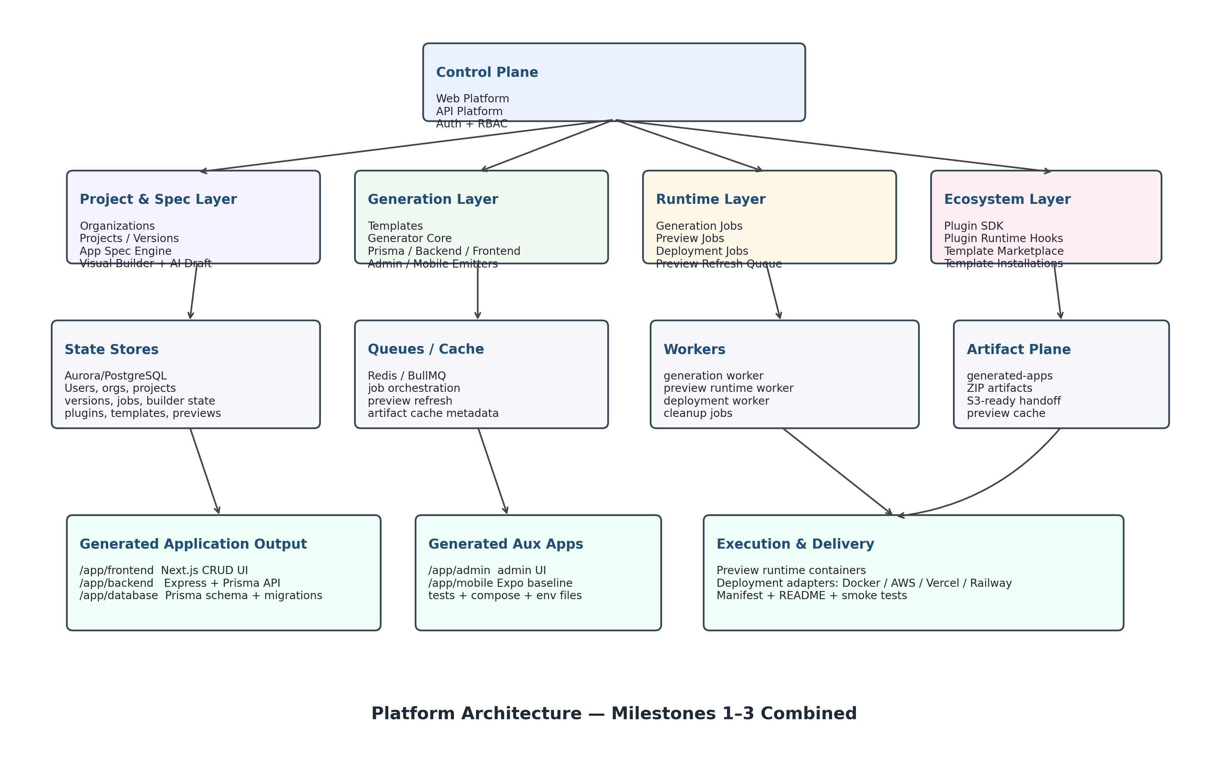
Figure 1. End-to-end platform architecture spanning Milestones 1–3.
2. Core platform planes
Plane | Primary responsibilities | Main modules
Control plane | Tenant management, project orchestration, versioning, builder UX, AI drafting | apps/web-platform, apps/api-platform, packages/auth, packages/app-spec, packages/shared
Generation plane | Read validated App Specs and emit deterministic full-stack apps | packages/generator, packages/templates, packages/database, apps/worker
Runtime & ecosystem | Preview, deployment, plugin execution, template marketplace, builder state, refresh workflows | platform jobs, preview runtime, plugin SDK, marketplace, visual builder, provider adapters
3. Primary runtime flows
Generation flow: Project → App Spec version → generation job → worker → generated application tree → ZIP artifact → download
Preview flow: Project version → preview job → artifact cache + container lifecycle → PreviewEnvironment → preview URL
Deployment flow: Project version → deployment job → provider adapter → deployment URL and job status
Builder flow: Visual builder state → spec patch → new project version → preview refresh / generation
Marketplace flow: Choose template → install into organization → bootstrap project + first version
Plugin flow: Built-in or external plugin → hook execution before/after generate, preview, deploy

4. Git repository structure
The repository is a monorepo using pnpm workspaces and Turborepo. The structure below reflects the combined system after Milestone 3.
platform/
├── apps/
│ ├── web-platform/ # Next.js control plane UI
│ │ └── src/app/
│ │ ├── dashboard/
│ │ ├── projects/
│ │ ├── visual-builder/
│ │ ├── ai-builder/
│ │ ├── preview/
│ │ ├── preview-runtime/
│ │ ├── deployments/
│ │ ├── marketplace/
│ │ └── plugins/
│ ├── api-platform/ # Express control-plane API
│ │ └── src/
│ │ ├── modules/
│ │ │ ├── auth/
│ │ │ ├── organizations/
│ │ │ ├── projects/
│ │ │ ├── versions/
│ │ │ ├── jobs/
│ │ │ ├── platform/
│ │ │ └── marketplace/
│ │ ├── services/
│ │ ├── validators/
│ │ └── middleware/
│ └── worker/ # BullMQ workers + runtime orchestration
│ └── src/
│ ├── jobs/
│ ├── providers/
│ │ ├── preview/
│ │ └── deployment/
│ └── runtime/
├── packages/
│ ├── auth/ # JWT/cookies/session helpers
│ ├── app-spec/ # App Spec schema + validation + defaults
│ ├── generator/ # App generation orchestrator
│ │ └── src/
│ │ ├── core/
│ │ ├── database/
│ │ ├── backend/
│ │ ├── frontend/
│ │ ├── admin/
│ │ ├── mobile/
│ │ └── utils/
│ ├── templates/ # Template registry metadata
│ ├── database/ # Prisma schema + repositories (platform state)
│ ├── plugins/ # Built-in plugins, SDK, loader, marketplace catalog
│ └── shared/ # logging, env, utilities
├── generated-apps/ # generated output and artifact cache
├── docker-compose.yml
├── pnpm-workspace.yaml
├── turbo.json
└── package.json
5. Package responsibilities
Package / app | Purpose
apps/web-platform | Operator-facing UI for projects, versions, AI builder, visual builder, previews, deployments, plugins, and marketplace.
apps/api-platform | Auth, project CRUD, versioning, generation endpoints, preview/deployment orchestration, marketplace APIs, builder APIs.
apps/worker | Background execution for generation, preview runtime, deployment adapters, cleanup jobs, and refresh queues.
packages/app-spec | Typed schema, defaults, validation, and normalized application specification model.
packages/generator | Transforms an App Spec into a deterministic full-stack output tree and ZIP artifact.
packages/database | Prisma models and repositories for users, orgs, jobs, preview environments, builder state, templates, and plugins.
packages/plugins | Built-in plugin registry, runtime hooks, external SDK contracts, loader, and template marketplace catalog.
packages/shared | Cross-cutting utilities such as env parsing, security helpers, logging, and common functions.
6. Platform state model
The platform database becomes the source of truth for tenant state, generation state, runtime state, and ecosystem state.
Tenant core: User, Organization, OrganizationMembership
Project core: Project, ProjectVersion, BuilderState
Generation/runtime: GenerationJob, GeneratedArtifact, PlatformJob, PreviewEnvironment
Security & access: RefreshToken, OrganizationInvite, AuditLog
Ecosystem: PluginInstallation, TemplateDefinition, TemplateInstallation
7. Generated application output
generated-apps/<projectId>/<versionId>/
├── manifest.json
├── docker-compose.generated.yml
├── README.md
├── tests/
│ └── generated-app-smoke.test.ts
└── app/
├── frontend/ # Next.js CRUD UI + API client
├── backend/ # Express + Prisma CRUD API
├── database/ # Prisma schema, migration bootstrap, seed script
├── admin/ # Admin UI
└── mobile/ # Expo baseline
8. Combined system interpretation
Milestone 1 establishes the secure multi-tenant control plane. Milestone 2 adds the code-generation engine that emits full applications. Milestone 3 elevates the system into a platform by adding previews, deployments, plugins, templates, AI drafting, and visual-builder state. Taken together, the result is a complete low-code application platform with both system depth and ecosystem extension points.

