Full Architecture & Operating Blueprint
Milestones 1–10
Unified platform architecture, Git monorepo structure, AWS production architecture, CI/CD pipeline, and operating model

This document consolidates the entire roadmap into one deployable blueprint: platform control plane, generator, autonomous systems, venture studio, AWS production topology, delivery pipeline, and governance model.

1. Executive Architecture Summary
The platform is a TypeScript monorepo with three primary application surfaces: api-platform for the control plane, web-platform for the operator and customer UI, and worker services for all asynchronous generation, orchestration, intelligence, and venture loops.
Packages provide the shared engines: database access, App Spec generation, templates, autonomous builder systems, agents, product intelligence, market discovery, growth automation, and venture automation.
At Milestone 10, the platform functions as an autonomous venture factory: it discovers opportunities, generates startup concepts, builds SaaS products, launches them, measures performance, and makes scale, pivot, hold, or shutdown decisions.

2. Full Visual Architecture Diagram
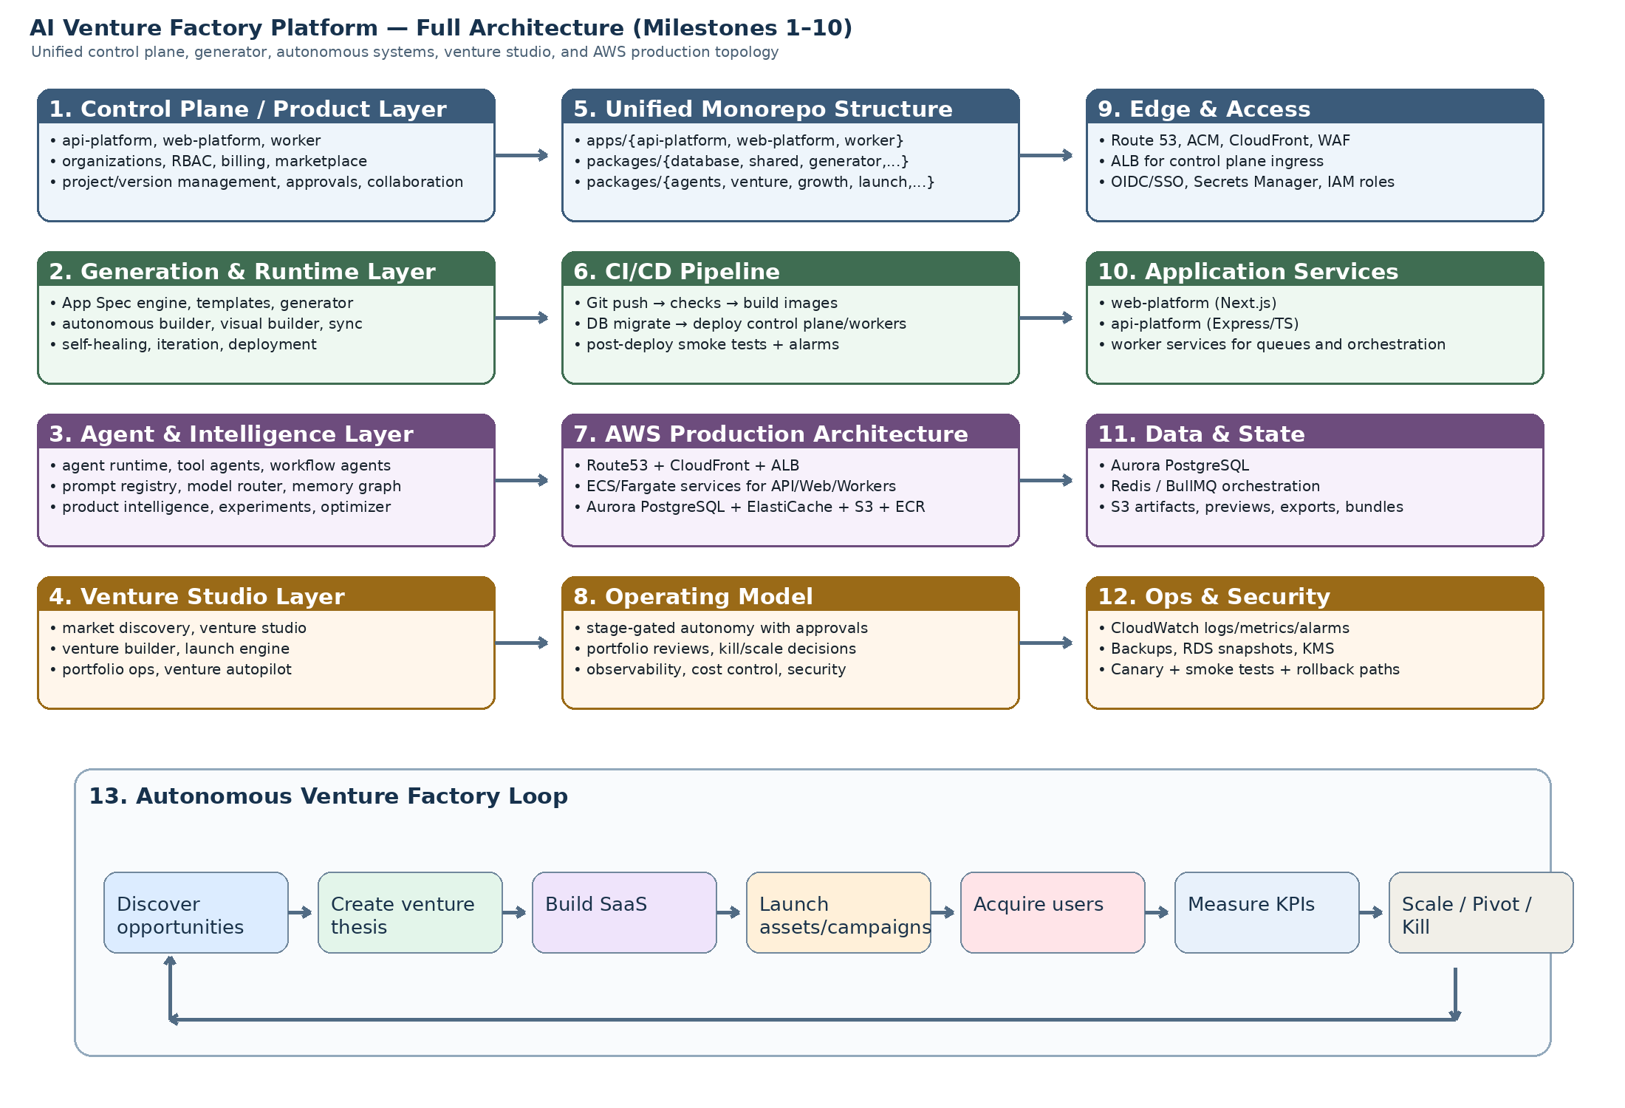
Figure 1. End-to-end platform architecture and autonomous venture loop.

3. Full Platform Architecture (Milestones 1–10)

3.1 Layered architecture
Layer | Purpose
Control plane | Identity, organizations, RBAC, billing, subscriptions, marketplace, collaboration, approvals, admin workflows.
Generation layer | App Spec engine, templates, generator, preview, project versioning, runtime deployment substrate.
Autonomous build layer | Autonomous builder, visual builder, sync engine, self-healing, iteration engine, autonomous deployment.
Agent layer | Agent runtime, tool agents, workflow agents, prompt registry, model router, agent memory and reasoning graph.
Product intelligence layer | Product signals, experimentation, optimizer, growth loops, market discovery.
Venture studio layer | Venture thesis generation, venture builder, launch engine, portfolio operations, venture autopilot.

3.2 Core apps
- api-platform: Express/TypeScript control plane for auth, organization management, project orchestration, marketplaces, agents, product intelligence, venture systems, and internal automation endpoints.
- web-platform: Next.js operator UI, builder UI, dashboards, venture studio, portfolio, growth, and launch surfaces.
- worker: asynchronous execution plane for generation jobs, sync runs, self-healing, iteration, deployment, model evaluation, market scans, growth loops, and venture-autopilot loops.

3.3 Persistent systems of record
- Aurora PostgreSQL is the canonical state store for users, organizations, projects, versions, build runs, experiments, venture records, launch assets, portfolio KPIs, and autopilot decisions.
- Redis backs BullMQ queues, transient orchestration state, concurrency control, and high-frequency coordination between API and workers.
- S3 stores generated artifacts, exported bundles, preview payloads, launch assets, reports, and archived venture outputs.

4. Unified Git Repository Structure
The full system is best maintained as a monorepo with a clear split between applications and reusable packages.
platform/
├── apps/
│ ├── api-platform/
│ │ └── src/modules/
│ │ ├── auth/ organizations/ projects/ versions/ jobs/
│ │ ├── autonomous-builder/ visual-builder/ builder-sync/
│ │ ├── auto-repair/ autonomous-iteration/ autonomous-deployment/
│ │ ├── agents/ tool-agents/ workflow-agents/
│ │ ├── prompt-registry/ model-router/
│ │ ├── product-intelligence/ experimentation/ product-optimizer/
│ │ ├── market-discovery/ growth-engine/
│ │ ├── venture-studio/ portfolio-ops/ venture-builder/
│ │ ├── launch-engine/ venture-autopilot/
│ │ └── enterprise/ marketplace/ monetization/ runtime/ ops/
│ ├── web-platform/
│ │ └── src/app/
│ │ ├── builders/ deployments/ iterations/ prompts/ model-router/
│ │ ├── product-intelligence/ experiments/ product-optimizer/
│ │ ├── market-discovery/ growth/
│ │ ├── venture-studio/ portfolio/ venture-builder/
│ │ ├── launch/ venture-autopilot/
│ │ └── admin/ workspace/ marketplace/
│ └── worker/
│ └── src/jobs/
│ ├── generation/ builder/ sync/ repair/ iteration/ deployment/
│ ├── agent-execution/ workflow-execution/ tool-execution/
│ ├── market-scan/ growth-loop/ insight-analysis/ experiment-analysis/
│ ├── venture-creation/ venture-build/ launch-orchestrator/
│ └── venture-autopilot-loop/
├── packages/
│ ├── shared/ database/ auth/ app-spec/ templates/ generator/
│ ├── autonomous-builder/ visual-builder/ builder-sync/ auto-repair-engine/
│ ├── autonomous-iteration/ autonomous-deployment/
│ ├── agent-runtime/ tool-agents/ workflow-agents/ prompt-registry/ model-router/ agent-memory/
│ ├── product-intelligence/ experimentation/ product-optimizer/
│ ├── market-discovery/ growth-engine/
│ ├── venture-studio/ portfolio-ops/ venture-builder/ launch-engine/ venture-autopilot/
│ └── marketplace integrations and enterprise extensions
├── infra/
│ ├── terraform/ or cdk/
│ ├── ecs-task-definitions/
│ ├── ci-cd/
│ └── alarms-dashboards/
└── generated-apps/

5. Complete AWS Production Architecture
The production design assumes Amazon Web Services as the hosting substrate for the monorepo control plane, asynchronous execution plane, data tier, and generated artifacts.
AWS layer | Service | Usage
DNS / Edge | Route 53, ACM, CloudFront, AWS WAF | Global routing, TLS, CDN delivery, and request filtering.
Ingress | Application Load Balancer | Routes public traffic to web-platform and api-platform services.
Application compute | ECS on Fargate or ECS on EC2 | Runs web-platform, api-platform, worker, and optional specialized worker pools.
Image registry | Amazon ECR | Stores immutable images for all services.
Relational data | Aurora PostgreSQL | System of record for all platform, intelligence, growth, and venture entities.
Queue/state cache | ElastiCache Redis | BullMQ orchestration, hot coordination state, throttling primitives.
Object storage | S3 | Bundles, generated artifacts, launch assets, reports, and exports.
Secrets | Secrets Manager + KMS | API keys, database credentials, OAuth secrets, encryption.
Observability | CloudWatch Logs, Metrics, Alarms, Dashboards | Runtime visibility, SLO alerts, cost and queue monitoring.
Security / IAM | IAM roles, SCPs, parameterized least privilege | Service-to-service trust boundaries and deployment controls.
Backups / DR | RDS snapshots, S3 versioning, cross-region replication where needed | Recovery posture for the control plane and venture factory state.

5.1 Recommended network topology
- Use a multi-AZ VPC with public subnets only for ALB and NAT, and private subnets for ECS services, Aurora, and ElastiCache.
- Place web-platform and api-platform behind one or more ALBs; isolate internal-only worker pools from public ingress.
- Use dedicated security groups for ALB, application tasks, Aurora, Redis, and administrative access paths.
- Keep generated application hosting isolated from control-plane infrastructure when practical, even if initially using the same AWS account.

5.2 Service segmentation
- Interactive pool: web-platform and api-platform tasks sized for predictable latency.
- Execution pool: general workers for generation, sync, repair, iteration, and deployment.
- Intelligence pool: market scans, experiments, model evaluations, product intelligence analytics.
- Venture pool: venture creation, venture builder, launch orchestration, autopilot loops.

6. Deployment Pipeline (CI/CD)
The platform should use one trunk-based CI/CD system with environment promotion gates.
- Developer push or merge to main triggers CI.
- Static checks run: TypeScript typecheck, lint, package dependency checks, unit tests.
- Database migration diff check runs against Prisma or migration manifests.
- Container images are built for api-platform, web-platform, and worker variants and pushed to ECR with immutable tags.
- Staging deployment runs first: migrate database, deploy ECS tasks, run smoke tests, verify health checks, verify queue workers.
- Post-staging validations cover key routes and key autonomous flows: builder, agents, experiments, growth, venture builder, launch, and autopilot.
- Promotion to production requires approval and uses the same validated image tags.
- Production deploy executes zero-downtime rollout where possible, followed by smoke tests and alarm stabilization checks.
- Rollback uses prior task definition revision and, when necessary, feature-flag disablement before service rollback.

6.1 Suggested CI/CD lanes
Lane | Purpose
Control plane lane | api-platform and web-platform build, test, deploy.
Worker lane | worker images and specialized queue processors.
Schema lane | database migrations with explicit staging-before-production promotion.
Infrastructure lane | Terraform/CDK changes for networking, secrets, task definitions, alarms, and scaling policies.
Artifact lane | bundles, exports, architecture docs, and generated product snapshots.

7. Operating Model for the Autonomous Venture Factory

7.1 Decision rights
- Autonomous systems may recommend and prepare actions by default; production-impacting actions should start behind approvals or thresholds.
- Human operators retain approval for high-cost launches, irreversible data changes, production promotions, and venture shutdowns until confidence is established.
- Portfolio reviews operate on a fixed cadence, with ad hoc intervention triggered by alarms, KPI regressions, or market opportunity spikes.

7.2 Standard operating loop
- Market discovery scans opportunity spaces and creates ranked opportunity clusters.
- Venture studio converts high-scoring opportunities into venture theses and startup concepts.
- Venture builder translates selected concepts into App Spec drafts and generator-ready build runs.
- Launch engine prepares landing pages, pricing pages, SEO pages, waitlist pages, and launch campaigns.
- Growth and product intelligence measure acquisition, activation, monetization, and retention.
- Portfolio operations reviews performance and produces interventions.
- Venture autopilot issues scale, hold, pivot, or shutdown decisions and schedules the next cycle.

7.3 Governance and guardrails
- Feature flags for every major autonomous subsystem.
- Budget caps by environment, subsystem, and model provider.
- Approval thresholds for production deployment, launch execution, and spend allocation.
- Audit logs for every major decision, generated artifact, lifecycle recommendation, and deployment action.
- Kill switches for queue classes so operators can stop a malfunctioning subsystem without full platform outage.

7.4 Metrics to operate the system
- Control plane: request latency, error rate, auth success rate, deployment health.
- Workers: queue depth, execution latency, retry volume, dead-letter counts.
- AI usage: tokens, cost per workflow, provider failure rate, route distribution.
- Product intelligence: number of signals, experiments launched, optimizer success rate.
- Venture factory: opportunities discovered, ventures created, launches executed, portfolio active count, scale/pivot/shutdown ratio.
- Commercial: sessions, conversions, MRR/ARR, CAC, LTV, payback period.

8. Practical Production Recommendations
- Split control-plane services from venture-factory worker pools at the ECS service and autoscaling-policy level.
- Introduce environment-specific feature flags so autonomy can mature progressively: observe-only → assistive → semi-autonomous → autonomous.
- Use a single canonical schema repository and enforce staging migration success before production deploys.
- Treat venture-autopilot as an orchestrator, not a privileged bypass; it should call the same internal APIs the human operator would call.
- Preserve a full audit trail for every venture decision and every autonomous product or launch change.

9. Deliverables Included
- Full architecture diagram for Milestones 1–10.
- Unified Git repository structure for the complete platform.
- Complete AWS production architecture blueprint.
- CI/CD deployment pipeline design.
- Operating model for the autonomous venture factory.

