Jason Santiago

CET-2793C  
Dr. Roberts  
November 30, 2024  
Final Hands-On Project: Shared Folders Build

You will need the following screenshots:

* Local Server on your File Server showing the roles (FSRM installed)  
  A screenshot of a computer

  Description automatically generated
* The list of folders on your file server  
  A computer screen shot of a computer screen

  Description automatically generated
* The list of folders on your client machine  
  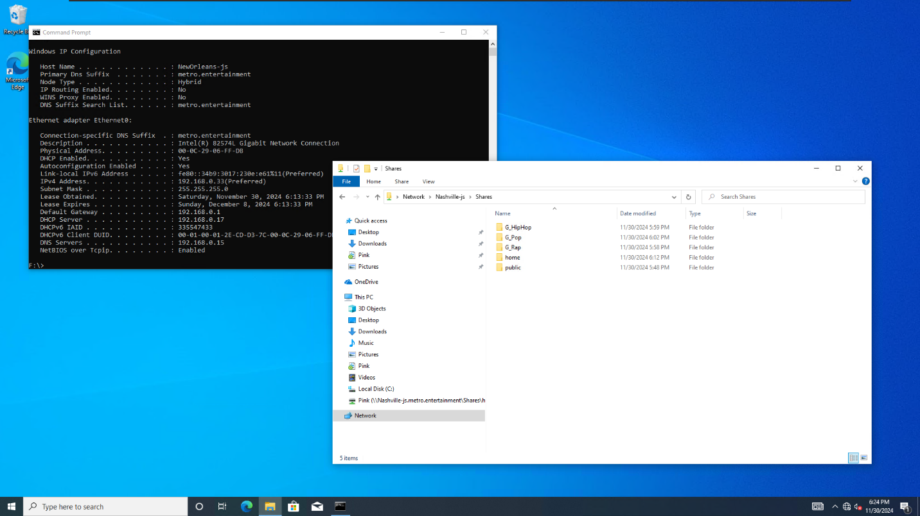
* The document you created on your client, opened up on your file server  
  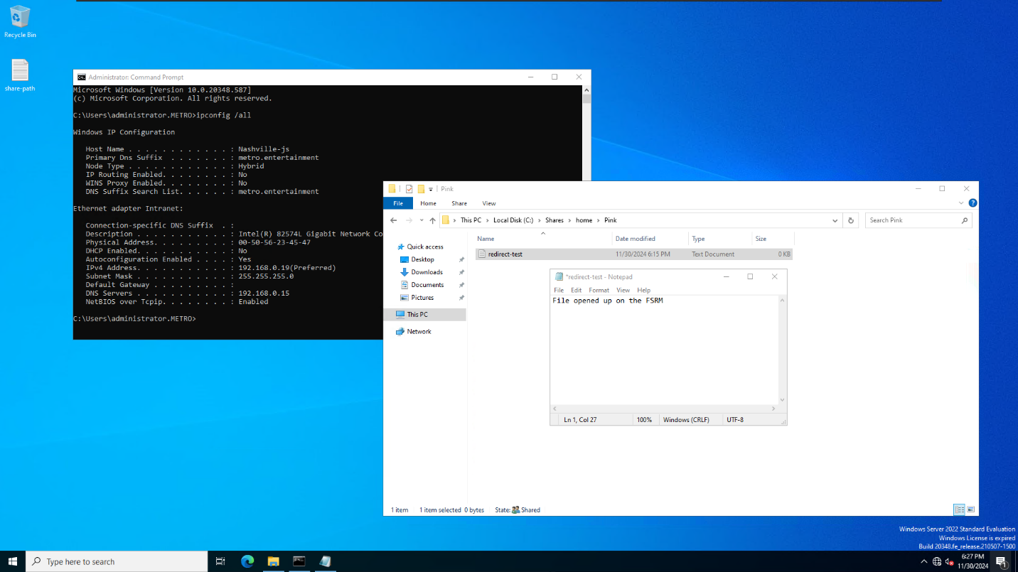
* Storage Quotas  
  A screenshot of a computer

  Description automatically generated