Jason Santiago  
CET-2793C  
Dr. Roberts  
Final Hands-On Project: Add a Client Computer to the Domain Build

**Required Screenshots:**

* Windows 10 machine - System > About screen  
  ping 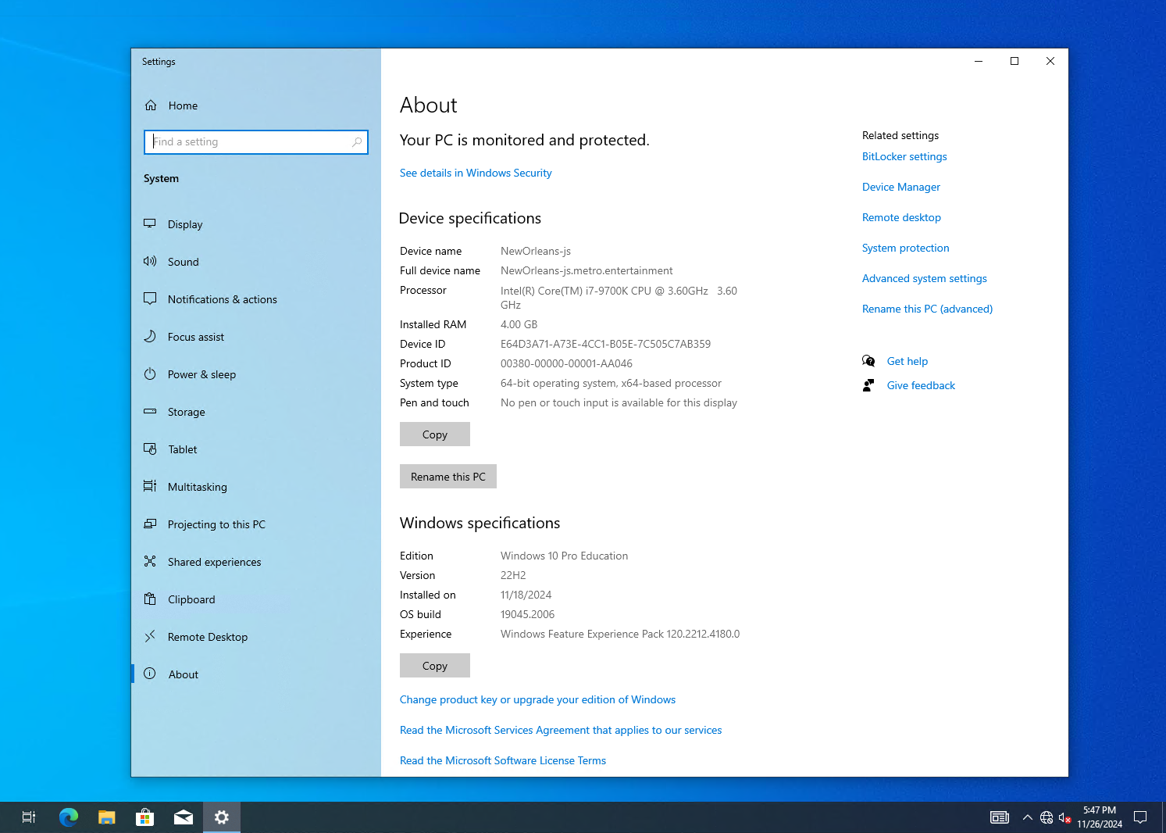
* Screenshot of the ping (showing connectivity)  
  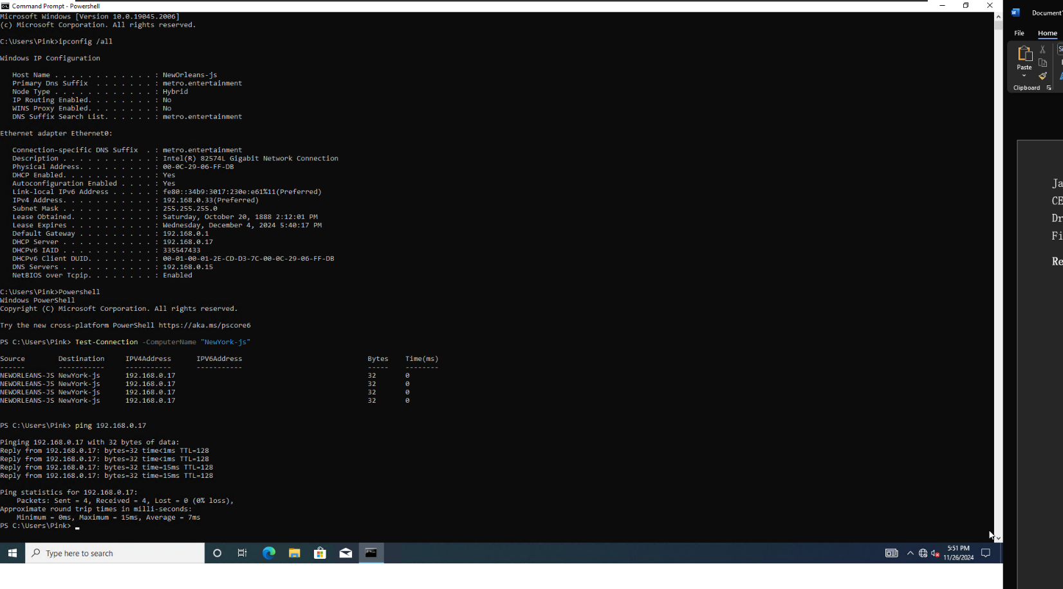
* Screenshot from the client showing a dhcp address (Ipconfig /all)  
  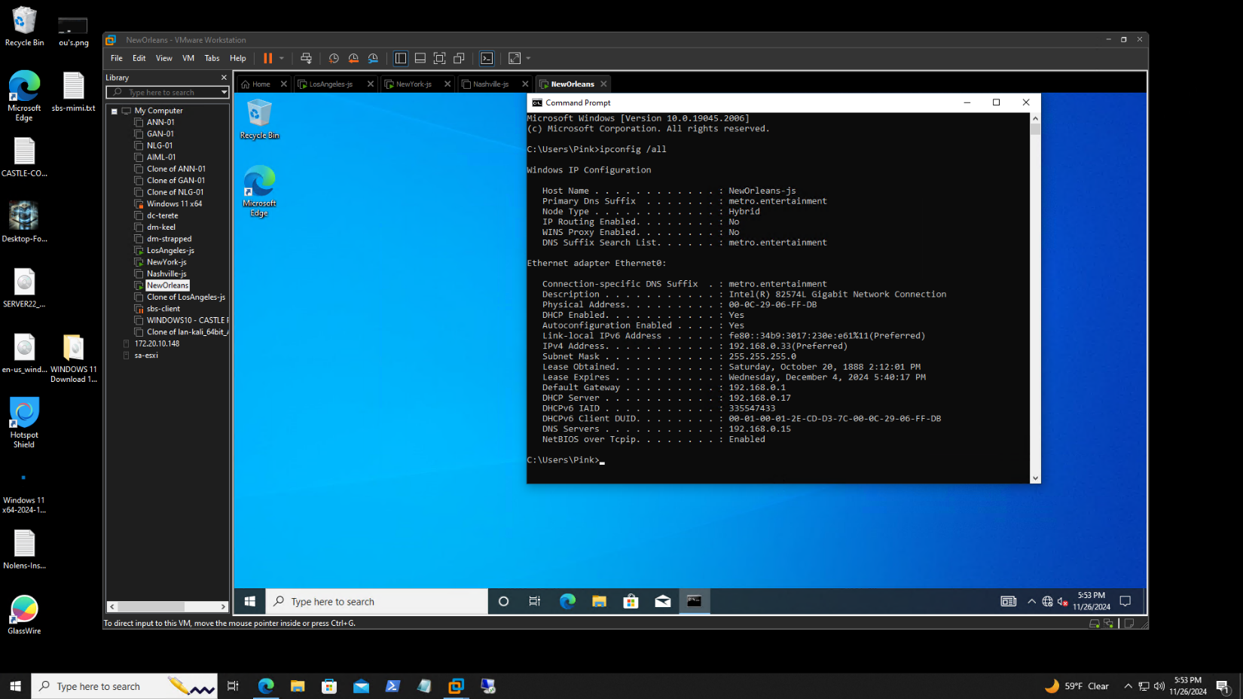
* Screenshot from the DHCP console on Server 2 showing the client in the address leases  
  