**References/Sources**

* <https://becominghuman.ai/image-processing-sudokuai-opencv-45380715a629>
* <https://github.com/aakashjhawar/SolveSudoku>
* <https://github.com/ibhanu/sudoku-solver>

**Dataset**

* MNIST
* Chars74k Dataset
  + For this dataset only use digits from 0-9
  + <http://www.ee.surrey.ac.uk/CVSSP/demos/chars74k/>

**MNIST Training**

* Utilizes CNN similar to LeNet-5 architecture but deeper
* 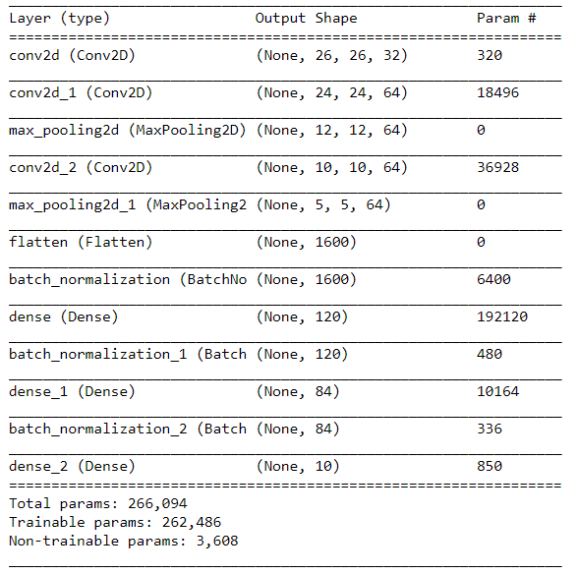Uses Image data Augmentation
* Model Summary:
* 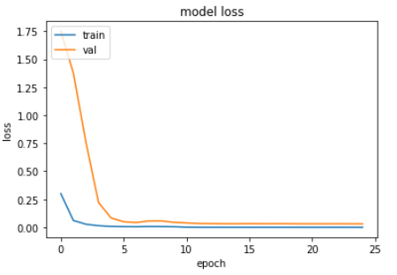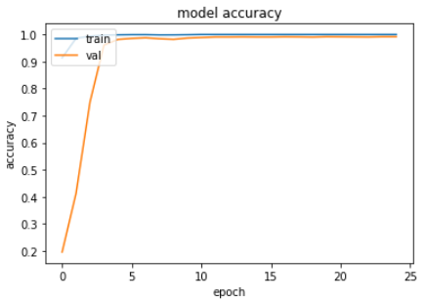Accuracy and Loss
* 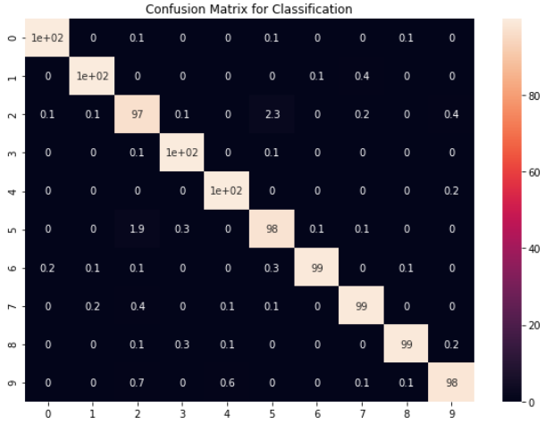Confusion Matrix

**Procedure**

* Image Preprocessing
  + Gaussian Blurring (if used)
  + Adaptive Thresholding
  + Find Contours of rectangle for sudoku board
  + Crop and Warp perspective
  + Split the warped image into 9x9 grids
* Prediction
  + From the 9x9 grids, use CNN to predict digits
  + CNN pretrained from MNIST and Chars74k dataset with 98.9% accuracy on validation set.
* Sudoku Solver: Utilizes Norvig’s Algorithm (<https://norvig.com/sudoku.html>)

**Streamlit**

**To Run Streamlit App:** streamlit run xxx.py

**Docker**

* Create a new folder called docker to keep everything clean
* Cd into that directory (use quotes)
* Build Images (name is mystapp:latest): docker build -t mystapp:latest .
* Build Container (map to port 8080): docker run -it -p 8080:8080 mystapp:latest
* Access app with: <http://192.168.99.100:8080/>
* Dig into a file system of an already run container: docker exec -t -i mycontainer /bin/bash
* Stop container: docker stop containerID
* View all container: docker ps -a
* View all images: docker images
* Remove all containers: docker rm $(docker ps -aq)
* Remove all images: docker rmi $(docker images -q)

**Heroku Deployment**

* Create project in Heroku.com
* To Login to Heroku via cli: heroku login
* Git init (if not already done)
* Git add .
* Git commit -m “commit1”
* Clone: heroku git:remote -a (project name)
* git push heroku master
* **App link:** <https://sudoku-solver-images.herokuapp.com/>

**Git**

* Undo git init: rm -rf .git
* OR Delte .git folder (hidden)

